MUID Efficiency Estimates

Introduction

- General idea
- Macros, scripts and results in CVS
- Files on disk and in HPSS

DataDriven Method

- Step-by-step info, from reconstructed roads to efficiency estimates

Muon Identifier HV

- Overview / Algebra
- Efficiency scans with cosmics
- Current draw for the Run5pp, Run5CuCu, Run4AuAu

HV Method

- Step-by-step info, from logs to efficiency estimates

Results and Method Comparisons

- Run5 pp
- Run5 CuCu

Systematic Errors

- Run5 pp
- Run5 CuCu

Introduction

General idea

We use two different methods to estimate the MUID efficiency. The first one, which we will refer to as the DataDriven method uses offline reconstructed roads. We make the requirement that the roads should have passed all cuts without the MUID plane in question, and then check if we have a hit or not in that plane to calculate the efficiency.

For the second method, which we will refer to as the HV method, we examine the HV log files from the experiment, which contain frequent snapshots (one approx. every 60 seconds) of the status for each MUID HV chain. Based on the determined no-beam currents, known broken wires etc., we estimate what the beam-related current draw, and resulting efficiency loss due to voltage sag was.
Note that this method will not catch other (non-HV) problems, such as LV, FEE or even from voltage sag present without beam.

We then compare the estimates from the two methods for the final result, where the DataDriven method results are used except for the chains that have very low statistics (and therefore large uncertainties) in the DataDriven method, where we then replace the values with the HV method results.

This note focuses mainly on Run5 (CuCu and pp). The run4 AuAu analysis is also described in a separate note by MinJung.

Macros, scripts and results in CVS

The macros and scripts mentioned later reside in the cvs analysis areas:

offline/analysis/muideff/macros/HVMethod HV Method macros
offline/analysis/muideff/macros/DataMethod DataDriven Method macros

How to run the macros etc. is outlined in README files in these directories.

There is also a results area where the final files (after merging HV and Data method results and after overlap corrections have been applied):
offline/analysis/muideff/results

The result files come in two flavors (hvgroup or twopack levels) and are named a la:
muideff_run5_CuCu_200GeV_hvgroup_north.dat

Files on disk and in HPSS

The Run5 MuidEffic ntuple root files are in HPSS:
/home/silvermy/MuidEff/run5{pp,CuCu200,5CuCu62}
and currently resides on the data disks under:
/phenix/data25/MUON_GROUP_PROJECTS/MuidEff/ run{5pp,5CuCu,4AuAu}
The original MUID HV log files are in HPSS; under
/home/claudius/
while the digested run-by-run ntuple info that we used are in the HPSS areas:
/home/silvermy/MuidHV/4.runbyrun_HVntuple/run{4AuAu,5CuCu,5pp}.tar
and reside on disk in the working dir. we used:
/phenix/data25/silvermy/work/042.run{5pp,5CuCu,4AuAu}_MUIDHV/\
4.runbyrun_HVntuple/

DataDriven Method

The plane efficiency calibration has been implemented in the mutoo_subsysreco module MuidEffic.cxx. The macro implementation runs in the fun4all framework and was part of the production for the Lvl2-filtered production passes at ORNL. We have included cuts in MuidEffic that are stricter than the cuts from Lvl1 and Lvl2 and thus removes a possible bias from the filtering. To be explicit, we require that the roads pass the cuts for Lvl1 and Lvl2 with and without a hit in the plane we estimate the efficiency for.

We use a steering macro GenMuidEffic.C to implement the cut selection. Since the trigger and filtering requirements were somewhat different between the different Runs, the applied cuts vary somewhat too.

After we have merged the information between this method and the HV method (we use values from the HV method for low statistics chains) we run a perl script that applies the overlap correction, called GenMuidEfficOverlapCorrect.prl.

Then we run a 3rd macro GenMuidEfficTwoPackC to reformat the text file generated by the analysis to be in the form used by the masking software.
The text files on both the HV group and two-pack levels are then checked into the CVS results area.

That was the introduction; Jamie, pls add info on Run-dependency etc.

Muon Identifier HV

Overview / Algebra

Each MUID channel or two-pack, consists (as the name suggests) of two individual Iarocci tubes. The two tubes are part of two different HV chains. Each HV chain typically serves 20 or so tubes. The two HV chains that serve the same two-packs make up what we will refer to as a HV ‘group’. The large panels have 3 HV groups in either orientation while the smaller panels have 2 groups in the horizontal orientation and 1 in the vertical orientation.

The HV setup, and expected resistance and current algebra is shown in the following image, for a chain with N tubes, and n broken wires :

Efficiency scans with cosmics

We have estimated the efficiency for the chains using our cosmics trigger as a function of applied HV. An example (for the South Horizontal view) is shown in the following image.
The plot has 6 panels, following the MUID layout with the large panels in the corners, and up to 3 HV groups per panel. The X-axis is the applied HV in V and the Y-axis is the estimated efficiency. The points are fitted with a function (to asymptotically reach full eff as HV approaches infinity): par[0] * ( TMath::TanH(par[1]*(x[0] - par[2])) );

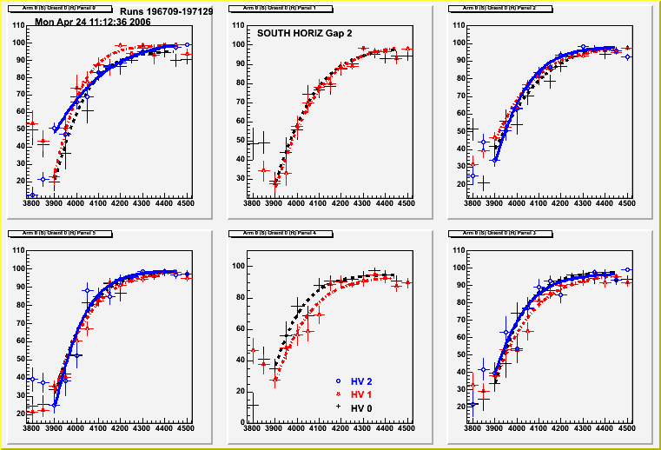
Eff. (%)
HV (V)

The default MUID HV operating value is at 4400 V, i.e. safely on the plateau, but one can see that if one experiences a voltage sag of about 100 V (to 4300 V) , which corresponds to an extra current of about 5 μA, the loss in efficiency can be significant. Averaging the results from the fits to the response curves gives us a formula for how the efficiency E (in %) can be described as a function of voltage sag V_{S} (down from 4400 V):
E = 96 (1 – 2.4e-6 V_{S}²)

The first step is then to estimate the voltage sag from the current draw.

Current draw

The beam conditions and backgrounds can vary from run-to-run and store-to-store. The current draw can also deviate from the normal 4.4 μA due to to broken wires and/or other problems. To see what the beam-related extra current is, we use a snapshot of the current values at the operating voltage but without any beam in the machine.
We can then compare the calculated average current run-by-run with the subtracted current. The difference between the average (with beam) current, and the subtracted (no beam) current for the Run5 pp & CuCu and Run4 AuAu for all chain is shown in the images below.

Run5pp:
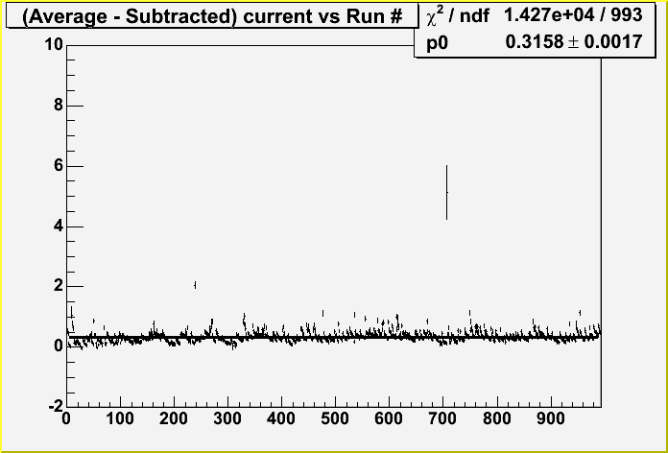

Each bin corresponds to a particular run. Y-axis is the difference between the average and subtracted currents, in μA.
As one can see, the current draw is quite low and stable throughout Run5.

Run5CuCu:

For CuCu, the current draw is marginally higher, but not too much worse. The store-to-store fluctuations are more apparent, but not too large.

The AuAu case shows more scatter in the average currents, particularly towards the later parts of the Run. But the average current is still not too much higher than the no-beam current.
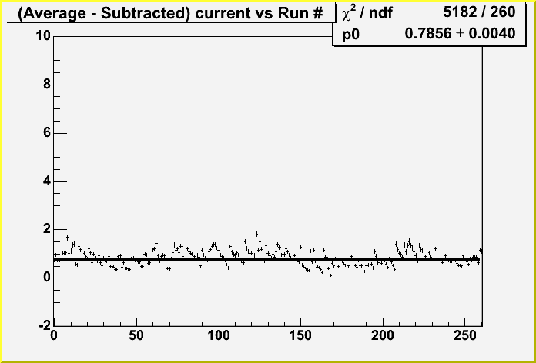

Run4AuAu:
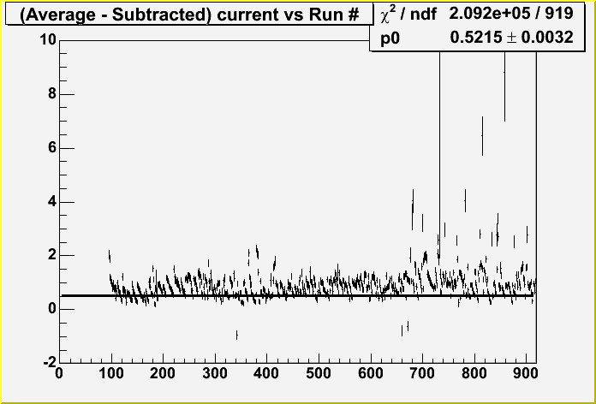

HV Method

Since this method has not previously been documented (unlike the DataDriven) method, and has in fact evolved somewhat recently, from just using a broken wire parameterization, we describe the involved steps in some detail.
The README (and DoAnalysis) files in the CVS area, which also holds all macros contain the full/exact description.

Step 1: SETUP / From HV logs to run-by-run ntuples

Description: After getting the raw HV log/ascii files from HPSS, and providing a list of runs that should be studied, we run two perl scripts to first extract begin and end times for each run in the list, and extract all HV readings that fall within the run’s time window into separate files. Then we convert the ascii files into ntuples, with the info still separated run-by-run. I.e. this step only involves translation of data from one form the other.

Step 2: Determining the HV status for each chain (and each run)

Description: Here we use the macro average.C for each run, and as the name suggests, take an average of the current and voltage values from the usually tens of snapshots readings for each chain. Checks are done that the voltages are up, and that no trips or ramps appear to have taken place.

After this step we can then produce (with scan_average.C, plot_average.C) the current draw plots that were shown above.

Step 3: Estimating the efficiency for each HV group (and each run)

Description: We run the macro muidHV_2pack_root.C for each run, which checks the average current draw, compares it with the normal current without beam, and consider the approximate acceptance loss from broken wires. Based on these numbers and the efficiency loss formula as a function of voltage sag, an efficiency value is estimated for each HV group.

We subsequently produce a combined ROOT file with the info for all runs that have passed our good run selection using the macro combine.C.

Step 4: Comparing results with the DataDriven Method.

Description: We compare the results from the HV method and the DataDriven method with the macro muidploteff.C, which makes the panel-by-panel plots that are shown first in the Results section. We also do a more detailed comparison of the difference between the two methods with the the compare.C macro. Finally, we merge the results from the methods (compare.C) whereby low statistics values (approx. 40 out of 600 chains; 41 for pp) from the DataDriven method are replaced by values from the HV method. These 40 groups all are from ‘group 0’ in the vertical orientation for the large panels (0,2,3,5) in all 5 gaps.

There was one extra group in run5pp, namely North, gap 1, horizontal, panel 4, group 0.

Results and Method Comparisons

Part I:
First we show the comparisons between the values from the DataDriven and HV methods. These plots show the efficiency values (Y-axis, in %) for both methods and all HV groups, as outlined in the legend. The panels on the plots again correspond to the real MUID panels and the X-axis to the MUID gaps (0-4). We make separate plots for each arm (South, North) and orientation (Horizontal, Vertical), i.e. a total of 4 plots per dataset.
The plots are all available under:
https://www.phenix.bnl.gov/phenix/WWW/publish/silvermy/muon/muid_hv/
run5{pp,CuCu}/all/ploteff-run_0-{0,1}-{0,1}.gif

Run5 pp :
South Horizontal
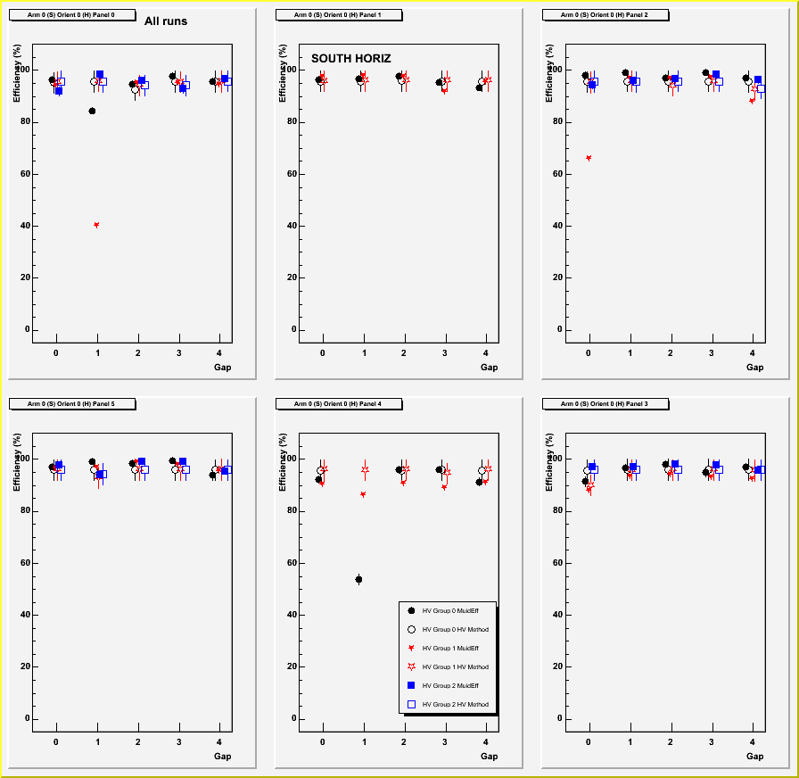

Run5 pp :
South Vertical
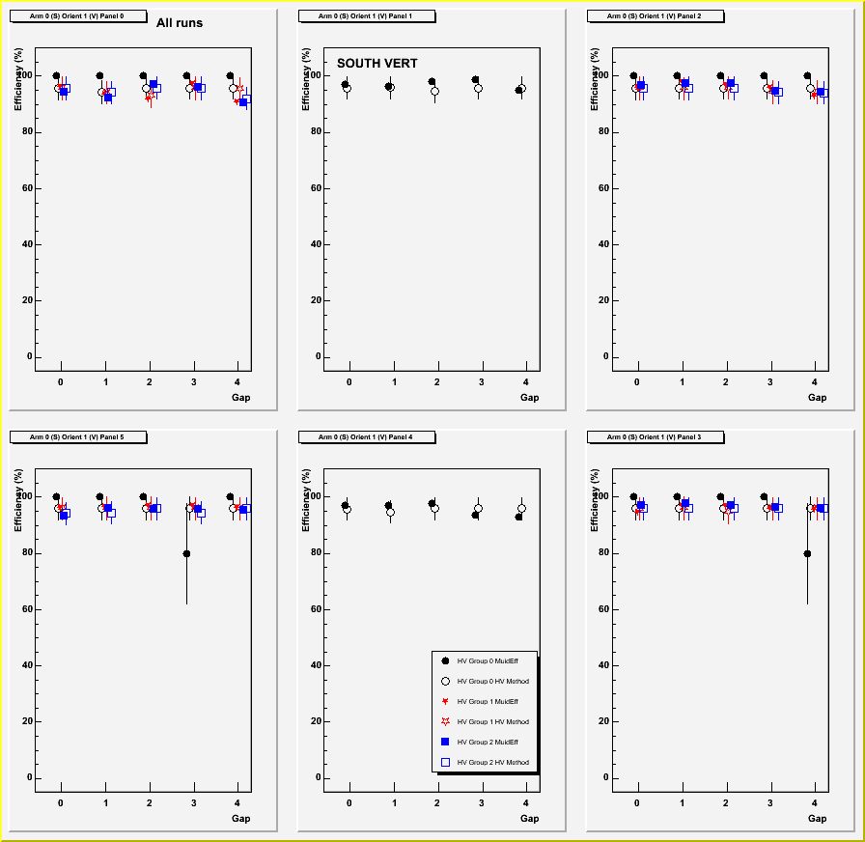

Run5 pp:
North Horizontal

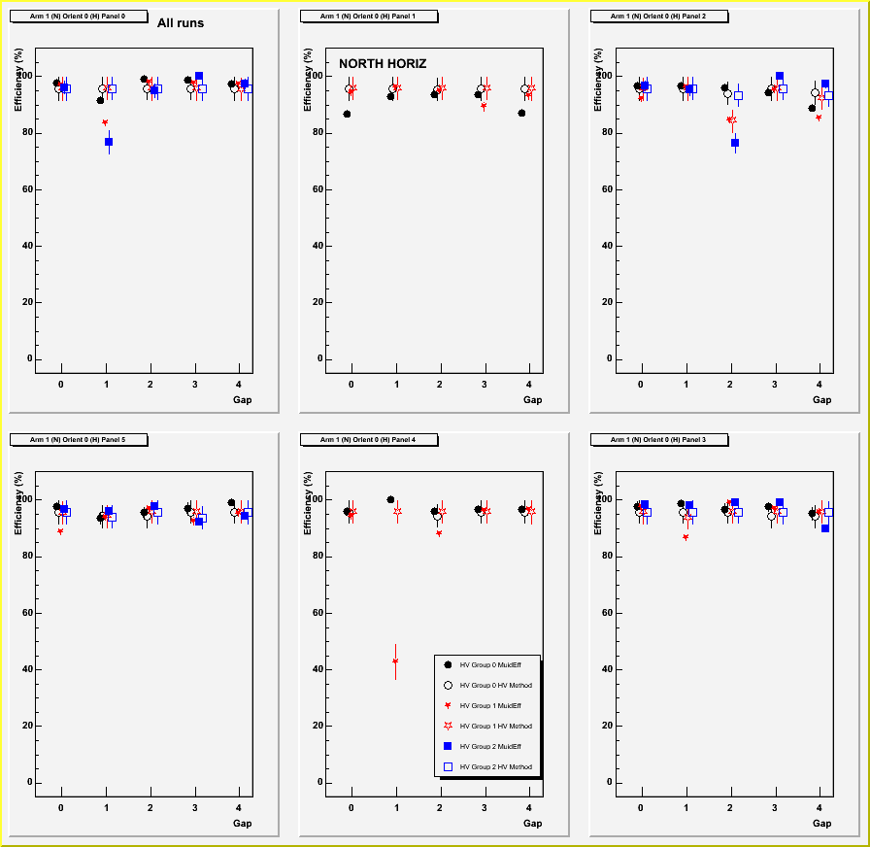

Run5 pp:
North Vertical

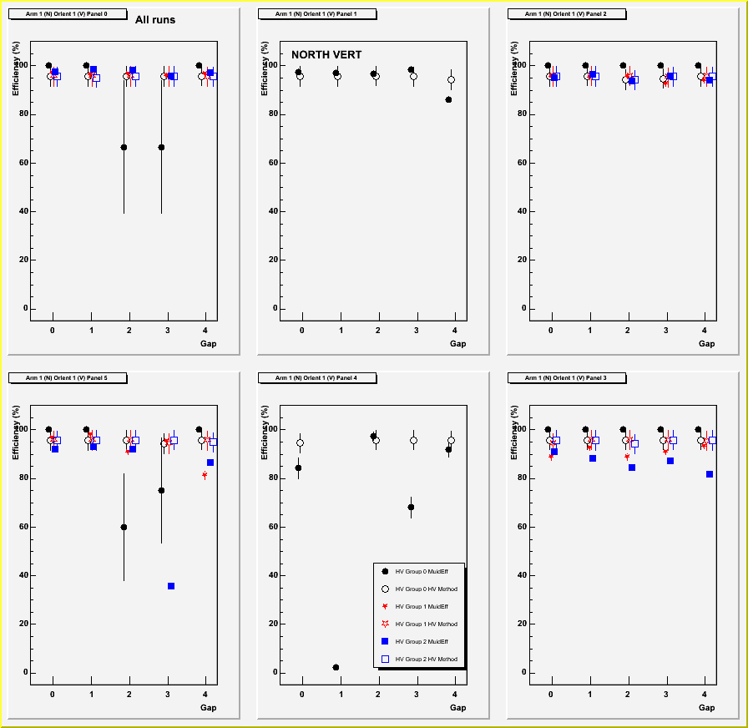

Run5 CuCu :
South Horizontal

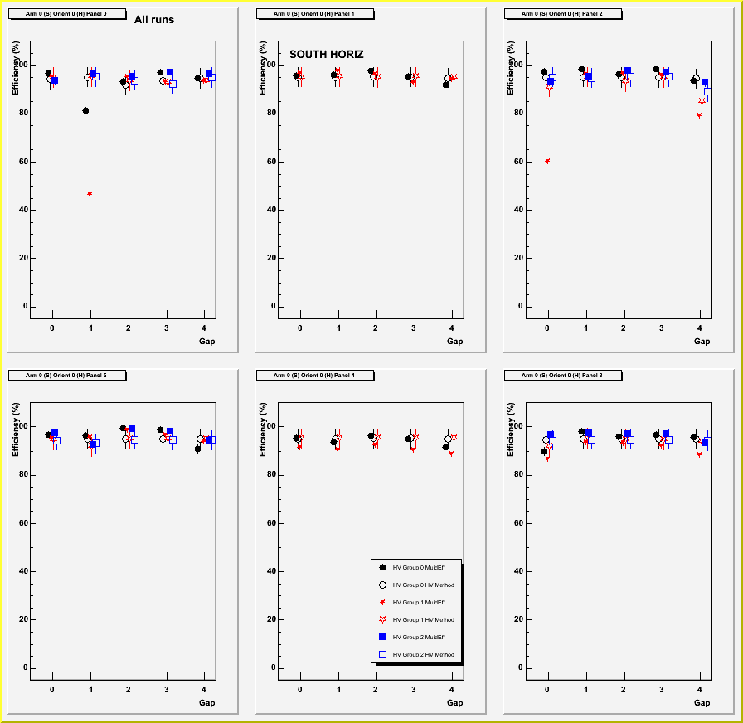

Run5 CuCu :
South Vertical

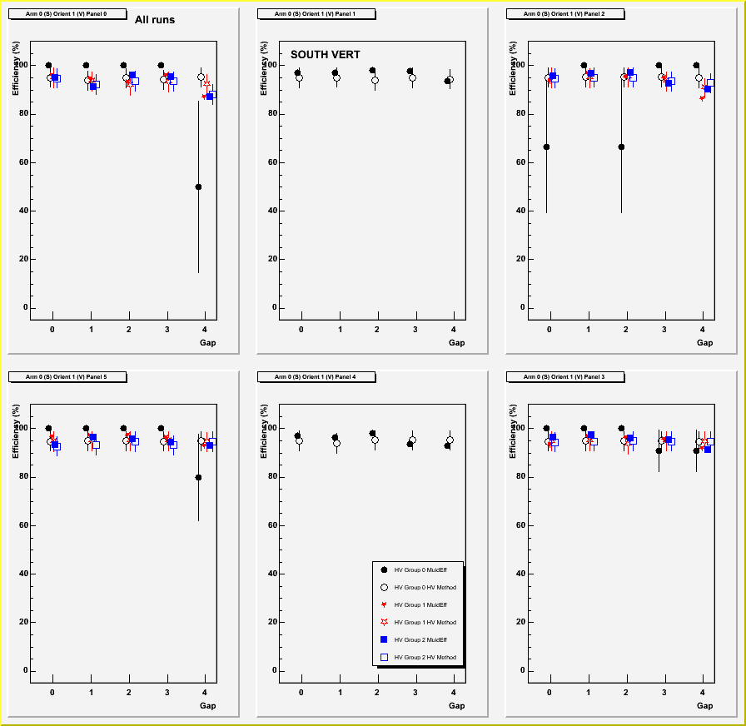

Run5 CuCu :
North Horizontal

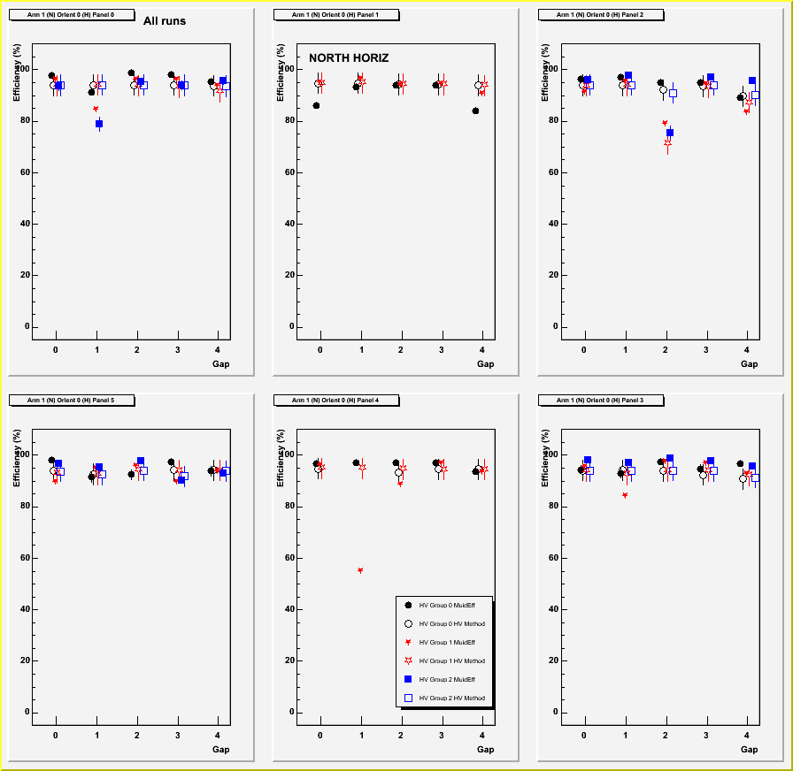

Run5 CuCu :
North Vertical

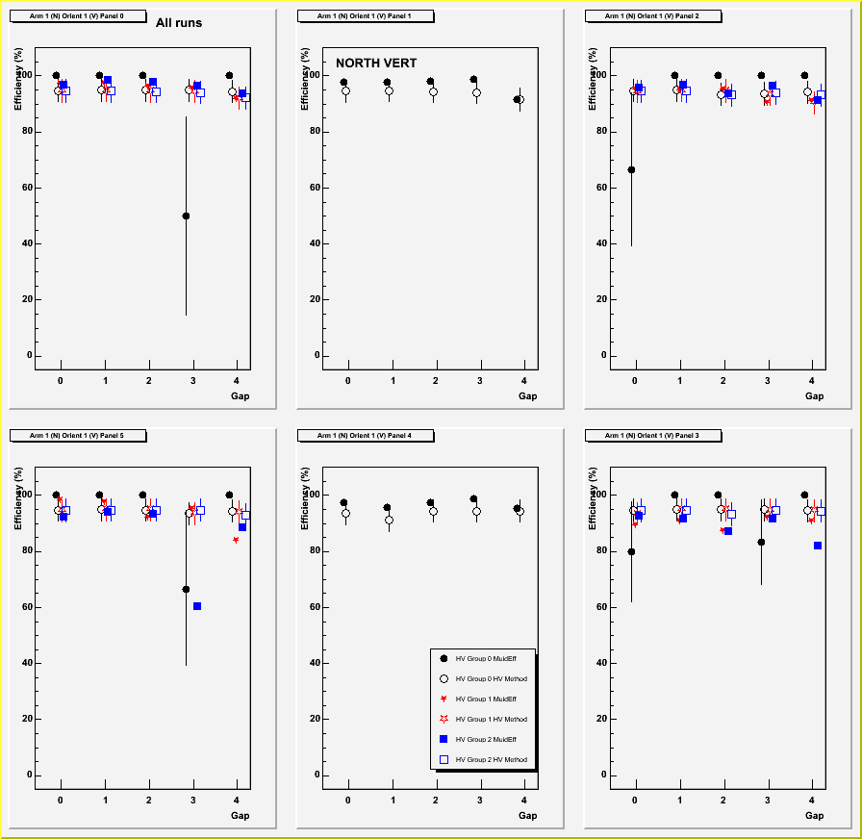

Part II

Then we have the difference between the values from the DataDriven and HV methods. These plots show the efficiency values difference (X-axis) distribution. A value of 1 here means 100% efficiency. The panels on the plots now correspond to to the MUID gaps (0-4). We make separate plots for each arm (South, North) i.e. a total of 2 plots per dataset.
The plots are all available under:
https://www.phenix.bnl.gov/phenix/WWW/publish/silvermy/muon/muid_hv/
run5{pp,CuCu}/all/compare_{south, north}.gif

Run5 pp :
South

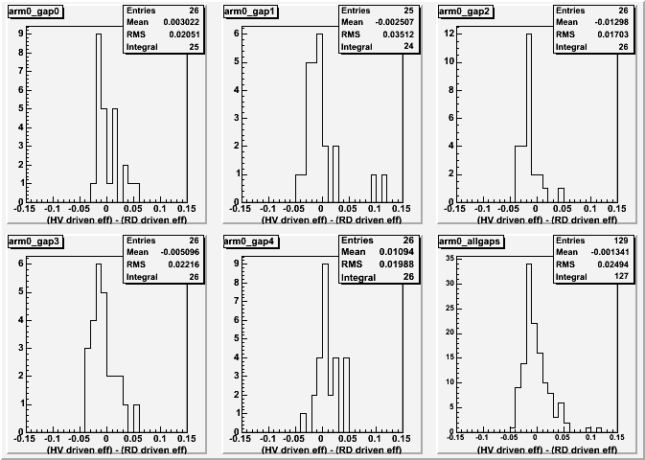

Run5 pp :
North

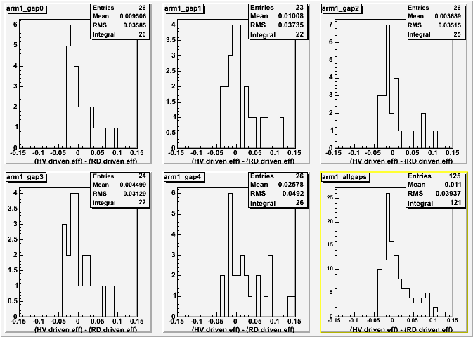

Run5 CuCu:
South

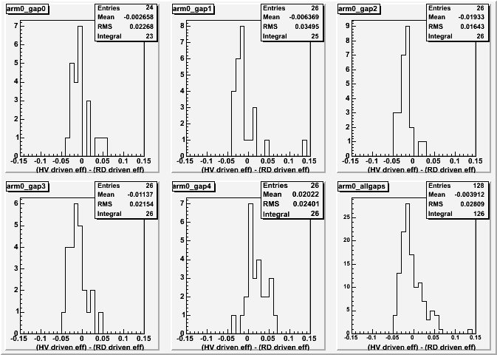

Run5 CuCu:
North

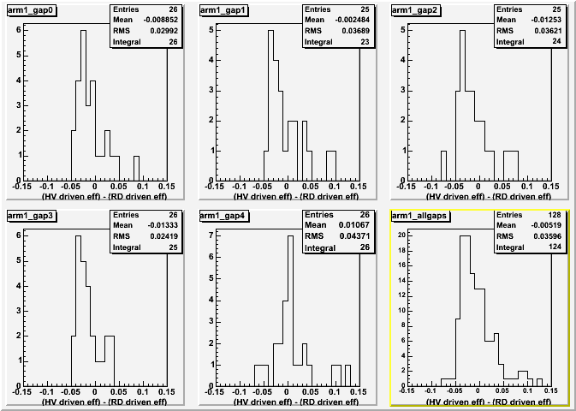

Part III

In this section we compare the values from Run5 CuCu to pp for both methods as a means to gauge the possible influence of random benefit. Similarly to the previous section, we require that the HV groups included in the comparison plots should have absolute efficiency errors larger than 0 and less than 5%, to exclude low statistics and poorly determined efficiencies. The errors displayed in the earlier plots are all binomial, i.e. if we label the efficiency p, and the number of trials N, the error is given by
Error = sqrt( p*(1-p) / N). So, if we only had 2 trials and both were successful we’d currently assign an efficiency value of 1 (100%) and an error of 0. So, this cut is just meant to remove such groups.

The plots are all available under:
https://www.phenix.bnl.gov/phenix/WWW/publish/silvermy/muon/muid_hv/
comparison/CuCu-pp//compare_{data,hv}_{south, north}.gif
Similar plots for the difference between Run4 AuAu and Run5 pp are available in a parallel directory (AuAu-pp) but not included in this note. We include the full +/- 1 scale in efficiency difference to show (and have the y-axis in log-scale) that there is not much grass around the central part of ~0% difference. One can see that there is not that much of difference between the CuCu and pp results.

Run5 CuCu - pp:
South, DataDriven Method

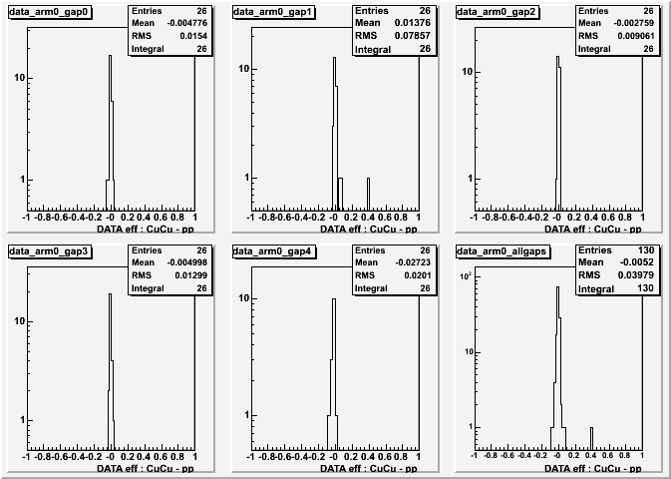

Run5 CuCu - pp:
North, DataDriven Method

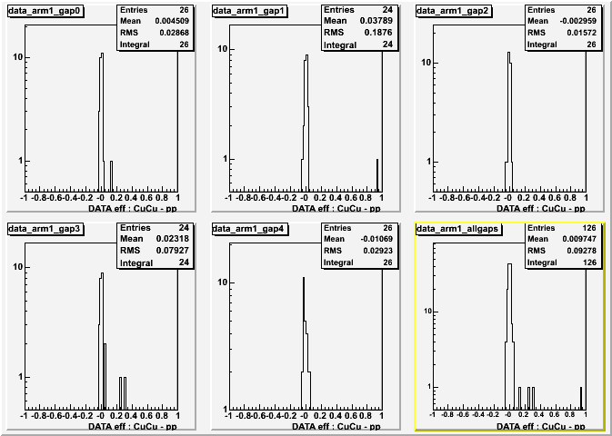

Run5 CuCu - pp:
South, HV Method

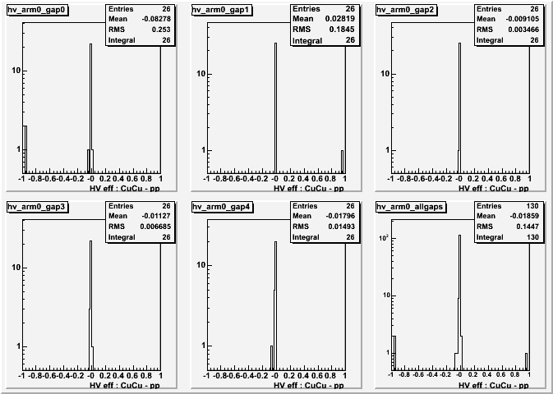

Run5 CuCu - pp:
North, HV Method

