A New Calibration Method for the Muon Tracker Cathode Strip Chambers

D.M. Lee and M.L. Brooks

Introduction

The high resolution of the muon tracker cathode strip chambers ( ~100 microns per plane) require that the transfer gains of the analog readout chain be calibrated to 1% or less. The method usually used to perform this calibration is to have a charge injected into each frontend amplifier through a precision capacitor from a precision voltage pulse.

The location of this precision capacitor was originally chosen to be on the input to the input amplifier. Tests were performed between using precision matched surface mount capacitors and fabricating capacitors into the PC board. The results showed that the surface mount capacitors even though matched to 0.2 % were only able to be matched on the PC board to 1.5-2% because of stray capacitance introduced by the solder. The capacitors fabricated into the PC board were matched to 0.6%. The inboard fabricated capacitors were therefore chosen to be the baseline.

Recently concern has been expressed about the implementation of these capacitors and interaction of high speed pulses on the input board. A request was made to see if an alternative scheme could be used, namely, pulsing the anode plane. This report documents the results of that study.

Background

The capacitance of the anode wire to cathode is about 9 pf/meter and the length of wire that a given strip sees is ~1 cm. Therefore, a 10 volt pulse on an anode wire should result in a charge on the cathode of about 5.6 x 10**6 electrons/strip/wire pulsed:

Charge (Q) = CV
= (9 pF/meter)(0.01 meters)(10V)
= 9 x 10⁻¹³ Coulombs = 5.6 x 10⁶ electrons

To cover our dynamic range we would like to get to an injected charge of ~ 5 x 10**6 electrons/strip. To keep the voltage level to a reasonable level this implies that we should pulse three wires to cover the dynamic range.

A good 1 % calibration requires good precision 1 % capacitors. For a technique involving pulsing the anode plane to induce charge in the cathode strips, the anode to cathode capacitance variation should be at or below the 1 % level. Since the capacitance depends on the mechanical gap the capacitance tolerance is directly related to the mechanical tolerance of the gap. The flatness of the honeycomb has been measured to be about 7 mils across the chamber so we expect the gap tolerance to be about 10 mils. This mechanical tolerance translates to a capacitance error of 2.4%, larger than we would like. However, if we assume that the tolerance of interest is only across three adjacent readout strips and across three wires then our expectation, based on previous flatness measurements, is that the flatness tolerance in that limited area is better than 2 mils and therefore the capacitance error will be better than 1 %.

Implementation

To implement this technique we can use the wires on the outside radius of the chamber that cover the region between 34.5 and 35 degrees. These wires will be able to induce charge on all cathode strips at the same time. These wires are not useful in the chamber acceptance since the large rear aluminum frame at station 2 is within this region. The field and sense wires will be or’d together and attached to ground through a terminating resister chosen to match the pulser cable. The last anode PC board would require a small modification

Test Results on the Prototype Chambers

To test this calibration method, the high-voltage bus on the Station 2 prototype was modified. The resistors on two of the top anode wires were by-passed so that the anode wires were directly connected to the HV bus. A lemo connector was soldered to the high-voltage bus, to allow injection of a voltage pulse from a DAC. The connection to the other 14 anode wires on the anode wire connector were left connected to the HV bus, through 500 MΩ resistors. The rest of the anode wires were disconnected from the HV bus by removing a jumper on the bus. These modifications allowed two of the top anode wires to be pulsed with the DAC.

First, the capacitance of the anode wire to the cathode strips was checked by putting known voltage steps onto the anode wires and reading out the cathode strip signals with a prototype cathode preamplifier and an off-the-shelf ADC. It was found that a step voltage of approximately 10 V was needed to reach full-scale on the ADC. The amplification of the preamplifier and a second-stage amplifier that was on the test-board was approximately 7 mV/fC. The full scale of the ADC was approximately 4 volts. Since two wires were pulsed, this implies that the anode wire to cathode strip capacitance was approximately:

C = Q/V
= (4000 mV)/(7 mV/fC)/(10 volts) / 2 wires
= 28.5 fF/cm = 2.85 pF/cm

This is smaller than the expected capacitance by about a factor of 3, but still allows the full scale of the preamplifier to be covered with reasonable pulser or DAC values.

We also attempted to check the accuracy of the gain measurements by 1) comparing the gains obtained by pulsing the anode wires to gains obtained by pulsing precision capacitors that were put between the detector and the front-end of the amplifier and 2) comparing the gains obtained with a given preamplifier chip when it was connected to different cathode strips on the prototype chamber.

Figure 1 shows the gains obtained for eight channels of preamplifier when the preamplifier was connected to two different sets of strips on the prototype chamber and 1) the preamplifier was pulsed through precision capacitors and 2) the two anode wires were pulsed. As can be seen, the relative gains obtained are similar for the two calibration methods, but the shapes of the curves are not exactly the same. The errors in the gains are probably somewhat higher than the desired 1% because the gains were extracted by performing a straight-line fit to the data even though the gain curves are not quite linear and the “precision” capacitors are known to not quite be matched to the 1% level. However, some of the deviations of the two methods are larger than either of these explanations would allow (channel 8, connector 4 for example).
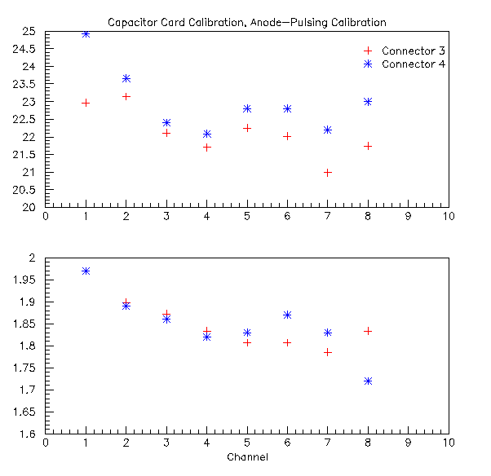
Figure 1. The gains of 8 preamplifier channels, measured when connected to two different sets of cathode strips, and measured using the capacitor-pulsing method (upper curves) and the anode-wire-pulsing method (lower curves).

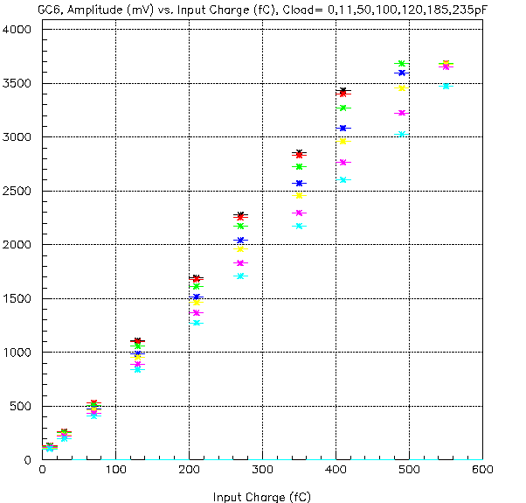
Figure 2. Gain curves for capacitance loads of 1, 11, 50, 100, 120, 185 and 235 pF.

It is possible that part of the difference in the gains obtained with the two methods can be attributed to the fact that when the anode wires are pulsed, the charge that is seen by the preamplifier is sensitive to the charge coupling between the readout and non-readout strips in the chamber, but when the capacitors are pulsed only the readout strips see charge. If the coupling is not the same for all strips connected to the preamplifier, then the relative gains would be measured as being different from the capacitor calibration method. This coupling, however, would also affect “real” signals, so it is an effect which you would like to measure when you measure gains. This effect is noticeable when a readout strip is not connected to the preamplifier (there are a few cases of this that were apparently caused by the strip losing the solder connection to the readout card). When a readout strip is not connected, the gain of the next readout strip seems to always be noticeably higher than other channels on the same connector.

The measured gains of the preamplifier chip were also compared when the chip was connected to different strips on the prototype chamber. The original intent of doing this was to see if the gains were the same when connected to different parts of the chamber, thus verifying that the mechanical tolerances of the chamber were good enough to ensure a 1% calibration method. However, the front-end capacitance that the preamplifier sees changes substantially as you move across the chamber. This change in capacitance changes the gain of the preamplifier, as shown from earlier tests of the preamplifier (see Figure 2).

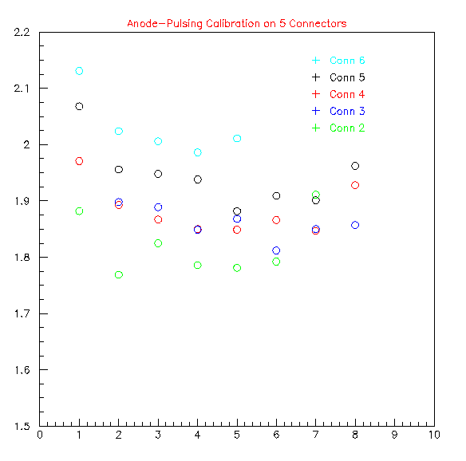
Figure 3 shows the gains obtained for the eight preamplifier channels when they were connected to five different sets of cathode strips on the prototype chamber. The relative gains of the eight channels look similar for the different data sets, and may very well be within the errors of the linear fits. The changes in gains look reasonable for connectors 3 through 6, but the lower gain of connector 2 is not understood. The strips on connectors 3 and 4 should be the longest and should thus provide the largest front-end capacitance
Figure 3: The gain measured (anode-pulsing calibration method) for the eight preamplifier channels, for five different sets of cathode strips.

for the preamplifier. Therefore, connectors 3 and 4 should have similar gains and they should be the lowest gains measured. Connectors 5 and 6 should provide successively shorter strips, smaller capacitance, and thus larger gain which is what you see in figure 3. However, connector 2 should also have shorter strips, smaller capacitance, and thus larger gain than connectors 3 and 4, but this is not what was measured.

Perhaps there is a geometric/electrical explanation for connector 2 strips giving a smaller gain. Figure 4 shows the orientation of strips, pulsed anode wires, and connectors. The strips that are connected to connector 2 are the furthest from the point that the anode wires are pulsed, and the signal has the longest strip length to traverse before reaching the preamplifier, so if there are any losses on either the anode wire or the cathode strips, it is true that connector 2 would be most affected, and the gain would tend to be reduced.
Figure 4: Orientation of cathode strip readout connectors, pulsed anode wires, and input of pulser for anode-pulsing calibration method.

We did try to calibrate the strips on the right-hand side of Figure 4 also. This side of the chamber tended to have more missing strips, so there were more anomalous gains, presumably because of the disconnected strips. Even so, the right-most connector did not seem to show the low gain that connector 2 did. Therefore, if the low gain of connector 2 is to be attributed to losses of the signal(s), it must be loss of the pulser signal along the anode wire.

