Nucleon Structure Physics by Proton-Proton Collisions

Ming Xiong Liu

Physics Division, Los Alamos National Laboratory, Los Alamos, NM, 87545, USA

E-mail: mliu@lanl.gov
(Received April 23, 2019)

Today, the nucleons (protons and neutrons) make up most of the visible matter in the universe, from the nucleus to the galaxy. Understanding the fundamental constituents of the nucleon and the internal parton dynamics is of great interest of modern physics. However, describing the nucleon structure with the fundamental degree of freedom of quarks and gluons in the QCD framework remains as one of the most outstanding challenges in modern high energy nuclear and particle physics. In the last decades, largely due to the worldwide collaborative effort and advances in beam acceleration and target polarization technologies, tremendous progress has been made in the study of nucleon structures with polarized high energy leptons and hadron beams. The complementarity of lepton scattering and pure hadronic interaction is critical in the study of nucleon structure and QCD. In this presentation, I highlight a few recent achievements in the study of the nucleon structures with high energy (polarized) hadronic scatterings at the Relativistic Heavy Ion Collider (RHIC) at Brookhaven National Laboratory, at COMPASS at CERN as well as the SeaQuest experiments at Fermilab. Future prospects of new opportunities at above and other facilities worldwide are also discussed briefly.
KEYWORDS: Proton, neutron, spin, QCD

- Introduction

Understanding the structure of the nucleon at the fundamental level with quark and gluon’s degree of freedom is one of the goals of modern physics. In the high-energy nucleon reactions, the nucleon can be described as a collection of partons, whose distributions inside the nucleon are generally universal and process independent, the so called parton distribution functions (PDFs). The reaction rate can be calculated in the perturbative QCD (pQCD) framework as a sum of the factorized individual parton-parton interactions. PDFs are fundamental properties of the nucleon. At the leading twist in the collinear factorization framework, there are three kinds of parton distribution functions: 1) the unpolarized parton distribution functions, ; 2) the parton helicity distribution functions, ; and 3) the transversity functions, . Here x represents the parton light-cone momentum fraction, and Q² denotes the momentum transfer under the reaction. In the three-dimensional partonic picture of the nucleon, one can go one step further beyond the above one-dimensional PDFs, describing the parton distribution functions in the (2+1) dimension, including the parton’s transverse momentum k_{T}, in addition to the longitudinal momentum fraction x, thus they are Transverse-Momentum-Dependent (TMD) functions. At leading twist, there are eight TMD PDFs describing the partons’ longitudinal and transverse motion distributions and their correlations with the nucleon spin and momentum directions. All these functions can be probed in high-energy hadron-hadron or hadron-lepton scattering experiments, for recent reviews and some early work, see [1] and references therein.

With the advance of accelerator technology, the world’s first high energy polarized proton collider was built at the Brookhaven National Laboratory in New York, USA, in late 1990s, and has been in operation since 2001. Since then, tremendous progress has been made in studying the proton internal structures and QCD dynamics using longitudinally and transversely polarized proton-proton collisions at high energies at the Relativistic Heavy Ion Collider (RHIC). Fig. 1 shows the layout of the world’s first high-energy polarized proton accelerator complex at RHIC.

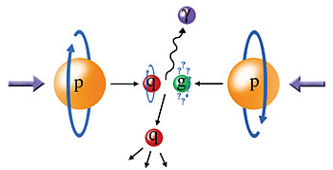
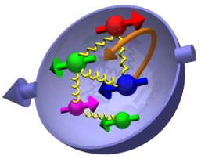

Figure 1. LH: The layout of the world’s first high energy polarized proton + proton collider at the Brookhaven National Laboratory in New York. The proton beam has been polarized up to about 60% either in longitudinal or transverse direction relative to the beam momentum direction, at center of mass energies from 62 to 510GeV. RH: High energy particles are produced in the polarized proton + proton collisions at RHIC. The polarized PDFs have be derived from the measured spin-dependent cross-sections in the pQCD framework.
QCD is the theory of strong interactions. Particle production in the high energy polarized proton + proton collisions can be calculated as a sum of the product of the universal PDFs, f(x₁) and f(x₂) of the incoming partons and the partonic scattering cross sections that can be calculated in the perturbative QCD framework:

Using above theoretical tool, one can derive the universal parton distribution function f(x) with the experimentally measured cross section, , and the theoretically calculated partonic cross-section, .

In the following, I present a few highlights selected from recent experimental and theoretical studies of the (polarized) nucleon structures using high energy (polarized) hadronic scatterings at BNL, CERN and Fermilab.

2. The proton spin puzzle and the polarized parton distribution functions

The nucleon’s quark and gluon helicity distributions, Δf(x, Q²), are universal property of the nucleon. They are derived from high-energy polarized nucleon-nucleon or polarized nucleon-lepton scattering data. Before 1987, it was believed through some naïve nucleon quark models that the proton’s spin is mostly coming from the sum of quarks’ spin. When EMC collaboration at CERN carried out the first measurement of quark’s spin contribution to the proton spin in the deep-inelastic polarized muon-proton scattering in 1987, the results socked the world – the sum of the quark’s spin can only account for about 30% of the total proton spin, known as the “spin crisis”, see [2] and references therein. Several new polarized DIS experiments were conducted following the EMC’s discovery and further confirmed the surprising results. Where does the rest of the proton spin come from?

In QCD, the proton helicity sum rule is given by [1],

where denotes the sum of the quark spin contribution, and is the gluon’s spin contribution, and represents the contributions from quarks’ and gluons’ orbital motion inside the proton. Could gluon and sea-quark’s spin make up the rest of the missing proton spin? It was highly motivated theoretically, see [2] and references therein. Since DIS is not sensitive to the (polarized) gluon and flavor-identified sea quark distributions, a new experimental tool was highly desired. This led to the development and construction of the world’s first polarized proton collider at the Relativistic Heavy Ion Collider at BNL, to directly probe the gluon and sea quark’s spin contributions to the proton spin.

2.1 Gluon polarization inside the proton
The polarized gluon distribution function (more exactly, the gluon helicity distribution function) is a fundamental quantity of the proton properties and has long been considered as a primary candidate for the missing piece required to solve the proton spin puzzle. RHIC has provided a great advantage over previous DIS by directly probing the gluon distribution at the leading order in the high energy QCD process. The double longitudinal spin asymmetry A_{LL} of a hard process, like the inclusive high-energy jet or high p_{T} hadron production in p+p collisions, is directly coupled to the polarized gluon distribution function at the leading order in pQCD, thus providing the ultimate sensitivity to the polarized gluon distribution.

Evidences of the first definite non-zero gluon polarization came from the precision measurements of double longitudinal spin asymmetry from the year 2009 high statistic RHIC data, in the inclusive jet production (STAR) and the inclusive production (PHENIX), Fig. 2.
STAR: PRL 115, 092002 (2015)
PHENIX: PRD 90, 012007 (2014)

Figure 2. First precision data from RHIC show the first evidence of non-zero gluon polarization in the proton.

Several theory groups carried out new next-to-leading order (NLO) global QCD analyses to include the latest RHIC data and extracted the gluon spin contribution. Fig. 3 (LH) shows one example from DSSV global fit, , in the x range from 0.05 to 0.2 that is covered by the RHIC data, and Fig. 3 (RH) shows how the future RHIC and EIC data will further constrain the polarized gluon contribution to the proton spin. For details, see [3] and references therein.

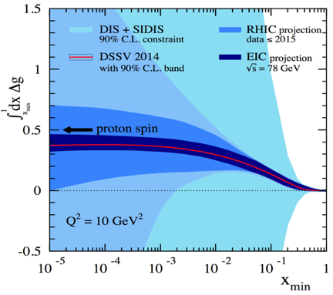
PRL 113, 012001 (2014), DSSV

Figure 3. LH: DSSV NLO global fit indicates non-zero gluon spin contribution in the x range from 0.05 to 0.2. RH: Projected sensitivity to the gluon spin contribution from the future RHIC and EIC data [3].

2.2 Sea quark polarization
For the first, flavor identified sea quark polarized PDFs are directly probed at leading order using the weak boson W^{+/-} productions in longitudinally polarized p+p collisions at RHIC. Although DIS data have provided high precision determination of the quark polarized PDFs at the intermediate x-range, flavor identified sea-quark polarization distributions are poorly constrained since DIS can’t directly access the quark flavor and only derived using additional not-well determined parton fragmentation functions. With center of mass energy as high as 510GeV, RHIC has provided a new unique experimental tool to directly determine the flavor identified sea quark polarization through the measurements of spin-dependent W^{+/-} production in the longitudinally polarized p+p collisions.

At RHIC energy (500 or 510GeV in the center of mass), weak bosons are predominantly produced through the quark and anti-quark annihilation process, shown in Fig. 4. The weak coupling of W^{+/-} to left-handed quarks and right-handed anti-quarks directly selects the incoming quarks’ helicity, and the charge of the produced W boson naturally determines the incoming quarks’ flavor,

Figure 4. At RHIC energy, weak boson W's are predominantly produced through quark and anti-quark annihilation.

where are are the light quark and anti-quark that annihilate into W^{+/-} through the

following processes, and . At the leading order, the longitudinal single spin asymmetry A_{L} of W^{+/-} is given by [4],

where ϑ is the polar angle of the out-going W^{+/-} relative to the incoming polarized proton beam.
STAR and PHENIX experiments at RHIC carried out the longitudinal single spin asymmetry measurements in the weak boson production in the polarized p+p collisions from 2011, 2012 and 2013 data sets, at center of mass energy of 510GeV, and beam polarization as high as about 60%. Shown in Fig. 5 are the W^{+/-} single spin asymmetry A_{L} vs lepton rapidity measured by the STAR (LH) and the PHENIX experiments (Center), also shown are the flavor-identified polarized u-bar and d-bar distributions from DSSV and NNPDF global fits (RH), see [4].

RHIC high energy W program has produced a substantial improvement of our understanding of the flavor-identified sea-quark polarization in the proton.

arXiv:1406.7122

Figure 5. Longitudinal single spin asymmetry vs lepton rapidity in W production from STAR(LH) and PHENIX ( Cent.) at RHIC; RH: flavor-identified sea quark helicity distributions extracted from global fits from NNPDF and DSSV collaborations.

3. Physics of TMD
To access the 3-D parton distributions, we go beyond the 1-dimmensional description by including the parton internal transverse momentum k_{T} relative to the nucleon momentum direction. As discussed above, there are 8 of them at leading twist. Several novel phenomena arise from the interactions involving these TMDs in transversely polarized nucleon scatterings.

In recent years, transverse spin physics has attracted tremendous attention from both experimental and theoretical communities, and as a result, significant progress has been made in understanding the spin dependent hadronic processes in QCD at high energy and the nucleon structure beyond the one-dimensional parton picture. Spin-dependent 3-D image of the parton distributions in the nucleon is under intense investigation and is the focus of the future EIC program, and also several novel transverse spin-dependent asymmetries have been confirmed experimentally in both SIDIS and p+p collisions, including Sivers and Collins transverse single spin asymmetries (TSSAs). One good example of the recent highlight is the study of the sign change in the Sivers transverse single spin asymmetry between SIDIS and Drell-Yan processes. Sivers TSSA were first measured in the Drell-Yan and W^{+/-} production processes in hadronic interactions by the COMPASS experiment at CERN and the STAR experiment at RHIC, respectively. Although statistically limited, the data are consistent or in favor of the sign change scenario.

3.1 Physics of the transeverse single spin asymmetry in p+p collisions
Contrary to the original expectation of very small TSSA, first experimental data from ZGS showed surprisingly large asymmetry [5], orders of magnitudes larger than the naïve expectation A_{N} ~ m_{q}/p_{T}. Such large TSSA have been persistent from the early fixed target energy all the way to the top collider energy at RHIC, , see [1,6] .
At the leading twist, it was expected that the TSSA of high p_{T} hadrons produced in the transversely polarized p+p collisions should be very small, as shown in Fig. 5.

Figure 5. Due to small quark mass, m_{q}, very small TSSA was expected for the outgoing hadrons with large p_{T}.

To explain the observed large TSSAs, several new ideas were proposed. Among them, here are two leading formalisms that can generate large TSSA in SIDIS and p+p collisions:
- Sivers function – a TMD function of the correlation of proton spin and parton transverse momentum k_{T}. For the transversely polarized proton, none-zero Sivers function implies parton transverse momentum distribution is not azimuthally symmetric, thus generating finite TSSA in the outgoing hadron distribution [7].
- Collins function – a TMD function that correlates the transvers spin of a fragmenting quark (transversity) and the transverse momentum distribution of the daughter hadrons [8].
And their equivalents in the colinear twist-3 approach, k_{T} integrated quark-gluon-quark and tri-gluon correlation functions [1,9].

None-zero Sivers and Collins functions were first observed by the HERMES and the COMPASS experiments in polarized SIDIS scatterings in charged hadron productions, see recent reviews of the history in [1]. Latest theoretical development show that these physics processes can be studies in p+p collisions also, see [10s] and references therein.

Figure 6. LH: Collins asymmetry can be studied with hadron distribution inside a jet. RH: Collins asymmetry measured by STAR in transverely polarized p+p collisions at center of mass envery 500GeV.

3.2 Sivers function and sign change
Among the 8 TMD functions, the Sivers function has attracted particular interest. Sivers function describes the correlation of intrinsic parton transverse motion and the nucleon’s spin direction. This function can be accessed either in the SIDIS process or Drell-Yan in p+p collisions. Besides providing the 3-D parton structure of the nucleon, the most interesting property of Sivers function is its process dependence, and as a consequence of the QCD gauge invariance and factorization assumption, the sign of Sivers function in SIDID and Drell-Yan (and W^{+/-}) is expected to be opposite [11]. This nontrivial process-dependence of Sivers function is a fundamental prediction of QCD. With the first confirmation of non-zero Sivers functions in SIDIS from COMPASS and HERMES, as well as several JLab experiments, it is extremely important to test this prediction. Recently, first experimental studies were carried out by the COMPASS experiment at CERN for Drell-Yan and by the STAR experiment at RHIC for the weak boson W^{+/-} productions at much larger Q², see Figs. 7 and 8.

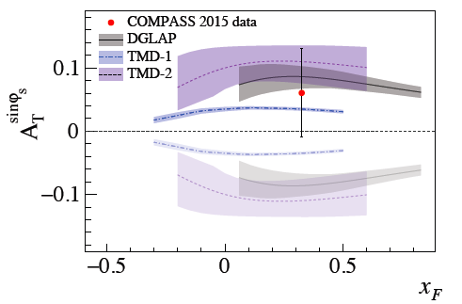

Figure 7. It is predicted Sivers function changes sign between SIDIS and Drell-Yan processes. RH: First Drell-Yan TSSA result from COMPASS, although statistically limited, it is consistent with the prediction.

Figure 8. TSSA of W^{+/-} production in p+p collisions measured by the STAR experiment at RHIC.

3.3 Future prospects
In coming years, RHIC will continue pursuing spin physics program with the current STAR and the future sPHENIX experiments, with possible forward detector upgrade for both detectors [3]. Also, there are several new polarized proton beam or target experiments either under commissioning now or being proposed. The upcoming Fermilab SpinQuest/E1039 fixed target experiment will utilize a polarized proton target (NH3) to study Drell-Yan TSSA using the 120GeV proton beam from the Main Injector [12]. The kinematics of the dimuon spectrometer selects sea-quarks from the polarized target thus directly accessing sea quarks’ Sivers function in the x range from 0.1 to 0.3, see Fig. 9.


SpinQuest

Figure 9. SpinQuest/E0139 experiment at Fermilab will study seaquark Sivers function. LH: SpinQuest spectrometer; RH: Projected Drell-Yan TSSA from 2-year operation of E0139 at Fermilab.

At CERN, there is a new COMPASS++/AMBER proposal to continue hadron physics program using the M2 beamline at SPS. This new QCD facility will cover a broad range of physics topics from nucleon structures, hadron spectroscopy to dark matter search [13].

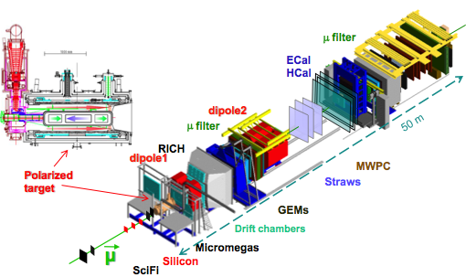
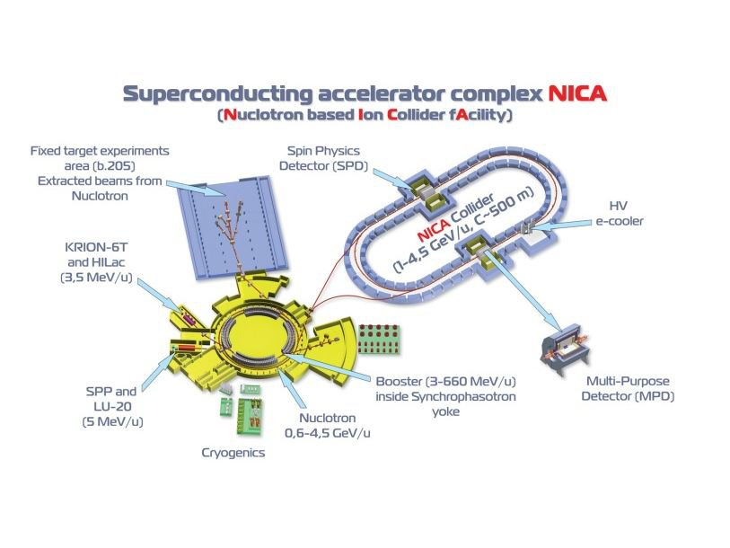

Figure 10. LH: COMPASS++/AMBER, a proposed New QCD Facility at M2 beam line of the SPS at CERN; RH: Proposed Spin Physics Detector at NICA to study polarized nucleon structures.

At Dubna, Nuclotron based Ion Collider fAcility (NICA) is a flagship project of the Joint Institute for Nuclear Research which is expected to be in operation by 2021. Main tasks of “NICA Facility” are study of hot and dense baryonic matter, investigation the polarization phenomena and the nucleon spin structure. The Spin Physics Detector (SPD) will carry out nucleon spin structure studies with Drell-Yan, J/Psi and other observables [14].

4. Conclusions

Tremendous progress has been made in the last decades in studying the 3-D structures of the nucleon and their roles in strong interactions. Recent polarized proton-proton or hadron collision data have shed new light in our understanding of phenomena that have puzzled us for decades, such as the “proton spin crisis”, the unexpected large TSSA in hadron production in transversely polarized p+p and DIS interactions, and the first experimental hints of process dependent sign change in Sivers function etc. Due to space limitation, only a few selected recent results are presented, and there are many interesting results that I just even couldn’t touch upon at all. I encourage interested readers to check out the review articles listed below and references therein.

Acknowledgment

The author thanks many experimental colleagues from RHIC, Fermilab, HERMES and COMPASS experiments and theory friends for valuable discussions. This work was supported in part by the Office of Nuclear Physics within the U.S. DOE Office of Science and Los Alamos National Laboratory LDRD program office.

References
- J. Ralston and D. Soper, Nucl. Phys. B152, 109 (1979);
R. L. Jeffe and X. Ji, Phys. Rev. Lett. 67, 552 (1991);
M. Amselmino et al, arXiv:0907.3999
J.C. Peng and J.-W. Qiu, Prog. Part. Nucl. Phys. 76, 43 (2014).
M.G. Perdekamp and F. Yuan, Annu. Rev. Nucl. Part. Sci. 65, 429 (2015).
E. C. Aschenauer et al, RHIC-Spin Collaboration, arXiv:1501.01220
- EMC Collaboration, Phys. Lett. B 206 (2) 364 (1888)
EMC Collaboration, Nucl. Phys. B 328, 1 (1989).
R. L. Jaffe, Physics Today 48, 9, 24 (1995)
T. P. Cheng and L-F Li, Phys. Rev. Lett. 62, 1441 (1989)
S. Brodsky, J. Ellis, and M. Karliner, Phys. Lett. B 206, 309 (1988).
- D. de Florian, R. Sassot, M. Stratmann and W. Vogelsang, Phys. Rev. Lett. 113, 012001 (2014);
NNPDFPol Collaboration, Nucl. Phys. B 887, 276 (2014);
STAR Collaboration, Phys. Rev. Lett. 115, 092002 (2015);
PHENIX Collaboration, Phys. Rev. D 90, 012007 (2014);
J. Blumlein and H. Bottcber, Nucl. Phys. B 841, 205 (2010);
E. Leader, A. V. Sidorov and D. B. Stamenov, Phys. Rev. D 82, 114018 (2010);
M. Hirai and S. Kumano, Nucl. Phys. B813, 106 (2009);
C. Bourrely, F. Buccella and J. Soffer, Phys. Rev. D 83, 074008 (2011);
P. Jimenez-Delgado, A. Accardi and W. Melnitchouk, Phys. Rev. D 89, 034025 (2014)
E. C. Aschenauer et al, RHIC-spin collaboration, arXiv:1602.03922
- C. Bourrely and J. Soffer, Phys. Lett. B 314, 132 (1993);
P. M. Nadolsky and C. P. Yuan, Nucl. Phys. B 666, 31 (2003);
D. de Florian and W. Vogelsang, Phys. Rev. D 81, 094020 (2010);
STAR Collaboration, Phys. Rev. Lett. 113, 072301 (2014);
PHENIX Collaboration, Phys. Rev. D 93, 051103(R) (2016);
PHENIX Collaboration, Phys. Rev. D 98, 032007 (2018).
- G. L. Kane, J. Pumplin and W. Repko, Phys. Rev. Lett. 41, 1689 (1978);
R.D. Klem et al, ZGS, Phys. Rev. Lett. 36, 929 (1976);
E704, PLB261, 201 (1991), PLB264, 462 (1991);
C. E. Allgower et al. (E925 Collaboration), PRD65, 092008 (2002);
- STAR, Phy. Rev. Lett. 92, 171801 (2004); and more.
- D. W. Sivers, Phys. Rev. D 41 83 (1990)
- J. C. Collins, Nucl. Phys. B 396, 161 (1993)
- A. V. Efremov and O. V. Teryaev, Sov. J. Nucl. Phys. 36, 140 (1982), Phys. Lett. B 150 383 (1985);
J.W. Qiu and G. F. Sterman, Phys. Rev. Lett. 67, 2264 (1991), Nucl. Phys. B 378, 52 (1992)
- F. Yuan, Phys. Rev. Lett. 100, 032003 (2008);
T. C. Roger and P. J. Mulders, Phys. Rev. D 81, 094006 (2010);
Umberto D’Alesio et al PRD 83 034021 (2011);
A. Metz and J. Zhou, Phys. Lett. B 700, 11 (2011)
L. Gamberg, B. B. Kang and A. Prokudin, Phys. Rev. Lett. 110, 232301 (2013);
- J. C. Collins, Phys. Lett. B 536, 43 (2002);
Z. B. Kang and J. W. Qiu, Phys. Rev. Lett.103, 172001 (2009)
- SpinQuest/E1039 at Fermilab, A. Chen et al, arXiv:1901.09994,
- COMPASS++/AMBER, arXiv:1808.00848
- NICA/SPD, arXiv: 1408.3959.

