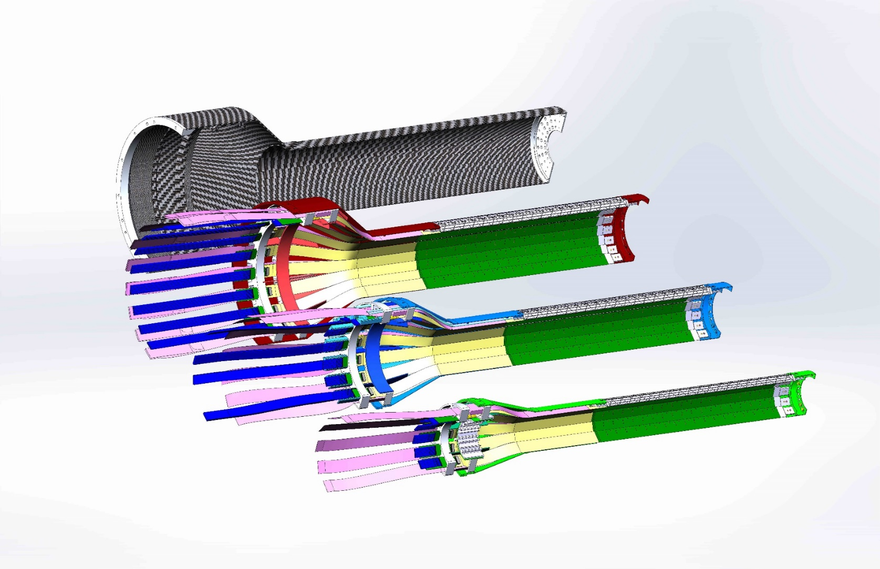

**Management Plan**

**for**

**A Monolithic-Active-Pixel-Sensor-based Vertex Detector (MVTX) Upgrade for the sPHENIX Experiment**

**at the**

**Brookhaven National Laboratory**

**July 22, 2019**

# **1 INTRODUCTION**

sPHENIX is a next-generation nuclear physics experiment providing world-class capabilities for multi-scale studies of the strongly coupled quark gluon plasma (QGP), planned for the Relativistic Heavy Ion Collider (RHIC) at Brookhaven National Laboratory in 2022 and beyond. The need for these capabilities to advance our understanding of the origins of novel QGP properties is detailed in the 2015 NSAC Long Range Plan.

Precise measurements of heavy flavor-tagged jets and B-hadron nuclear modification and flow in heavy ion collisions are key scale-dependent observables. Measuring these rare observables demands high precision tracking with excellent displaced secondary vertex capabilities. While the baseline sPHENIX detector anticipates a small aperture detector for secondary vertexing, exploiting the full potential of heavy flavor QGP signatures, and optimizing the use of RHIC luminosity and available running time, is only possible with a large acceptance precision vertex detector. We propose to build a thin, extremely precise silicon pixel vertex detector for the sPHENIX experiment to enable these key measurements. The detector will be based closely on the latest generation of Monolithic-Active-Pixel-Sensor (MAPS) technology, developed for the ALICE collaboration at CERN, and leveraging the extensive R&D investments made in this technology over a period of several years. Last summer, the Los Alamos National Laboratory High-Energy Nuclear Physics Group was awarded an internal LDRD grant ($5M over 3 years, FY17-19) to develop a state-of-the-art MAPS-based telescope to demonstrate the tracking capability of such a device for the sPHENIX experiment. The LANL LDRD will allow us to carry out the much needed early R&D for the MAPS readout electronics and produce the initial conceptual design of mechanical system integration into the sPHENIX detectors, and also develop a state of the art theoretical calculation, modeling and full physics simulations and analyses with a realistic detector configuration.

# **2 Project Baseline**

**2.1 Physics**

The MAPS-based Vertex Detector (MVTX) is proposed to be ready for Day-1 sPHENIX data taking. To meet this challenge, we propose to use the same ALICE ITS upgrade facilities at CERN to continue producing MAPS staves for the sPHENIX MVTX project, starting from mid 2018 following the completion of ALICE production. This detector will provide world-class scientific results in key areas encompassed by the DOE Nuclear Physics mission. It will allow U.S. scientists to make fundamental inquiries into the nature of the QGP that cannot be probed with other existing facilities worldwide. In particular, the sPHENIX experiment, which was granted with DOE CD-0 in September 2016, will complement and extend the ongoing and future QGP studies at RHIC and LHC, and will become the next generation U.S. flagship high energy nuclear physics program at the DOE’s key facility in this field.

The physics goals of the proposed vertex detector project are aligned with the key challenges and physics opportunities outlined in the 2015 NSAC Long-Range Plan: “There are two central goals of measurements planned at RHIC, as it completes its scientific mission, and at the LHC: (1) Probe the inner workings of QGP by resolving its properties at shorter and shorter length scales. The complementarity of the two facilities is essential to this goal, as is a state-of-the-art jet detector at RHIC, called sPHENIX. (2) Map the phase diagram of QCD with experiments planned at RHIC.”

The key approach for goal (1) is microscopy of the QGP through probes that are sensitive to characteristic scales in the plasma. The baseline sPHENIX design is optimized to employ light quark and gluon jets over a wide kinematic range and Upsilons as such scale-sensitive probes. The vertex detector described in this proposal will greatly expand the sPHENIX capabilities in an additional dimension related to scales in the QGP, by allowing a range of precision studies as a function of parton mass. Studies of heavy-flavor hadrons have been a focus of recent upgrades in sPHENIX and STAR at RHIC. These studies, as well as new measurements by the current LHC experiments form the key motivation for the ALICE Phase-I upgrades for the early 2020’s. In combination with the large acceptance and high rate capability of sPHENIX, the vertex detector upgrade provides access to observables that are not accessible with the present RHIC detectors and are complementary to those at LHC.

Heavy flavor quarks (c, b) play a unique role for studying the QCD in vacuum as well as at finite temperature or density. Their masses are much larger than the QCD scale (LQCD), the additional QCD masses due to chiral symmetry breaking, as well as the typical medium temperature created at RHIC and LHC. Therefore, they are created predominantly from initial hard scatterings and their production rates are calculable in perturbative QCD. They are thus calibrated probes that can be used to study the QGP in a controlled manner.

The vertex detector will enable a wide range of heavy-flavor studies, extending present RHIC measurements to significantly larger transverse momenta, and provide access to qualitatively new QGP signatures. A new capability, in combination with the sPHENIX calorimetric jet reconstruction, is the identification of jets originating from heavy quarks. In this proposal, we will use the measurements of b-tagged jets as a case study to illustrate the new capabilities the upgrade brings to RHIC and the overall field. This measurement represents both a new opportunity at RHIC and an example of complementarity to the LHC: the projected sPHENIX measurement both extends the LHC measurement to lower transverse momenta and provides a kinematic overlap, where the same jets can be studied in the different QGP conditions at RHIC and LHC.

**2.2 FUNCTIONAL REQUIREMENTS**

The principal functional requirement of the MVTX is to provide precise measurements of tracks back to the collision vertex with a transverse distance of closest approach (DCA) resolution on the order of 25 μm or better. The MVTX project will be complete when the parameters in Table 1 have been demonstrated and the deliverables in Table 2 are satisfied.

General requirements:

* The system must fit into the integration envelope agreed to within sPHENIX
* The system must be able to operate inside the sPHENIX magnet. 
* The system must be safe. The system must meet BNL Collider-Accelerator Department (C-AD) safety requirements.
* The system must not interfere with the VT other detector subsystems.
* Each stave must have a radiation length of less than 0.5 %.
* The system must operate in a temperature range of 0o C to 30o C.
* The noise hit rate for each MVTX shall be less than 0.01% for a threshold of ~2000 electrons.
* Survive 200 krad integrated radiation dose over 10 years.
* The MVTX will function properly under all beam species.
* The MVTX system must work within the existing sPHENIX readout scheme,
  + must store the data for the LVL1 latency (4 µs),
  + must have a 4-deep buffer of LVL1 accepted events,
  + must readout data within 100 µs to its front-end modules (FEMs) off the detector so as to not significantly reduce the maximum rate of sPHENIX Level-1 triggers which is designed to be 10 kHz.

A subset of these requirements is summarized in Table 1 and represents the performance parameters that the project will be responsible for delivering at the project close-out.

Table 1 sPHENIX MVTX System Functional Requirements

|  |  |
| --- | --- |
| pixels active | >80% |
| Hit efficiency | >90% |
| Radiation length per wedge | < .5 % |
| Detector hit resolution | < 25 µm |
| Noise hits/chip | <1% |
| LVL1 latency | 4 µs |
| LVL1 Multi-Event buffer depth | 4 events |
| Read-out time | < 10 µs |
| Read-out rate | > 10 kHz |

**Table 2 MVTX Deliverables**

|  |  |  |
| --- | --- | --- |
| **ITEM** | **Quantity** | **Spares** |
| RU* | 48 | 12 |
| Felix Board | 6 | 2 |
| Staves* | 48 | 36 |
| ½ Barrel Assembly | 2 | 0 |
| Power Supply | 1 | 0 |
| Service Barrel | 1 | 0 |

**\***The RU and Staves are not part of the cost of MVTX project but are still a deliverable.

The Large number of stave spares allows the construction of a two layer barrel detector should the three layer detector suffer a catastrophic failure.

**2.3 TECHNICAL SCOPE**

The sPHENIX MVTX project is divided into three major subsystem groups: (a) ALPIDE chip, High Density Interconnect (HDI) and cooling plate, collectively termed the stave assembly, (b) DAQ electronics, and (c) mechanical and infrastructure. A summary of the design parameters of the MVTX is given in Table 2.

Table 3. Summary of main design parameters of each MVTX

|  |  |  |  |
| --- | --- | --- | --- |
|  | Layer 0 | Layer 1 | Layer 2 |
|  |  |  |  |
| Radial position (min.) (mm) | 22.4 | 30.1 | 37.8 |
| Radial position (max.) (mm) | 26.7 | 34.6 | 42.1 |
| Length (sensitive area) (mm) | 271 | 271 | 271 |
| Active area (cm2) | 421 | 562 | 702 |
| Number of pixel chips | 108 | 144 | 180 |
| Number of staves | 12 | 16 | 20 |
|  |  |  |  |

## 

## **2.4 Cost Breakdown**

The budget summary for the MVTX project is shown in Figure 4 . The inflation adjusted costs of the MVTX project is $ 3.9 M. The breakdown for costs in FY19 dollars is shown in Table 3. The electronics costs are manly for procurements because the R&D effort was covered under a LANL LDRD. The largest cost item is WBS 3.02.3.02.03

**Figure 4 Cost breakdown in FY 19 dollars. No contingency is included.**

|  |  |  |  |  |
| --- | --- | --- | --- | --- |
| **WBS** | **Level 2 WBS Description** | **Burdened AY$ labor** | **Burdened AY$ M&S** | **Burdened AY$ Total** |
| 3.20.3.02.01 | MVTX Project Management | $498.9k | $63.2k | $562.1k |
| 3.02.3.02.02 | MVTX Electronics | $211.2k | $358.4 | $569.6k |
| 3.02.3.02.03 | MVTX Mechanics and Detector Assembly | $1241.6k | $667.0K | $1908.6k |
| 3.02.3.02.04 | MVTX Integration and Installation | $454.8k | $400.0k | $854.8k |
|  | Total | $2406.4k | $1488.7k | $3895.1k |

## **2.5 Schedule**

The WBS schedule was begun using MS Project and we have continued using that to get a final version. We are now at a point where the final version has been transmitted to BNL for inclusion into the overall sPHENIX P6 file. We have used the current P6 file (16-July-19) for the information in this PMP. A simplified schedule is shown in figure 1. The current WBS schedule is in Appendix 1

**2.5.1 MVTX Project Schedule**

The current schedule has the stave and RU production being done at CERN (started) and covered under separate funding and not part of this PMP. Some of the detector and interface design has already begun before April 2019 through conceptual design efforts performed under the LANL LDRD. With a MVTX start date of October 2019 the MVTX is ready for commissioning at the end of September 2022. The beginning installation of the MVTX is constrained by the finish date of the sPHENIX 7/1/2022. The fully tested silicon barrels are delivered to BNL for full system tests in 2/26/2021. The electronics arrive at BNL on 8/8/28/20.



Figure 1. Simplified schedule showing the MVTX will be ready for beam at the end of FY 2022.

The fully tested half barrels arrive at BNL for testing and installation in sPHENIX at BNL in mid FY2021.

**2.5.2 Milestones**

Milestones will be used to mark the progress of scheduled tasks. A milestone may

mark the start, an interim step, or the end of one or more activities as needed to

provide insight into the project’s progress. The following Table 4 detail the high level

milestones for the project. In addition, there are several lower level milestones in

the project WBS schedule.

**Table 4 Milestones**

|  |  |
| --- | --- |
| **Milestone** | **Date** |
| Start Construction | 1st Qtr FY 2020 |
| MVTX Final Design Review | 1st Qtr FY 2021 |
| Half Barrels Assembled | 3rd Qtr FY 2021 |
| Installation Finished | 4th Qtr FY 2022 |
| Ready for Beam | 1st Qtr FY 2023 |

**2.5.3 Work Breakdown Structure (WBS)**

The MVTX project has been organized into a WBS for the purposes of planning,

managing and reporting project activities. Work elements are defined to in Table 5

**Table 5 Work Breakdown Elements**

|  |  |  |
| --- | --- | --- |
| WBS | Work Elements | Effort |
| POM2B_3.02.3.02.01 | Management | Level of effort tasks associated with the daily  management, oversight, and assessment of the project.  Oversight, documentation, and reporting, included. |
| POM2B_3.02.3.02.02 | Electronics | Procurement of off project developed electronics, testing, and installation into MVTX. |
| POM2B_3.02.3.02.03 | Mechanics and Detector Assembly | Design, production, and installation of the carbon structures to support the silicon staves, and enclosure to transport the electronics cables to the electronics racks locate outside of the sPHENIX magnet. |
| POM2B_3.02.3.02.04 | Integration and Infrastructure | Incorporates the effort to integrate the MVTX subsystem into the rest of the sPHENIX detector. Includes the details of the designs of the support structures for the INTT and TPC. Includes the cooling designs, safety systems, infrastructure for utilites that adhers to BNL standards. Defines the Installation sequence of the MVTX into sPHENIX. |

**2.6 Funding Profile**

The funding spike in FY2020 is due to the engineering design and fabrication of the carbon structures.

**2.7 Planned BNL Funding**

The MVTX project is funded out of the BNL operations budget spread over 5 years.

**2.8 Baseline Change Control**

Changes to the approved technical, cost, and schedule baselines will be controlled

using the thresholds described in Table 6-1 .

The change request will be initiated by the sub-system manager regarding a change

to the cost, schedule, or technical baseline. A draft Project Change Request is

generated by PM and pertinent data/documents are attached.

All Level 3 PCRs will be approved by the PM. Level 1 and 2 PCRs will be submitted

by the PM to the Physics Department Associated Chair person for Nuclear Physics.

All Level 2 PCRs will be reviewed and approved by the Physics Department

associate Chair. For PCRs exceeding the thresholds of Level 2, they will forward

them to the ALD for Nuclear and High Energy Physics with a recommendation for

approval.

If the change is approved, PM is responsible for implementing the approved cost,

budget, schedule or milestone changes in the official MVTX documents. If approval is

denied, no changes are made to project documents. All PCRs, approved or rejected,

are maintained in the document repository.



**3 MANAGEMENT STRUCTURE**

**3.1 Management Structure and Team**

The management structure of the MVTX is shown in figure

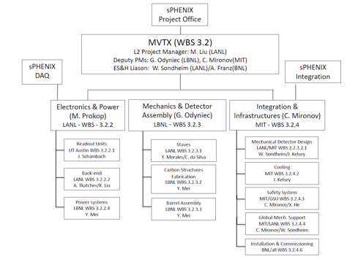

**3.2 Management Responsibilities.**

The sPHENIX Project Office provides the primary oversite of the MVTX project.

* Ultimately responsible and accountable to the BNL for executing the Project

within scope, cost and schedule in a safe and responsible manner.

* Provides access to laboratory/contractor resources, systems, and capabilities

required to execute the Project.

MVTX Project Manager (PM) has the responsibility and authority for delivering the

project scope on schedule and within budget.

* Manages the execution of the project to ensure that the project is completed

within approved cost, schedule and technical scope.

* Ensures that effective project management systems, cost controls and milestone

schedules are developed, documented and implemented to assess project

performance.

* Ensures that project activities are conducted in a safe and environmentally

sound manner.

* Ensures ES&H responsibilities and requirements are integrated into the project.
* Oversees design, fabrication, installation, and construction. Represents the

project in interactions with the DOE.

* Requests and coordinates internal and external peer reviews of the project.
* Responsible for risk evaluation and management in accordance with the risk

management plan.

* Manages the interface and coordination of requirements with other sPHENIX

projects.

MVTX Deputy Project Managers (DPM)

* Assists the PM in all matters relating to the MVTX Project, including the

planning, procurement, disposition and accounting of resources, progress

reports on project activities, ESSH/QA issues, and Risk Management. In the

absence of the CPM, the DPM assumes the project management responsibilities.

* Coordinates the interface with the LBNL engineering division.

MVTX Subsystem Managers

* Report directly to the PM
* Responsible for the design, fabrication, assembly, and testing of their subsystem

in accordance with the performance requirements.

* Provide a quarterly status reports on both technical progress and schedule.
* Participates in weekly management meetings

**3.3 Participating Institutions**



**4 PROJECT MANAGEMENT AND OVERSIGHT**

**4.1 Risk Management**

Risk management is based on a graded approach in which levels of risk are assessed

for project activities and elements. Assessments of technical, cost and schedule

risks are conducted throughout the project lifecycle.

The MVTX risk management approach consists of a five-step process:

1. Identifying potential project risk – any member of MVTX team may identify a

potential risk. The subproject (WBS level 2) managers are responsible for

addressing the potential risks with the DPM or PM’s concurrence.

2. Analyzing project risk - the probability of a project risk occurring will be

evaluated together with the potential impact to the project’s technical

performance, cost and/or schedule baseline. Probability is assessed qualitatively

(Low, Moderate, and High).

3. Planning for and developing risk abatement strategies.

4. Executing risk abatement strategies - abatement strategies differ according

to the potential risk and its timing. Monitoring and tracking the results and

revising risk abatement strategies - risk assignments are associated to specific

WBS entries down to Level 3. This serves to emphasize the role of the Level 2

WBS manager in risk management. Risk information, including the probability

and impact assessments and brief summaries of mitigation strategies, are stored

in the MVTX risk registry.

The risk management Plan can be found in Appendix C. The most important risks

for the MVTX project are documented in the report on “Risk assessment of

the MVTX upgrade”.

**4.2 Project reporting**

The PM will lead quarterly cost and schedule reviews and report the results to the

sPHENIX Project Office.

The standard BNL accounting system is the basis for collecting cost data, and the

Control Account structure for the MVTX will separate costs according to the WBS

elements. A direct one-to-one relationship will be established between each WBS

element of Level 2 or lower with a separate control account in the BNL accounting

system.

Technical performance will be monitored throughout the project to ensure

conformance to approved functional requirements. Design reviews and

performance tests of the completed systems will be used to ensure that the

equipment meets the functional requirements.

**4.3 Engineering and Technology Readiness**

The project will assess engineering and technology readiness through design

reviews, IPRs, and other independent technical reviews as required.

**4.4 Quality Assurance and Configuration/Document Management**

The project shall adopt in its entirety the BNL Quality Assurance Program

maintained in the SBMS. This QA Program describes how the various BNL

management system processes and functions provide a management approach that

conforms to the basic requirements defined in DOE Order 414.1C, Quality

Assurance. These requirements will include:

* Management criteria related to organizational structure, responsibilities,

planning, scheduling, and cost control

* Training and qualifications of personnel
* Quality improvement
* Documentation and records
* Work processes
* Engineering and design
* Procurement
* Inspection and acceptance testing
* Assessment

The quality program embodies the concept of the “graded approach” i.e., the

selection and application of appropriate technical and administrative controls to

work activities, equipment and items commensurate with the associated

environment, safety and health risks and programmatic impact. The graded

approach does not allow internal or external requirements to be ignored or waived,

but does allow the degree of controls, verification, and documentation to be varied

in meeting requirements based on environment, safety and health risks and

programmatic issues.

20

**4.5 Operation Readiness Plan**

To ensure that sPHENIX will be ready to operate with the new inner sectors and the

associated electronics the constructing and testing plan includes time to achieve this

goal.

The project plan includes sufficient time to develop prototype for the electronics

readout, and checkout of these both with and without beam. This will first allow for test of the RU’s and FELIX on both half barrel’s instrumented with electronics before the final installation of all electronics for subsequent years. This also allows for development of any new online, offline code well ahead of the physics run.

**4.6 ESSH Plans for Fabrication**

The MVTX upgrade for sPHENIX will use the BNL Quality Assurance Program to identify and control hazards for all equipment and work at BNL for the MVTX. The project will prepare designs and work procedures and have them reviewed by the appropriate laboratory or department review committees. The equipment and work practices used at sPHENIX will be reviewed by the C-AD Experimental Safety Review Committee (ESRC). The installation will be covered under the rules and safeguards in place for work in the RHIC experimental halls and assembly area.

**4.7 Project Closeout**

Project closeout will begin when all equipment is ready for installation in the sPHENIX

detector. A Closeout Report will be developed prior to the date that closeout is

expected in order to demonstrate the fulfillment of the functional requirements and deliverables. The report will address the closure status of purchase orders, the expected total cost of the Project and the value of remaining contingency. The report will also explain

when the Project is expected to close the control accounts and complete the

financial closeout. BNL will hold a Project Closeout review to assess whether the

deliverables and functional requirements have been met.

Appendix 1

MVTX Full Proposal (Feb. 2018).