Mvtx question and comments

Some of these are already given to Ed.

* include milestones (L2/3 in PMP
* quarterly reports to physcs/DOE
* have a list of external dependencies and milestones

Make sure there are sufficient low level milestones so they can be followed ~ 1 per quarter per major WBS.

Review costs –

Are there enough risks?

Personnel at different institutions (FTE’s per labor group (tech,eng, students, scientist) noticed also in April review.

How will accounting be done. How will sPHENIX project office interact with LAN,LBNL, MIT to follow cost spending closely (get monthly reports from accounts that have been setup at each institution – worked well for MIT – short monthly report and meeting

Prepare the intro sides for executive session (split the assignment a bit more (looking at Ed’s slides divided the other items (electronics testing acceptance )

**Comments per talk**

**Eds talk**

The sphenix MIE is not yet baselined. Therefore the mVTX cannot be an upgrade to

--PD-2/3 review May 2019 (approval expected Sept 2019)

Management chart has been approved (slide 12 by BNL,OPA)

The mVTX management is well integrated into the sPHENIX management. The mVTX level2 PM is Ming Liu.

Issues and concerns

-integration with sphenix

Cost of carbon fibres

--end wheels, not identical

--high risk in risk

Staves (84) and RUs are purchased by BNL, and will be given to mVTX if approved

**Mings talk**

**High risks:**

Major challenge is the mechanical

End-wheel and insertion mechanism.

Lees talk

Contingency and risk are low on readout integration.

Questions:

We will like to hear more details on potential usage at the carbon fiber shop at LBNL

* how the request between LBNL physics and engineering division is envisioned to be done.
* What is the planned schedule and possible conflict with other activities in the carbon fiber shop (ATLAS,…)
* Please highlight the entries in WBS that involves work at the CF shop.

**Walter S**.

Mechanical setup

The 4 layer assembly is only 1.1 kg

The cold plate structure has to be grounded.

Half shells are tricky to produce. Making detailed drawings for eng at LBNL to evaluate how to produce the

Less mechanical sag with vertical splitting, clam shelled together.

Slide 14-15

Part of the end are Al to have good structural support

Order of assembly – outer shell add layer 2,1 and then 0

Slide 16

Prototype pieces and design about 1 year. (Slide 23..)

Integration

It seems that extending the Be/Al section is not a major concern. C-AD is investigating, and will look into trying to welding parts together.

Once its agreed upon this scope of work should be added to the agreement between sPHENIX and C-AD.

Could we see all the 8 sequences for the insertion sequence?

Camelia service panel discussion

It will be necessary to modify beam pipe

Is there no good alternative if the beam pipe cannot be extended. Is a high risk? Will be known in a few weeks (months). Tolerance requirement for 2mm is tough.

Concerned about the lack of quote’s from LBNL since this is the highest cost. We understand that R&D funds will be transferred shortly so a much better engineering estimate can be made shortly.

There is also a potential issue how to guarantee the schedule for CF production in view of the other activities that the CF shop is involved in.

The contingency of 40% is judged to be too low as BOE was based on pre conceptual design. The methods calls for 60%.

(where is this cost in the P6?)

LBNL

Is producing power system already for ITS in ALICE.

Will need to duplicate the test setup, as the test are ongoing for ITS.

(M&S)

Testing, assembly will be carried out by postdocs/students also by people that comes off lots of experience from ITS; LANL Post Doc will also return to US.

A little ‘we know how to do this attitude’ w/o documentation.

**electronics and testing**

The electronics testing seem well in hand, and well documented.

System has been well tested, twice in test beam.

All final hardware including cooling with negative water cooling present.

Bit error was measured on shorter cable

We will test full-length MVTX cables in the next months - Can perform tests to measure BER (J-BERT), eye diagram (ALPIDE and scope), jitter (ALPIDE and scope), attenuation (VNA) and impedance (TDR and/or VNA) - Cameron

FELIX will be produced with instrumentation; The mVTX will be tested

The testing and FPGA programming will be done at LANL, (Alex. T) . They have 6 months for that purpose. I did not see those cost in the WBS (or are it all done from the R&D).

KPP/UPP.

Include explanation in the PMP

Questions:

***A: Insertion of MVTX***

1. Can we see all 8 steps of the insertion i.e. step 1-8 slide 13 in Mironov’s presentation.

A: Yes: [ppt link](https://www.dropbox.com/s/ba3cnkqigsibqem/mvtxInstallationSteps_jasonIntegrationMeet_20190710.pptx?dl=0)

1. Do you have a drawing of the beam pipe and the proposed extension?

A: Yes: The beam pipe drawings both existing and proposed modification have been posted to the review Indico page in the Beam Pipe Drawings directory.

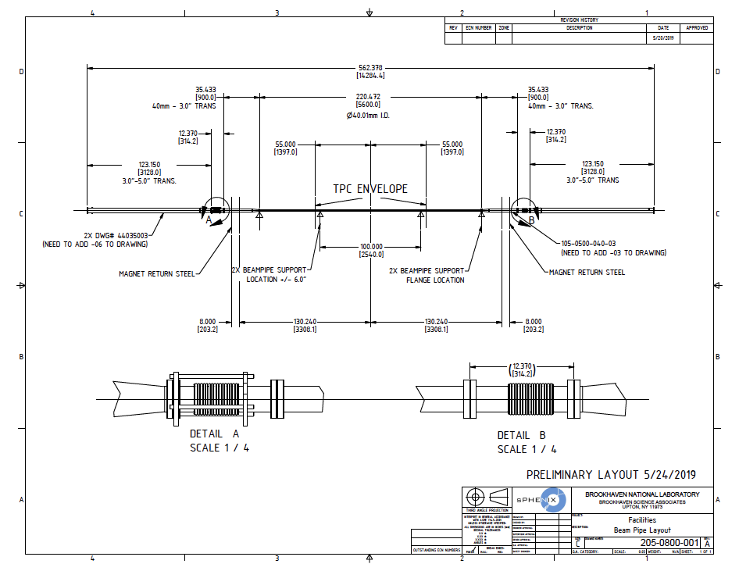

Drawing of the proposed modified beam pipe with supports

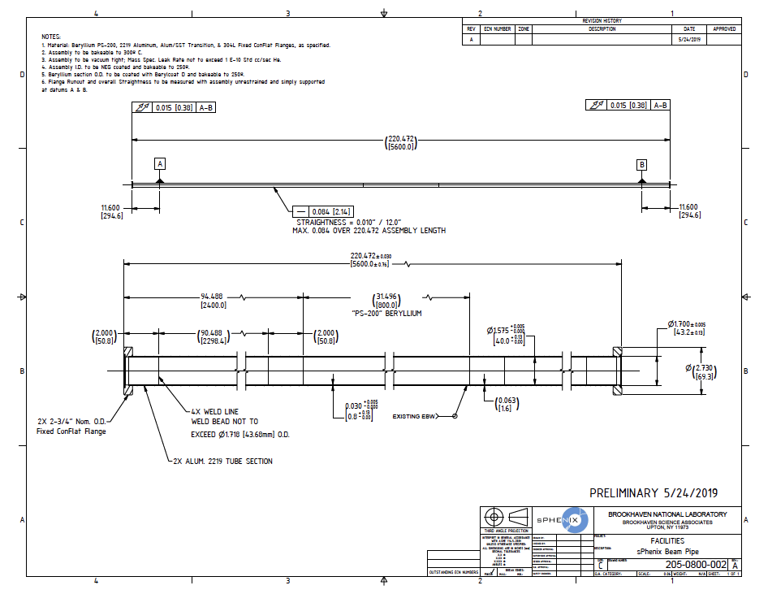

Drawing of the modified beam pipe.

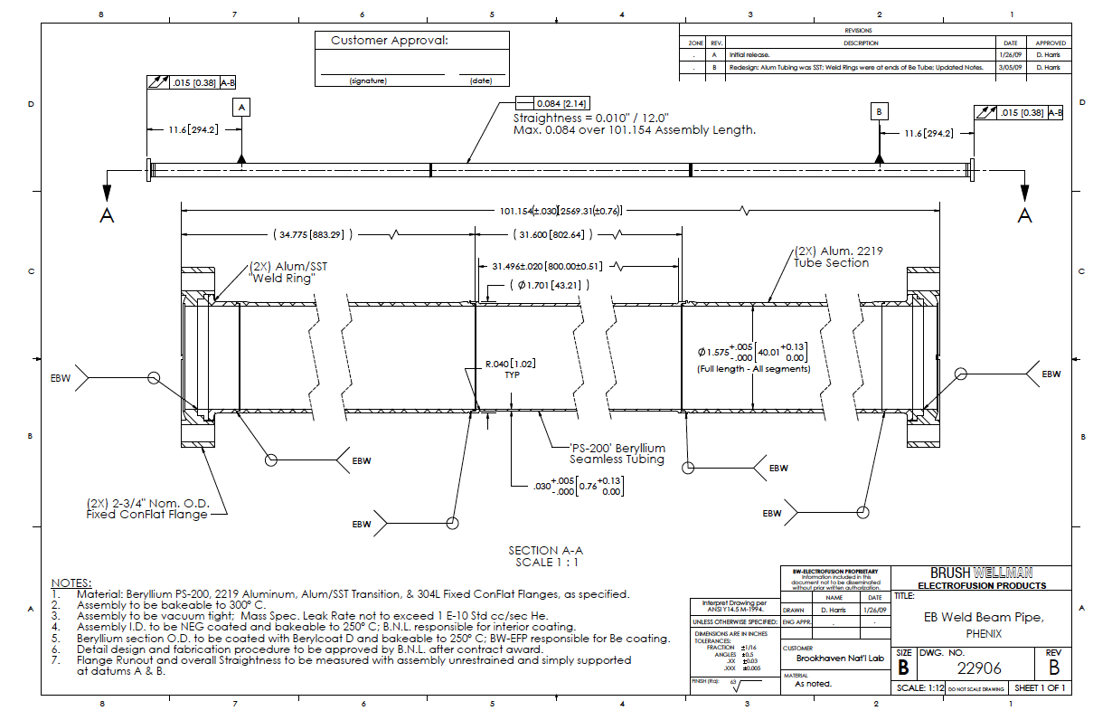

Drawing of the existing beam pipe.

1. Are there plans to test insertion of MVTX with a mockup beam pipe?

A: Yes, we will design a full-scale mockup at BNL to check that there are no space constraints or contentions associated with the MVTX installation inside the TPC/INTT and around the beam pipe. The mock-up installation exercise should be carried out once the detector installation design plans are mature enough to allow for a viable test. We expect that the mock-up installation test can be carried out at BNL within the next 6-9 months. The results will be used to guide the development of the final installation scheme for the sPHENIX inner components including the TPC support services (cables and plumbing), INTT, MVTX, and beam pipe.

***B: Carbon fiber work***

We would like to hear more details on usage of the carbon fiber shop at LBNL

* Please highlight the entries in WBS that involves work at the CF shop.

A:

EndWheels:

S110900--- S111600

CYSS:

S113000 --- S113800

SB:

S113900 - 114600

* Discuss possible conflict with other activities in the carbon fiber shop (e.g. ATLAS,…).

A:

Based on Eric Anderssen’s estimate, MVTX carbon composite structure production has no conflict with current LBNL CF activities

EndWheel production: 1/30/2020 - 8/19/2020

CYSS production: 1/30/2020 - 9/2/2020

SB: 4/10/2020 - 10/8/2020

* How many iterations of CYSS, LO-L2 shells, and service barrel are permitted in schedule?

A: Conical carbon composite structures require a number of trial-and-error iterations in modifying the mold to compensate for the structural relaxation of carbon composite in order to meet the specification. The exact number of iterations needed depends on the details of the structure. The shop at LBNL is experienced with this production procedure. As discussed, the LBNL shop engineers will receive advanced funding to perform manufacturability studies and the number of iterations, the cost, and the schedule will be included in the updates to the estimates.

Cylindrical structures do not need such iterations.

Eric Anderssen’s past experience:

“For the ATLAS Hat Stiffener, we machined a first tool, pulled 3 parts off of it (for statistics), then re-machined. Due to a calculation error, we had to re-machine again.

In the end, I think 2 re-machining steps should be in base plan with the 'opportunity' that the second re-machining is not required. Note: we leave enough meat on the tool to simply re-machine the same part, not a whole new tool i.e. material is free for the iterations.”

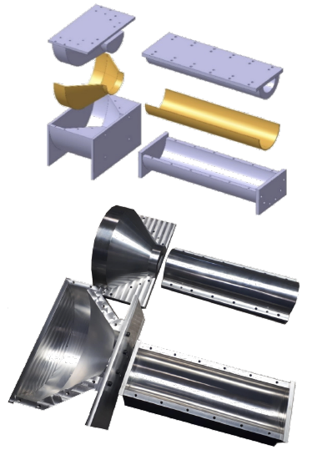

5. What is your plan for evaluating the commercial carbon fiber vendors while simultaneously engaging with LBNL as vendor?

A: in process of discussing to produce a prototype set of CYSS and Layer-2 End-Wheels, if successful, could also be used as part of production . Evaluation process:

1. requested preliminary quotes -- DONE (received already from 1 vendor - did not take into account desired final tolerances)
2. send vendors an updated set of detail drawing for revised quotation
3. they have to provide prototypes and proof they can deliver the desired specs
4. Q&A has to be performed on any prototype piece delivered, example CMM at LBNL
5. Decide (considering also costs) on the vendors