**Detector-Specific Quality Assurance Plan**

**For MVTX Readout Unit Production/Acceptance**

**For the sPHENIX Project**

**Physics Department**

**University of Texas**

**Austin, Texas**

**Revision 1.0**

**July 2, 2018**

**sPHENIX Project**

**DETECTOR-SPECIFIC QUALITY ASSURANCE PLAN**

**Approved by:**

_________________________________________ Date

Joachim J. Schambach

sPHENIX L3 Manager for MVTX RU production

University of Texas at Austin

**Accepted by:**

________________________________________ Date

Edward O’Brien

sPHENIX Project Director

Brookhaven National Laboratory

_________________________________________ Date

James Mills

sPHENIX Project Manager - Engineering

Brookhaven National Laboratory

_________________________________________ Date

Glenn Young

sPHENIX Project Manager

Brookhaven National Laboratory

**Detector-Specific Quality Assurance Plan**

**Project Name:** Readout Unit Production for sPHENIX Project

**Department at BNL:** Physics

**Document Number:** ###

This version of the document may not be the current or approved revision. The current revision is maintained by the Physics Department of the University of Texas at Austin and a copy is kept in the sPHENIX Project’s document management system.

Note: The current approved version is always available in the sPHENIX Project’s document management system. It is also included as part of any subcontract issued by BNL to the University of Texas at Austin for preparing the Readout Units.

Approvals for this document will be required from:

L3 Manager for Readout Units: Joachim J. Schambach

**Quality Assurance Plan Version Control**

|  |  |  |  |
| --- | --- | --- | --- |
| **Revision** | **Date** | **Authors** | **Change Description** |
| 1.0 | 4/4/2018 | Joachim J. Schambach | Initial release |
|  |  |  |  |
|  |  |  |  |
|  |  |  |  |
|  |  |  |  |

# LIST OF ACRONYMS AND ABBREVIATIONS

BNL Brookhaven National Laboratory

CD Critical Decision

DOE Department of Energy

DQAP Detector-Specific Quality Assurance Plan

ES&H Environment, Safety and Health

L2 Level 2

L3 Level 3

PHENIX Pioneering High-Energy Nuclear Interacting Experiment

QA Quality Assurance

QAP Quality Assurance Plan

RHIC Relativistic Heavy Ion Collider

SBMS Standards-Based Management System

UT-Austin University of Texas at Austin

WBS Work Breakdown Structure

**TABLE OF CONTENTS**

LIST OF ACRONYMS AND ABBREVIATIONS

INTRODUCTION

Purpose

Scope

Approach

Graded Approach

Definitions

QUALITY ASSURANCE PROGRAM

Responsibility for Managing

Organization and Level of Authority and Interface

PERSONNEL TRAINING AND QUALIFICATION

QUALITY IMPROVEMENT

DOCUMENTS AND RECORDS

WORK PROCESSES AND PROCEDURES

PROCUREMENT

INSPECTION AND ACCEPTANCE TESTING

LINKS

REFERENCES

# 

# INTRODUCTION

The sPHENIX Project is a project to upgrade the Pioneering High-Energy Nuclear Interacting Experiment (PHENIX) detector at the Relativistic Heavy Ion Collider (RHIC) at Brookhaven National Laboratory (BNL). This upgrade brings exciting new capability to the RHIC program by opening new and important channels for experimental investigation and utilizing fully the luminosity of the recently upgraded RHIC facility. It enables a compelling jet physics program that will address fundamental questions about the nature of the strongly coupled quark-gluon plasma discovered experimentally at RHIC to be a perfect fluid. The project is funded by the U.S. Department of Energy (DOE), RIKEN and other organizations.

A key component of sPHENIX is the Monolithic-Active-Pixel-Sensor(MAPS)-based Vertex Detector, or MVTX, which is capable of high precision and high efficiency tracking close to the interaction point with excellent displaced secondary vertex reconstruction capabilities. The 50 um thick silicon sensors use the latest Monolithic Active Pixel Sensor (MAPS) technology developed for the Heavy Flavor Tracker (HFT) in STAR and ALICE ITS upgrade at CERN. The sPHENIX MVTX consists of 48 staves covering 2π in azimuthal angle and pseudorapidity η between -1 and 1, which covers the acceptance of sPHENIX.

The Readout Unit is an FPGA-based data processing system designed to exploit the CERN Versatile Link hardware with three (GBT)-based fiber optic transmitters for data/status transmission and two GBT-based fiber receivers for timing/trigger and control input. There is one RU necessary for reading data from each stave. Control, data and trigger for the stave is transmitted over one of the copper twinax pairs in the stave “firefly” cable. The clock for the sensor stave is also transmitted over one of the copper twinax pairs. The RU input consists of 9 independent 1.2 Gbit/sec data streams, one from each of the ALPIDE chips on the stave. The RU combines the 9 independent Gigabit data streams, appends a header and trailer for each trigger event, and transmits the data to the DAM via GBT-based fiber links. The GBT-based data links on the RU use radiation hardened integrated circuits. In addition, the RU hardware is designed to detect and mitigate radiation upsets. The main logic is triplicated and verified with an auxiliary FPGA, in the event there is a mismatch in the triplication output the auxiliary FPGA re-programs the main FPGA. Trigger and timing data for the RU comes from the DAM via one of the radiation hardened GBT-based fiber receivers. The RU slow control information is received on another GBT-based fiber receiver. The RU also has a control interface to the power board. The MVTX system will consist of 48 RU boards.

The production plan for the Readout Units includes the plans and procedures described in this document, the Detector-Specific Quality Assurance Plan for the Readout Unit production.

## Purpose

The purpose of this Detector-Specific Quality Assurance Plan (DQAP) is to establish the Quality Assurance (QA) requirements for Readout Unit production for sPHENIX and describe how the requirements will be met, using a graded approach. This plan describes the Readout Unit production project’s QA activities, which are conducted largely at the Physics Department of the University of Texas at Austin (UT-Austin) and culminate in reception testing at LANL after shipping from UT-Austin, and is implemented via processes described herein that address specific quality requirements.

## Scope

This DQAP provides requirements applicable to Readout Unit production for sPHENIX, encompassing all activities, including but not limited to fabrication and testing at UT-Austin, and shipping to LANL. Specific QA procedures are described in the following for raw materials and component testing, Readout Unit manufacturing, and testing prior to shipment to LANL. The production work to be done will be described in a Statement of Work (SOW) issued by BNL/sPHENIX and incorporated into a subcontract between BNL and UT-Austin.

## Approach

UT-Austin Physics will be the responsible organization for implementing the QA requirements for all Readout Unit production activities through completion of testing and subsequent shipment to LANL.

Additional Readout Unit production QA procedures will be developed, as necessary, if early production experience indicates they are warranted. Similarly, the QA procedures listed herein may be modified or improved, as experience dictates. All such additions and modifications will be captured in a formal revision to this DQAP.

## **Graded Approach**

This DQAP embodies the concept of graded approach; that is, selecting and applying an appropriate level of analysis and controls to work activities, equipment, and items commensurate with the potential for environmental, safety, health, radiological, or programmatic impact.

## Definitions

The following is a list of definitions for terminology used in this plan:

**MAPS-based Vertex Detector (MVTX)**– Device for measuring the track and vertex of charged particles passing through it.

**Readout Unit (RU) –** A frontend module of the MVTX, consisting of an FPGA-based data processing system.

**Measuring and Test Equipment (M&TE)** - Devices or systems used to calibrate, measure, gauge, test, inspect, or control to acquire research and development, test, or operational data to determine compliance with design, specifications, or other technical requirements

**Quality** **(Q)** - The condition achieved when an item, service, or process meets or exceeds the user’s requirements and expectations.

**Quality Assurance (QA)** -All actions and controls necessary to provide confidence that quality is achieved.

**QA Plan (QAP)** -The document describing the QA program requirements that the project will implement.

**QA Program** - The overall program or management system established to assign responsibilities and authorities, define policies and requirements, and provide for the performance and assessment of work.

# QUALITY ASSURANCE PROGRAM

The Readout Unit production is included in the sPHENIX project’s Work Breakdown Structure (WBS) under section WBS 1.5.2.2 and includes therein all preproduction and production steps together with an enumeration of the delivered objects, the Readout Units.

## Responsibility for Managing

The sPHENIX L3 Managers are responsible for constructing specific items of apparatus, such as the Readout Units, following a DQAP developed for the specific item, and reporting their QA issues to their respective L2 manager and as needed to the sPHENIX Project Director.

## Organization and Level of Authority and Interface

This DQAP for Readout Unit Productiondefines the responsibility, authority, organization and interrelation of personnel who manage, perform, and verify work that affects Readout Unit quality.

All employees of UT-Austin are responsible for the quality of the work that they perform and/or supervise for Readout Unit production. Each has the authority to stop work and report adverse conditions that affect the quality of the project deliverables to their respective managers. The L3 Manager for the Readout Unit production is responsible for the Readout Unit components and determines and documents their acceptance criteria. Management at each level is responsible for evaluation of quality through management assessments; however, independent assessments may be requested by sPHENIX management.

# PERSONNEL TRAINING AND QUALIFICATION

The L3 Manager for Readout Unit production is responsible for ensuring that all UT-Austin staff members are trained and qualified to perform their assigned work effectively and safely.

Before personnel are allowed to work independently, the L3 Manager for Readout Unit production is responsible for ensuring personnel have the necessary experience, knowledge, skills, and abilities. Personnel qualifications are based on factors such as:

* Previous experience, education, and training
* Performance demonstrations or tests to verify previously acquired skills
* Completion of training or qualification programs
* On-the-job training.

All project participants are responsible for ensuring that their training and qualification requirements are fulfilled.

The group led by Research Scientist Joachim Schambach, the L3 Manager for Readout Unit production, has been leading the tungsten powder-scintillating fiber MVTX development for sPHENIX for three years and has successfully built blocks for three prototype calorimeters (Ref.1).

# QUALITY IMPROVEMENT

Processes to detect and prevent quality problems will be established and implemented, including:

* Inspection and testing
* Work planning
* Assessments

Item characteristics, process implementation, and other quality-related information will be reviewed, and the data analyzed to identify items and processes needing improvement.

Problems identified by assessment, test, inspection, and other means will be controlled and corrected using the graded approach described in this plan. Where appropriate, the cause(s) of the problem will be identified and corrected to prevent recurrence.

To promote continual improvement, suggestions for process improvement will be gathered throughout the duration of the Readout Unit production. These will be communicated to sPHENIX project management.

Project participants are encouraged to identify problems or potential quality improvements.

# DOCUMENTS AND RECORDS

Documents will be prepared, reviewed, approved, issued, used, and revised to prescribe processes and specify requirements, and to fabricate, review, and repair if necessary, the Readout Units.

Project management and the L3 Manager for Readout Unit production are responsible for identifying the records to be preserved. Records that show evidence or proof that a decision was made, or an action taken, will be part of the records submitted. Records for the Readout Unit production project will be kept in a database for the project located in sPHENIX and keyed specifically to this project. This guarantees regular archiving (backups) of the data are made and also enables remote access under permission control.

The L3 Manager for Readout Unit production is responsible for bringing to the attention of project management any deficiencies in documentation that compromise the performance and reliability goals for the Readout Units.

Readout Unit identification and key manufacturing parameters to be recorded are noted here.

Each Readout Unit will receive a database number DBN?? .

The DBN will be associated with both the block characteristics (RU board ID, version, etc.), but also with the names of technicians and students who worked on the test. This information will be tracked in a computer-based Traveler as the block is produced.

An index of all Travelers will be kept in a summary Spreadsheet. The Travelers and summary Spreadsheet with be archived on a regular basis. The Spreadsheet provides a compact way of keeping track of the over 58 Travelers for individual RUs.

The fields in the Traveler will be: Board ID, OK or NOT, and a short note if not fully functioning.

The Readout Unit itself will have the DBN written on the board.

The final designs of the Readout Units were prepared by CERN, and the final drawings of the Readout Units to be manufactured, as agreed upon by UT-Austin with CERN, are archived at BNL. Any modifications need to be agreed on by BNL and UT-Austin sPHENIX group.

Access to the RU Travelers and Spreadsheet noted above will be provided to BNL and a final copy will be provided to BNL upon completion of the work. A paper copy of the corresponding records will be shipped along with the blocks.

# WORK PROCESSES AND PROCEDURES

The L3 Manager for Readout Unit production is required to identify the resources and support systems to enable staff to do their work.

The work procedures for the Readout Unit production QA steps are listed in the following sections below.

The QA methods and procedures for the sPHENIX Readout Units have been established over the R&D phase from 2015 to 2018. Three prototype Readout Units have been produced.

Testing will be done in a 3-stage approach:

* Testing at the manufacturer
* Board bring-up and initial hardware verification at Nikhef/Utrecht
* Functional Testing at 2 collaborator sites, UT-Austin and LANL

**Testing at Manufacturer**

* PCB Testing:
  + Visual inspection (metallographic cuts, thickness of board, …
  + Electrical Connectivity Test (flying probes test)
  + Controlled Impedance Testing
* Assembly Testing:
  + Correct placement of parts
  + Soldering Quality
  + X-ray of BGAs
  + Automated Optical Inspection (AOI)
* Initial Powering and Testing for shorts
* All inspections will be in accordance with IPC-A-610 Class-2 specifications

**Testing at Nikhef/Utrecht**

* Power on test: Voltages & Current verification
* Verify I2C bus for GBTx configuration; fuse all GBTx chips
* Read out Voltages, Currents, and temperature values via SCA
* JTAG configuration of Ultrascale & Microsemi FPGAs
* Check FX3/USB3 interface:
  + Use Cypress USB “Control Center” application to verify connection over USB
  + Use Control Center to program FX3 boot PROM

**Functional Testing at Collaborator Sites**

* Test the various I/Os and internal connections of the board
* Uses a custom board to interface to the various I/Os
* Testing will be scripted to provide a “yes/no” type result
* Failing boards will be returned to Nikhef/Utrecht for further trouble shooting

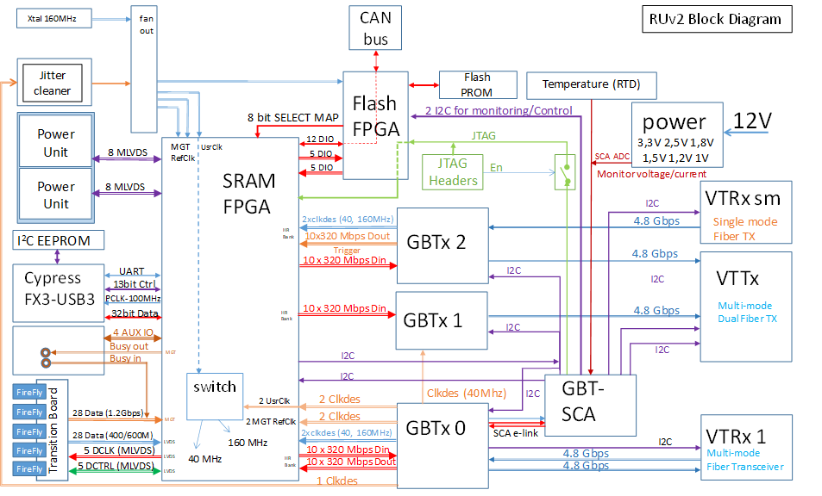

**Interfaces to be verified in functional tests**

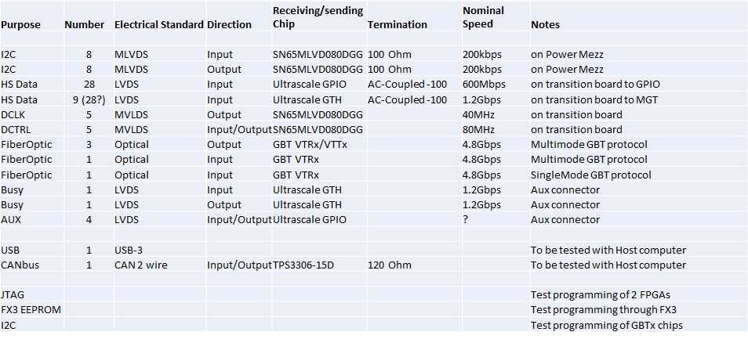

* **JTAG**: Program testing firmware to 2 FPGAs via JTAG; verify running firmware (e.g. blinking LEDs)
* **USB:**  verify communication between host computer & FPGA via FX3
* **I2C**: generate PRBS pattern @200kbps on 8 outputs (SCL_w, SDA_w), receive on 8 inputs (SCL_r, SDA_r)
* **GBT**: GBT_FPGA on test board, generate PRBS on TX, receive PRBS on RX
* **Alpide Data lines**: Transceiver IP with 28 RX; generate 1.2Gbps test pattern with OSERDES @ 600MHZ DDR; receive PRBS on Transceiver RX
* **DCTRL, DCLK**: Generate 80Mbps PRBS on DCLK; receive PRBS on DCTRL
* **BUSY**: Loopback PRBS patterns from OUT to IN, using transceivers?
* **PA3-Flash I/F**: Read Flash ID; read & catalogue “bad blocks” (page 0)
* **“Serial Number”:** Read and catalogue UltraScale FPGA DNA value as unique identifier for Readout Unit
* **CANbus:** Connect USB CAN dongle to host computer, send and receive simple CAN packets @ 1Mbp
* **Ultrascale-PA3 I/F**: Send & receive test patterns
* **SelectMap I/F:** PA3 reads US SelectMap ID

# PROCUREMENT

Procurement controls will be implemented to ensure that purchased items and services meet project needs and comply with applicable quality requirements.

# INSPECTION AND ACCEPTANCE TESTING

Inspection and testing of Readout Unit materials and final blocks will be conducted using established acceptance and performance criteria, and equipment used for inspection and tests will be calibrated and maintained.

# LINKS

1. ALICE Review Page, <https://twiki.cern.ch/twiki/bin/viewauth/ALICE/Reviews>
2. PRR slides from April 13, 2018: <https://indico.cern.ch/event/698929/contributions/2928304/attachments/1623336/2603301/Testing_plans.pdf>
3. PRR review responses from May 15, 2018 (see #9): <https://indico.cern.ch/event/698929/attachments/1645606/2671481/20180414ITSROPRRWP10_20180515_PRR_Answers_v2.pdf>
4. slides 20-25 here (June plenary, 2018): <https://indico.cern.ch/event/736897/contributions/3040002/attachments/1669657/2678199/20180618_WP10_ITS_Plenary_v1.pdf>
5. slides 12-14 here (June plenary, 2018): <https://indico.cern.ch/event/736897/contributions/3040827/attachments/1669785/2678365/RUv2.pdf>
6. Readout Unit v2.0: <https://twiki.cern.ch/twiki/bin/view/ALICE/ITS_WP10_RUV2>
7. RU prototype v1.0: https://twiki.cern.ch/twiki/bin/view/ALICE/ITS_WP10_RUV1

All ALICE documents are also posted on the review agenda page, password protected.

# REFERENCES

1. MVTX proposal: <https://www.overleaf.com/10919417bwssgrhhgryc#/41088970/>