

Scientific Instrumentation

ITS upgrade

RUv1 manual

Project | ITS upgrade (W0004592) | Author(s) | M.J. Rossewij
 |  | Date | 18-August-2017
Name | RUv1 manual | ID | W0004592_001
 |  | Status | Concept
Filename | ITS_RUv1Manual.docx | Version | r1
Printed | 15-12-2017 18:40
University of Utrecht, Faculty of Science
Scientific Instrumentation
P.O.Box 80004, 3508 TA Utrecht
Tel: 030 2532293
Email: d,killian@uu.nl WWW: http://www.science.uu.nl/instrumentatie/

Document History
Version | Date | Author | Section | Description
0.1 | 24-August-2017 | M.J. Rossewij | - | First concept.
0.13 | 22 sept |  |  | Added SCA functionality
0.14 | 15-dec |  | 3, 8.5, 9 | J37 reversed, added RUv1_1 differences
0.15 | 12-feb-2018 |  | 2.3 | Reference to 2.8
R1 | 11-april-2018 |  | Appendix | Added block diagram

Contents
1 Connectors 3
1.1 J0, Power connector 3
1.2 J1 VME style 3
1.3 J2 Transition board 4
1.4 J3 VTRx 4
1.5 J4 VTTx 4
1.6 J5 VTRx (single mode) 5
1.7 J6 Micro B USB3 5
1.8 J7 BUSY-AUX connector 5
1.9 J8 JTAG connector (front panel) 5
1.10 J9 CAN connector 5
1.11 J10 Power mezzanine 5
1.12 J11 JTAG connector (Microsemi-FlashPro compatible) 6
1.13 J12 GBTx I2C connector 6
1.14 J13 Xilinx GPIO header 6
1.15 J14 PA3 GPIO header 6
1.16 J15 & J16 Jitter Cleaner SMA differential input 6
1.17 17 & J18 Jitter Cleaner output/clock buffer input 6
1.18 J19 & J20 Clock Buffer SMA differential output 6
1.19 J21 & J22 Xilinx SMA differential IO 6
1.20 J23 Fan Connector 6
2 Jumpers 7
2.1 J25, J26 & J27 FX3 power 1V2, 1V8 & 3V3 7
2.2 J28 FX3 power VIO5 7
2.3 J29, J30 & J32 JTAG2 bypass FX3, GBTx, GBTx1 & GBTx2 7
2.4 J33 JTAG bypass PA3 8
2.5 J34 JTAG bypass Xilinx 8
2.6 J35 JTAG bypass JTAG2 8
2.7 J36, J37 & J38 8
2.8 J39 Disconnect SCA-JTAG & extra GND FlashPro cable 8
2.9 J40 POWER to INIT LED 8
2.10 J41, J42 & J43 GBTx configSelect 9
2.11 J44 & J45 JitterCleaner_CLKIN2 select SMA or X2 Oscillator 9
3 Switches 10
3.1 S9 FX3 configuration 10
3.2 S10 JitterCleaner configuration 10
4 LED 11
5 Xilinx 11
6 PA3 12
7 SCA 12
7.1 I2C 12
7.2 GPIO 12
7.3 JTAG 13
7.4 SPI 13
7.5 ADC 13
7.5.1 Regulator Voltage and current 13
7.5.2 VTRx Optical power 13
7.5.3 Temperature 14
7.6 DAC 14
8 Differences RUv1_0 & RUv1_1 15
Appendix A : RUv1 clocking scheme 16
Appendix B RUv1 JTAG configuration scheme 17
Appendix C RUv1 Block Diagram 18

Connectors
The table below gives an overview of the RUv1 connectors. More details are presented in the following subsections.
CONNECTORs |  | Type | Function/Intended for
J0 | POWER | SL508-4-90B | Power-in for table top operation
J1 | VME J1 style | DIN41612 | Power-in for rack operation & alternative Power board control
J2 | Transition Board | QFS-104-01-SL-D-RA | Interface to Alpide sensor modules via transition board
J3 | VTRx | TYCO 1888247 | Primary (sensor) data uplink & control/status link
J4 | VTTx | TYCO 1888247 | Up to 2 optional (sensor) data uplinks
J5 | VTRx | TYCO 1888247 | Downlink for receiving trigger/timing
J6 | USB3 | micro B SuperSpeed | USB3 connector for table top operation
J7 | BUSY_AUX | ERF8-010-01-L-D-RA-L | BUSY signal and optional links for future applications
J8 | JTAG | MOLEX_08783-1420 | Programming FPGAs (compatible with Xilinx 20 pin connector)
J9 | CAN | MOLEX087833-0420 | Access in absence of DAQ/GBT system
J10 | Power mezzanine Board | ERF8-030-05.0-L-DV-TR | Primary path for Power board control & LEDs
J11 | JTAG | HTST-105-01-L-DV-A | Programming FPGAs (compatible with Microsemi connector)
J12 | GBTx I2C interface | Boxed header 4x2 | Access to GBTx registers using CERN USB-I2C dongle
TEST-CONNECTORs
J13 | Xilinx pinheader | TSM-110-04-T-DV | Connected to Bank47 (1,8V)
J14 | PA3 pinheader | TSM-110-04-T-DV | Connected to Bank 5 (3,3V)
J15 | JitterCleaner_IN+ | SMA | Alternative/external input for jitter cleaner
J16 | JitterCleaner_IN - | SMA | Alternative/external input for jitter cleaner
J17 | clockBuffer_IN+ | SMA | Alternative/external input for 1-8 LVDS clock buffer
J18 | clockBuffer_IN - | SMA | Alternative/external input for 1-8 LVDS clock buffer
J19 | clockBuffer_OUT - | SMA | 1-8 LVDS clock buffer output 6
J20 | clockBuffer_OUT+ | SMA | 1-8 LVDS clock buffer output 6
J21 | XilinxIO - | SMA | Xilinx bank 68 (1V8) differential test IO
J22 | XilinxIO+ | SMA | Xilinx bank 68 (1V8) differential test IO
J23 | FAN connector | MOLEX-22-11-2032 | FAN power connector

J0, Power connector
For table top operation, Power can be applied on the J0. Voltage can range from 5…12V. Take care that the voltage applied is compatible with the FAN connected to J23. Typical settings:
Voltage (V) | Current (A)
5 | 3
12 | 1,5
REMARK: THE RUV1 J0 polarity is reversed to RUV0 !!!!!

J0 pinnout:
Pin | Function
1,2 | Power_In
3,4 | GND

J1 VME style
The type and position of the J1 connector is compatible with the VME standard, including the location of the (GND, 5 & 12V) power pins. When using J1, the placement of the polyswitch-fuses determines which J1 power input is used:
Voltage (V) | Current (A) | F2 | F3
5 | 3 | PolySwitch 5A  2920L500/16MR | Absent
12 (DEFAULT) | 1,5 | Absent | PolySwitch 2A2  2920L200DR

REMARK: Do not place both Polyswitch fuses (F2&F3) as this results into a short
Also here, take care that the voltage selected is compatible with the FAN connected to J23.

The complete J1 pinout is shown below:
 | VME-J1 |  |  |  | J1 backplane
 | Row A | Row B | Row C |  | Row A | Row B | Row C
 | D00 | BBSY | D08 |  | GNDA | GNDA | GNDA
 | D01 | BCLR | D09
 | D02 | ACFAIL | D10
 | D03 | BG0IN | D11
 | D04 | BG0OUT | D12 |  | SCL1_AUX_WRITE_N |  | SCL1_AUX_READ_N
 | D05 | BG1IN | D13 |  | SCL1_AUX_WRITE_P |  | SCL1_AUX _READ_P
 | D06 | BG1OUT | D14 |  | SDA1_AUX_WRITE_N |  | SDA1_AUX _READ_N
 | D07 | BG2IN | D15 |  | SDA1_AUX_WRITE_P |  | SDA1_AUX _READ_P
 | GND | BG2OUT | GND |  | GND |  | GND
 | SYSCLK | BG3IN | SYSFAIL |  | SCL1_WRITE_N
 | GND | BG3OUT | BERR |  | GND
 | DS1 | BR0 | SYSRESET |  | SCL1_WRITE_P
 | DS0 | BR1 | LWORD |  | SDA1_WRITE_N
 | WRITE | BR2 | AM5 |  | SDA1_WRITE_P |  | SCL1_READ_N
 | GND | BR3 | A23 |  | GND |  | SCL1_READ_P
 | DTACK | AM0 | A22 |  | SCL2_WRITE_N |  | SDA1_READ_N
 | GND | AM1 | A21 |  | GND |  | SDA1_READ_P
 | AS | AM2 | A20 |  | SCL2_WRITE_P |  | SCL2_READ_N
 | GND | AM3 | A19 |  | GND |  | SCL2_READ_P
 | IACK | GND | A18 |  | SDA2_WRITE_N | GND | SDA2_READ_N
 | IACKIN | SERCLK | A17 |  |  |  | SDA2_READ_P
 | IACKOUT | SERDAT | A16
 | AM4 | GND | A15 |  | SDA2_WRITE_P | GND
 | A07 | IRQ7 | A14 |  | SCL2_AUX_WRITE_N |  | SCL2_AUX_READ_N
 | A06 | IRQ6 | A13 |  | SCL2_AUX_WRITE_P |  | SCL2_AUX_READ_P
 | A05 | IRQ5 | A12 |  | SDA2_AUX_WRITE_N |  | SDA2_AUX_READ_N
 | A04 | IRQ4 | A11 |  | SDA2_AUX_WRITE_P |  | SDA2_AUX_READ_P
 | A03 | IRQ3 | A10
 | A02 | IRQ2 | A09
 | A01 | IRQ1 | A08
 | -12 V | +5 V STDBY | +12 V |  |  |  | +12V
 | + 5 V | +5 V | +5 V |  | +5V | +5V | +5V

GNDA (& R234) was introduced to enable the use of 1:1 backplanes instead of a standard VME backplane.

The RUv1-J1 connector provides (besides power-in) also an alternative path for the Power board control signals (using differential MLVDS). As this is the secondary path, the MLVDS transceivers are by default disabled: R244…R249=Not placed. To enable, make R244=R246=R247=R249=1k. R245 & R248 provides the option to enable power module 1 and/or 2 via the VME backplane. In that case, make R244…R249=1k.

J2 Transition board
After inserting the transition board in J2, it can be fixated with 4 M2 bolt/nuts. The J2 pinout can be found in the schematics. Depending on the decoupling capacitors placed, ALPIDE_DATA_MGT_dp[27] shares a MGT with BUSY_IN (for more details, see section 1.8).

J3 VTRx
J3 allows the installation of a VTRx to provide the primary GBT transceiver path for data and control. The VTRx should be fixated with 2 M1.4 screws.

J4 VTTx
J4 allows the installation of a VTTx to provide up to 2 additional GBT uplink data channels. The VTTx should be fixated with 2 M1.4 screws.

J5 VTRx (single mode)
J5 allows the installation of a VTRx (-SingleMode) to provide a receive path for the trigger (and LHC bunch clock). The VTRx (-SingleMode) Tx channel is unconnected and the Rx channel is connected with GBTx2. The VTTx (-SingleMode) should be fixated with 2 M1.4 screws.

J6 Micro B USB3
J6 is a Micro B USB3 (super speed) receptable, intended for table op operation and/or when no GBT/DAQ system is available.

J7 BUSY-AUX connector
The BUSY_AUX connector has the following pinout:
pin | Signal | Pin | signal
1 | GND | 2 | GND
3 | BUSY_IN_P | 4 | BUSY_OUT_P
5 | BUSY_IN_N | 6 | BUSY_OUT_N
7 | GND | 8 | GND
9 | AUX_dp0 | 10 | AUX_dp1
11 | AUX_dn0 | 12 | AUX_dn1
13 | GND | 14 | GND
15 | AUX_dp2 | 16 | AUX_dp3
17 | AUX_dn2 | 18 | AUX_dn3
19 | GND | 20 | GND

The BUSY_OUT signal goes to the Xilinx US MGT27 transmitter and the BUSY_IN goes to the Xilinx US MGT27 receiver. The receiver is shared with the 27th sensor receiver pair. The connectivity of the MGT27 receiver is selected by placing/removing the proper capacitors:

MGT27 receiver function | C319&C320 | C526/C530
ALPIDE_DATA_MGT_27 | Removed | Placed
BUSY_IN | Placed | Removed
Default (bad SI due to stubs) | Placed | Placed

The 4 AUX signals are connected to the Xilinx US FPGA select IO (e.g. LVDS) and routed as differential pairs. The direction (IN/OUT/BI) is determined by the firmware. These signals are intended for optional future use.

J8 JTAG connector (front panel)
The front panel JTAG connector is compatible with the Xilinx 20 pin connector. The SCA-JTAG, J8 and J10 can act as JTAG masters and are connected in parallel. Placing the Xilinx download cable automatically disconnects (using PGND to disable U19, the FET switch) the SCA JTAG master from the JTAG chain.

J9 CAN connector
This CAN is intended to provide an alternative patch to access the RU and Power board when the GBT/DAQ system is not available. The CAN connector has the following pinout:

pin | Signal | Pin | signal
1 | CANL | 2 | GND
3 | CANH | 4 | GND
There is no CAN bus termination on the RU.

J10 Power mezzanine
The main function of the power mezzanine is to provide the primary access path to the power board using several I2C busses. The power mezzanine also has 6 LEDS: LED[0:3] are connected to the Xilinx US FPGA and LED[4:5] go to the Microsemi PA3 FPGA. The power mezzanine can be fixated using 2 M2.5 bolts/nuts. The J10 pinout can be found in the schematics.

J11 JTAG connector (Microsemi-FlashPro compatible)
J11 allows direct connection of the microsemi FlashPro(4) download cable. When connecting the download-cable, the SCA-JTAG master is automatically disconnected (by disabling U19, the FET switch) from the JTAG chain. Jumper J11 also disabling U19 (and disconnects the SCA-JTAG) and provides improved GND connection to the FlasPro download cable.

J12 GBTx I2C connector
J12 provides a path to access and program the GBTx with the Cern configuration software by connecting the CERN USB-I2C dongle. To access to the GBTx from the dongle, the Xilinx I2C master and the SCA I2C[7] master must be disabled. If the SCA I2C lines cannot be disabled (e.g. when using SCA version 1), the SCA I2C can be disconnected by removing R277 & R278. By default, each GBTx is set to a unique I2C address using resistors:

device | Address1 | Addres2 | Address | FusePower | FusePulse
GBTx | R14=NP | R190=NP | 0x1 | R279 | R280
GBTX1 | R26=100Ω | R191=NP | 0x3 | R282 | R283
GBTX2 | R39=NP | R192=100Ω | 0x5 | R285 | R286
As it is not known is the GBTx-EFUSE process can be controlles by I2C, individual resistors (shown above) can be placed/removed to provide the FusePower and FusePulse to an individual GBTx.

J13 Xilinx GPIO header
Provides access to 10 signals from Xilinx bank 47 (1,8V).

J14 PA3 GPIO header
Provides access to 10 signals from PA3 Bank 5 (3,3V). RUv1.0 has a patch that also connects header pin 9 (CE2) & 10 (R/B2) to the flash memory.

J15 & J16 Jitter Cleaner SMA differential input
To provide an external clock signal to the jitter cleaner. Intended for test purposes. Selection of the jitter cleaner input source is done by S10_A1 or CS signal (coming form PA3):
S10[1] | R162 | CS | Jitter Cleaner source
0 | NP | X | GBTx Clockdes6
T | 0 | 0 | GBTx Clockdes6
T | 0 | 1 | Oscillator X2 OUT or  SMAJ15/J16 In
1 | NP | X | Oscillator X2 OUT or  SMAJ15/J16 In
Furthermore resistors or capacitors must be placed on J44 and J45 in such a way that the SMA signal (and not the oscillator signal) is propagated to the jitter cleaner. Optionally, Oscillator X2 can be disabled by placing 1kΩ on R344 (default).

17 & J18 Jitter Cleaner output/clock buffer input
Provides a path for monitoring the jitter cleaner output or can act as an external input for the clockbuffer. In the latter case, the JitterCleaner output should be disabled by setting S10[4:3]=LM and the IN_SEL should be pulled high (with R341 or from the PA3).

J19 & J20 Clock Buffer SMA differential output
Clock buffer LVDS monitoring output.

J21 & J22 Xilinx SMA differential IO
Xilinx US differential test output. Connected to bank 68 (1V8).

J23 Fan Connector
The Fan connector was initially designed to be compatible with RUv0. To be compatible with the FANs ordered (FA35(12V)/FB35(5V)+K52B+T710/T725 from www.radianheatsinks.com), it was decided to place the FAN connector reversed. After the reversal, the pinout is:
Pin | RUv1.0 after connector reversal | RUv1.1
1 | GND | GND
2 | J1_5V & powerIn(=5…12V) when F2 placed | PowerIn (=J0 or J1-5V(12V) when F2(F3) placed)
3 | J1_12V & powerIn(=5…12V) when F3 placed | NC

When RUv1.0 F3 is placed or powered from J1 with 12 V present (on pin 31 row C), it is recommended to cut/disconnect pin3 from the connector J23 to avoid damage to the FAN tacho output (pin3).

Jumpers
The table below gives an overview of the RUv1 jumpers:
RefDes | Function | Default
J24 | Done LED (does not work due to low voltage) | Not placed
J25 | FX3 power 1V2 | 1-2 (GND)
J26 | FX3 power 1V8 | 1-2 (GND)
J27 | FX3 power 3V3 | 1-2 (GND)
J28 | FX3 power VIO5 | 1-2 (FX3 1V8)
J29 | JTAG2 bypass FX3 | 2-3 (bypass)
J30 | JTAG2 bypass GBTx | 1-2 (bypass)
J31 | JTAG2 bypass GBTx1 | 1-2 (bypass)
J32 | JTAG2 bypass GBTx2 | 1-2 (bypass)
J33 | JTAG bypass PA3 | 1-2 (include)
J34 | JTAG bypass Xilinx | 1-2 (include)
J35 | JTAG bypass JTAG2 | 2-3 (bypass)
J36 | JTAG forward TRST2 | 2-3 (GND)
J37 | JTAG forward TMS2 | 1-2 (1V5)
J38 | J38 forward TCK2  Terminate TCK | 2-4 (GND)  1-3 not placed
J39 | Disconnect SCA-JTAG & extra GND FlashPro cable | Not placed
J40 | Power LED | Not placed
J41 | GBTx configSelect | 1-2 (GND, IC channel)
J42 | GBTx1 configSelect | 2-3 (1V5, I2C)
J43 | GBTx2 configSelect | 2-3 (1V5, I2C)
J44 | JitterCleaner_CLKIN2- select SMA or X2 Oscillator | X2 Oscillator  (see picture)
J45 | JitterCleaner_CLKIN2+ select SMA or X2 Oscillator | X2 Oscillator  (see picture)
Default refers to the setting during the actual Alice experiment.

J25, J26 & J27 FX3 power 1V2, 1V8 & 3V3
The USB3 functionality is intended for stand-alone/table top operation (when GBT system in not available) and is therefore not qualified for a radiation environment. As in the actual (Alice) experiment all data/control data transfer will go via the GBTx links, the USB FX3 chip must be disabled (powered down) in order to avoid radiation related issues like latch-up (SEL). For this purpose are jumper J25-J27, which have their default setting to GND.

J28 FX3 power VIO5
J28 sets the voltage (1V5 or 1V8_USB3 or GND) on FX3-VIO5 rail/bank which powers the FX3 JTAG and I2C interface. The lowest voltage where the I2C serial EEPROM (U8, U9: 24FC1025 used to store the FX3 boot image) can operate on is 1,8V. All RUv1 devices in the JTAG chain operate on 1,5V (determined by the GBTx DIO power rail). So when doing a boundry scan test (only needed with the production test), the jumper should be set to 1,5V (FX3 booting from the I2C PROM might fail in this situation). When operating the RU in a table-top situation, FX3 booting from EEPROM requires J28 to be set to 1V8_USB3 (and J26 to 1V8). In the actual (Alice) experiment, the FX3 must be switched off (so J25…27) and J28 must be set to 1V8_USB3 (which is also to GND due to J26).

J29, J30 & J32 JTAG2 bypass FX3, GBTx, GBTx1 & GBTx2
These jumpers are used to include (or disable) JTAG by connecting TDI from corresponding IC to the daisy chain (or GND). The FX3 and GBTx JTAG functionality is limited to boundry scan and will therefore only be used for (production) test and not during the experiment. Therefore the default jumper position is to GND.

J33 JTAG bypass PA3
J33 includes (or bypasses) the PA3 in the primary JTAG chain. The PA3 JTAG provides besides boundry scan also the FPGA configuration interface. It is foreseen to be the primary path to reprogram the PA3 (from the SCA JTAG master) when the system is installed. Therefore the default configuration is to include the PA3 in the chain.

J34 JTAG bypass Xilinx
J34 includes (or bypasses) the Xilinx in the primary JTAG chain. The Xilinx JTAG provides besides boundry scan also access to the FPGA configuration logic. As this provides a path for scrubbing actions, the Xilinx JTAG is included in primary JTAG chain in the default configuration.

J35 JTAG bypass JTAG2
J35 allows to include the secondary JTAG chain (=JTAG2). As JTAG2 ICs (FX3 and GBTx) only support boundry scan, it should only be included with production test. The default configuration is therefore to bypass JTAG2.

J36, J37 & J38
J36, J37 & J38 are needed to forward the TRST, TMS and TCK to the secondary JTAG chain (=JTAG2). As JTAG2 ICs (FX3 and GBTx) only support boundry scan, it should only be enabled with production test. The default configuration is therefore force the JTAG2 signals to GND or 1V5.

J38 in addition the option the terminate TCK (from the primary JTAG) with 68Ω and 100pF in series. Initial test showed that this termination network is not effective and it is therefore disabled in the defaults configuration.

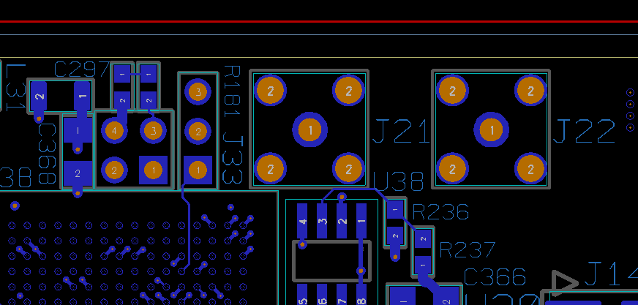

J39 Disconnect SCA-JTAG & extra GND FlashPro cable
Placing J39 disables the FET switch (U19: QS3VH126S1G) which disconnects the SCA JTAG master from the JTAG chain. In addition, it provides an improved GND connection to the FlashPro cable. As the SCA-JTAG master is intended for accessing the FPGA configuration when the system is installed, the jumper should not be placed in the default configuration.

J40 POWER to INIT LED
J40 enables or disables the bicolored LED D2 which indicates the status of the INIT signal. As no light sources are allowed in the magnet during the experiment, the jumper must not be placed in the default configuration.

RUv1.0 has a bug causing the LED not to work properly. Jumper J40 should therefore never be placed on RUv1.0.

J41, J42 & J43 GBTx configSelect
J41, J42 & J42 select whether the GBTx, GBTx1 and GBTx2 are configured via the IC channel (optical link) or the GBTx I2C interface (using the Cern USB-I2C dongle or the Xilinx FPGA as I2C master). In the default configuration, GBTx is set to the IC channel (allowing it to be controlled directly from the control room GBT link) while GBTx1 and GBTx2 are controlled via I2C.

J44 & J45 JitterCleaner_CLKIN2 select SMA or X2 Oscillator
These are nit pin-header jumpers bet SMA resistor/capacitor selection circuits allowing the source of the JitterCleaner CLKIN2 input, i.e. the SMA connector or the X2 Oscillator. The default configuration is the X2 Oscillator with 100nF coupling as shown below:

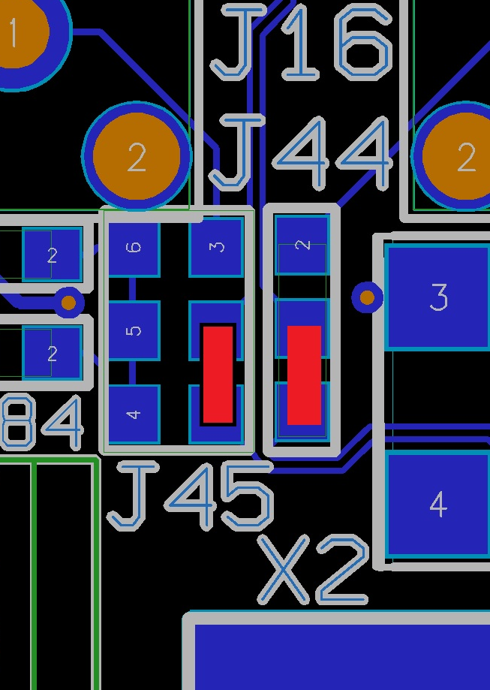

Switches
The RU has the following switches
S0…S3 | Push button connected to both PA3 and Xilinx  Pushed =>HIGH (1V8)  Relaxed => LOW (GND)
S4 | Push button: Reset Jitter Cleaner (U18: Si5316)
S5 | Push button: Reset GBTx, GBTx1 GBTx2 and SCA
S6 | Push button: Pulls Xilinx PROGRAM signal low
S7 | Push Button: Reset FX3 (U5: CYUSB3014)
S8 | 10 channel DIP switch connected to both PA3 and Xilinx  ON position => High (1V8)  OFF position => LOW (GND)  Intended for testing purposed or to set a CAN bus address
S9 | DIP switch for FX3 configuration (see below)
S10 | DIP switch for jitter cleaner configuration (see below)

S9 FX3 configuration
S9 is an 8 channel DIP switch. Each channel has 3 states:
- +: HIGH, pulled to 1V8
- 0: Floating
- -: LOW, pulled to GND
S9 channel | Function | Default
1 | PMODE[0] | -
2 | PMODE[1] | 0
3 | PMODE[2] | -
4 | FSLC2 | -
5 | FSLC1 | -
6 | FSLC0 | -
7 & 8 | Unused | X

PMODE selects the FX3 boot source:
PMODE[2:0] | Boot from
F11 | USB boot
F1F | I2C, On failure USB Boot is enabled
1FF | I2C only

RUv1 has the 19.2MHz crystal installed, therefore FSLC0…2 must be set to -. In fact, the FSCL pins refer to the CVVQ_FX3 power rail which is on RU connected to 3,3V. As S9 HIGH is 1,8V, this would possibly not work. Fortunate, all FSLC pins must be pulled down.

S10 JitterCleaner configuration
S10 is an 8 channel DIP switch. Each channel has 3 states:
- +: High, pulled to VSI (2,5 or 3,3V)
- 0: Middle/Floating
- -: Low, pulled to GND
S10 channel | Name | Function | Default
1 | CS | Clock Select
2 | DBL_BY | Output disable/bypass
3 | SFOUT[0] | Signal Format Select | M
4 | SFOUT[1] | Signal Format Select | H
5 | FRQSEL[0] | Frequency select | L
6 | FRQSEL[1] | Frequency select | M
7 | BWSEL[0] | PLL bandwidth Select | TBD
8 | BWSEL[1] | PLL bandwidth Select | TBD

CS: Clock Select
L | CLKIN1: GBTx CLOCKDES6
M | Selection controlled by PA3
H | CLKIN2: Oscillator X2 or external CLK via SMA J15/J16

DBL_BY: Output disable/bypass
L | CKOUT enabled
M | CKOUT disabled
H | Bypass mode with CKOUT enabled

SFOUTn: Signal Format Select
HM | LVDS
HL | CML
MH | LVPECL
ML | Low Swing LVDS
LH | CMOS
LM | Disabled
others | Reserved

FRQSEL: Frequency select
FREQSEL[1:0] | F_{MIN}(MHz) | F_{MAX}(MHz)
LL | 19.38 | 22.28
LM | 38,75 | 44.56
LH | 77.5 | 89.13
ML | 155 | 178.25
MM | 310 | 356.5
MH | 620 | 710
The optimal PLL bandwidth Select (BWSEL) needs to be determined experimentally.

LED
The RUv1.0 has one bi-colored LED (D2) indicating the XILINX FPGA INIT signals status:
RED
GREEN

Xilinx
The Xilinx has the following bank:
Bank | Voltage | Interface/functioin
0 | 1,5V | Configuration/Slave SelectMap
44 | GND | Unused
45 | 1V8 | FX3 interface (DQ[0:31], CTL[0:12], INT_n, CLK, RESET, UART_RX/TX)
46 | 1V8 | GBTx SLVS (DIN[0:9], DOUT[0:9], DCLK[0:1])
47 | 1V8 | GBTx1 SLVS (DIN[0:9])  GBTx CLOCKDES[2:3]  LOCALCLK[2]  AUX[0:3] differential signals  LED[0:3]  GPIO PINHEADER
48 | 1V8 | GBTx2 SLVS (DIN[0:9], DOUT[0:9], DCLK[0:1])  PUSHBUTTON[0:3]
64 | 3V3 | Alpide Sensor Control Interface (DCLK[0:5], DCTRL[0:5])  Power Board Interface (SCL1/2_(AUX)_READ/WRITE, SDA1/2_(AUX)_READ/WRITE,)
65 | 1V5 | Slave SelectMap
66 | 1V8 | Alpide Sensor Datal Interface (ALPIDE_DATA_GPIO[1:24])
67 | 1V5 | GBTx/1/2 CMOS signals (TXRDY, RXRDY, RXDATAVALID, TXDATAVALID)  I2C master to GBTx1/2  SCA (GPIO[0:11], I2C4 slave, SPI slave)
68 | 1V8 | Alpide Sensor Datal Interface (ALPIDE_DATA_GPIO[0], ALPIDE_DATA_GPIO[25:27])  DIPSWITCH[0:9]  PA3 single ended IO (PA3_IO[0:11])  PA3 diff. out (PA3_IO_d[0:4])  PA3 diff. in (PA3_IO_d[5:9])

PA3
The PA3 (A3PE600L-FG484M) has the following banks:
Bank | Voltage | Interface/function
0 | 1V8 | PA3 single ended IO (PA3_IO[0:11])  DIPSWITCH[0:9]  PUSHBUTTON[0:3]  LED[4:5]
1 | 1V5 | Xilinx SelectMap (D[0:7], CCLK, CSI_B, DONE, INIT, PROGRAM, RDWR)
2 | GND | Unused
3 | GND | Unused
4 | VSI | Jitter Cleaner Control signals (C1B, C2B, LOL, CS, RST)
5 | 3V3 | Flash (DATA[0:7], CONTROL)  CAN (D, R, LBK, RS)  WATCHDOG/POWERON reset
6 | 1V5 | SCA ( GPIO[12:19], I2C0 slave, I2C5 slave)
7 | 2V5 | Xilinx diff. in (FPGA_IN_d[0:4])  Xilinx diff. out (FPGA_OUT_d[5:9])  Clock input (CLOCKDES5, LOCAL_CLK)  Clock Selection signal (IN_SEL) for Clock Buffer (U17:CDCLVD1212)
VSI is determined by the placement of L24 (3V3) or L25 (2V5).

SCA
The SCA has a number of analog and digital (LVCMOS1V5) interfaces that are described here.

I2C
The SCA has 16 I2C masters, from which 7 are used on RUv1:
I2C | Connected to | Function
0 | PA3 | TBD
1 | VTTx | Adjust 1st channel laser diode power
2 | VTTx | Adjust 2nd channel laser diode power
3 | VTRx2 | Adjust laser diode power
4 | Xilinx US | TBD
5 | PA3 | TBD
6 | - | -
7 | GBTx | Acces5 to the GBTx, GBTx1 and GBTx2 registers
8 | - | -
9 | - | -
10 | - | -
11 | - | -
12 | - | -
13 | - | -
14 | - | -
15 | - | -
The I2C-channel 7 in fact has 3 masters:
- I2C channel 7
- I2C master on the Xilinx
- USB-U2C dongle connected to header J2
It is the responsibility of the user to ensure only one master is active.

GPIO
The SCA has 32 GPIO, from which 23 are used on RUv1:
GPIO | Connected to | Function
0..3 | Xilinx US | Each GPIO is connected with 3 Xilinx IO pins to provide TMR
4…11 | Xilinx US | TBD
12…19 | PA3 | TBD
20…22 | - | -
23 | PROGRAM_B | Xilinx US configuration status signals
24 | DONE | Xilinx US configuration status signals
25 | INIT_B | Xilinx US configuration status signals
26…31 | - | -

JTAG
The SCA has one JTAG master that (depending on the board jumper settings) can be connected to the following slaves: Xilinx US, PA3, GBTx, GBTx1, GBTx2 and FX3.
It is intended to configure the FPGAs, especially the PA3.

In fact there are 3 JTAG-masters possible:
- Xilininx download cable via front panel connector (J8)
- Microsemi FlasPro download cable (J11)
- SCA-JTAG
The SCA JTAG is connected to the JTAG chain with a switch (U19) that automatically disconnects the SCA JTAG master from the chain when one of the download-cables is plugged in.

SPI
The SCA has one SPI master that is connected to the Xilinx US. It can function as a backup communication path to the SEM IP.

ADC
The SCA has 31 ADC inputs(12 bit, 0,0…1,0V), from which 18 are used on RUv1:
I2C | Connected  to | Measured voltage means |  | Calculation
I2C | Connected  to | RUv1_0 | RUv1_1 | RUv1_0 | RUv1_1
0 | I_{MGT} | I_{MGT}/10 | I_{MGT}/5 | I_{MGT}=10*ADC_{VAL}/4095 | I_{MGT}=5*ADC_{VAL}/4095
1 | I_{INT} | I_{INT}/10 | I_{INT}/5 | I_{INT}=10*ADC_{VAL}/4095 | I_{INT}=5*ADC_{VAL}/4095
2 | I_{1V2} | I_{1V2}/10 | I_{1V2}/5 | I_{1V2}=10*ADC_{VAL}/4095 | I_{1V2}=5*ADC_{VAL}/4095
3 | I_{1V5} | I_{1V5}/10 | I_{1V5}/5 | I_{1V5}=10*ADC_{VAL}/4095 | I_{1V5}=5*ADC_{VAL}/4095
4 | I_{1V8} | I_{1V8}/10 | I_{1V8}/5 | I_{1V8}=10*ADC_{VAL}/4095 | I_{1V8}=5*ADC_{VAL}/4095
5 | I_{2V5} | I_{2V5}/1 | I_{2V5}/5 | I_{2V5}=1 *ADC_{VAL}/4095 | I_{2V5}=5*ADC_{VAL}/4095
6 | I_{3V3} | I_{3V3}/1 | I_{3V3}/5 | I_{3V3}=1 *ADC_{VAL}/4095 | I_{3V3}=5*ADC_{VAL}/4095
7 | I_{IN} | - | I_{IN}/5 | - | I_{IN} =5* ADC_{VAL}/4095
8 | V_{MGT} | V_{MGT}/2 |  | V_{MGT}=2 * ADC_{VAL}/4095
9 | V_{INT} | V_{INT}/2 |  | V_{INT} =2 * ADC_{VAL}/4095
10 | V_{1V2} | V_{1V2}/2 |  | V_{1V2}=2 * ADC_{VAL}/4095
11 | V_{1V5} | V_{1V5}/2 |  | V_{1V5}=2 * ADC_{VAL}/4095
12 | V_{1V8} | V_{1V8}/2 |  | V_{1V8}=2 * ADC_{VAL}/4095
13 | V_{2V5} | V_{2V5}/5 |  | V_{2V5}=5 * ADC_{VAL}/4095
14 | V_{3V3} | V_{3V3}/5 |  | V_{3V3}=5 * ADC_{VAL}/4095
15 | V_{IN} | - | V_{IN/21} | - | V_{IN}=21*ADC_{VAL}/4095
16 | V_{RSSI1} | Receiver optical power of VTRx1 |  | I( A) = ( 2,5 -((ADC_{VAL}/4095)*69/22) )/4700  I(uA) = 532 - 0,163 * ADC_{VAL}
17 | V_{RSSI2} | Receiver optical power of VTRx2
18..22 | - | -
23 | R361 | PT1000-Xilinx |  | T(°C) =((10*ADC_{VAL}/4095)-1)*1000/3,85 or  T(°C)=0,634286 * ADC_{VAL} - 259,74
24 | R360 | PT1000-Regulators
25..30 | - | -

Regulator Voltage and current
In RUv1_0, ADC Channel 0…6 are used to measure the 7 power rail currents. ADC[0…4] have an effective current sense resistor of 1mΩ*100(=AD626 gain). ADC[5…6] have an effective current sense resistor of 10mΩ*100(=AD626 gain).

In RUv1_1, ADC Channel 0…7 are used to measure the 8 power rail currents. All power rails have an effective (combination of sense resistor, amplifier gain and voltage divider) current sense resistor of 0,2Ω.

ADC Channel 8…14(15) are used to measure the 7(8) power rail voltages. They are pre-scaled using a resistor divider as indicated in the table.

VTRx Optical power
From V_{RSSI}, The optical average photo current can be calculated with:
V_{RSSI}=(VCC-I*R1)*R2/(R1+R2)
Filling in: R1=4k7, R2=2k2 and VCC=2,5V:
V_{RSSI}=0,8-1499*I
Or;
I = ( 2,5 - (V_{RSSI}*69/22) )/4700

Temperature
The PT1000 are 1 kΩ at 0 °C. The temperature sensitivity is 3850ppm/K, or 3,85Ω/K. so:
R=1000+3,85*T
Using the SCA-ADC channel internal (100μA) current source, the measured voltage corresponds to:
U=I*R=0,0001(1000+3,85*T)
So
T=(10*U-1)*1000/3,85=(10.000*U-1000)/3,85

DAC
Not used

Differences RUv1_0 & RUv1_1
The following table shows the functional differences between RUv1_0 and RUv1_1:

REFDES | Type | Sheet | RUv1_0 | RUv1_1 | Motivation
U28 | Error fix | 7 | U28 pin 5&6 swapped | pin 5&6 ok | Fixed component geometry pin 5&6 swap. Now INIT led ok.
C323 |  | 7 | C323=100nF | C323=NP | Remove de-bounce capacitor allowing PA3 to drive PROGRAM line
U2, U4 | Improvement | 30, 36 | DCLK0=>DCLK24 | =>DCLK16 | Use clocks from different e-link groups.
U30, R359 | Error fix | 29 | PA3pins:  U8=>CE2 & J14-17  T11=>NC  W7=> R/B2 & J14-19  R11=>NC | PA3pins:  U8 =>CE2  T11=>J14-17  W7=> R/B2  R11=>J14-19 | On RUv1_0, the Flash CE2 & R/B2 were not routed on the board, but with a wire patch connected to test header pins J14 pin 17 & 19. On RUv1_1, the Flash CE2 & R/B2 lines are routed to the old shared PA3 pins (to maintain compatibility) and PINHEADER[8:9] (connected to J14 pin 17&19) are reassigned
U31, J14 | Error fix | 45 |  | PA3pins:  U8 =>CE2  T11=>J14-17  W7=> R/B2  R11=>J14-19
U31 | Improvement | 45 | T9 =>NC | T9=>RESET_n | U38 RESET now also connected with PA3 global clock input T9
J23 | Error fix | 39>59 | Pin3=GND | Pin1=GND | Pinout fan connector made compatible with FANs foreseen
R177,R178 | Improvement | 40 | R177=NP, R178=10k | Reversed | Change TRST pull-down to pull-up (Xilinx cable has no TRST drive)
J12 | Error Fix | 51 | J12 mirrored | J12 ok | Fixed the mirrored USB-I2C dongle connector (J12)
R124/R139 | Addition | 52 | - | 20k/1k | Added to support board input voltage measurement
U39 | Addition | 59 | - | AD8418WBRZ | Added to support board input current measurement
U20-U26 | Improvement | 60-66 | AD626AR | AD8418WBRZ | The AD626AR differential amplifier has high offset when operated single ended. Therefore replaced by AD8418WBRZ.
R74, R82 | Improvement | 60-66 | 5mΩ | 10mΩ | To compensate to the AD8418WBRZ reduced gain, 5 sense resistors doubled in value.
R75-R77 | Improvement | 60-66 | 10mΩ | 20mΩ
Current  sense amplifier resistor divider | Improvement | 60-66 |  |  | Also the voltage divider ratio on the output of the current sense amplifier has changed to improve the dynamic range. Now for all power rails, the effective current gain is 0.2Ω, so the divider output voltage must be multiplied by 5 to obtain the actual current. See § 7.5

: RUv1 clocking scheme

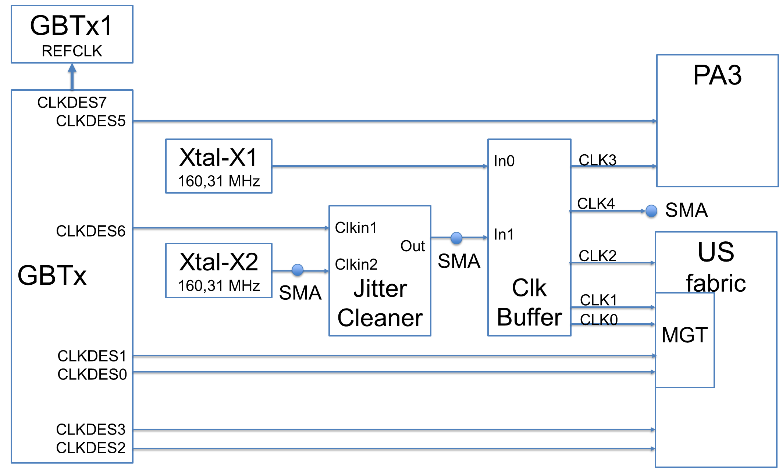

RUv1 JTAG configuration scheme

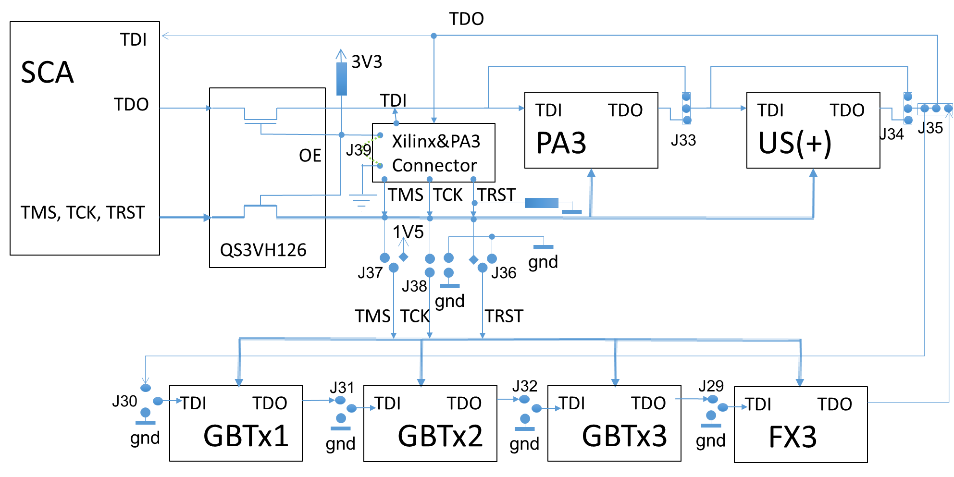

RUv1 Block Diagram

