IT-4396/EP/ATLAS
The ATLAS FELIX Project
Invitation to Tender

Technical Specification
Production, Test and Support of PCIe I/O Modules for the ATLAS Experiment

Abstract
This technical specification concerns the supply of custom designed PCIe modules. Deliveries are foreseen until the end of 2020.

Table of Contents
1. INTRODUCTION 1
1.1 Introduction to CERN 1
1.2 Introduction to the ATLAS Experiment 2
2. SCOPE OF THE SUPPLY 2
2.1 Deliverables Included in the Supply 2
2.2 Required Quantity 2
2.3 Activities at the Contractor’s Premises 3
2.4 Items and Services provided by CERN 3
2.4.1 Delivery Acknowledgement by the Contractor 3
2.4.2 Acceptance of Furnished Components by the Contractor 4
2.4.3 Furnished Components during the Warranty Period 4
2.4.4 Test bench 4
2.5 Options 5
3. Technical requirements 5
3.1 General Description 5
3.2 Printed Circuit Boards 5
3.3 Assembly Work 5
3.3.1 Assembly of Printed Circuit Boards 5
3.3.2 Identification 6
3.4 Applicable Standards, Rules and Regulations 6
3.4.1 CERN Regulations 6
3.4.2 EU Regulations 6
3.4.3 International Standards 6
3.5 Specific Material Requirements 7
3.6 Manufacturing and Tooling 7
3.7 Operational and Environmental Conditions 7
3.8 Quality Assurance and Documentation 8
4. performance of the Contract 8
4.1 Production Process 8
4.2 Deviations from this Technical Specification 8
4.3 Assembly of the Modules 8
4.4 Delivery Schedule 9
4.5 Tests 9
4.5.1 Assembled Printed Circuit Boards 9
4.5.2 Mechanical Parts 9
4.5.3 Module burn-in 9
4.5.4 Functional Test 9
4.6 Contract Follow-Up and Progress Monitoring 10
4.7 Packing and Shipping 10
4.8 Acceptance and Warranty 10
4.9 Spare Parts 11
5. cern contact PERSONS 11
6. ANNEXES 11

INTRODUCTION

Introduction to CERN
CERN, the European Organization for Nuclear Research, is an intergovernmental organization with over 20 Member States. Its seat is in Geneva but its premises are located on both sides of the French-Swiss border (http://cern.ch/fplinks/map.html).
CERN’s mission is to enable international collaboration in the field of high-energy particle physics research and to this end it designs, builds and operates particle accelerators and the associated experimental areas. At present more than 11 000 scientific users from research institutes all over the world are using CERN’s installations for their experiments.
The accelerator complex at CERN is a succession of machines with increasingly higher energies. Each machine injects the beam into the next one, which takes over to bring the beam to an even higher energy, and so on. The flagship of this complex is the Large Hadron Collider (LHC) as presented below:
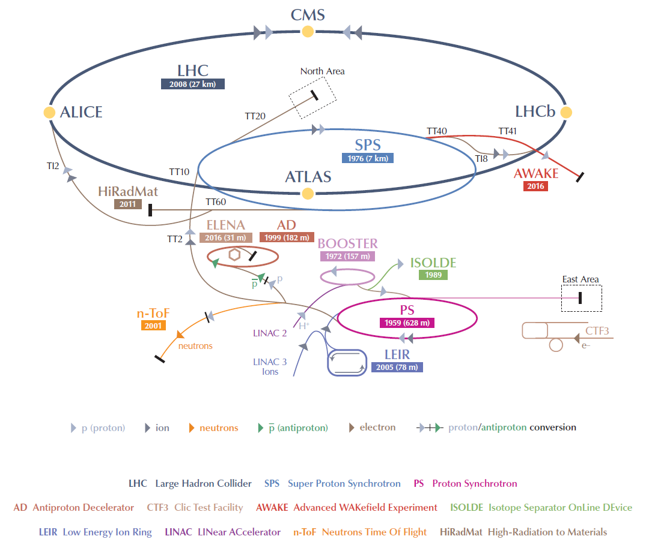
Figure 1: CERN Accelerator Complex
Further information is available on the CERN website: http://cern.ch

Introduction to the ATLAS Experiment
ATLAS, or A Toroidal LHC ApparatuS (www.atlas.ch), is a particle physics experiment at the Large Hadron Collider (LHC) at CERN. The ATLAS detector is designed and constructed to make new particle discoveries resulting from head-on collisions of protons produced by the LHC of extraordinarily high energy. ATLAS will investigate the basic forces that have shaped our Universe since the beginning of time and that will determine its fate. Among the possible discovery candidates are particles that could confirm the existence of extra dimensions in space, unification of fundamental forces, and evidence of dark matter in our Universe. The ATLAS detector is located in an underground cavern on the Swiss part of CERN. The experiment is in operation and produces physics results. The ATLAS collaboration involves more than 3000 scientists from 174 institutions in 38 countries.

SCOPE OF THE SUPPLY
The successful bidder (hereinafter referred to as the “contractor”) shall supply the PCIe modules and timing mezzanines known as FLX-712 (hereinafter referred to, in whole or in part, as the “supply”) as defined in this technical specification and the documents and drawings attached to it.

Deliverables Included in the Supply
The supply shall include:
- 120 fully assembled and tested PCIe modules with I/O brackets, fans, stiffener bar and heat-sinks mounted;
- 120 fully assembled and tested timing mezzanines mounted on the PCIe modules;
- 4 bare PCBs for quality control;
- Component traceability list (see section 3.5);
- Warranty for a duration of five years with an option to extend it to ten years;
- A test data package composed of a quality control record, test reports, x-ray images and a Certificate of Conformity for each module. Test reports shall include evidence of the following:
- Conformity of PCB production quality (see section 3.2);
- Conformity of PCB assembly quality (see section 4.5.1). The inspection report must comply with IPC-610;
- Conformity of ionic residues (IPC/EIA J-STD-001, Cleanliness Designator C-22), tested on 100% of the boards (see section 4.5.1);
- Conformity of mechanics (visual inspection report) (see section 4.5.2);
- Production test results (see section 4.5.4);
- Test and Measurement reports and Certificate of Conformity of the final supply (see document “Test Procedure of FLX-V712 card”);
- Diagnostics and repair of broken modules.

Required Quantity
The supply consists of a basic requirement of 120 modules. The first 20 modules, together with four bare PCBs to be used for validation purposes, is considered as the “pre-series”. The remaining 100 modules is considered as the “series production”.
Work on the series production shall not start before CERN has given its formal approval of the pre-series in writing.

Activities at the Contractor’s Premises
The contractor shall perform the following activities at his premises:
- Quality control of the PCBs;
- Ordering of passive and active components for the pre-series and series production;
- Input quality control of all components (including those provided by CERN, see section 2.4);
- Assembly of the components on the PCBs and soldering followed by testing for ionic residues (see section 4.5.1);
- Production of mechanical components such as brackets;
- Installation of the timing mezzanine of the main PCIe module as well as the assembly of brackets, heat sinks, fans and internal optical patch cords;
- Quality control of the assembled modules;
- Tests of the complete modules including execution of tests specified by CERN;
- Packing, and shipping if required by CERN (see section 4.7).
The contractor shall not sub-contract any of the above-mentioned activities.

Items and Services provided by CERN
Per PCIe module ordered CERN will provide the following items to the contractor:
- One Xilinx XCKU115-2FLVF1924E FPGA;
- Two (24-channel) or four (48-channel) pairs of transmitters (Avago AFBR-814FN1Z) and receivers (Avago AFBR-824FN1Z);
- One fibre assembly that will connect the MiniPODs to the PCIe bracket.
Each of these items is hereinafter referred to as a “furnished component”.

CERN will procure the furnished components from official distributors and free issue them to the contractor. CERN will be responsible for associated transport costs, transport insurance and adequate packaging in order to reduce the risk of damage. In order to preserve the storage conditions, CERN will not unpack the furnished components.
CERN will ensure that the furnished components required by the contractor for the production of the supply are shipped at the same time as making a release order so as not to cause any delays. The contractor shall store the furnished components in an appropriate environment in accordance with the manufacturer’s instructions until they are required for the production of modules.
The contractor shall ensure that all equipment and materials made available by CERN are clearly marked as “CERN property” and are kept separated from any other equipment and materials (see also clause 15 of General Conditions of CERN Contracts).

Delivery Acknowledgement by the Contractor
The contractor shall immediately acknowledge receipt of a delivery of furnished components to CERN. At the same time, the contractor shall inform CERN of any discrepancies between the number of each type of furnished component received and the number of each type of furnished component stipulated in the accompanying papers. CERN will make any necessary follow-up with the distributor(s) and CERN will provide any missing furnished components at no charge to the contractor.

Acceptance of Furnished Components by the Contractor
The contractor shall perform input quality control of the furnished components promptly following their delivery, and in any case prior to mounting them on the PCB. Such input quality control shall allow the contractor to identify if any furnished components are non-conforming (e.g. they have been damaged during transportation, degraded due to incorrect storage or are of the wrong type).
The contractor shall, within 30 days of shipment from CERN of a furnished component, accept or reject the furnished component. If the contractor rejects a furnished component then it shall do so in writing together with a full justification as to why. The contractor shall provide supporting test results, if applicable. If the contractor does not explicitly reject a furnished component within 30 days of its shipment from CERN then that furnished component shall be deemed accepted by the contractor.
If the contractor rejects a non-conforming furnished component in accordance with the above paragraph, CERN will provide a replacement furnished component free of charge.
If a furnished component that has been accepted or deemed accepted by the contractor in accordance with the above paragraph is found to be non-conforming or otherwise becomes damaged after acceptance or deemed acceptance, the contractor shall be liable to CERN for the price paid by CERN for the replacement furnished component. The non-conforming or damaged component shall be returned to CERN.
Non-conforming furnished components shall not be used for the production of the supply. The contractor shall return non-conforming furnished components to CERN with a written description of the defect.

Furnished Components during the Warranty Period
CERN will provide the contractor with replacement furnished components that may be required to repair PCIe modules during the warranty period.
If a replacement furnished component is needed due to a defect that is not related to the furnished component itself, then the contractor shall be liable to CERN for the price paid by CERN for the replacement furnished component. If a replacement furnished component is needed due to a defect with the furnished components itself that is not related to any other part of the supply, CERN will provide a replacement furnished component free of charge.
All defective or damaged furnished components shall be returned to CERN with a written description of the defect.

Test bench
CERN will provide the contractor with a test bench consisting of a computer with pre-installed operating system (Linux) and test software, a desktop power supply, cables and accessories as well as a detailed test procedure (see attached documents). This material will remain at the contractor’s premises for the entire duration of the contract including the warranty period. The contractor shall provide a PC with Windows operating system for the upload of firmware to the FLX-712 cards.

Options
CERN reserves the right to order additional PCIe modules until 31 December 2020. The contractor shall deliver such additional modules within 24 weeks of receipt of a relevant order.

Technical requirements

General Description
The supply concerns fibre optic interface modules in PCIe form factor as well as timing mezzanines. The modules are made up of a wide range of active and passive components of several package types. In addition, the motherboard drives a large number of high-speed serial links at up to 14 Gbits/s.
CERN requires two different configurations of the PCIe modules; referred to as “24-channel” and “48-channel”. The only difference is that on a “24-channel" module only four of eight MiniPOD transceivers are mounted.
The timing mezzanine is a comparably simple device. It consists of a PCB and a small number of active and passive components. Every PCIe module must be equipped with one mezzanine.
The supply must comply with the technical requirements set out in this technical specification including its annexes.

Printed Circuit Boards
The PCB for the motherboard (PCIe module) is the most critical item since it embeds a large number of staggered vias, connected to an expensive component with 2000 high-density connections. In addition, it has to deal with strong requirements on the impedance and carry high current flow.
The contractor shall work in close collaboration with the PCB manufacturer, without CERN intervention, in order to optimize the production flow as well as the quality assurance. The contractor shall be responsible for the quality control of the PCBs.
The contractor shall not make any modifications to the PCB drawing without prior written agreement from CERN.
Any PCBs to be held in stock for more than one month shall be dried out and sealed in appropriate moisture barrier bags with a bag of desiccant inserted.
The PCB must be produced by a NADCAP certified company. The contractor shall inform CERN of the name of the proposed PCB manufacturer. The contractor shall not start production of the PCBs until CERN has given its written consent to the choice of PCB manufacturer.

Assembly Work

Assembly of Printed Circuit Boards
The assembly of the PCBs will consist of mounting and soldering through-hole components and surface mounted components, on both sides of the modules. The contract shall comply with and apply the IPC Standards Class 2 (see section 3.4.3), especially for the following activities:
- Handling electronic assemblies;
- Component installation location / orientation;
- Soldering acceptability requirements;
- Cleanliness acceptability requirements;
- Marking acceptability requirements;
- Surface mount assemblies acceptance requirements.
The modules must be soldered using lead-free solder and must be RoHS compliant. Either reflow or vapour phase soldering must be used. Both sides of the assembly must be cleaned and a test for ionic residues is required (IPC/EIA J-STD-001, Cleanliness Designator C-22). Modules must be cleaned to meet the Cleanliness Designator C-22, including after rework or repair.

Identification
Each board shall be individually identified with a serial number. The number should be printed on the PCB. If this is not possible, the use of a sticker is permitted.
The contractor may add additional identifications to the board.

Applicable Standards, Rules and Regulations
The contractor shall comply with and shall ensure that the supply complies with all relevant professional and CERN standards and codes including, but not limited to:

CERN Regulations
The supply shall be in compliance with CERN safety rules available at: http://cern.ch/safety-rules.

EU Regulations
Hazardous material content for substances listed in the RoHS Directive must be within the limits defined in EU Directives 2011/65/EU and 2012/19/EU and relevant amendments.
The supply must comply with CE marking and related regulations.

International Standards
For the production of PCBs:
- NADCAP.
For the assembly of PCBs:
- IPC Standard IPC-A-610 (Class 2);
- IPC Standard IPC/EIA J-STD-001 (Class 2). In case of conflict, IPC-A-610 shall prevail over IPC/EIA-J-STD-001;
- Cleanliness Designator C-22. Both sides of assembly must be cleaned. A test for ionic residues is required.
For the finished product:
- PCI-SIG PCI Express Base Specification Revision 3.1a;
- PCI-SIG PCI Express Electromechanical Specification Revision 3.0;
- IPC 7711 Rework, Modification, and Repair of Electronic Assemblies;
- The modules must be assembled, tested and repaired by an operator with an IPC certification (class 2).

Specific Material Requirements
The contractor shall purchase all materials and components exactly as specified in the bill of materials (BOM) annexed to this technical specification. The selected components are RoHS compliant (see section 3.4.2). The contractor shall not use alternative components without CERN’s prior written approval. The contractor shall procure components from official distributors. The contractor shall not procure components from brokers without prior written agreement from CERN.
At the end of the production period, the contractor shall provide in a spreadsheet file the delivery date, batch number and specific manufacturer reference of each component used for the execution of the production. The file must allow, upon discovery of a faulty component, to ascertain whether the whole production is affected or not.
The contractor shall apply a strict procedure to protect all components in goods reception and storage areas. This is particularly important for surface mounted devices. The components must be stored in conditions that minimize the growth of oxides on surfaces to be soldered and held in sealed bags or boxes containing dry desiccant (e.g. silica gel). In addition, before mounting, components must be dried in a suitable oven as specified in section 3.6.

Manufacturing and Tooling
The contractor shall follow all the necessary operations and shall have available all the tooling for the proper execution of the contract.
The process and equipment for the motherboard assembly must comply with the following steps:
- MSL controlled storage of the components and the PCB;
- Baking of the components (according to the respective data sheet) and of the PCB for a minimum of 12 hours at 110 °C;
- SAC 305 (Tin 97 % / Silver 3% / Copper 0.5%) solder past coalescence test;
- SPI (Solder Past Inspection) in 3D is mandatory in order to guarantee the good solder paste deposition;
- Pick and place and reflow of a solder test PCB for the solder profile investigation made with tooling (solderStar, Datapack ….);
- Flying probe test of the bare PCB;
- Full AOI (Automated Optical Inspection) ;
- X-ray images shall be taken of all modules after thermal stress (specific life cycle tests see 4.5.3). The images must be inspected by the contractor and sent to CERN.

Operational and Environmental Conditions
CERN will install the PCIe modules in rack-mounted server PCs. These PCs will be installed in the underground area of the ATLAS experiment. The PCs will be equipped with adequate ventilation in order to guarantee that the components of the PCIe modules (in particular the FPGA) will be operated at temperatures that do not exceed their maximum recommended operation temperatures. The modules will not be subjected to particular vibrations, magnetic fields or ionizing radiation. The humidity will be 10-80 % non-condensing. Once installed, the PCIe modules will be powered for at least 11 months per year and must operate for at least five years.

Quality Assurance and Documentation
All specified tests and measurements carried out during all stages of production, from raw material procurement up to delivery and installation shall be recorded. The contractor shall provide these records to CERN at the end of the production period.
The contractor shall have an approved and formal process in line with ISO 9001 standards, designed to monitor and record each phase of the manufacturing of the supply, such that complete conformity with the requirements of this specification is achieved.
This process includes individual sub-assembly inspection and test procedures accompanied by written records in electronic format at each stage, and shall allow all faults to be rapidly located, identified and their causes eliminated by the contractor. Any modifications to the material resulting from a systematic manufacturing fault shall be carried out on all modules by the contractor. This activity must not be sub-contracted and it must be done at the contractor’s cost.
- The contractor shall submit all documents produced in electronic format;
- Text documents in Microsoft Word® or OpenDocument ODT and/or PDF format;
- Schedule in Microsoft Project® or in Microsoft Excel® or OpenDocument ODS format.

performance of the Contract
All deliverables and activities that are not explicitly mentioned in the technical specification but are essential for the execution of the contract shall be considered an integral part of the technical specification and therefore subject to clause 3.1 of General Conditions of CERN Contracts.

Production Process
The contractor shall manufacture the modules according to the manufacturing files provided by CERN (see annexes). Deviation from these manufacturing files is not allowed unless it is authorised in advance in writing by CERN.

Deviations from this Technical Specification
If the contractor discovers that it has misinterpreted this technical specification, this shall not be accepted as a justification for deviation from the technical specification and the contractor shall deliver the supply in conformity with this technical specification at no extra cost. CERN reserves the right to modify this technical specification. The consequences of such modifications shall be mutually agreed between CERN and the contractor.

Assembly of the Modules
The main PCIe module consists of a motherboard with a large FPGA and its associated logic. It has a bracket on which are fixed several connectors including two optical patch cords coming from transceivers spread over the board. A ventilator is mounted on top of the main FPGA.
In addition, the supply includes a timing mezzanine that has to be manufactured separately by the contractor and install on the main PCIe module
Before running the functional tests (see section 4.4), the following operations shall be done:
- Fixing the bracket to the main board;
- Assembling the optical patch cords between the optical transceivers and the bracket;
- Mounting the ventilator over the large FPGA.

Tests
The contractor shall comply with the requirements set out in the document entitled “Test Procedure
of FLX-712 Card” (see annexes).
The contractor shall carry out the following tests at its premises:

Assembled Printed Circuit Boards
The contractor shall inspect all parts individually according to the applicable standards (see section 3.3). All component defects and assembly errors shall be eliminated.
The contractor shall test the boards for ionic residues (IPC/EIA J-STD-001, Cleanliness Designator C-22).

Mechanical Parts
The contractor shall check the dimensions of the mechanical parts to ensure conformity. Items which are outside tolerance for straightness, hole position or other reasons shall be rejected.

Module burn-in
Temperature cycling: Each mezzanine and motherboard shall be tested (unpowered) with 2 thermal cycles following IPC9701A standard (0 °C to 100 °C with 10 minutes dwells at both temperature extremes and an increase and decrease of temperature in the range 10 – 15 °C/min).

Specific tests for the pre-series: The pre-series shall be tested in view of checking the PCB and the quality of assembly. For this purpose, before functional testing, the modules shall be subjected (unpowered) to 10 thermal cycles following IPC9701A standard (0 °C to 100 °C with 10 minute dwells at both temperature extremes and an increase and decrease of temperature in the range 10 – 15 °C/min).

Specific tests for the series-production on a sampling basis: The temperature-cycling test described in the bullet above shall be performed on one module chosen randomly from a batch of every twenty modules.

Functional Test
The contractor shall perform a functional test for each assembled PCB on test equipment made available by CERN. This equipment, together with written instructions for the use of it, will be delivered at the start of the production.
The duration for the functional test for each board is estimated at 30-60 minutes. This time includes connecting the module to the test system, performing the actual test, disconnecting and the final packing as well as documentation of the test results. Please note that some components of the PCIe module, including the timing mezzanine, cannot be tested in this way. These functionalities will be tested by experts at CERN and the contractor will be notified in case of failures.
All items requiring component changes, re-soldering etc., shall be treated as untested items and shall be passed through the entire inspection process and test procedures again.

Delivery Schedule
The contractor shall deliver the supply according to the following delivery schedule:
- Delivery of the pre-series within 10 weeks from the date of notification of the contact;
- Delivery of the series production within 10 weeks from the date CERN gives its written acceptance of the pre-series.
At the beginning of the contract and before the start of material procurement, the contractor shall submit for CERN’s approval a detailed schedule defining the processes and methods, which it intends to implement. At CERN’s request, the contractor shall provide for information, in writing, a detailed account of the arrangements, which it intends to make, and the equipment and installations to be provided.
CERN and its representatives shall have access at mutually agreed times during normal working hours to the manufacturing or assembly sites, including any subcontractor’s premises, during the contract period. The place of manufacture may only be changed after written approval by CERN.

Contract Follow-Up and Progress Monitoring
The contractor shall assign a person responsible for the technical execution of the contract and its follow-up, as well as a person responsible for the commercial follow-up, throughout the duration of the contract. They shall be able to communicate in English. This activity must not be subcontracted.
CERN reserves the right to request periodic written progress reports from the contractor during the production of the validation samples and series production.

Packing and Shipping
The contractor is responsible for the packing and, where specified by CERN (see tender form document), for the transport to CERN. In all cases, he shall ensure that the equipment is delivered to CERN without damage and any possible deterioration in performance due to transport conditions.
The contractor shall comply with professional regulations in matter of packing and shipping. In particular, the contractor shall comply with the following:
- Each assembled and tested module shall be individually packaged in a metallized ESD protective bag that is closed with an ESD Sensitive Product warning label. The use of pink polyethylene ESD protective bags is not accepted;
- Each single module in its ESD bag shall be placed in an individual cardboard box with appropriate shock absorbing material.

Acceptance and Warranty
Acceptance of the supply shall be given by CERN only after the commissioned supply is deemed to be in conformity with the contract including documentation referred to in this technical specification, all tests specified have been successfully completed and all tests or other certificates have been submitted to CERN.
The warranty shall be five years from the date of acceptance of the supply by CERN, and otherwise in accordance with section 25 of the General Conditions of CERN Contracts. The contractor shall offer an extension of the warranty to ten years.
During this period the contractor shall maintain at its premises a test bench and tools that allow for the:
- Diagnosis of faults down to the level of the components;
- Replacement of defective components;
- Verification of modules after the execution of a repair.
The contractor shall repair or replace defective modules under warranty within four weeks, from the receipt of the defective module by the contractor to the receipt by CERN of a repaired or replaced module, unless a longer time period is agreed in writing by CERN.
The contractor shall be responsible for the transport of any defective modules from CERN to the contractor and for the transport of repaired or replaced modules back to CERN. The cost of the transport shall be borne by the contractor.

Spare Parts
The contractor shall be able to provide spare parts for the duration of the warranty period. The contractor shall monitor the components for obsolescence throughout the warranty period and shall take all actions needed to avoid delays due to obsolescence. The contractor shall be responsible for all costs associated with component obsolescence.
The replacement or substitution of components listed in the BOM (e.g. due to obsolescence) is subject to CERN’s prior written approval.
This section 4.9 does not apply to furnished components.

cern contact PERSONS
Persons to be contacted for technical matters:

Name/Department/Group | Telephone | Email
Mr Markus Joos | Tel: +41 22 767 2364 | markus.joos@cern.ch
In case of absence:
Mr Hucheng Chen | Tel: +41 22 767 6312 | hucheng.chen@cern.ch
Persons to be contacted for commercial or administrative matters:

Name/Department/Group | Telephone | Email
Mr Joshua Davison IPT/PI | Tel: +41 22 767 4458 | joshua.luke.davison@cern.ch
In case of absence:
Mr Charles Carayon IPT/PI | Tel: +41 22 766 3328 | charles.carayon@cern.ch

ANNEXES

The tender documents is complemented by a large file archive in Windows “ZIP” format. This archive contains all the files that are required for the production of the FLX-712 cards (such as the BOM, Gerber files and drawings of the mechanical components) as well as the description of the test procedure.

¹ http://home.web.cern.ch/about/member-states

