**Shift Instructions**

for the ITS commissioning

**THESE INSTRUCTIONS ARE UPDATED REGULARLY. MAKE SURE YOU READ THEM AT THE BEGINNING OF YOUR EVERY SHIFT!**

Table of Contents

IMPORTANT CONTACTS - 2 -

COMPUTING PRE-REQUISITES AND USEFUL LINKS - 2 -

GENERAL RECOMMENDATIONS (about power, cooling and interlocks) - 3 -

SHIFT SCHEDULE AND TASKS (Changing frequently) - 3 -

DETAILED INSTRUCTIONS - 5 -

Access to the local PC - 5 -

Check cooling interlock, power consumption and temperature of readout, power electronics and staves - 5 -

What if… - Instructions to be followed in case of problems - 10 -

Run control Panel - 10 -

Executing Threshold scan - 11 -

Executing fake-hit rate scan - 11 -

Executing fake-hit rate scan with pulsing - 11 -

Logging the runs - 12 -

QC (Quality Control) - 12 -

End of shift report (EOS) - 13 -

General remarks on writing logbook entries - 14 -

TROUBLESHOOTING - 15 -

Taking screenshots - 15 -

Preparing the tmux windows - 15 -

No Run Control window on DCS (Windows) machine - 16 -

Re-open all the windows in the DCS machine - 17 -

# **IMPORTANT CONTACTS**

* **Control room (you) in 23/R-020:** 65444
* **Clean room**: 65676
* **Shift leader:** number available in Control Room
* **DAQ:** Miljenko Šuljić (Miko) 65193, Magnus Mager 161912
* **DCS:** Ivan Cali 168814, Michael Peters 169047, Paolo Martinengo 163757
* **QC:** Markus Keil 162061
* **Cooling plant:** Sergey Senyukov 161465
* **Everything else:** Felix Reidt 161632 / 63996

# **COMPUTING PRE-REQUISITES AND USEFUL LINKS**

Please make sure you have access to **all** of the following links BEFORE you start your shift:

* Mattermost channel: <https://mattermost.web.cern.ch/aliitscomm/channels/commissioning-shifts>   
  (make sure you are member, if you are not, click here <http://cern.ch/go/Ll9n>)
* Logbook: <https://alice-logbook.cern.ch/its-run3/> **- ALWAYS CHECK THE URL - MAKE SURE YOU ARE USING ITS-RUN3 LOGBOOK AND NOT THE ALICE RUN2 LOGBOOK**
* TWiki: <https://twiki.cern.ch/twiki/bin/viewauth/ALICE/ITS-IB>
* This document online: <http://cern.ch/go/7PpH>

# **GENERAL RECOMMENDATIONS (about power, cooling and interlocks)**

The shifter task is to **monitor the status** of power and cooling and immediately react in case of problems. When possible, will be also asked to **execute** **run** for data taking. Please, be aware that the shifter is **NOT supposed to switch on/off** the detector; this is done only by an expert. Precise instructions about tasks to be executed during your shift will be provided in the next paragraph (SHIFT SCHEDULE AND TASKS).

**ATTENTION!** in case of not conform behavior of the detector you are asked to react as fast as possible, possibly within 10 minutes. How to react to different situations will be listed below in this guide (Sub-paragraph What if… - Instructions to be followed in case of problem).

**ATTENTION!** Do NOT leave the control room at the end of your shift without either handing the detector over to the next shift or getting it switched off by an expert.

# **SHIFT SCHEDULE AND TASKS (Changing frequently)**

The list of tasks the shifters have to execute is reported below. In the following paragraphs detailed instructions about how to execute these tasks and further useful instructions are reported.

Detector status

IB-TOP (HL0-T, HL01-T HL2-T) is powered ON.

~~Data taking is ongoing on HL2-T.~~

DBL is powered OFF.

Actions

* Constantly look at the safety status panel
  + ~~DBL status is monitored on channels L0_06 – L0_11~~
  + IB-TOP status is monitored on channels L0_00 – L0_L05, L1_00 – L1_07, L2_00 – L2_11
* Every 10 minutes:
  + Check the global monitoring panels and the specific trending panels for each powered HLs and Staves
* If a NOT conform behavior is present in one of the parameters to be checked, call immediately the Shift-Leader. **Be aware that the safety of the detector depends on your reactiveness.** 
  + ~~Every 30 minutes execute (in the suggested order): a Threshold scan~~ ~~and a Fake-hit Rate scan~~ ~~and a Fake-hit Rate scan with pulsing~~. ~~Configuration to be set in the “Options” field in the Run Control panel is, for all the runs:~~  
    “--configure_from_file config/threshold_tuned_hl2_100e_0V_run100001.json”

“--skip"

“--configure_from_file config/threshold_tuned_dbl_100e_3v_run002050.json”

“--configure_from_file config/threshold_tuned_dbl_100e_0V_run001483.json"

~~Notice that:~~

* ~~If the run stops with the last message like “STOP_READOUT” click “STOP RUN” before starting a new run.~~
* ~~If “START RUN” remains disactivated click “CLEAR RUN ERRORS”~~
  + ~~If during a run, you see some of the channels blinking (Yellow/Purple) in the Safety Status Overview panel take a note and report in the EOS logbook entry. In case it will blink for more than 6 seconds the Interlock will be triggered and the detector will be switched OFF automatically; if this happens, call the Shift Leader.~~
  + ~~Execute QC on the Fake-hit Rate scan only (on flpits7).~~
  + ~~At the end of each run, check that the logbook entry has been correctly added to the logbook and follow it up if needed, as instructed below.~~
* ~~After completion of the hourly runs (mentioned in the previous point),~~ **~~start a Readout test run~~** ~~(selecting it form the usual dropdown menu in the Run Control panel).~~
  + ~~This test is supposed to run indefinitely and would stop automatically in case of recorded error. A STOP RUN button is available in the Run Control panel to manually close the run.~~
  + ~~If there are no errors, stop the run manually before starting the three hourly runs.~~
  + ~~If readout test run stops due to an error restart it manually.~~
  + ~~At the end of each run, check that the logbook entry has been correctly added to the logbook and follow it up if needed, as instructed below. For each exceptional event (e.g. switching OFF) create a logbook entry with description.~~
* At the end of your shift create an End-Of-Shift (EOS) entry in the logbook.

# **DETAILED INSTRUCTIONS**

Access to the local PC

Account details:

* User: pALPIDEfs
* Password: ask Shift Leader

## Check cooling interlock, power consumption and temperature of readout, power electronics and staves

Connect to aliitsdcs5.cern.ch

* Click on "Connect to DCS" icon on the Desktop (do not use anymore Remote Desktop app)
* User: itsshift
* Password: saved on file "Shift_Instructions.txt" on Desktop
* The new window cover the two available screens. To have window in fullscreen use the sequence: [CTRL] + [ALT] + [ENTER]; similar sequence to exit from fullscreen

There should be the following panels open:

* (Temporarly disabled) **~~PLC monitor panel ("Vision_1: IB_HIC\plc_monitor.xml")~~** ~~to monitor the status of the Interlock; the two leds~~ *~~isInterlocked1~~* ~~and~~ *~~isInterlocked2~~* ~~(highlighted in the picture below) have to be~~ **~~GREEN~~** ~~and report "FALSE" as status value.~~

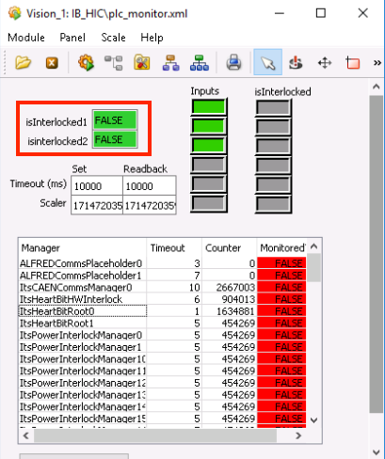

* **Global Monitor panel ("Vision_1: IB_HIC\global_mon_shifter.xml")** to monitor analog and digital voltage and current, PU and detector temperatures. On the left part of the panel (highlighted in the picture below) the full list of HLs is reported and allow to access to the dedicated panel. In each stave section, the parameters to be checked are:
  + AVDD and DVDD voltage and current values (highlighted in picture below): the status of these parameters is reported for easy check with a led in the column   
    *Pwr Status*; it must be **GREEN** with "ON" as status value. Led in column *Backbias* is normally "OFF" and red (at the moment, since we are not applying the reverse bias voltage to the chips).
  + *Monitoring* led (highlighted in picture): tells us if the monitoring process is active and must be **GREEN** with "ON" as status value.
  + Power Unit and Stave temperatures (highlighted in picture): Stave temperature (*External. Temp 1*) have to stay below 32 Celsius degrees while the Power Unit temperature (*Int. Temp*) have to stay below 25 Celsius degrees.

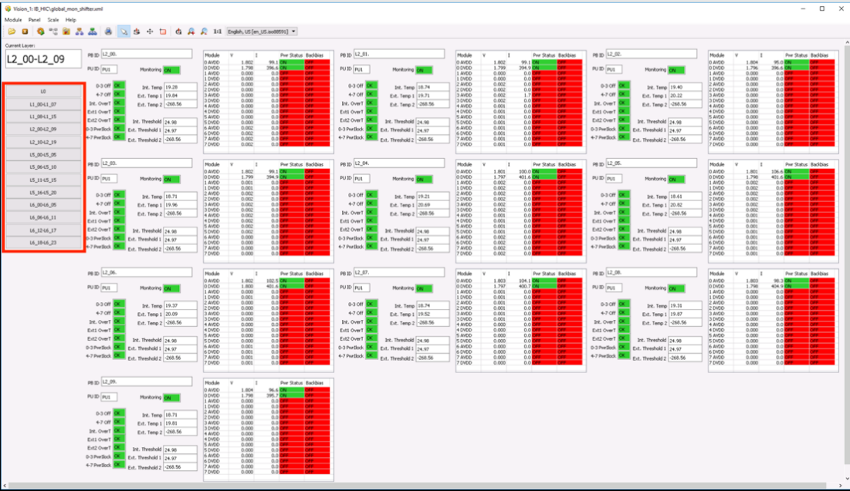

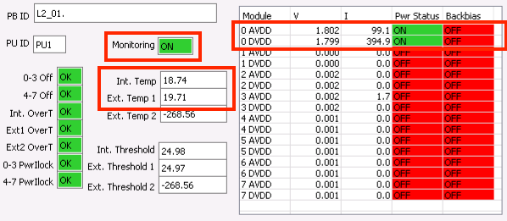

* **Trends panel ("Vision_1: IB_HIC\shifter_trends.xml")** that allow to open the relevant parameter trending panels. As you can see in the picture a dropdown menu allows to select the panel for each Stave; to open the panel, just select it in the dropdown menu and press the button *Open Trends* (just on the right side of the dropdown menu). An example of trending panel is reported below. As you can see three different panels are available:
  + Trending plot for Internal Power Unit and Stave temperature
  + Trending plot for Analog and Digital voltage
  + Trending plot for Analog and Digital current

The currents have to stay stable within 5 mA and the temperatures within 1 Celsius degree; you can clearly see this from the trending plots.

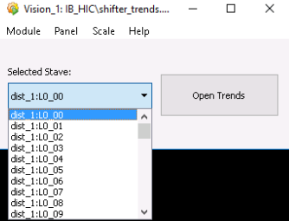 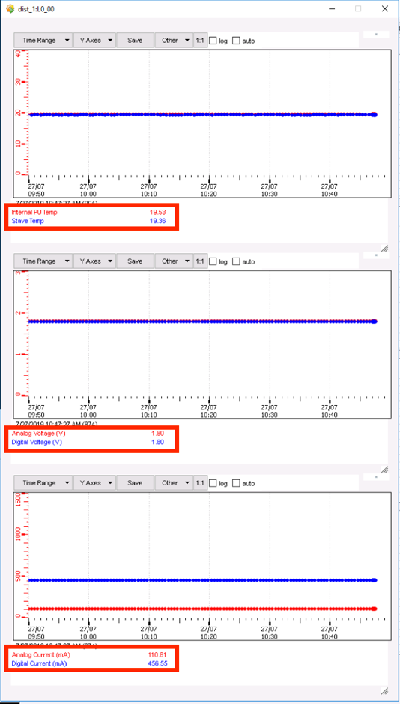

* **Safety Status Overview panel ("Vision_1: IB_HIC\safety_status_overview.xml")** that gives you a general status overview of the full detector safety status in a glance. This panel has to be used for fast checking, between the every-ten-minutes review of the trending plots in the Trends panel. First led column (PUI Monitored?) tells you that the monitoring process is up, while the second led column (PUI Safe?) tells you the actual safety status of the corresponding stave. Both the leds have to be **GREEN** with "TRUE" as status value. In case of problem the led will start blinking in **YELLOW** and **PURPLE** color.

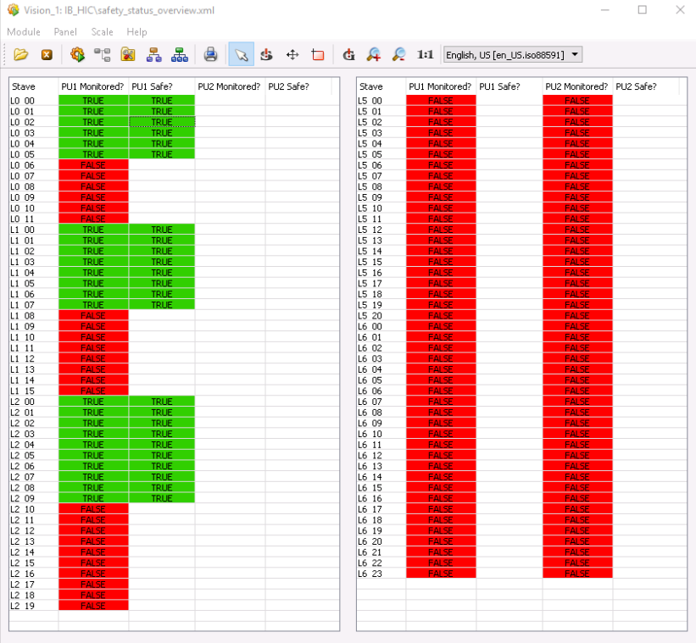

## What if… - Instructions to be followed in case of problems

* If one of the leds in the Safety Status Overview panel start to blinking, CALL THE SHIFT-LEADER.
* If the Status fields of *Pwr Status* (in the "global_mon_shifter" panel) of one of the staves stay **PURPLE** instead of **GREEN** for more than 1 minute, CALL THE SHIFT-LEADER. If the Shift Leader doesn’t reply within 5 min, please use the button indicated below, which will switch off all the HLs. This panel is also always open in the DCS window.

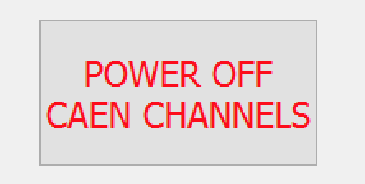

* If the current and temperature valued in the trending plots ("shifter_trends" panel) do exceed the limit of 5 mA and 1 Celsius degree, CALL THE SHIFT-LEADER.
* If the Interlocks are not **GREEN** and FALSE status value, CALL THE SHIFT-LEADER.

## Run control Panel

The “Run Control” panel (shown in the picture below) must be open in the DCS machine (where the other monitoring panels are available). You have a “START RUN” button, to be pressed to actually launch the run, a “Run type selection” scroll-down menu, to select between Threshold scan and Fake-hit rate scan, an “Option” field to specify the configuration for the run, a “Running?” led that tell you if the run actually started.

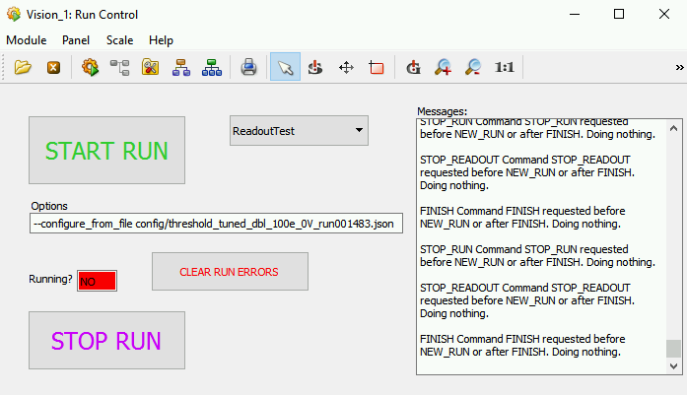

**Configuration text box**

**Running indicator**

**Run type selection box**

## Executing Threshold scan

Here the list of actions to be executed to launch a threshold scan:

1. Select ThresholdScan in "Run type selection” box
2. In the configuration text box write the options specified in the shift schedule and task paragraph
3. Press START RUN and wait until the run completion (Running led, just above the START RUN button, should became **GREEN** with “Yes” value)
4. If any ERROR, WARNING, CRITICAL or EXCEPTION appear in the “Messages” section, contact the Shift Leader and **DO NOT RUN ANY OTHER SCRIPT OR RUN!!!!**
5. Check the logbook entry and follow up if needed (see below); if there were errors during the run, the quality flag is BAD, otherwise GOOD

## Executing fake-hit rate scan

Here the list of actions to be executed to launch a fake-hit rate:

1. Select FakeHitRate in "Run type selection” box
2. In the configuration text box write the options specified in the shift schedule and task paragraph
3. Press START RUN and wait until the run completion (Running led, just above the START RUN button, should became **GREEN** with “Yes” value)
4. If any ERROR, WARNING, CRITICAL or EXCEPTION appear in the “Messages” section, contact the Shift Leader and **DO NOT RUN ANY OTHER SCRIPT OR RUN!!!!**
5. If the run has finished SUCCESSFULLY 🡪 Start the QC (see instructions below)
6. Check the logbook entry and follow up if needed (see below); if there were errors during the run, the quality flag is BAD, otherwise GOOD

## Executing fake-hit rate scan with pulsing

Here the list of actions to be executed to launch a fake-hit rate with pulsing:

1. Select FakeHitRatewPulsing in "Run type selection” box
2. In the configuration text box write the options specified in the shift schedule and task paragraph
3. Press START RUN and wait until the run completion (Running led, just above the START RUN button, should became **GREEN** with “Yes” value)
4. If any ERROR, WARNING, CRITICAL or EXCEPTION appear in the “Messages” section, contact the Shift Leader and **DO NOT RUN ANY OTHER SCRIPT OR RUN!!!!**
5. Check the logbook entry and follow up if needed (see below); if there were errors during the run, the quality flag is BAD, otherwise GOOD

## Logging the runs

After ***each run*** a logbook entry is created automatically; but you should check it has been correctly created. To be able to view automatically generated log entries, make sure you have ***disabled*** Log Entries “Class” filter:

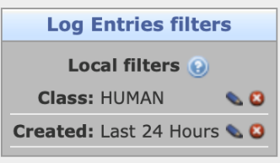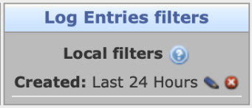

**“Class” filter disabled**

“Class” filter enabled

If the log entry is present, add a follow-up entry ( icon) with the additional information (if applicable):

* If a run has finished with errors because of some other issue (e.g. detector went off)
* If you have run QC, make a screenshot of the plots and attach it to the follow-up log entry, for precise instructions what to screenshot see below. Write if the QC detected any errors.

If the log entry is not present, add a log entry as following and inform Shift Leader.

**Type**: GENERAL  
**Subsystem**: Inner Barrel  
**Title**: [ThresholdScan/FakeHitRate/FakeHitRateWpulsing] run123456 [VCASN XY ITHR YX/configuration_file_name] [BAD if errors]  
**Log entry**:

[ThresholdScan, FakeHitRate or FakeHitRate with pulsing]  
[VCASN XY ITHR YX or configuration file name]  
Run number: run123456  
Quality flag: [GOOD/BAD] + comment if any (see executing runs section for details)  
# if there are errors, paste here the output for run123456, at least last 20 lines

**Files**:

* If you have run QC, make a screenshot of the plots and attach it to the log entry, for precise instructions what to screenshot see below

**N.B. Always use full run number in the form run000976, pay attention to the number of digits (6)**

## QC (Quality Control)

There are three ***QC related tasks that have to be executed for each Fake Hit Rate (not Threshold) run***:

1. Start the analysis of the new run
2. Check the processing status
3. After processing, check the errors and add a screenshot of the histograms to the logbook entry

All three steps are explained in detail below:

**1. Analyzing a new run:**

Assuming tmux has been configured as instructed in a following section, go to tmux tab 2 (CTRL+b followed by 2).

To start, go to the following working folder:

cd /home/its/QCNew/workdir

Then execute the following command with the run name as argument:

./shift_run_QC.sh run123456

Copy the line you executed to the logbook

**2. Check the status of the processing on the GUI:**

To check the current status of QC, go to the link: <http://cern.ch/go/qr8S>

THE QC ON THE LINK WILL UPDATE EVERY MINUTE SO YOU HAVE TO WAIT AT LEAST A MINUTE AFTER RUNNING THE ./shift_run_qc.sh COMMAND FOR HISTOGRAMS TO UPDATE!

If you see the QC Task light is green, that means QC is running and processing a file.***Always check that this is the case after you have started the QC script (shift_run_QC.sh).*** When the QC Task light turn yellow, it means that the QC has finish processing one file in a run but there are still files left.Once the analysis of the run has finished, the QC Task light turns red again, which means that QC is waiting for a new file. Also, you will see the printout "done" in the terminal. The processing will take some time (~ 1h).

**3. Adding QC information to the logbook:**

Once the analysis of the run has finished, the QC Task light turns red again, which means that QC is waiting for a new file. At this point, check the other plots on the same page.

***Refresh (reload) the page and take a screenshot of the plots and add it to the logbook entry.***

Once the run is finished (or stuck), perform ps –a | grep shift_run_QC in the terminal.  
Copy the output to the logbook. Add whether QC exited normally or got stuck. Make sure you have copied the instruction to start QC to the logbook (see point 1).

If there are any entries in the error plots write in the Commissioning shifts Mattermost channel.

**If there are any problems (e.g. web page not accessible) *call* the QC expert and WRITE A LOGBOOK ENTRY with type DQM/QA. If the QC hasn’t started processing the run before the shift_check_data.py has finished, omit the QC for that run, and write in the logbook entry “QC unavailable”.**

**4. Restarting the QC:**

Usually the QC panel should display the new file name immediately after the injection of a new run. The number of events will stay at 0 for a couple of minutes, until the first chunk of data has been analysed. If the file name (run number) is not updated or the number of events stays at 0 for more than 5 minutes, the QC is stuck. In this case, shifters can restart QC by doing:

./shift_QCRestart.sh

The script will indicate the shifters to reinject the run number and the shifter should proceed to inject the run they desire to analyze.

## End of shift report (EOS)

At the end of every shift, please write a summary according to the template below:

**Crew:**

**Detector Status:** on/off + who switched it off before you stop the shifts

**Run list:** *(see example lines below)*

ThresholdScan run000406 VCASN 52 ITHR 51 GOOD  
FakeHitRate run000407 VCASN 52 ITHR 51 GOOD  
QC good

ThresholdScan run000408 HL0_threshold_tuned_100e GOOD  
FakeHitRate run000409 HL0_threshold_tuned_100e GOOD  
QC good

Every run should contain its run number, settings and the result or potential errors as well as the status of the QC.

## General remarks on writing logbook entries

* For any issue not covered in this Shift Instructions write a detailed logbook entry with a clear description of the problem and solution (AFTER contacting the expert)
* If you have contacted an expert because of any issue, in the corresponding logbook entry specify that you contacted an expert and which expert it was
* Take note of the time of the different actions e.g. if there is a cooling interlock write cooling interlock at 12:53, contacted expert at 12:54, expert solved the problem and released the control of detector at 13:12
* Try to attach useful information to do log entries, e.g. in case of a cooling interlock attach screenshot of the cooling panel.

# TROUBLESHOOTING

## Taking screenshots

Instruction how to make a correct screenshot:

1. Open "Screenshot" application: Applications -> Utilities -> Screenshot
2. Select "Select area to grab" option
3. Press "Take a screenshot" button
4. Choose area for screenshot (Temperature trends)
5. Set correct name (THRESHOLD_run123456 / FAKEHITRATE_run123456 / QC_hitmaps_run123456) and folder name where the file is located on the local PC.

## Preparing the tmux windows

1. If not already, ssh to flpits7 with command:  
   ssh its@flpits7
2. try:  
   tmux a -t shifters
3. if this doesn't work check whether the *shifters* session is not there:   
   tmux ls
4. and then create a new one:   
   tmux new -s shifters
5. go to the scripts folder:   
   cd ~/shifts/ib-commissioning-tools/
6. Create a new tab with CTRL + b followed by c.
7. Create another tab with CTRL + b followed by c.

To switch between the tabs, use CTRL+b followed by 0 for tab 0 or 1 for tab 1, 2 for 2...  
Tab 1 is to be used for the temperature text file and the tab 0 for the execution of scripts. Tab 2 is to be used for QC and data checking. To scroll in tmux window type use CTRL+b followed by [. To exit scrolling mode type q.

## Re-open all the windows in the DCS machine

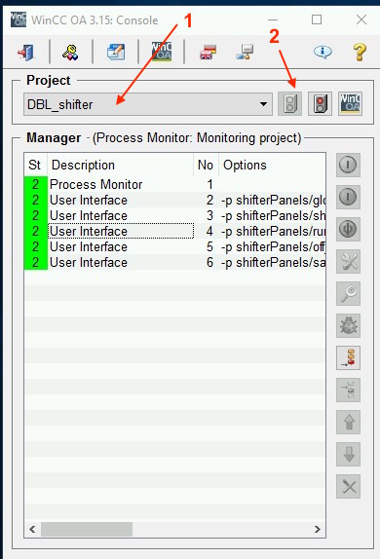 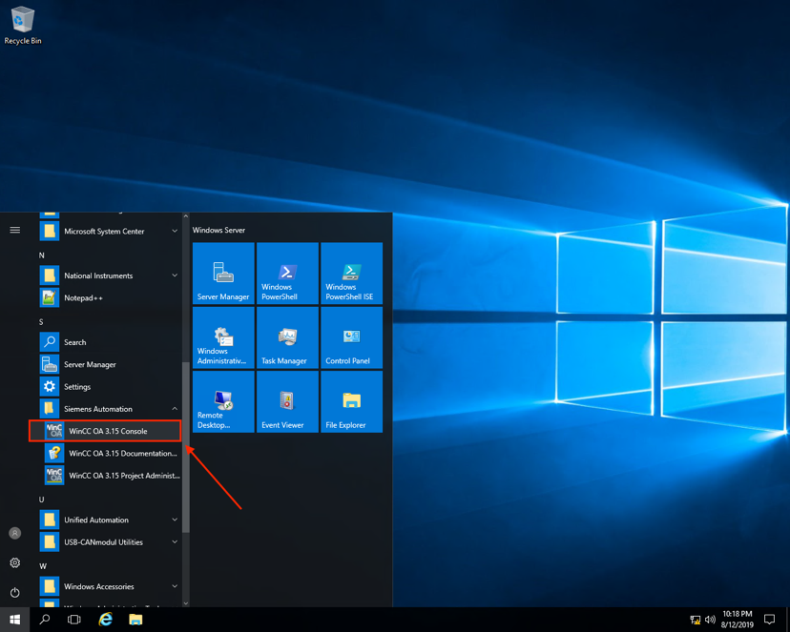

If, for whatever reason, the panels in the DCS PC are close, you can open them through the following instructions:

* Locate WinCC OA Console window on the remote windows PC
* Select in the Project field the entry “DBL_shifter” (1)
* Click the “Start manager” button (2)

The Project have different name depending on the part on the detector to be controlled:

* HIB-T --> its_wn_1_shifter
* DBL --> DBL_shifter

**BACKUP**