**E1039 Proptube Preamp Card Test Procedure**

Pat McGaughey and Ming Liu

12/19/2019

**Proptube preamp card test stand setup, normal operating parameters:**

1. Pulse generator AFG3102
   1. 10kHz square wave
   2. V_pp, >= 200mV
2. Digital scope with differential probe TDS5034B
   1. Chan-1, monitoring input test pulse (1 MOhm)
   2. Chan-2, Regular probe, 1MOhm;
   3. Chan-3, Differential probe to check output signal
3. Proptube front panel, with stands
4. Power supply, +/-5V, 1A each;
   1. +5V, I = 0.40 A
   2. -5V, I = 0.55 A
5. Preamp card to be tested
   1. 56 Ohm version
   2. 300 Ohm version

Normal output: V_pp = 1.0V (ECL output)

=========================

Test logbook:

https://docs.google.com/spreadsheets/d/1jzI36KzsCZkU85pxJ0IMISJ86WhYzkeignXAFpBP5RA/edit?usp=sharing

=========================

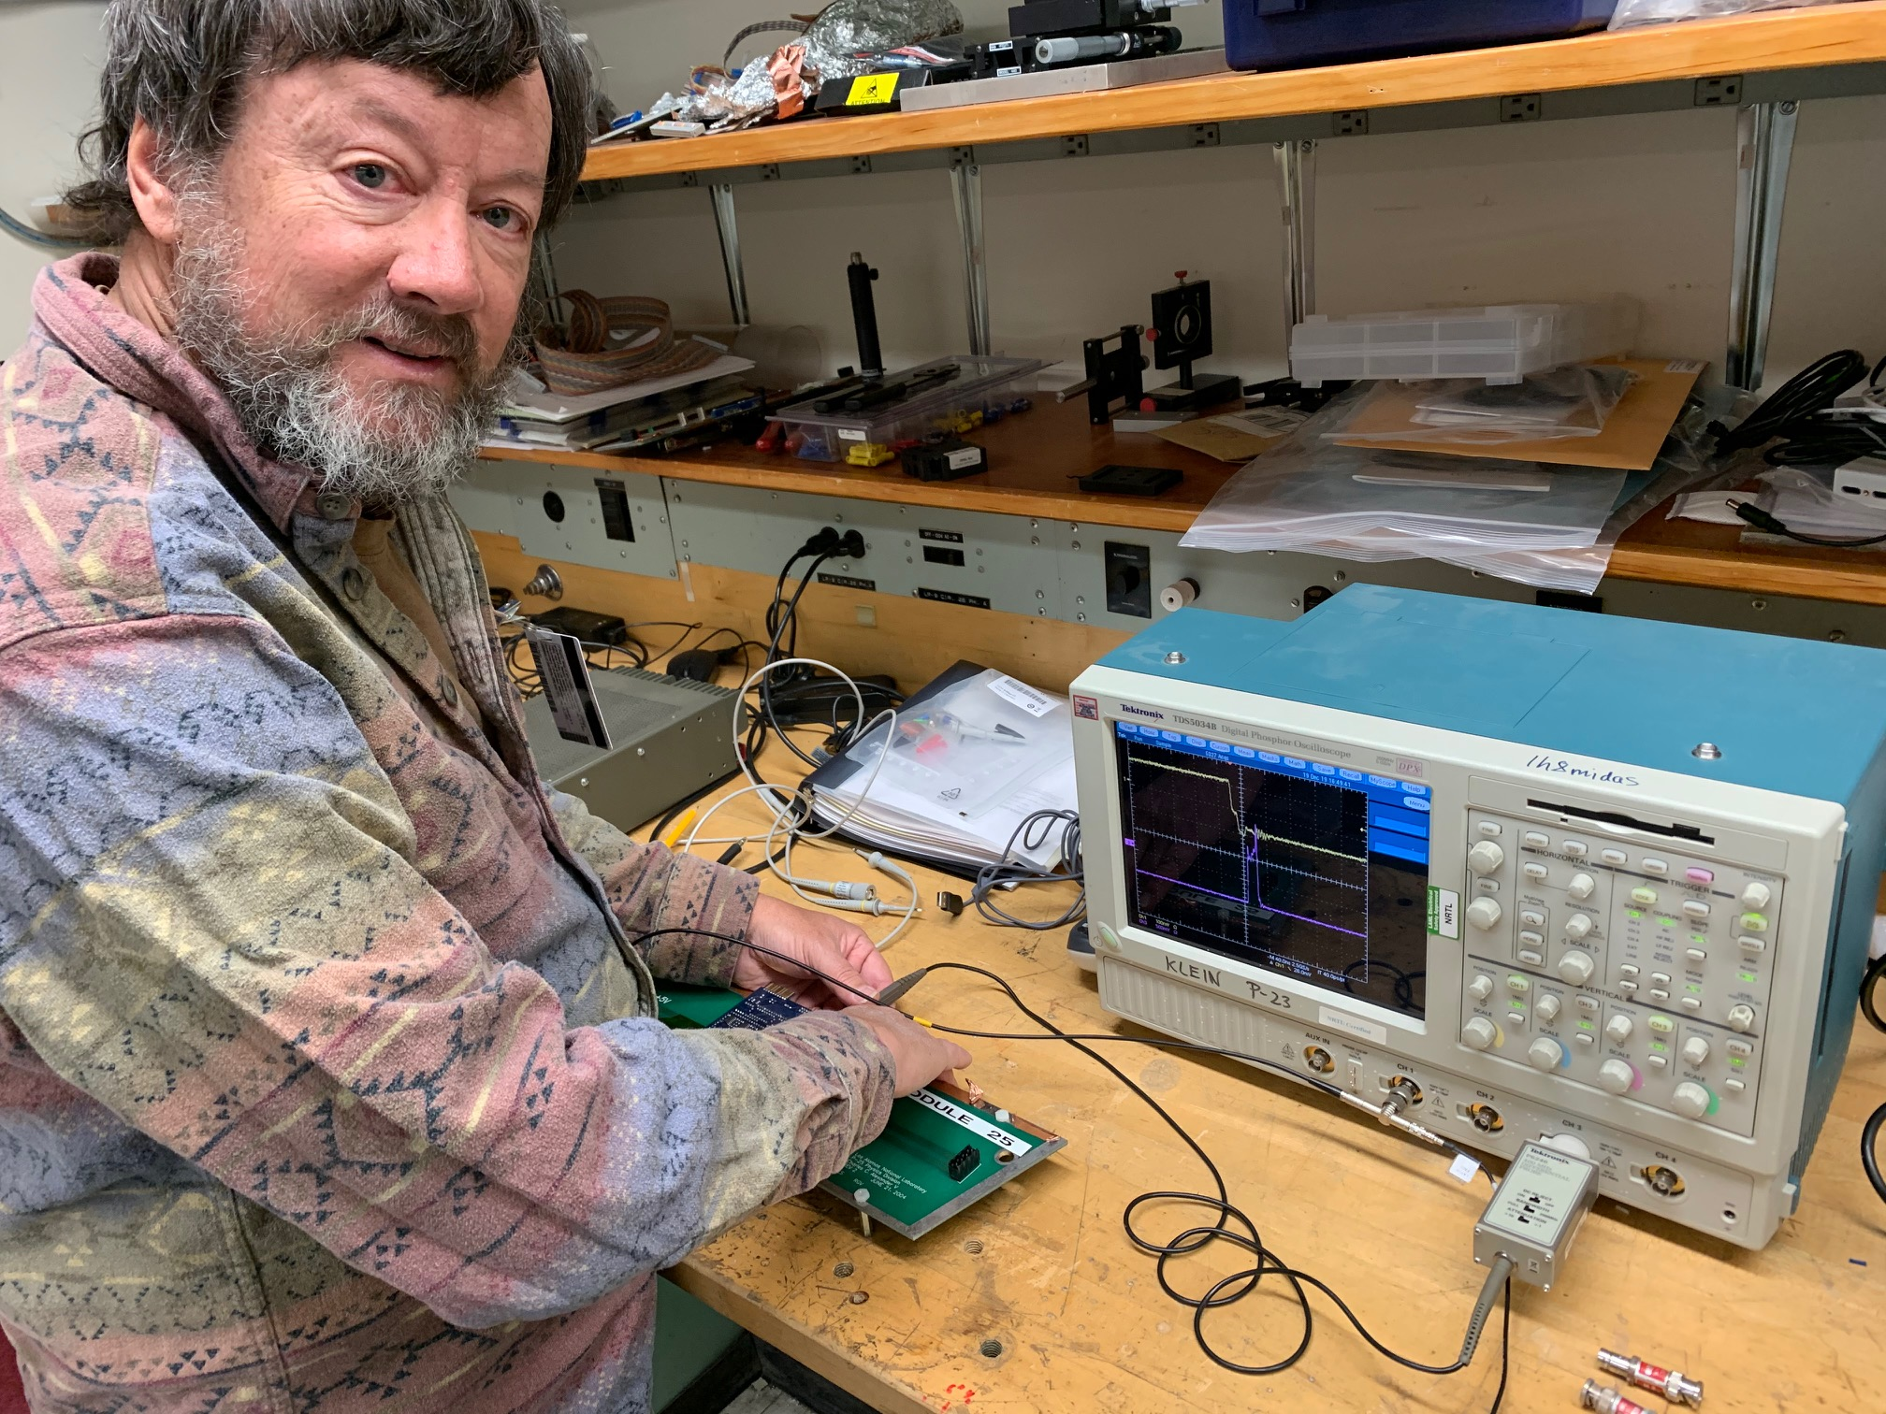

Prop-Tube_PreApm-Card_Channel-Map-IMG_0078.jpg

Test bench @C129

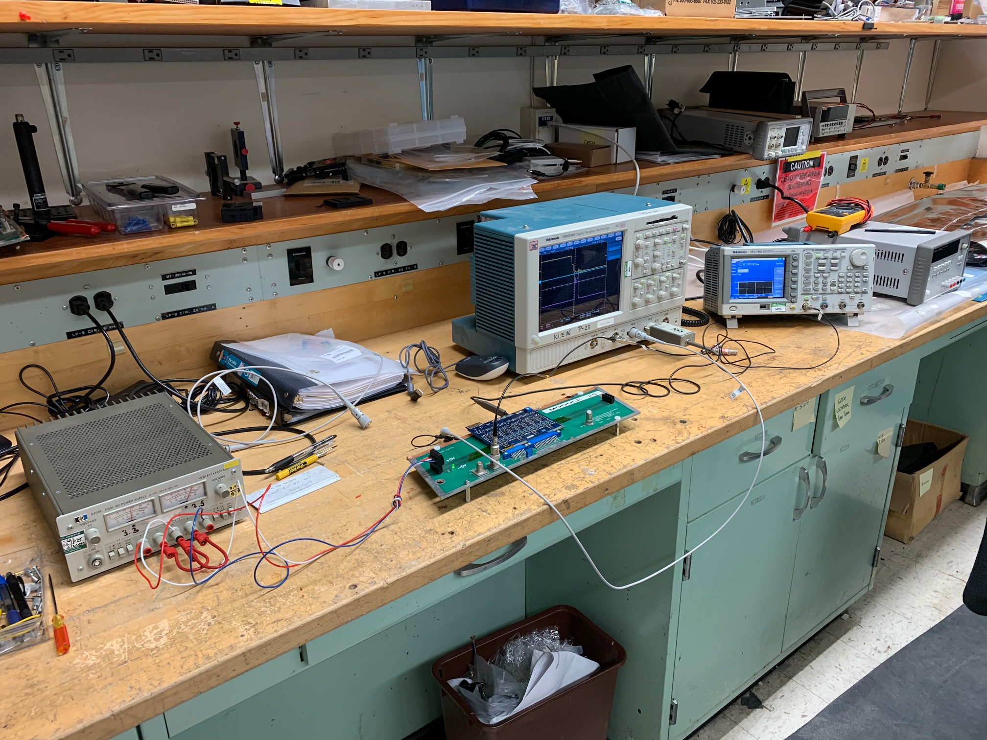

Power Supply: +5V (0.4A) and -5V (0.55A)

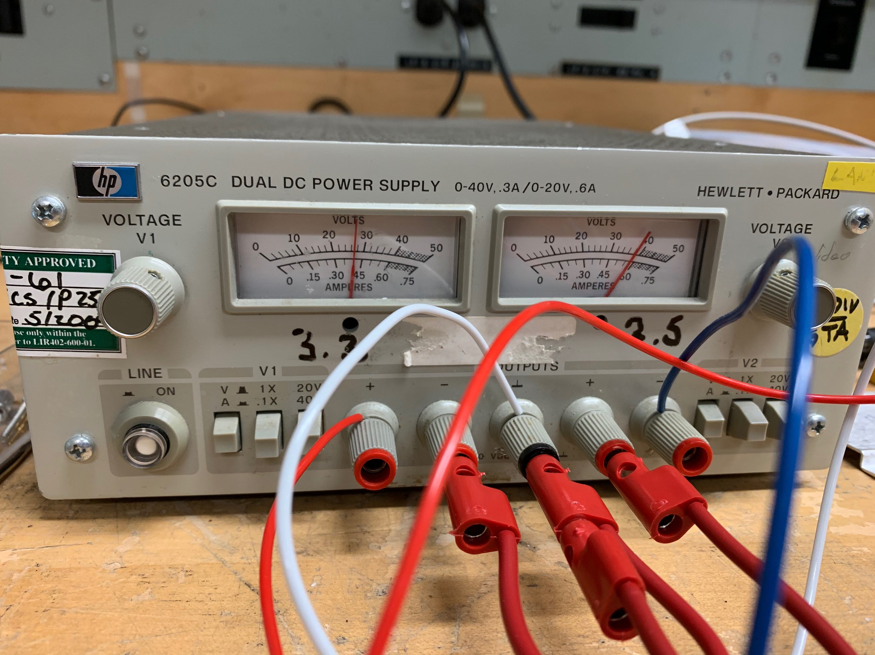

Pulser: 10kHz square wave, V_pp > 200mV

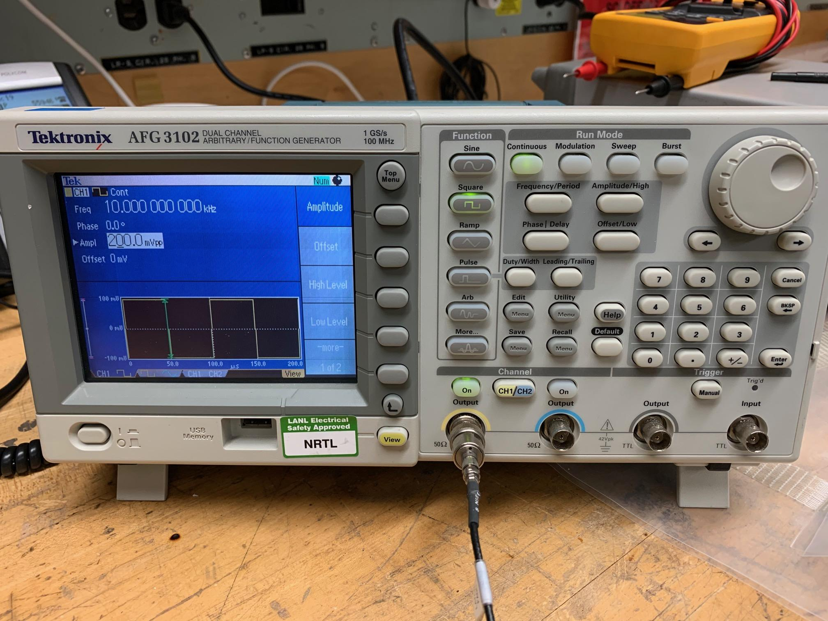

Signals: with external pulser, output = Differential ECL signal V_pp = 1V

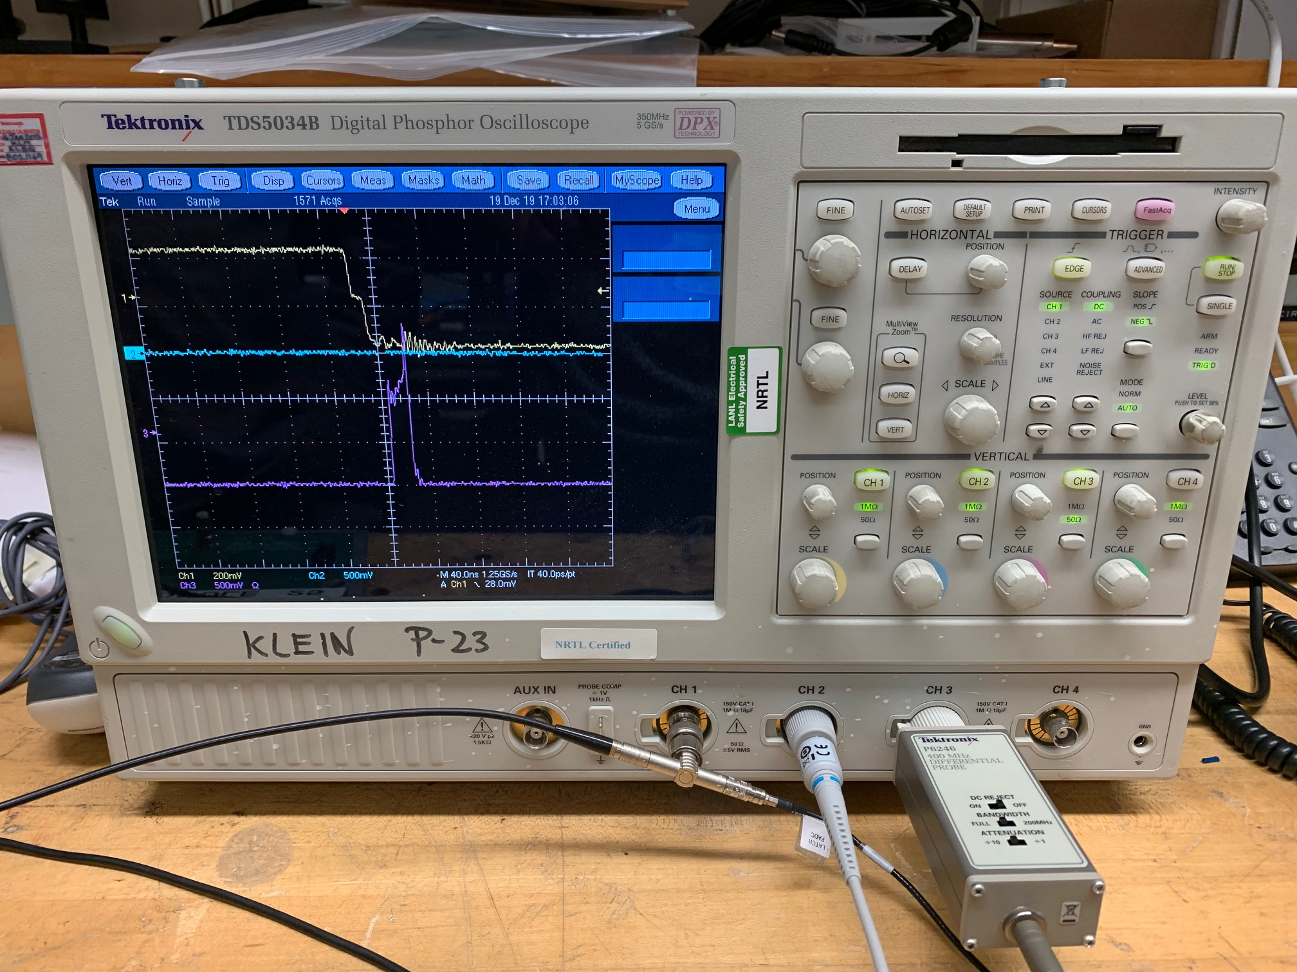

**Preamp card output channel map:**

From Right to Left: 1, 2,3, …, 16, 17, see photo below.

