**Engineering Note for**

**E-906 Tube Assembly**

Project: E906, P-25 (LANL)

Title: E-906

Author: Matt Fagan, AET-1, Los Alamos National Laboratory

Date: 7/2010

Reviewers: Walt Sondheim, P-25, Los Alamos National Laboratory

John Ramsey, P-25, Los Alamos National Laboratory

**ABSTRACT:**

The following calculation note pertains to the E-906 Prop Tube Assembly, as developed by Ming Liu and Walt Sondheim. These calculations describe the ability of the Tube Assembly to handle service and handling loads.

**DESIGN:**

Two rows of tubes are nested one on top of the other, but staggered. A bead of glue is placed longitudinally at the tube to tube interface. This glue will provide additional structural support, but it will not be taken credit for in the structural analysis for simplicity. Additionally, uncertainties regarding the strength of the glue and its ability to adhere to the aluminum tube make it difficult to include in the analysis.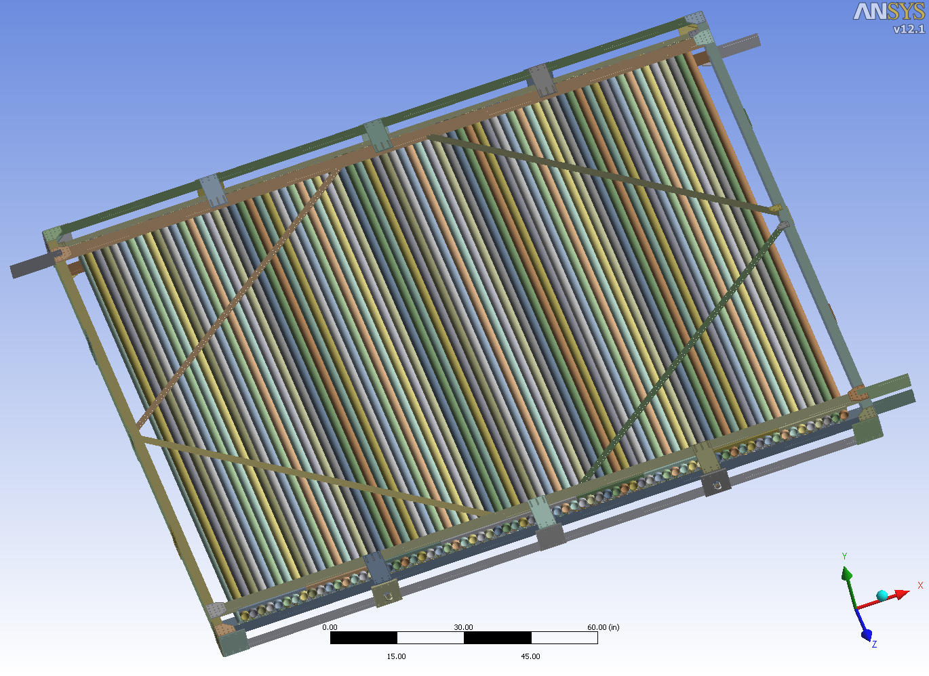

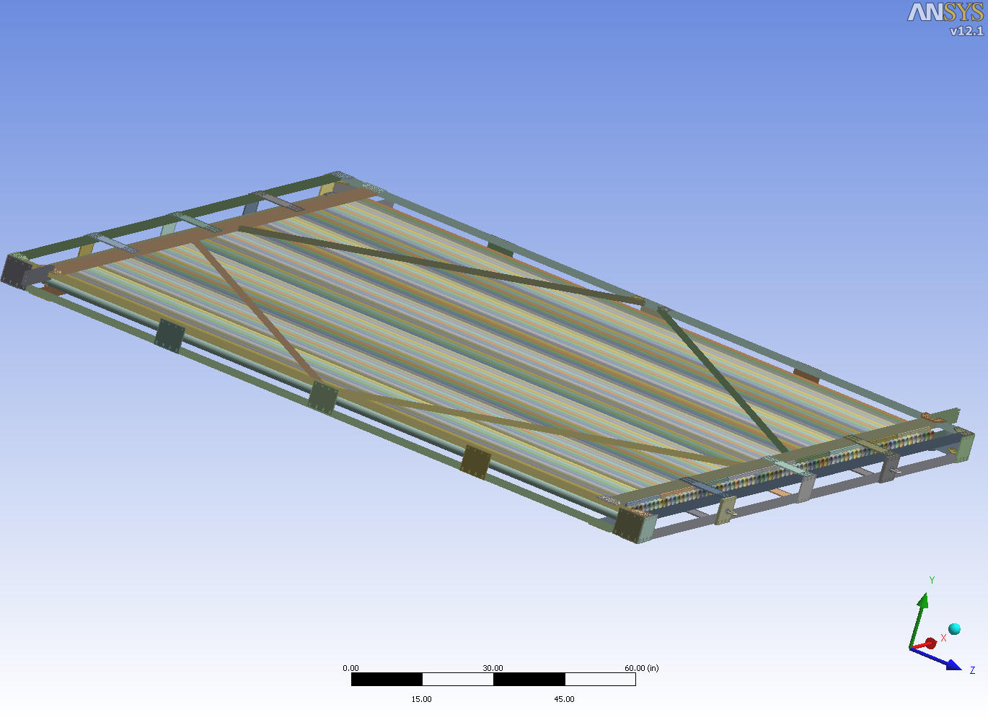

**ANALYSIS:**

Refer to the Appendix in “Mechanical Engineering Design”, 4th Edition, Shigley and Mitchell, for maximum moment, stress, and deflection formulas. Refer to Appendix C, “Mechanics of Materials”, Second Edition, Gere and Timoshenko for formula and explanation of the parallel axis theorem.

**Calculation # 1**

Analyze the one tube alone to determine if it can support its own weight, simply supported at the ends.

Calculate weight of tube,

douter = 2.00 in.

dinner= 1.93 in.

ttube wall = 0.035 in.

Weightsingle tube = (cross sectional area)(length)(density)

Areatube cross section= π [(1.0 in.)2 – (0.965 in.)2] = 0.2161 in.2

Densityaluminum = 0.1 lb/in.3

Length = 144 in.

Weightsingle tube = 3.11 lb

Weightsingle tube/length= 0.0216 lb/in

Isingle tube = π [(douter )4 – (dinner)4] / 64 = 0.1043 in.4

Maximum moment for a simply supported beam with a distributed load is

Mmax = (*w* l2)/8 = 56 in-lb

*w* = 3.11 lb/144 in. = 0.0216 lb/in.

l = length = 144 in.

σmax = M c/I = (56 in-lb)(1.00 in.)/0.1043 in.4 = 537 psi

c = tube radius = 1.00 in.

δmax = (5*w*l4)/(384EI) = 0.12 in.

Ealuminum = 10,000,000 psi

Tubes are aluminum 6061-T6 with a yield stress of 35,000 psi, per ASTM B308. Thus, stress is acceptable. Deflection is small. Stress is also low enough so that local tube wall buckling should not be a concern. Glued joints not taken credit for, and ends are clamped by the scalloped pieces. Thus, tubes individually are acceptable.

**Calculation # 2**

Calculate weight of tube array. Each tube weighs 3.11 lb, and there are 144 tubes. Thus total tube weight is 450 lb. Add 10% for glue. For analysis purposes, use:

Weighttube array = (450 lb)1.1 = 495 lb

Weight of the structural members must be considered. Use a total weight (tubes and structural frame) of 700 lb.

**Calculation # 3 – Lifting Features**

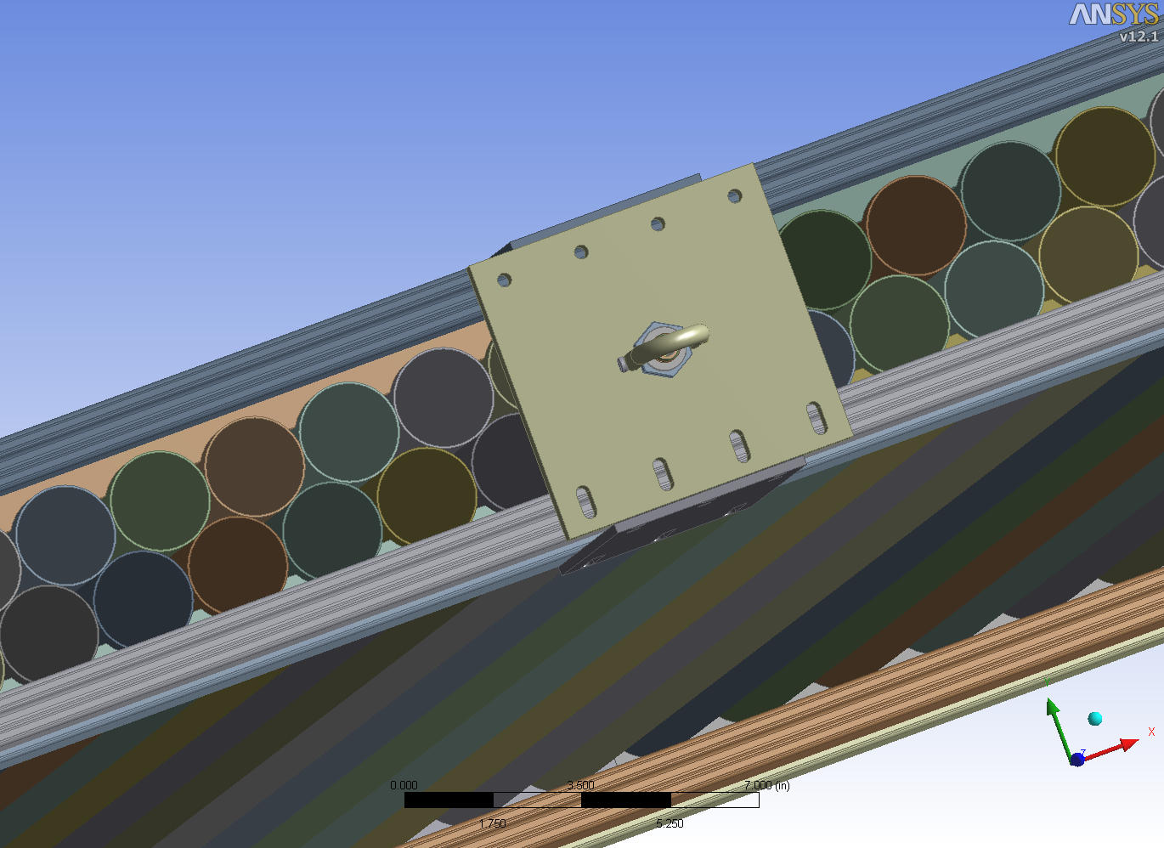

Frame in vertical position (tube axes perpendicular to floor)

A lifting plate and swivel hoist ring will be used at each corner. The plate will be 5/8 inch thick and made from 6061-T6. A Carr-Lane swivel hoist ring (CL-1000-SHR-1) with a 1000 lb capacity will be mounted to the plate. The swivel hoist ring bolt is 0.54 inches long, and the plate is 0.625 inches thick, so sufficient engagement exists. Calculate thread shear stress in the mounting plate (frame in upright position).

Ashear, 5/8” threads in the hoist ring mounting plate = π(5/8 in.)(0.625 in.)(1/2) = 0.61 in.2

τ = V/A5/8” threads in the hoist ring mounting plate = (1000 lb)/0.61 in.2 = 1,640 psi

The shear yield strength of 6061-T6 is 60% of the tensile yield, where the tensile yield strength is 35 ksi. Thus, the shear yield strength is 21 ksi. Shear stress calculated above is acceptable.

Check tensile strength of eight fasteners which secure the plate to the frame. Use actual load of 350 lb (700 lb frame weight divided amongst two hoist rings).

Atensile, 1/4” screw = 0.0318 in.2

σ0.25”hoist ring plate screws = F/A = 350 lb/(8(0.0318 in.2 ))= 1,376 psi

This stress is acceptable at it is less than the tensile allowable calculated in Calculation #9 below.

Frame in horizontal position (tube axes parallel to floor)

The plate is secured to the frame with eight 0.25 inch diameter screws. Check shear strength of screws.

Ashear, 1/4” screw = 0.0269 in.2

τ = V/Ashear, eight 1/4” screw = (350 lb)/(8(0.0269 in.2 ))= 1,626 psi

The shear stress is acceptable since it is less than the allowable calculated in Calculation #9.

**Calculation # 4 – Stresses in Frame Due To Lifting**

The frame may be lifted from the horizontal position (frame parallel to floor) into the vertical position.

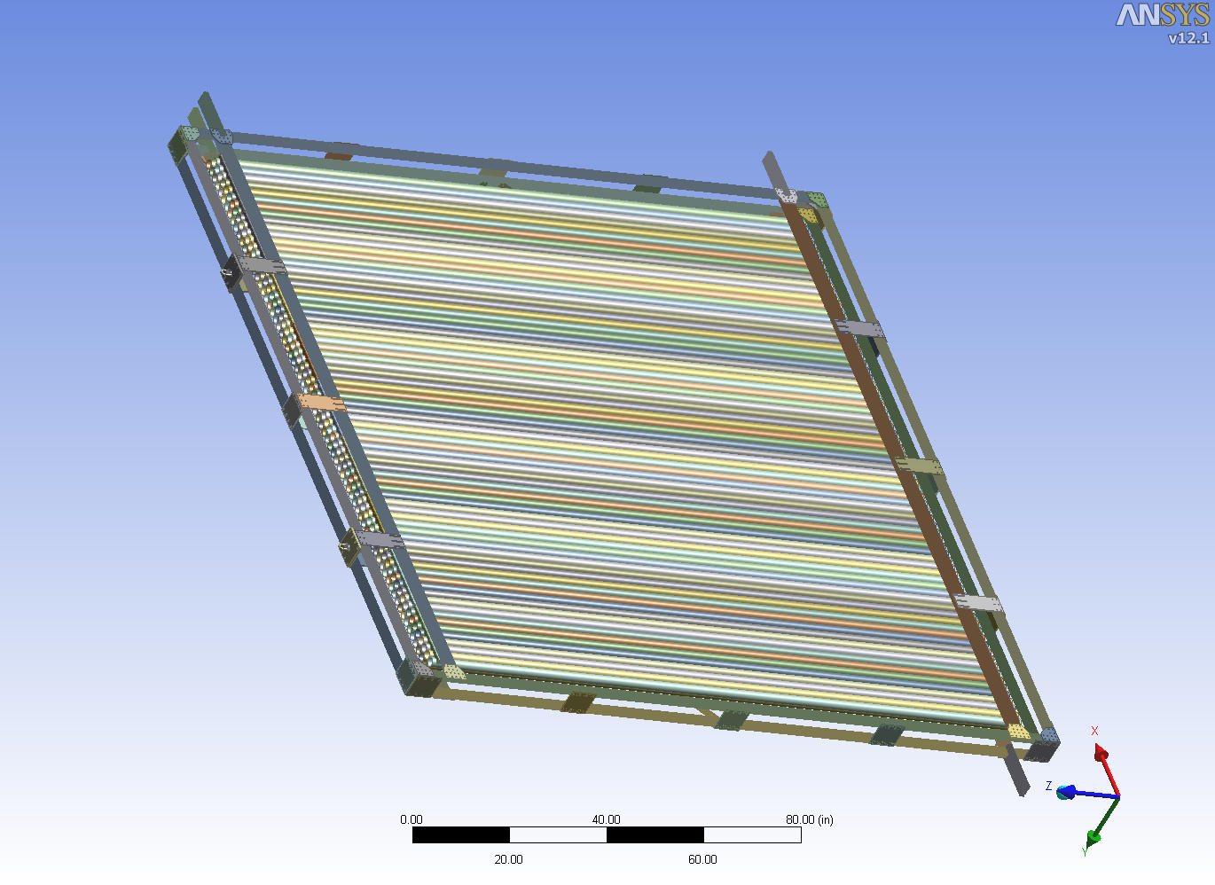

Frame in horizontal position (tube axes parallel to floor)

The frame would be supported along two opposite edges of the frame. Total frame weight is estimated at 700 lb. This will be a distributed load between the two supported ends. Maximum bending moment will occur between the supported ends.

Mmidspan = wL2/8 or FL/8

Where:

L=length of span

w = distributed load = 700 lb/152 in. = 4.6 lb/in.

F = total load = wL

Mmidspan = (700 lb)( 152 inches )/8 = 13,300 in-lb

Need to take credit for both top and bottom layers of 1020 structural members. This will mean that shear must be transmitted effectively between top and bottom layers. Check bending stress for situation where top and bottom 1020 layers participate. Use parallel axis theorem to calculate net moment of inertia (Ix = Ixc +Ad12). Refer to included vendor data attached.

I total = 2(0.0833 in.4 ) + 2( 0.7914 in.2)(2 in.)2 = 6.5 in.4

σmax = M c/I = (13,300 in-lb)(2.5in.)/6.5 in.4 = 5,116 psi

Bending stress is acceptable for the 6105-T6 1020 members. Per attached manufacturer’s catalog page 153, the minimum yield strength of 6105-T6 is 35,000 psi.

Maximum deflection is calculated as follows.

Ymax =5wL4/(384 EI)= 0.5 in.

E = 10,000,000 psi for aluminum

No credit is taken for the tubes. Actual deflection will be less than this.

Maximum shear load occurs at each supported end, and is equal to 700 lb/2. Shear will be carried on either side of the frame, so each side must carry 175 lb. Strap plates are 5.75 in. x 6.00 in. and are 0.188 thick. Shear stress is calculated as follows.

Ashear = 6.00 in. x 0.188 in. = 1.13 in.2

τ = V/A = 175 lb/1.13 in.2 = 155 psi

Calculate stress in the screws which attach the strap plate to the 1020. Four 0.25 inch diameter screws must react both the actual shear force (175 lb/4 screws = 44 lb) as well as the couple developed by 175 lb over a lever arm of 5 inches.

(175 lb)(5 in.) = 4(2.8 in.)Vcouple (do not take credit for inner two screws as lever arm is short)

Vcouple = 78 lb

Vlateral load =175 lb/4 screws = 44 lb

Vtotal = 78 lb + 44 lb = 122 lb

τ = Vtotal/A0.25 in. diam. screw = 122 lb/0.0269 in.2 = 4,535 psi

Shear stress is acceptable since it is less than the allowable calculated in Calculation #9. The directions of the two shear forces are 45 degrees apart, which will lower the stress. Additionally, the other three plates inboard of the ends will help carry the shear as well. Shear stress calculated above is conservative.

Frame in vertical position (tube axes perpendicular to floor)

Stresses in the frame are minimal in the vertical position. Loads are well distributed throughout frame, no significant bending moments occur, and stresses are primarily membrane through the frame members. Loads are well distributed from the lifting lug locations.

**Calculation # 5**

Calculate bending stress and shear stress for the situation where the frame is supported by a support that runs across the middle of the frame. In other words, frame is set down on a 4” X 4” wood member lying on the floor. The wood member runs across the frame mid-span perpendicular to the tube axis direction.

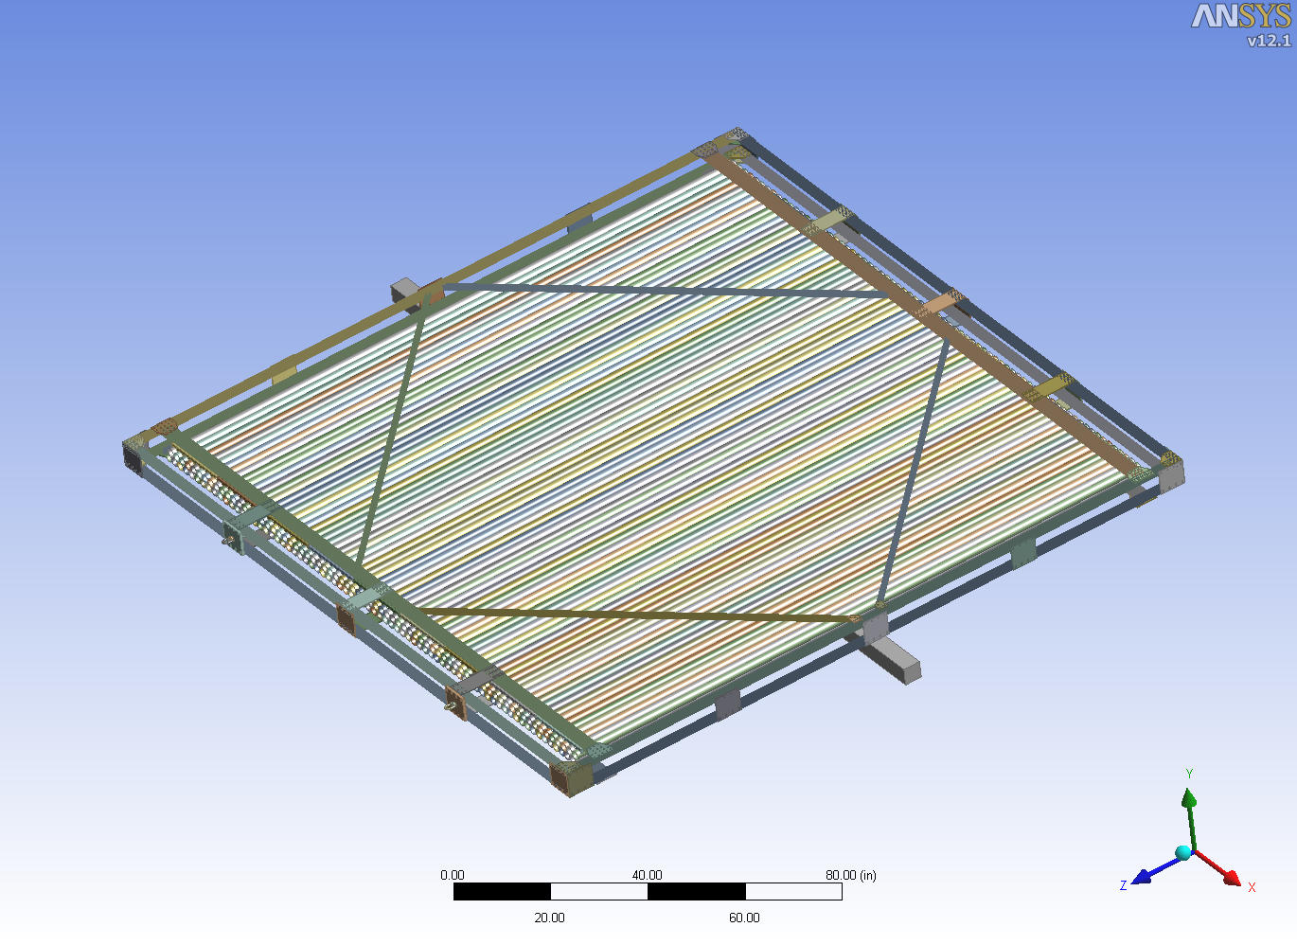

Attached 1020 information shows the moment of inertia about the weak axis of a 1020 member to be 0.0833 in.4 The tubes are supported at the ends via the scalloped brackets. The bottom 1020 pieces (one on each side) will initially be considered to carry the load. Use the case of a cantilevered beam whose length is 76 inches. Point load is 700 lb/4 or 175 lb.

Moment max = (175 lb)(76in) = 13,300 in-lb

σmax = M c/I = (13,300 in-lb)(0.5in.)/0.0833 in.4 = 79,832 psi

Stress is too high, as yield stress is 35 ksi for 6105-T5 aluminum.

Need to take credit for both top and bottom layers. This will mean that shear must be transmitted effectively between top and bottom layers. Check bending stress for situation where top and bottom 1020 layers participate. Use parallel axis theorem to calculate net moment of inertia (Ix = Ixc +Ad12).

I total = 2(0.0833 in.4 ) + 2( 0.7914 in.2)(2 in.)2 = 6.5 in.4

σmax = M c/I = (13,300 in-lb)(2.5in.)/6.5 in.4 = 5,115 psi

Bending stress is acceptable. Reaction load at ends is 175 lb, so shear force of 175 lb must be carried within the frame at the ends. Strap plates are 5.75 in. x 6.00 in. and are 0.188 thick. Shear area is

Ashear = 6.00 in. x 0.188 in. = 1.13 in.2

τ = V/A = 175 lb/1.13 in.2 = 155 psi

Calculate stress in the screws which attach the strap plate to the 1020. Four 0.25 inch diameter screws must react both the actual shear force as well as the couple developed by 175 lb over a lever arm of 5 inches.

(175lb)(5 in.) = 4(2.8 in.)Vcouple (do not take credit for inner two screws as lever arm is short)

Vcouple = 78 lb

Vlateral load =175 lb/4 screws = 44 lb

Vtotal = 78 lb + 44 lb = 122 lb

τ = Vtotal/A0.25 in. diam. screw = 122 lb/0.0269 in.2 = 4,535 psi

Stress is acceptable at is less than the allowable calculated in Calculation #9 below. The directions of the two shear forces are 45 degrees apart, which will lower the stress. Additionally, the other three plates inboard of the ends will help carry the shear as well. Shear stress calculated above is conservative.

**Calculation # 6**

This calculation is similar to Calculation #5 above, but the wood beam placed on the floor runs coincident with the tubes. It supports the frame in the middle, but 90 degrees to the wood floor support in Calculation #5. The frame is square and there are more support members running across the ends so stresses will be lower.

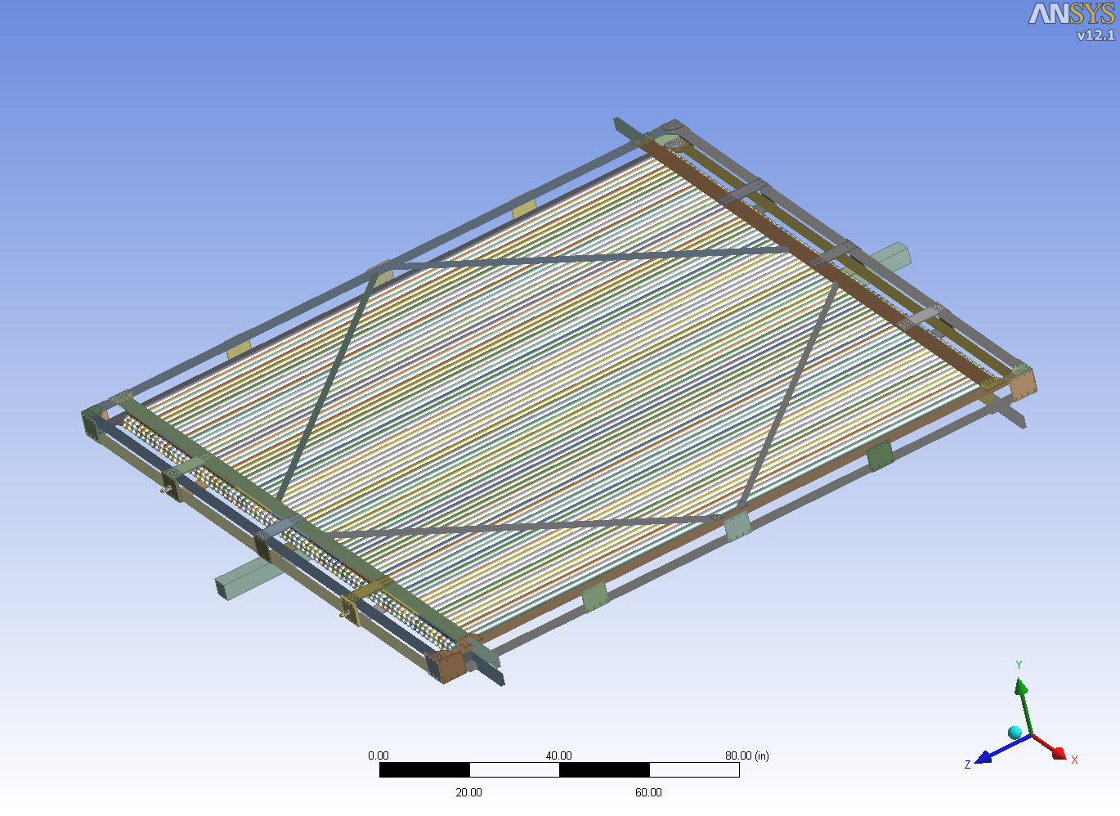

Momentmaximum = 13,300 in-lb (from above, as frame is square)

Frame has a lower layer and an upper layer. Strap plates will connect the upper and lower layers, so that the upper and lower layers can be taken credit for in bending, as in Calculation #5. There is a 1020 and 1030 piece on the bottom, and a 1020 and 1030 piece on top. The effective I for these bottom and top layers is more than for Calculation #5. The maximum moment and c are the same. Thus bending stress will be lower. Shear will be transmitted as in Calculation #5, so shear stress is acceptable. Scalloped pieces were not taken credit for. Also this case involves more of a distributed load along beam, versus a point load at the end for Calculation #5.

**Calculation # 7**

Check bending stress for bending about an axis that runs corner to corner. Frame laid down on floor onto wood beam from Calculation #5 and #6, wherein beam runs from frame corner to frame corner. Use parallel axis theorem again, and use the plate thickness at the corners.

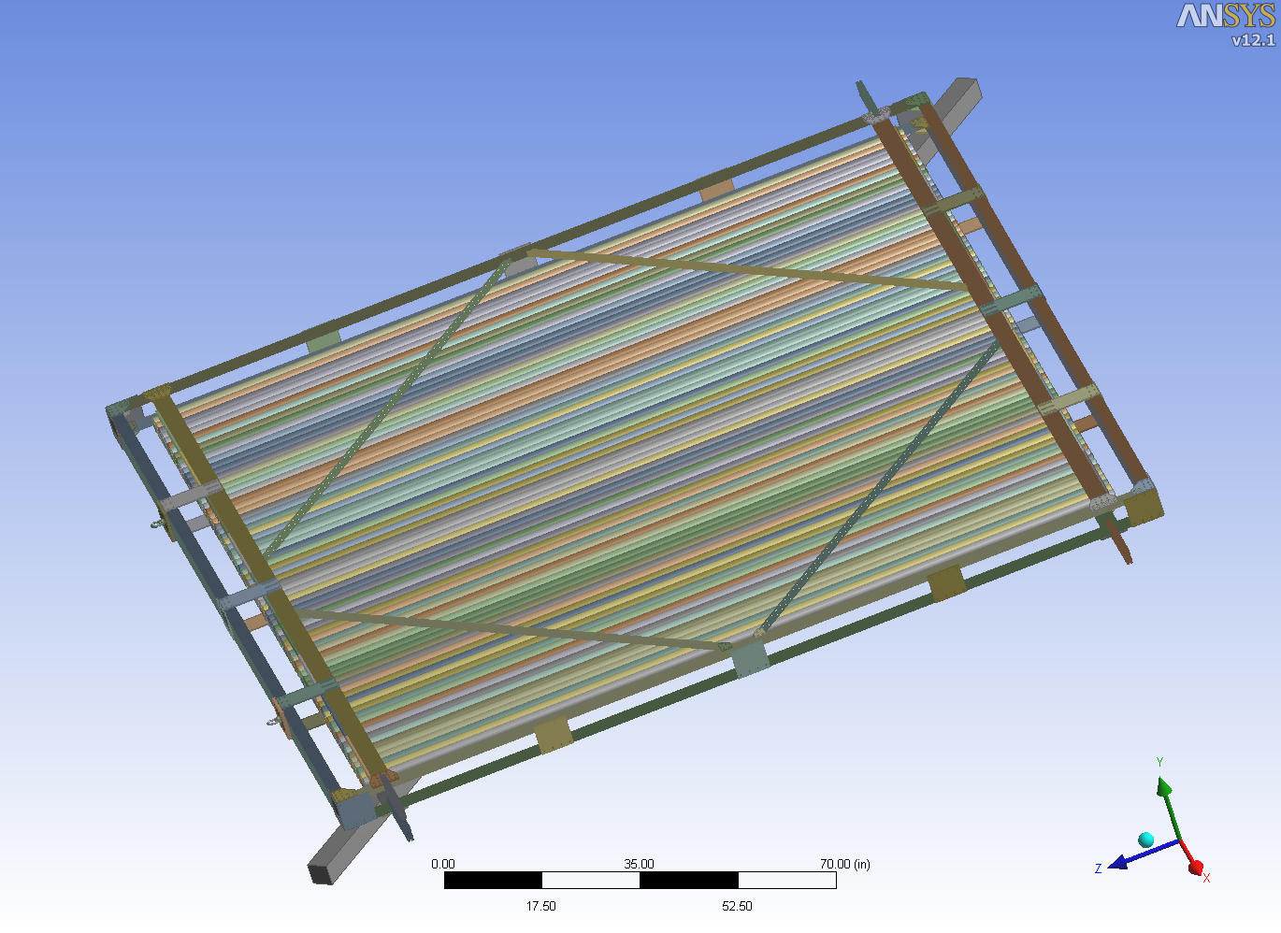

Calculate maximum moment. The area on either side of the wood beam is triangular, with the center of mass 1/3 of the way out from the diagonal bending axis, or 108.2 in./3 or 36 inches.

Momentmaximum = (350 lb)(36 in.) = 12,600 in.-lb

Use parallel axis theorem to calculate net moment of inertia (Ix = Ixc +Ad12) for the brackets at the frame corners.

I total for brackets at corners = ~0 in.4 + 8(0.188 in.)( 4.0 in.)(2.5 in.)2 = 37.6 in.4

σmax = M c/I = (12,600 in-lb)(2.5in.)/37.6 in.4 = 838 psi

Check shear stress in screws that attach the eight plates.

Momentmaximum = (5in.)(4 plates)Fplate  (summing moments about lower frame surface at brackets)

Fplate =630 lb.

Each plate has at least 12 screws. Each side of the plate has six screws. Force per screw is then 630 lb/6 or 105 lb. Screws are ¼”-20, with a shear area of 0.0269 in.2 The shear stress in the screw is calculated as follows.

τ = Vtotal/A0.25 in. diam. screw = 105 lb/0.0269 in.2 = 3,904 psi

Shear stress is acceptable as it is less than the allowable calculated in Calculation #9 below.

**Calculation # 8**

The following calculation will consider frame skewing (i.e. frame tendency to go from a square to a parallelogram shape). This deformation mode is what the four diagonal members are used to prevent. This scenario would cover an event where the frame is lowered onto one corner while providing lateral restraint. The following will calculate the stress in the diagonal, the attachment plate and the screws.

As the frame tries to skew, two of the four top diagonals will be placed in tension, and two in compression. The same holds true for the bottom layer. Only the diagonals placed in tension will be taken credit for since the compressed two could bow. Refer to Sketch 1 below.

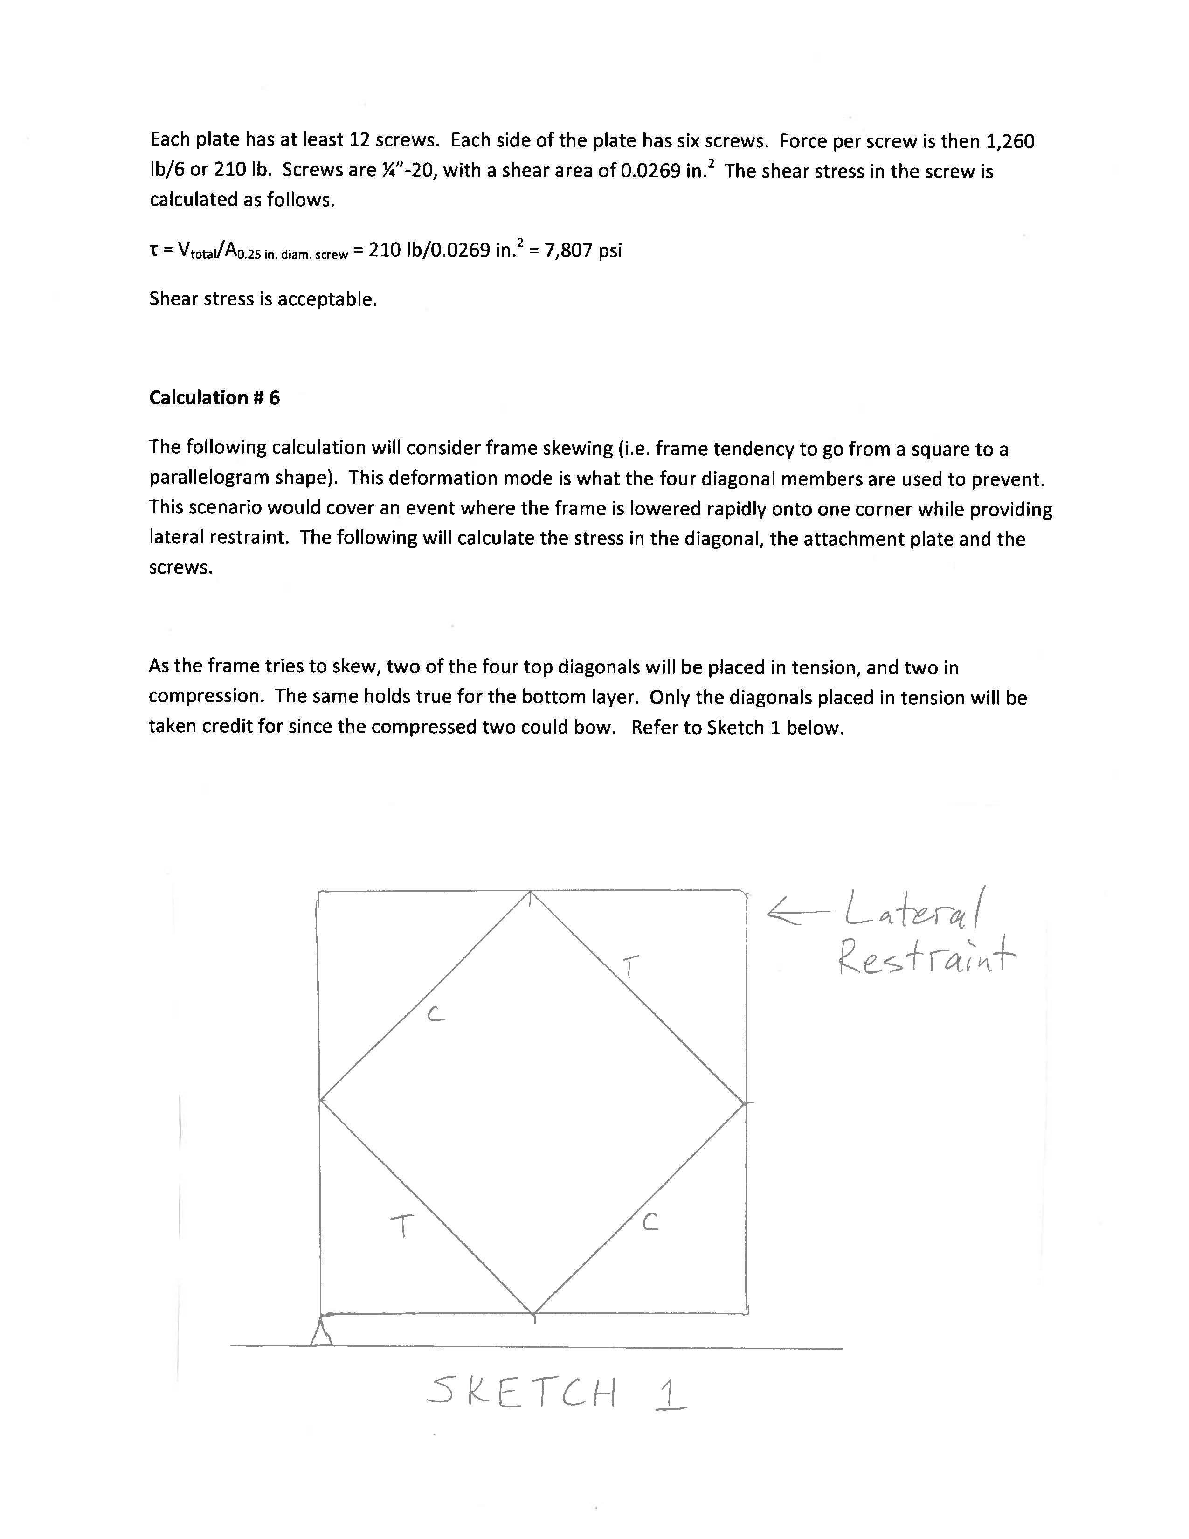

The total frame weight is 700 lb. Frame corner connections will be assume to be pinned, with all of the support provided by the diagonals. Half of the load carried by the bottom layer of four diagonals , and half carried by the top layer. Each top layer tensile diagonal then carries 175 lb (700 lb /2 layers is 350 lb per layer, then divided by two for two tensile diagonals is 175 lb per tensile diagonal) . Summing moments about pivot 1 in Sketch 2, Fcross piece, frame is 88 lb. Summing forces about Pivot 2 in Sketch 3, the force in the diagonal is 250 lb. The diagonal is made from 1010 with a cross sectional area of 0.4379 in.2

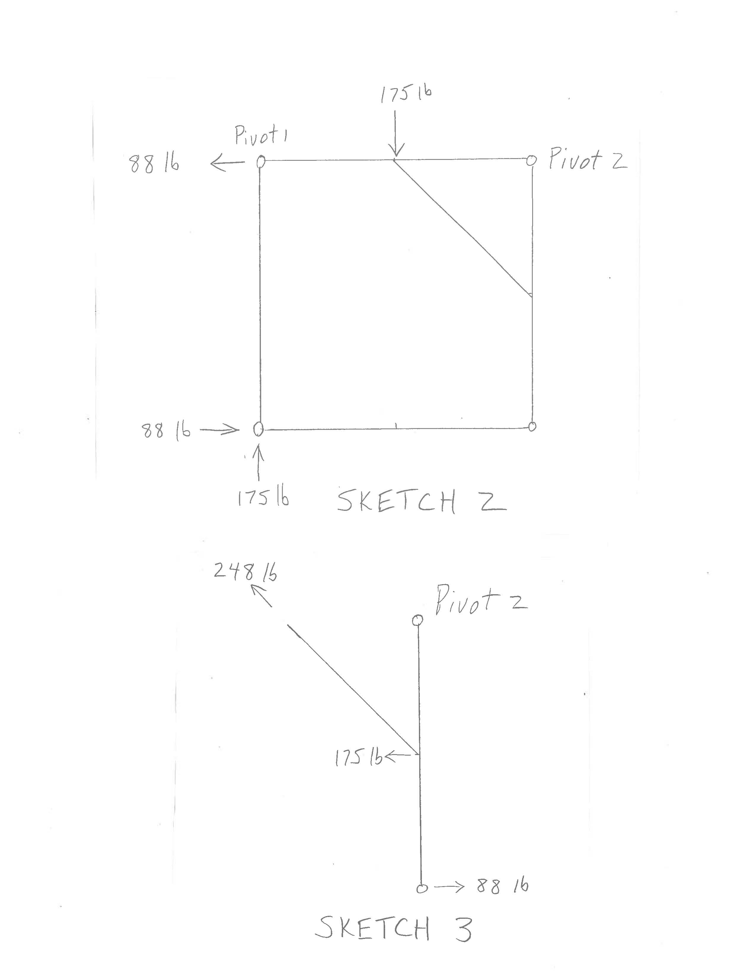

σbrace = F/A =250 lb/0.4379 in.2 = 571 psi

The bracket attaching the diagonal is 0.188 in. thick with a min. width of 2 in.

Abracket, cross section = (0.188 in.)(2 in.) = 0.376 in.2

σbracket = F/A = 250 lb/0.376 in.2 = 665 psi

Bracket is attached with two screws on either side. Shear stress in screws is calculated as follows.

Ashear, 0.25 in. diam.= 0.0269 in.2

τ = Vtotal/2A0.25 in. diam. screw = 250 lb/[2(0.0269 in.2 )] = 4,647 psi

The same results hold for the other top layer diagonal, as each is assumed to carry 175 lb.

The calculated stress in the screw is less than the allowable calculated in Calculation #9, and is therefore acceptable.

**Calculation # 9**

The strength of the fastened connection between joining plates and the 1020 or 1030 members will be evaluated herein. The fasteners which attach the joining plates to the 1020 or 1030 members are ¼”-20 screws. According to the manufacturer, these screws are made from SAE Grade 8 material. These screws go through the joining plates and are threaded into an “economy nut” within the 1020 or 1030 channel. It is difficult to analyze the shear strength (load across fastener) or tensile strength (load along fastener axis) of this connection with respect to the nut pulling out of the extruded part. Optimistically one would consider the shear strength or tensile strength of the screw (Grade 8 material) and use a large allowable shear force or tensile force. The 80/20 manufacturer recommends an allowable shear load of 175 lb per the attached page 155 of their catalog. The shear area of a ¼”-20 screw is 0.0269 in.2. The allowable shear stress cold be calculated using the vendor load as,

τallowable = Vvendor allowable / Ashear = 175 lb/0.0269 in.2 = 6,505 psi

This pertains to shear loading of the screw. This stress will be treated as the maximum allowable shear stress in the ¼”-20 screws for the frame analysis. This stress will also be treated as the maximum allowable tensile stress for the screws for the frame analysis.

For reference, the tensile yield strength of SAE Grade 8 material is 130,000 psi, per SAE J429. The shear yield strength is taken as 60% of this value, or 78,000 psi. The shear and tensile allowable stress of 6,505 psi used for the frame analysis is much lower (order of magnitude) than the 78,000 psi (shear) or 130,000 psi (tensile) based upon Grade 8 material of the fastener.

