E906 St4 Muon Module Assembling Procedure

One MuID plane is made of 8 (9) modules sandwiched by two 80-20 frames that connected by custom made aluminum plates/straps #8 and #9 along the 4 sides.

See fig1.

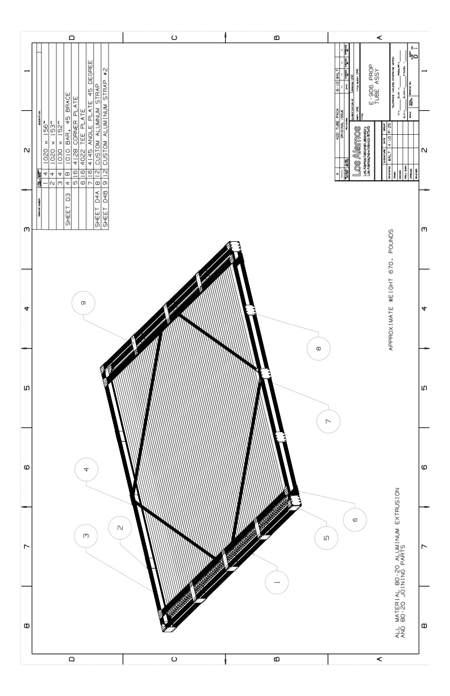

Figure One plane of muon ID detector

Step-1:

Assemble the two layers of 80-20 frames separately on a flat surface., using all #1, 2, 3, 4, 5, 6, 7, 9, except #9 straps.

Step-2:

Place one layer of 80-20 frame on a lifted flat platform (~ 1m from the ground by 4 wood blocks or tables at the corners), start laying out muon modules one by one on top of the 80-20 frame.

Step-3:

Put the 2nd layer of 80-20 frame on the top of the muon modules

Step-4:

Align all modules and 80-20 frames and tie the two 80-20 frames with custom made aluminum/steel ½” thick corner plates with tapped hole #??? at 4 cornners. See figure 2,

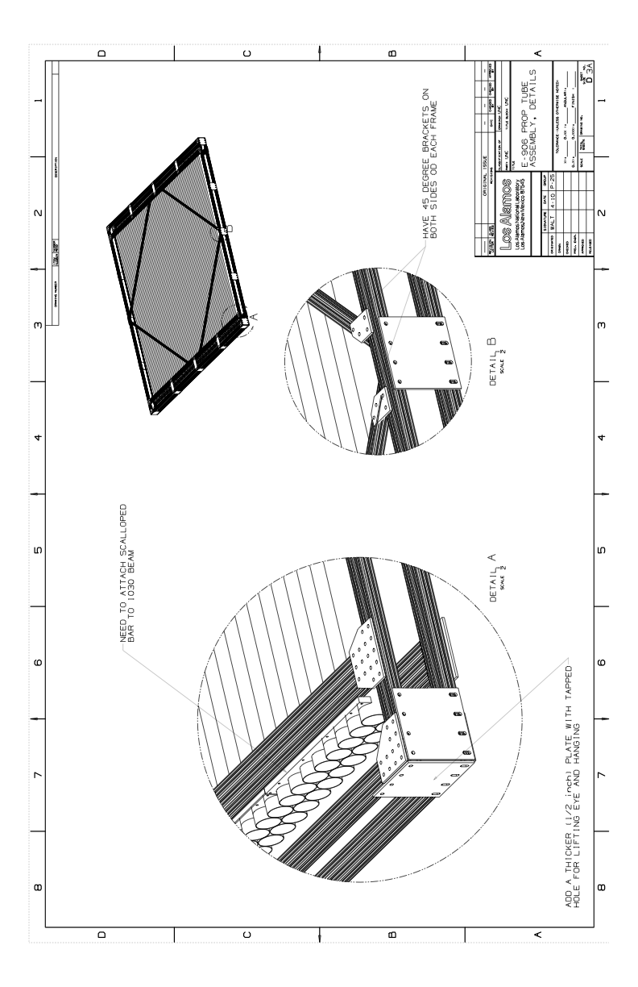

Figure Tie two layers of 80-20 frames with 8 corner plates first, then tie the sides with straps #4A.

Step-5

Tie 80-20 frame on the sides with aluminum straps #4A. See Figure 2.