Benchmark of DY measurement at RHIC with the PHENIX muon detector

Physics dimuon contributions at sqrt(s)=200GeV

Signal:

Drell-Yan process: q+qbar -> mu+mu-

Backgrounds:
Light charged hadron decays: pi +/- & K+/- -> muon+/- +X
Semileptoinc decays of heavy quarks:
D/B ->mu +X:
c->mu+ and c_bar -> mu-
b->mu- and b_bar -> mu+

Heavy quarkonium decays:
J/Psi, Psi’, Upsilons -> mu+mu-

The PHENIX muon spectrometers measure high-energy muons at forward rapidity in 2pi azimuthal angle:

P > 2.5 GeV
1.2 < eta < 2.2 (north arm) and -2.2 < eta < -1.2 (south arm)

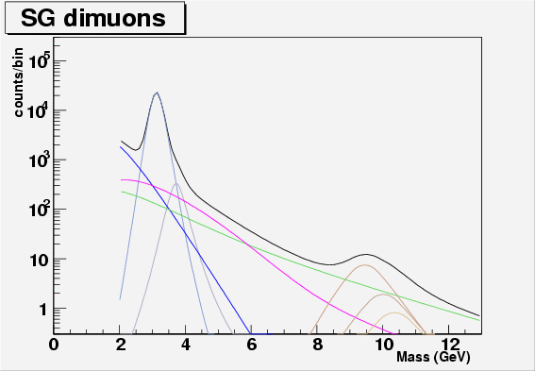

http://www.phenix.bnl.gov/WWW/publish/mxliu/RHIC2-DY/Dimuon_Cocktail_full_200GeV.gif(eps)

Fig 1. PYTHIA (v6.205) simulation of dN/dM (counts/GeV) cocktail of dimuon mass distributions in the forward PHENIX muon spectrometers acceptance 1.2 < |eta|< 2.2 in p+p collisions at sqrt(s) = 200GeV, the corresponding luminosity is about 1pb^-1 p+p collisions. Simulations are done with realistic detector responses, including the muon spectrometers resolutions.

The cocktail shapes are determined from PYTHIA simulations with CTEQ5M PDF functions and with realistic PHENIX muon spectrometer response.

1. PYTHIA DY dN/dM shape is in a good agreement with NLO calculations (with CTEQ5M1 and CTEQ6M, by R. Vogt) in the high mass region, 4 < M < 12 GeV.

2. For charm production: PYTHIA parameters are tuned to best fit PHENIX single electron data; for beauty production, used parameters tuned by ALICE collaboration to reproduce as best as possible QCD@NLO calculations (actual parameters are very similar to the open charm ones).

The cocktails’ relative yields are determined from the best fit to PHENIX run6 pp data with the following constrains:

1. heavy quarkonium states: (R. Vogt, Phys. Rept. 310 (1999) 197)

- N_Jpsi/N_psi’ = 58 +8/-7
- N_Y / N_Y’ ~ 3.6
- N_Y/N_Y’’ ~ 8

2.ratio of open beauty to charm yields (M. Cacciari, P. Nason and R. Vogt, PRL 95, 122001 (2005), hep-ph/0502203)
- sigma_cc = 256 +400/-146 ub
- sigma_bb =1.87 +0.99/0.67 ub

--> N_bb/N_cc = (8.4 +4.2/-4.0) x10^-3

There is a large uncertainty in the beauty contribution in the high mass region 4< M < 10GeV where DY will be measured. The heavy quark mass used for charm and beauty in the simulations are 1.25GeV and 4.75GeV, respectively.

Black = Total sum of cocktails
Light-Blue = J/Psi ;
Light-Gray = Psi’
Blue = open charm
Megenta = open beauty
Green = DY
Light-Brown = 3 Upsilon states

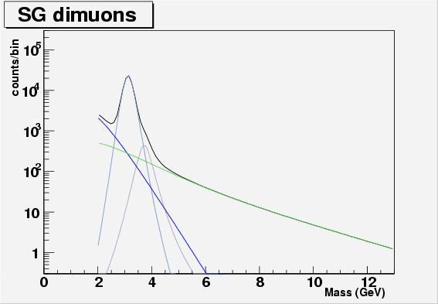
http://www.phenix.bnl.gov/WWW/publish/mxliu/RHIC2-DY/Dimuon_Cocktail_D_only.fig(eps)

Fig 2. Same cocktails as in Fig. 1, but without beauty contributions.

For practical purpose, the experimentally accessible kinematic region for DY production is about 4 < Mass_dimuon < 9 GeV. One concern is the contribution from beauty decays in this region. We have explored the possibility to reject such background with the FVTX upgrade detector. It is estimated that the beauty contribution can be reduced by a factor of 9 if we cut the muon’s impact parameter at 1 sigma level for prompt muons. Figure 2 shows the survival probability for single muons from charm and beauty decays with 1-sigma and 2-sigma cut.

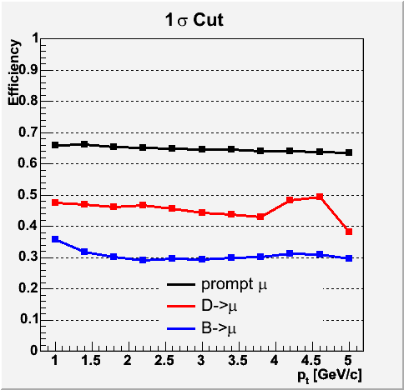

Fig 2. Single muon survival probability with 1 sigma impact parameter cut with the PHENIX upgrade FVTX detectors.

Other Drell-Yan kinematic variable distributions:

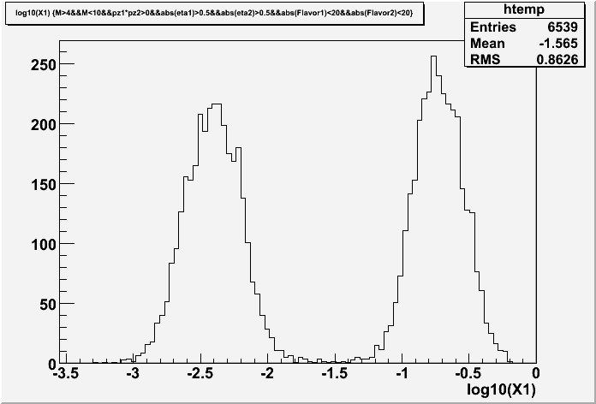

Fig 3. Incoming quark “x” distributions for 4<M<10GeV

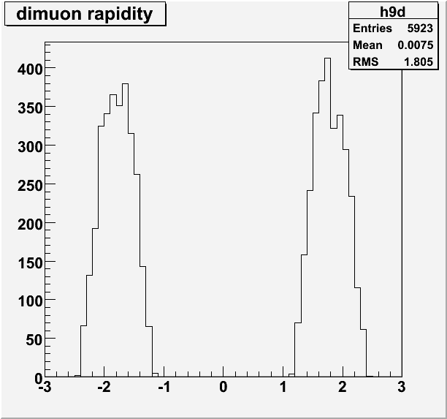

Fig 4. Drell-Yan rapidity distributions measured by the PHENIX muon spectrometers, 4 < Mass < 10 GeV.

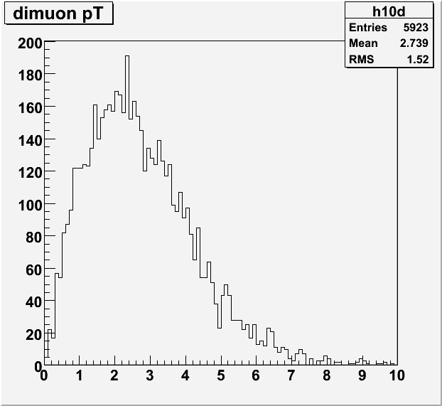

Fig 5. Drell-Yan pT distribution.

DY yields : PYTHIA vs NLO (P. Rosenet)

