2.3.4.3 Drell-Yan production in$p^{­}p→g^{}→m^{+}m^{−}$ and a new fundamental test of pQCD

The strong force is least constrained by experimental data among the three known fundamental interactions (electro-magnetic, weak and strong) in the standard model of particle physics. A fundamental property of Quantum Chromodynamics is asymptotic freedom of quarks and gluons at short distances. This is the regime where QCD has been subjected to the most stringent tests, and where it has been established as the leading theory of the strong interaction. Thanks to asymptotic freedom, it is possible to use QCD-based perturbation theory to treat the interactions of quarks and gluons that occur in high-energy hadronic processes.

Over the past few years, physicists have studied a class of parton (quark and gluon) distributions inside the proton that is related to the internal quark and gluon transverse momentum correlation with the proton’s spin direction. These correlations, named the Sivers effect, were discovered in semi-inclusive DIS at HERMES and COMPASS very recently,., where the out-going quark interacts attractively with the color field of the remnant of the polarized proton, resulting in a significant positive left-right asymmetry. In contrast, for the Drell-Yan process, where the incoming quark from the polarized proton annihilates with an anti-quark in the target, the interaction is predicted to be repulsive and leads a negative left-right asymmetry. This is a fundamental prediction of QCD, directly rooted in the quantum nature of the strong interactions. Its verification (or not) will be an important milestone in our study of the strong interaction, as it tests all concepts for analyzing hard-scattering reactions that we know of today. Figure 1 shows the dimuon cocktail from PYTHIA simulations. Figure 2 shows the expected experimental sensitivity from PHENIX with projected RHIC-II luminosity.

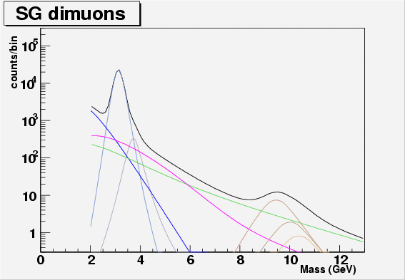
Figure 1 DY cocktail PYTHIA (v6.205) simulation of dN/dM (counts/GeV) cocktail of dimuon mass distributions in the forward PHENIX muon spectrometers acceptance 1.2 < |eta|< 2.2 in p+p collisions at sqrt(s) = 200GeV, the corresponding luminosity is about 1pb^-1 p+p collisions. Simulations are done with realistic detector responses, including the muon spectrometers resolutions.

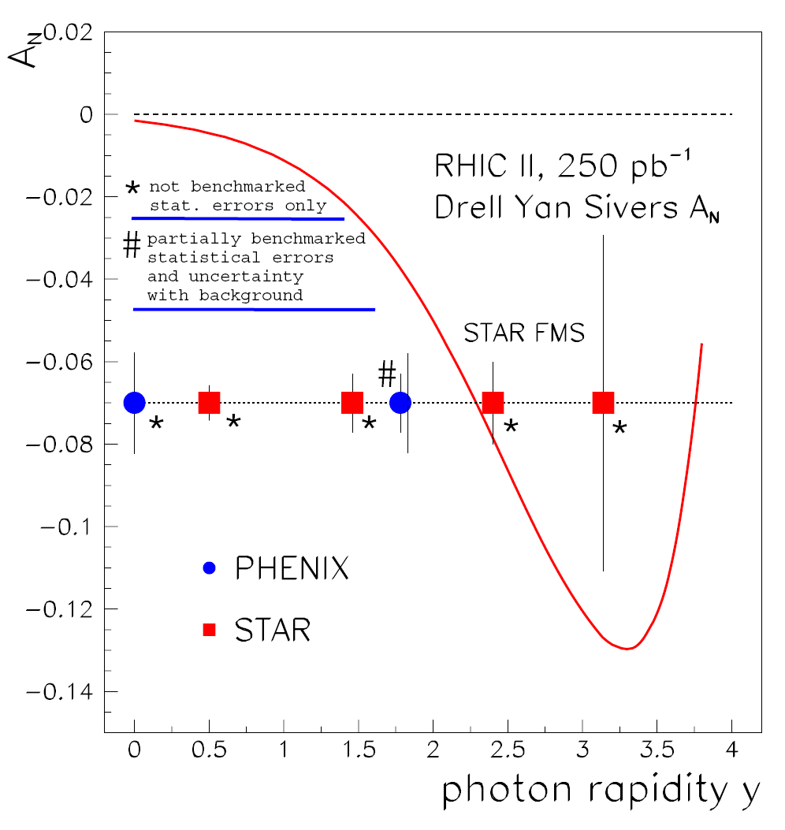

Figure 2. Expected DY transverse single spin asymmetry with projected RHIC-II luminosity. Two blue points are expected sensitivity from PHENIX at central (<y>=0) and forward (<y>=1.7) rapidity via electron and muon measurements, respectively. The red theory cure if based on the latest SIDIS Sivers single spin asymmetry results.

HERMES collaboration, Phys. Rev.Lett. 94, 012002 (2005)
COMPASS collaboration, Phys. Rev. Lett. 94, 202002(2005)

