Wedge Assembly and Testing
D. Winter, Columbia University

Assembly

Summary
The wedge is the basic unit of the FVTX detector, covering 7.5º of azimuth. It consists of a carbon-fiber (TPG) backplane, a High-Density Interconnect (HDI), readout chips (the FPHX), and silicon sensor. There are two sizes of wedge, “A” and “B”. Wedge type A is 4.990 cm in radial dimension and type B is 1.268 cm. Apart from length, the two wedges are identical. The assembled FVTX will contain 96 Type A wedges and 288 Type B wedges, for a total of 384 wedges.

The current plan has the assembly taking place at FNAL’s Sidet facility, which has many years’ experience in microassembly and silicon detectors. Sidet will handle both mechanical assembly and wirebonding. They also will provide space to set up test equipment for FVTX collaborators to test the wedges. We have worked with Sidet to develop the current procedure and will continue to work closely with them to finalize it. The procedure has been developed to achieve the needed mechanical tolerances, while minimizing complexity and maximizing robustness. Testing at various stages of the assembly is integral to the process.

The scope of wedge assembly and testing consists of WBS items 1.4.1.3.3, 1.4.1.3.4, 1.4.1.3.5 and 1.4.1.3.6. In this document, we describe the current assembly and testing plans. The wedge assembly starts with delivery of the TPG backplanes, HDIs populated with the required surface-mount components and certified as working by the vendor, sensors, and FPHX chips.

Procedure
The assembly will take place using only pre-tested HDIs, FPHXs, and sensors.

The steps in the assembly procedure consist of:
- Bond HDI to backplane, using dowel-pin placement. The backplane is held in place using a vacuum.
- Bond FPHX chips to HDI, using vacuum fixture to transfer chips from alignment fixture to assembly fixture.
- Wirebond FPHX output pads to HDI
- Test electronic integrity of FPHX chips
- Bond sensor to HDI, using vacuum fixture (similar to FPHX transfer).
- Wirebond sensor outputs to FPHX input pads
- Test electronic integrity of wedge
- Encapsulate wirebonds
- Bend HDI

The wirebonding procedure will include both the actual wirebonding as well as inspection of the wirebonds. The wire bond material is 1% Si and 99% Al. Al is the preferred material for the current HDI vendor under consideration. There are 157440 wirebonds for 96 Type A wedges and 1385472 wirebonds for 288 Type B wedges, for a total of 1.4 million wirebonds.
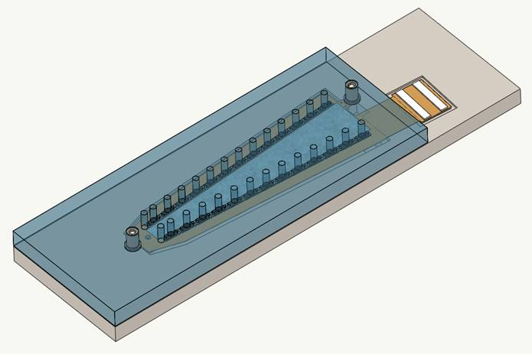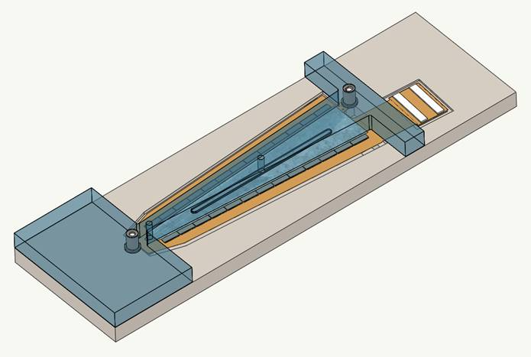
Figure 0-1 Prototype design models for assembly fixtures. (Left) FPHX Transfer jig with wedge alignment jig. (Right) Sensor transfer jig with wedge alignment jig.

The equipment required for wedge assembly is expected to be fairly standard. Vacuum fixtures are being designed by HYTEC in conjunction with Sidet, and will be fabricated by an outside vendor. Optical placement of FPHX chips in the fixtures will require a microscope. Other parts will be placed using a CMM. The planned adhesives require no special equipment for curing. Sidet has all needed equipment (including wirebonding stations) aside from the vacuum fixtures.

Initial designs for the assembly fixtures have been developed with the help of the Sidet team. The current design for the fixtures can be seen in Figure 0-1. There are placement jigs for the sensor and FPHX chips that define the relative placement of the parts to one another. Vacuum pickup jigs are then used to transfer the parts to the assembly jig. Both the backplane and HDI will be placed using dowel-pin alignment (relying on hole and slot to eliminate binding). Each wedge contains one TPG backplane, one HDI, and one sensor. Wedge Type A has 10 FPHX chips (5 per side) and Wedge B has 26 FPHX chips (13 per side).

All parts will be bonded using Arclad 8026 transfer adhesive, based on the recommendation of the Sidet team. This is a non-conducting adhesive tape, requiring no curing time. Using procedures developed by Sidet, the sensor will be bonded using a thin band of 8026 along the edges (extending under all bond pads). A conducting epoxy (such as TRA-DUCT 2902) will be used under the center region of the sensor to provide electrical connection to the bias plane on the HDI.

Currently Sidet is being contracted to develop the prototype assembly procedure. This includes feedback for the design of the assembly fixtures and dicing of dummy silicon parts for mockups of the FPHX chips and sensor. FVTX will supply Sidet with prototype (and/or mockup equivalents) of the backplane and HDI. The primary goal is to confirm the validity of the proposed assembly procedure, as well as produce an estimate for the cost and schedule of the production assembly.

Testing

Summary
Testing refers to the electronic testing of the wedge, at various points in the assembly process. The goal is to ensure that the wedge is working to spec at each of the critical stages. In this way we can identify problems as early as possible, as well as certify that the unit works as expected before shipping to the cage assembly location.

Testing will include the use of a “mini-DAQ” which will interact with the wedge in the same way as the PHENIX DAQ. Thus tests will be based on the integrity of the readout chain.

Test Procedures
Testing will take place at three stages of the assembly: after FPHX chips have been wirebonded to HDI, after sensor has been wirebonded to the FPHX chips, and then finally when the wedge is completed (ie. after the final encapsulation). All results will be recorded in a database. All tests will require the use a mini-DAQ similar to the planned readout chain for PHENIX.

The first set of tests will be after the FPHX chips have been mounted on and wirebonded to the HDI. Such tests will include (but not necessarily be limited to):

- Successful power-on of the FPHX chips.
- Read back of initial state of the FPHX chips to confirm they have powered on in the expected state.
- Downloading a standard configuration to all the FPHX chips.
- Read back of the configuration from all the FPHX chips to confirm the successful download.
- Noise floor measurement for all FPHX chips.
- Threshold (turn-on curve) measurements of the ADC for all FPHX chips, pulsing the channels using an external signal.

The above set of tests have been developed using the FPIX chip. Since the FPHX chip has been designed using the principles of the FPIX, this test suite is considered appropriate and easily adapted to the FPHX. The procedure will be extended and tailored as needed once FPHX chips are available.

Based on procedures developed with the FPIX chip, we estimate the above procedure will take approximately 2 hours per wedge (large wedge) and 50 mins per wedge (small wedge). In reality the testing should take significantly less time, since the FPHX chip has 22 times fewer channels to test.

The second set of tests will be essentially the same, but with the sensor now attached:

- Repeat the above set of tests, to confirm that all previously existing parts still operate to spec.
- Execute the power-on sequence with sensor bias included, repeat tests to confirm that all parts still operate to spec.
- Apply external stimulation to the sensor (LEDs) to measure response. In addition to the mini-DAQ, such tests will require a dark box in which the wedge can be mounted and exposed to the attached LED. Standard logic (such as NIM) will be needed to trigger the readout in coincidence with the LED.

The third set of tests (after final encapsulation) will be the same as or a subset of the second set. The goal is not to determine if the parts are working, but rather to confirm that no damage has occurred during the encapsulation.

Sidet has ample laboratory space adjacent to the assembly area for FVTX collaborators to set up and perform the above tests, and has offered it for our use (this is a standard procedure for Sidet customers). The FVTX project will have to supply the mini-DAQ as well as other test equipment.

Repairs
Every effort possible will be made to ensure that no damage is done during the assembly process. All fixture surfaces will be polished or coated in Teflon, and all wedge parts (HDI, FPHX, and sensors) will be certified as working before being received. Nevertheless, it is unavoidable that some problems may arise, and we need to plan for possible repairs to the parts.

HDI
Repairs of the HDI may or may not be possible. This will be the subject of R&D. If an HDI is found to be non-functioning at any stage of the assembly, every effort will be made to salvage the remaining parts if possible.

FPHX
The question of repairing FPHX chips falls into two categories: before and after sensor placement. Should any FPHX chip be damaged during placement or be found to be defective during the first round of tests, it will be removed and replaced. Sidet has experience with this particular problem and understands the technical issues of such procedures. After the sensor has been placed, replacement of an FPHX chip is much more difficult. A proper procedure for this will be developed during the prototype assembly development.

Sensors
If a sensor is damaged or found to be defective, replacement will depend on the extent of the problem. It is expected that if a sensor is removed from the assembly, it will be unusable. Extraction of the sensor will require care to ensure no damage takes place to the HDI, FPHX chips, or wirebonds.

Wirebonds
Should a wirebond be damaged in the process of assembly or testing, it is straightforward to have it repaired at Sidet. After encapsulation, the possibility of damage should be minimal. Even so, Sidet has experience with repairing encapsulated wirebonds, and can do so if needed.

Once the wedges have been shipped, should there be damage to a wirebond, there are facilities at BNL that can be contracted to do the repair. If that facility is not available, the unit may also be shipped back to Sidet. It may also be possible to include FVTX institutions in the list of potential repair shops, especially if we find the average repairs are simple enough to be feasible.

Documentation
All stages of assembly and testing will be documented. The exact implementation of the documentation will be developed so as to make it as efficient as possible for the testers and assemblers as well as provide a seamless connection with the PHENIX databases. PHENIX relies on both MySQL and Postgres databases to record configuration state data. Both are open source and free, and therefore have been proven to be flexible and easy to use. There is a slight preference for Postgres, since that is the database that stores calibration information for the experiment. Regardless of the choice of technology, suitable interfaces will developed for input and export of data from the database.

“Traveler” files will be developed to document all activity for each of the wedges. This file will be updated with each modification or test (including times, tests, assembly steps, part serial numbers, and other relevant information), and will travel with the wedge from cradle to grave. Currently it is planned that this file be paper forms to be filled out by the user and later entered into the database for online archiving. If it proves to be more beneficial to enter traveler information directly into the database (updating paper copies as changes take place), it will be trivial to swap the order. In the past, Sidet has maintained a traveler (paper binder) for each assembled module, so this plan is consistent with previous experience.

Ultimately the history of the wedge will be incorporated into the configuration database for data production.

Shipping
Standard COTS containers will be purchased to house the assembled units. Enough containers will be purchased to house all units (including spares). These containers will provide the needed mechanical and electrostatic protection to allow them to be used both as storage boxes and shipping containers. Units will be shipped from FNAL to BNL in batches as they pass their final tests and inspections.

HDI Bending
HDI bending refers to the fact that the ends of the HDI (the “ear”, containing the connector) will need to be bent at 90º. This requirement is because the wedges are mounted on a plane transverse to the beamline, but the signals in and out are carried on flex cables running parallel to the beamline.

Because the width of wedges extends beyond the 7.5º of the active area of the sensor, the wedges will also be mounted on their support planes staggered at two different heights (from the support disk), and alternating in which side they face. The fact that half the wedges will be facing opposite directions means that the HDI connector will be bent either up or down (relative to the face of the sensor), depending on where it will be mounted. The bending procedure is still a subject of R&D.

The original plan for the HDI bending includes it as part of the contract with the HDI vendor. However, in planning the prototype assembly, it was decided that the prototype would not be bent prior to the prototype assembly. Sidet recommends that the bending take place as late in the assembly as possible. Doing so minimizes stress on the HDIs. The wedges can be shipped unbent, and bending would take place at the cage assembly area, prior to mounting of the wedge. This approach also allows greater freedom for choosing where each wedge is located, rather than committing a wedge to one orientation or another prior to assembly. Part of the bending R&D will include an assessment of the tradeoffs between having the vendor perform the bending and impact prebent wedges have on the assembly, storage, and shipping processes.

The radius of curvature for the bend is estimated at 1.0 cm. Since the HDI is .300mm in thickness, this is a ratio of 33:1, which is not considered aggressive. We will work closely with the HDI vendor to ensure that the proper bending procedure has been implemented. In addition, we will capitalize on the experience the VTX pixel project gains, since they will be faced with a similar task in assembling their ladders (the VTX plan has the bending taking place after ladder assembly, at the equivalent of the cage assembly location).

Schedule
The scope of wedge assembly and testing consists of WBS items 1.4.1.3.3, 1.4.1.3.4, 1.4.1.3.5, and 1.4.1.3.6. During schedule discussion, additional WBS items may be mentioned as appropriate.

A summary of the current schedule for the wedge assembly WBS items is shown here:

WBS | Description | Start | End | Duration | Duration
1.4.1.3.3 | Attach flex cable (HDI) | 4/10/09 | 11/5/09 | 36 weeks | 84 weeks
1.4.1.3.4 | Attach sensor | 4/17/09 | 11/12/09 | 36 weeks
1.4.1.3.5 | Wirebond Assembly | 4/10/10 | 11/15/10 | 37 weeks
1.4.1.3.6 | Test chip, sensor, + cable assemblies | 5/18/10 | 12/13/10 | 28 weeks

Preliminary discussions with Sidet have allowed for an estimate of assembly time. With a current understanding of the tasks involved, we estimate an assembly time of 11 hours/wedge. This includes all lamination, wirebonding, and encapsulation, but does not include testing time. For 400 wedges, this requires 15 weeks to perform the entire production. The current project schedule includes 84 weeks from start to finish, which includes significant contingency.

Manpower
Manpower requirements for assembly prototyping and production will be handled by Sidet. FVTX manpower will be applied to the testing and oversight of the assembly production. The prototype assembly will involve only Sidet personnel, and the process will help us understand to what tasks FVTX manpower can be applied (as cost and time contingency).

Sidet’s preliminary plans include one station for assembly, which includes HDI lamination and chip and sensor placement. Each assembly step will require a single technical person, either a Technician I, Senior Technician, Technician Specialist, or Technical Supervisor. It is anticipated that as experience is gained in the assembly, as much as possible will be performed by lower-ranked individuals.

There is room for more than one assembly station although the later steps (chip and sensor placement, for example) are highly specialized and it may only be possible for technical individuals to be involved. Additionally, there is only one wirebonding and encapsulation station available for the wedges.

We plan to train FVTX collaborators to contribute to the assembly. The first several steps, up to and including the bonding of the HDI, could be done by trained FVTX contributors. This is one possible place to incorporate some schedule contingency. The more specialized work (as mentioned) will be done by the Sidet personnel. All testing will be done by FVTX collaborators.

