FVTX Sensor Specification
July 29, 2008

Sensors

The silicon sensor is a 7.5 degree wedge comprised of two columns of mini strips (see Figure 1). Each column of strips is read out independently, on the left or right side of the sensor. The strips approximate a 3.5 degree arc in phi. The length of the strip is a function of radius. For example, the strips on the large wedge are 3.4 mm long at the inner radius, and they continuously lengthen with increasing radius, reaching 11.57 mm length at the outer radius. The strip pitch is 75 μm in the radial direction. There are 640 strips per column on the sensors in the two forward-most disks, and 1664 strips per column in the remaining six disks. The radial length of the small wedges that comprise the two forward-most disks is 50.0 mm and the length is 126.9 mm for the six disks comprised of larger wedges.

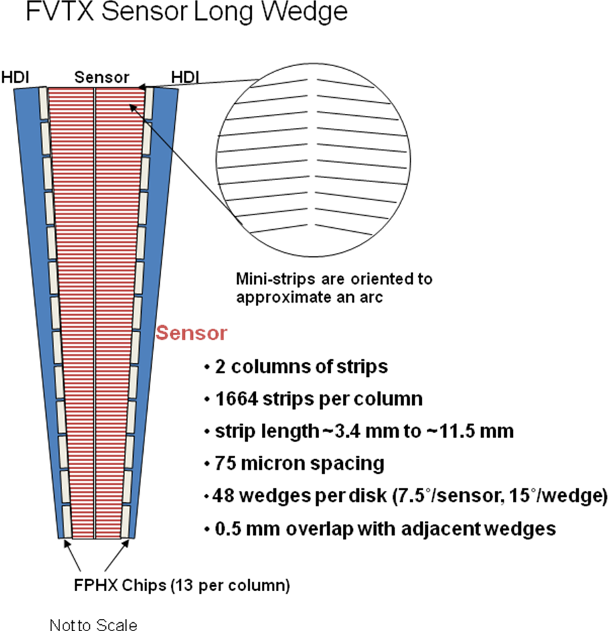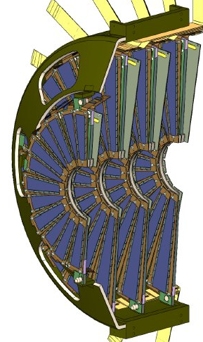

Figure 1 – Strip geometry (left) and wedge geometry for a ½ shell (right)

The sensor is 320 μm thick. The wafer resistivity, which is inversely proportional to the depletion voltage, is 2.0 to 5.0 kΩ, corresponding to depletion voltage less than 100V. Operating voltage is defined as 50V + depletion voltage. The starting material is n-doped bulk with p-type implants. The backside of the detector is aluminized. The detector bias voltage is applied to the backside. The strips are at ground potential.
The strips are ac-coupled on the sensor. The capacitor is made by depositing an oxide layer of approximately 200 nm on top of, and over the entire length of the p-implant. An aluminum metallization is placed on top of the oxide to complete the capacitor and to form the readout conductor. The bias connection to the p-implants is made by a polysilicon resistor of approximately 1.5 MΩ, which is electrically connected to a common bias ring on one end, and to the p-implant on the other end. There is an individual polysilicon resistor for each strip. There are three sets of pads on each strip. There is a spy pad which penetrates the oxide layer to allow probing of the dc characteristics of the strip. There are probe pads, which are dedicated for probing the ac characteristics of the strips. And there are bond pads which are only used to wire bond from the detector to the electronics. All non-contact surfaces of the top side of the sensor are covered with a passivation of silicon-oxide or silicon-nitride. A guard ring is implanted around the perimeter of the wedge between the bias ring and the cut-edge of the sensor to prevent breakdown at the cut-edge of the sensor under a normal range of bias voltage. Additionally there is an n+ implant around the entire perimeter of the detector between the guard ring and the cut edge to isolate the active part of the sensor from surface and edge current.

The sensor breakdown voltage is specified to be ≥200V or ≥50V+ operating voltage, whichever is greater. There is no need to specify higher breakdown voltage, or to incorporate multiple guard ring structures, because the anticipated integrated 10 year radiation dose of 200 krads in the PHENIX experiment does not require it. Leakage current at 20˚ C is specified to be ≤ 160 nA/cm² at operating voltage.

Production will be made in two stages. First, a minimum lot size to evaluate the process, followed by production of the balance of the order. It is assumed that the small wedges and the large wedges can be incorporated together on a single mask. We believe 3 large wedges and, more small wedges than we need, will fit on one mask.

We require 288 large wedge sensors + 42 spares = 335 sensors
We require 96 small wedge sensors + 24 spares = 115 sensors

The numbers above suggest an order of approximately 110 wafers.

Hamamatsu has been awarded the purchase contract to produce a prototype run of large wedge sensors, 20 each. The design drawings produced by Hamamatsu are shown in Figures 2a and 2b.

All sensors will be diced from the wafer and tested before delivery by Hamamatsu.

- General Detector Specifications

A.1 Overall device length

Wedge A
50.06 mm from cut line to cut line

Wedge B

  - mm from cut line to cut line

A.2 Overall device width

Wedge A (7.5 degree wedge)
Inner radius 8.77 mm cut line to cut line
Outer radius 15.32 mm cut line to cut line

Wedge B (7.5 degree wedge)
Inner radius 8.77 mm cut lint to cut line
Outer radius 25.36 mm cut line to cut line

A.3 Number of strips (2 columns of independent strips per detector)

Wedge A
640 strips per column, 1280 strips per wedge detector (all strips read out)

Wedge B
1664 strips per column, 3328 strips per wedge detector (all strips read out)

A.4 Strip pitch: 75 μm

A.5 Implant strips dimensions

18 μm wide, p-implant strips, variable strip length on 7.5 degree opening angle, 2 columns of strips separated by a 75 μm gap between adjacent columns
Wedge A: strip length from 3.4 mm to 6.55 mm
Wedge B: strip length from 3.4 mm to 11.57 mm

A.6 Read-out strips

Aluminum, capacitively coupled over the p-implant with the processed aluminum edge, ≥ 1 μm along the entire strip length.

A.7 Bias Resistors

Overlap the implants or contained within the guard ring.

A.8 Sensitive region to cut-edge distance: 1.0 mm

A.9 Guard ring to cut edge distance: ≥ 300 μm

A.10 Guard ring design: Large contactable p-implant with overlapping aluminum. Contacts shall be in all four corners of the detector.

A.11 Read out pads: 150 x 50 μm wire bond pads, two staggered rows, one primarily for probing and one for bonding.

A.12 p-implant bias ring contacts at all four corners of the detector.

A.13 Spy pads to probe p-implants.

A.14 Back Contact: Contactable aluminum over highly doped n-implant.

A.15 Passivation: Sensors shall be passivated on front (microstrip) side.

A.16 Identification: Every 10th strip to be numbered, beginning at the bottom. Scratch pads for detector identification. Alignment marks for metrology.

- Mechanical specifications

B.1 External cut dimensions:

Wedge A
  - mm from cut line to cut line

Wedge B
126.91 mm from cut line to cut line

B.2 Overall device width:

Wedge A (7.5 degree wedge)
Inner radius 8.77 mm cut line to cut line
Outer radius 15.32 mm cut line to cut line

Wedge B (7.5 degree wedge)
Inner radius 8.77 mm cut lint to cut line
Outer radius 25.36 mm cut line to cut line

B.3 Thickness: 320 ± 15μm

B.4 Uniformity of thickness: ± 10 μm

B.5 Surface Damage: Detector shall not have large scratches or other gross surface defects.

- Detector Electrical Specifications

C.1 Strips: p-implant.

C.2 Bulk dopant: n-type.

C.3 Readout strips: Aluminum ≤ 20 Ω/cm.

C.4 Bias resistors: 1.5 ± 0.5 MΩ polysilicon resistors.

C.5 Capactive coupling: ≥ 10 pF/cm.

C.6 Uniformity of resistivity: ± 25% wafer-to-wafer.

C.7 Depletion Voltage: < 100V.

C.8 Operation Voltage (Vop): Depletion Voltage + 50V.

C.9 Breakdown Voltage: Vop + 50V.

C.10 Leakage Current: ≤ 150 nA/cm² at 20 degrees centigrade at Vop verified by vendor.

C.11 Current slope: at 20 degrees centigrade, I(Vop)/I(Vop – 50V) < 2.

C.12 Oxide breakdown voltage: > 50V (seller shall measure on a test device located on each wafer).

C.13 Detector current shall increase by no more than 25% after 12 hours of operation in dry air (RH ≤ 40%) at Vop (verified by LANL).

- Bad Strips Shall Include But Not Be Limited To;

D.1 Capacitive coupling dielectric: short through dielectric at 50V.

D.2 Defective strips: Metal or implant opens, or shorts to neighbors.

D.3 Polysilicon resistors: Strip connection to resistor open.

D.4 Acceptance testing: Each aluminum strip shall be contacted with a probe and checked for shorts through the coupling dielectric at 50V by the seller.

D.5 Total strip acceptance: LANL requires a mean acceptance of 99% good strips in each delivery with no devices below 98%.

- Seller Shall Supply Data Sheets for Each Detector As Follows;

E.1 IV curves: LANL requires the plot of I versus V up to 200V.

E.2 Depletion Voltage: LANL requires the value of the wafer depletion voltage.

E.3 Thickness: LANL requires the value for the wafer thickness.

E.4 Bad Strips: LANL requires the seller’s list of bad strips and the plot of capacitance versus strip number.

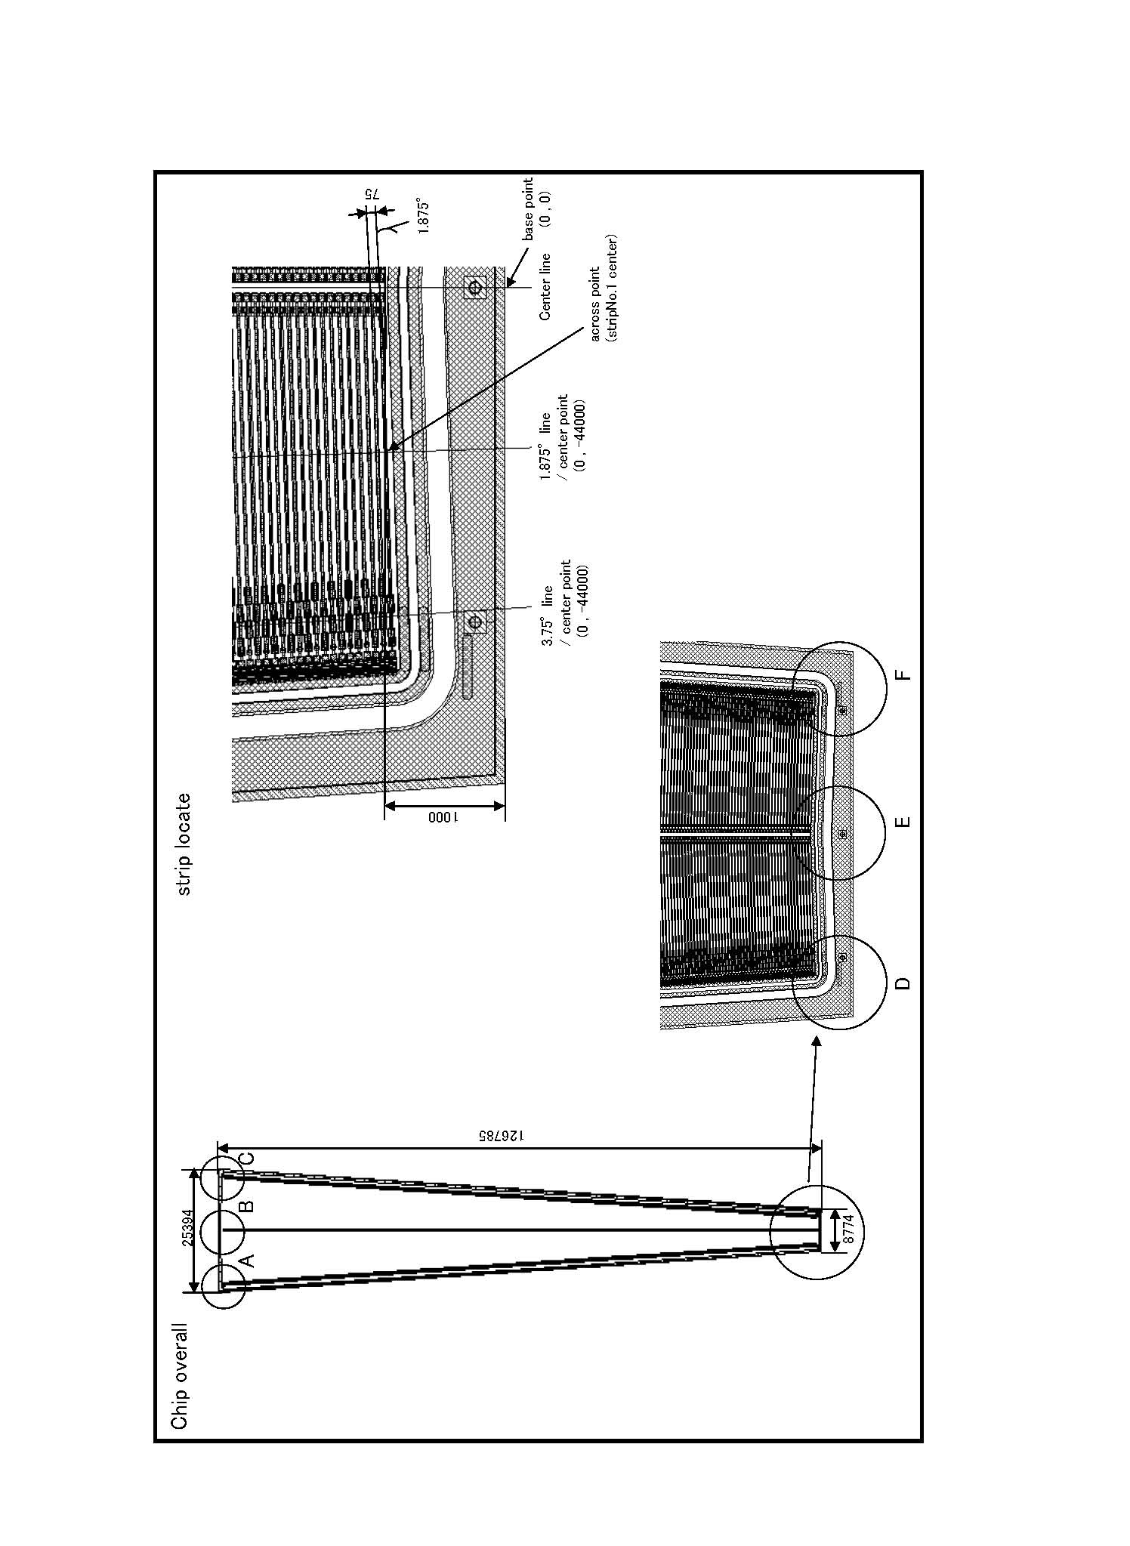
Figure 2a – Hamamatsu design drawing of the FVTX sensor.
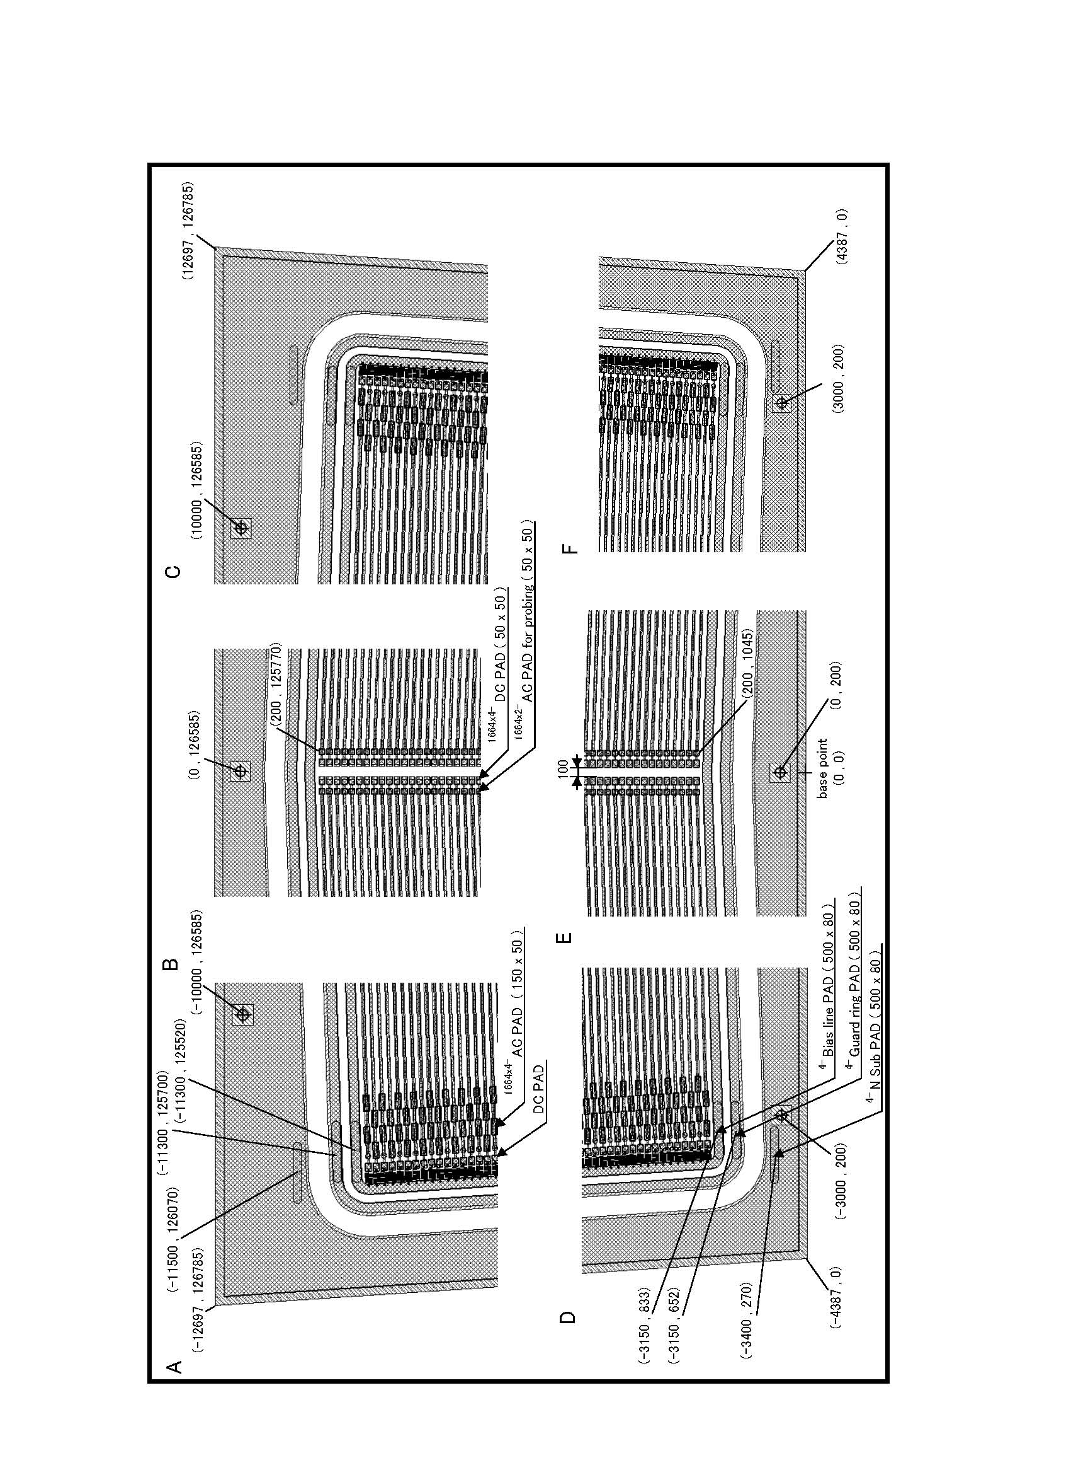
Figure 2b – Hamamatsu design drawing of the FVTX sensor.

