FPHX Specifications
July 29, 2008

FPHX Chip
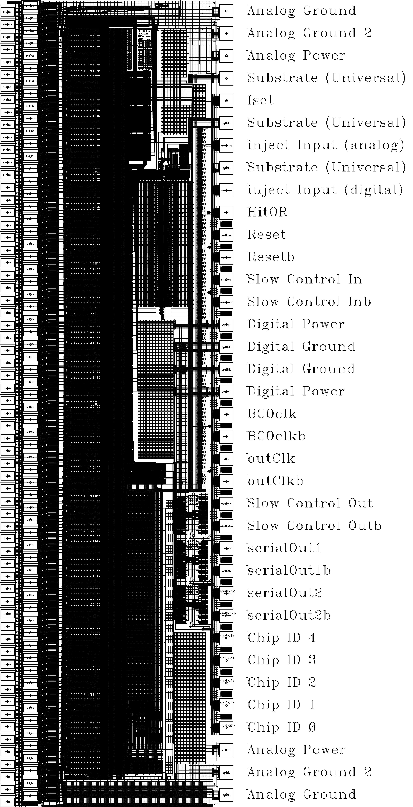

Figure 1 – FPHX chip.
The FPHX is the custom readout chip designed for the FVTX Silicon Sensor. Each FPHX chip integrates and shapes (CR-RC) signals from 128 channels of mini-strips, digitizes and sparsifies the hit channels each beam crossing (106ns beam clock), and serially pushes out the digitized data. The chip is designed for positive charge (hole) collection from p-on-n detectors. The strips used by the experiment have different lengths, resulting in a varying distribution of input capacitance across different chips. Long latency is not desireable, and it is therefore required that four hits will be read out within four beam cross-over periods of an event. The user must be able to control internal parameters and biases, therefore a digital slow control interface is provided on each chip to enable programming.

The FPHX is a mixed-mode chip with two major and distinct sections, the front-end and the back-end. Figure 2a is a block diagram of the complete chip, and Figure 2b is the top level full chip schematic, with the two major sections outlined. The mostly analog front-end contains the 128 channels of integrators, shapers, and comparators, in addition to several programmable bias circuits and DACs that are used for setting internal parameters. The output of each front-end channel is simply an 8-bit digital word from 8 comparators (forming one hit discriminator output and seven thermometer-coded ADC outputs, which results in 3-bit magnitude information). Each comparator’s threshold is independently programmable, effectively allowing a custom non-linear ADC. The hit and ADC information serves as the input to the Core Logic section of the back-end, which processes the data for readout. Also part of the back-end is the Slow Controller, which accepts a serial data stream to program the chip after power-up.

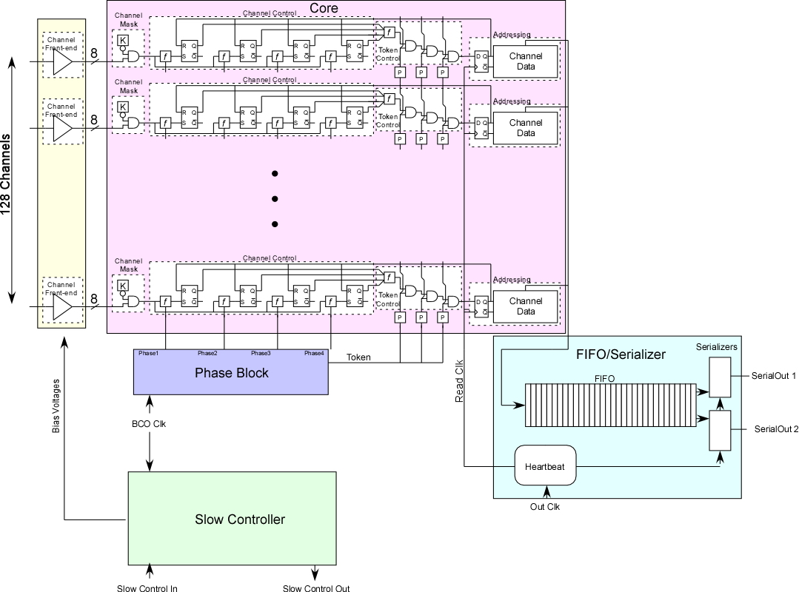
Figure 2a- The FPHX Block Diagram

Front-end Specifications

- Configuration: 128 identical channels. Each channel contains a charge integrator, shaper, programmable threshold discriminator, and an 8-comparator thermometer ADC with fully programmable thresholds.
- Input charge signal polarity: positive (holes)
- Input capacitance: the design is optimized for an external detector capacitance of approx. 1.5pF (and estimated chip parasitic C of 0.5pF)
- Detector leakage current compensation: programmable maximum of 0 – 50nA
- Effective Channel gain: 50, 67, 100, or 200 mV/fC (programmable)
- Output: 3-bit digital code per channel (digitized shaper output pulse height). No analog output.
- Output pulse dynamic range (shaper output): >800mV (25ke to 100ke, depending on the gain setting)
- Nominal output pulse peaking time: 60 ns (programmable, set by the shaper)
- Output pulse fall time: programmable, set by the integrator fall time adjust
- Noise at shaper output: (approximate from simulations)
- At max. input transistor bias of 38uA: 115e + 134e/pF (linear for total Cin>=2pF, including chip parasitics of approx. 0.5pF)
- At input transistor bias of 14uA: 110e + 196e/pF
- Power: Approx. 140 uW per channel for the maximum input transistor bias current of 38uA, 70 uW per channel for minimum input transistor bias current of 10uA.
- External biasing components required: one resistor to ground to set master Iref
- 2 test pulse inputs: one direct analog, one controlled by a DAC and digital input.

128 channels of integrator, shaper, and comparators are output on 1024 digital lines that feed the back-end. A bias generator block provides the necessary biases for the integrators, shapers, and comparators. The bias generator is programmable to allow for adjustment of critical analog parameters, through downloading to the program register in the back-end Slow Controller. A “clean digital” buffer powered by the analog supply is used to prevent any back-end digital noise from entering the bias generator. A test pulse inject circuit is provided to allow a pulse of programmable magnitude to be injected to any number of the 128 channels simultaneously. A programmable inject enable for each channel also comes from the back-end program register to allow for injection of arbitrary channel patterns.

When the integrator receives a charge input impulse, it produces a fast (relative to the shaper peaking time) output step followed by a programmable discharge time, giving the “CR” portion of the CR-RC response. The integrator bias level, gain, and bandwidth are programmable in order to allow optimization of noise and response time for a variety of total input capacitance values (typically from 0.5 pF to 2 pF). The shaper has a fixed gain and limits the signal bandwidth, which determines the signal rise time and peaking time. The nominal peaking time of the shaper is intended to be about 60 ns, so that there will be no ambiguity about which 106 ns beam clock period produced the signal. The shaping time can be adjusted via the programmable shaper bias.

A new type of continuous reset and leakage compensation circuit has been designed for the integrator. A programmed current determines the maximum value of available leakage current compensation. With this configuration, the circuit response is very insensitive to changes in DC leakage current.

The shaper baseline is set with a programmable reference voltage (Vref), and the output pulse feeds eight programmable-threshold comparators, the first of which is used as a hit discriminator. The other seven comparators, along with the hit discriminator, form a simple thermometer-code “flash ADC.” The thresholds are referenced to the shaper baseline Vref.

The heart of the comparator operation is a single PMOS transistor with the input applied to the source and the threshold applied to the gate. The threshold is set to a programmable amount above Vref. The comparator input sits quiescently and an excursion on the shaper output of more than (Vthreshold – Vref) turns on the comparator transistor. One advantage of this configuration is that with no signal, the comparator PMOS transistor draws no quiescent current – it only turns on temporarily during the time that the signal exceeds threshold.

FPHX Back-end

Each front-end channel provides eight bits of digital information (one bit of hit discriminator and seven bits of thermometer-coded magnitude information) to the back-end Core. If the channel is masked in the Core, then the front end signals are blocked by the Channel Mask and nothing more happens. If the channel is unmasked, then the signals are passed unchanged to the Channel Control circuitry. The Channel Control circuitry breaks the signals up by phase depending on the state of the 4-Phase Block. Tokens are then passed by phase into the Token Control circuitry which selects one channel at a time to output its data (address and ADC value) into the FIFO/Serializer. The Read Clock for the Channel Data output to the FIFO is provided by a Heartbeat generator inside the FIFO/Serializer. Once in the FIFO/Serializer the data is serialized and output on one of two serial lines. If desired all data can be output on Serial Out 1.

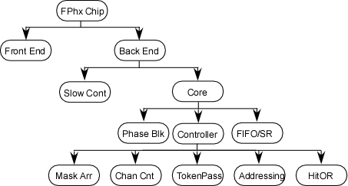

How the chip breaks down logically inside the Cadence Database

Each of the FPHX two serial output words will drive a continuous stream of 20-bit words. Each word will be 1 sync bit followed by 19 data bits. If all 19 data bits are zeros, then that 20-bit word is a Sync Word placed in the data stream to enable the data acquisition hardware to align itself to the data flow from the FPHX chip. If the 19 data bits are NOT all zeroes then that 20-bit word is a Data Word and it contains information on a hit strip.

The data is organized as follows

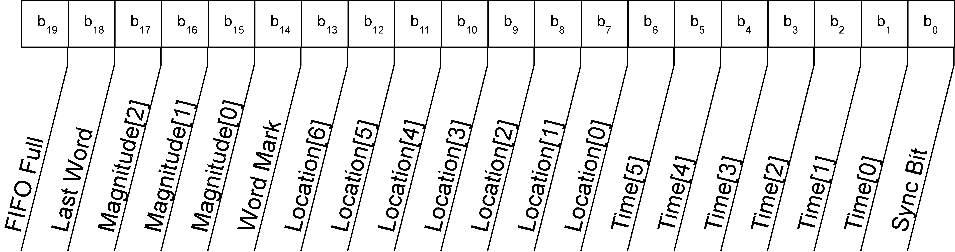
The Serial Output Data Word Structure

Note that in time order, the Sync bit comes out first and the FIFO full bit comes out last.
The Slow Controller provides a serial interface between the user and the chip. Most notably, this allows the user to adjust the bias values for the front end. The FPHX Slow Controller uses a so-called “three-wire” interface, meaning that communication is accomplished through three lines. – Slow Control In, Slow Control Out, and Slow Control Clock.

Slow Control In is an input to the Slow Controller that will communicate the Slow Control Words from the user to the chip. The Slow Control In line can be shared among several chips or connected point-to-point.

Slow Control Out is an output line from the chip that will provide the user with read-back information from the chip. The FPHX Chip assumes that the Slow Control Out line is bussed with several other chips. Therefore, the Slow Control Out line is tri-stated unless there is data to be output from the chip.

Slow Control Clock is an input to the chip that provides a clock for data processing. Slow Control In data is assumed to change on the rising edge of the Slow Control Clock and will be latched on the falling edge of the Slow Control Clock. Slow Control Output will be changed on the rising edge of the Slow Control Clock. In the FPHX chip, the BCO clock is used as the Slow Control Clock to reduce pad count.

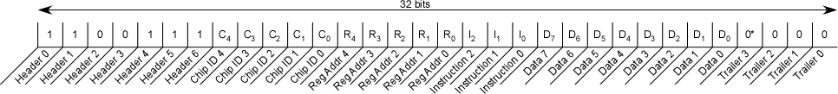
The Slow Control Word

The Slow Control Word is a 32-bit word that is input to the Slow Controller through the Slow Control In line. [In time sequence, the word is shifted from left to right.] The Slow Control Word consists of a 7-bit header (always 1100111), a 5-bit Chip ID, a 5-bit Register Address, a 3-bit Instruction, an 8-bit Data Word, and a 4-bit Trailer (always 0000).
It is assumed that upon power-up the chip will be reset. There is no power-on-reset built into the chip and if the chip is not reset, the state of the chip cannot be predicted. Once the reset is given, all hits will be erased, all bias voltages will be sent to their default values, the time stamp will be reset to zero, the chip will be operating with two active lines and the chip will be rejecting any hits presented to it.

Back-end Features

- Up to 4 hit strips can be read out in 4 beam clock cycles (4 x 106 ns)
- Hits are processed in a 4-phase architecture
- Access to the readout bus is controlled by token logic
- Data is pushed onto one or two LVDS serial outputs lines (user selected)
- Data output word is 20 bits
- Output word includes channel ID, 3-bits ADC, time stamp
- Sync word is provided to synchronize DAQ, 1 “sync bit” followed by 19 zeroes
- Serial data output clock is 200 MHz
- Channels can be masked off in any pattern (programmable)
- Output data is zero-suppressed
- FIFO is 20 bits wide and 32 words deep.
- FIFO Full is set when input pointer +2 = output pointer
- Slow control is a serial read/write interface to the FPHX, 32-bit word, clocked at 10 MHz
- FPHX will be reset to default values on power up

