t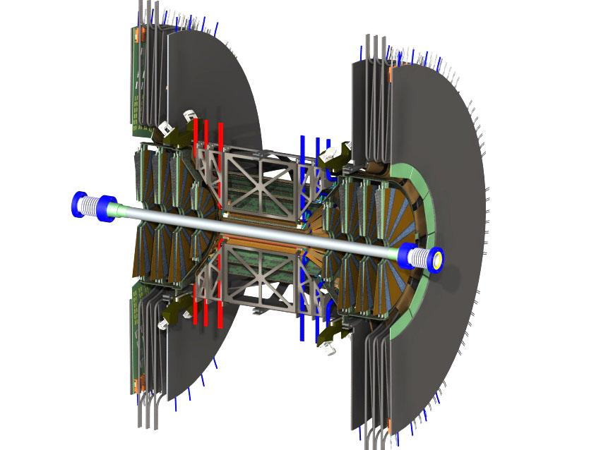

Cost Book
for the
Forward Silicon Vertex Trackers (FVTX)
for PHENIX

at
Brookhaven National Laboratory

For the U.S. Department of Energy
Office of Science
Office of Nuclear Physics

November 11, 2007

1. Project Schedule 3
2. Cost Summary 5
3 Workforce Detail 6
3. WBS 1.4 Wedge Components 8
3.1 WBS 1.4.1 Wedge Sensors 9
3.1.1 Hamamatsu Quote 9
3.1.2 Czech correspondence and ON Semi 9
3.1.3 CIS Quote 10
3.1.4 Micron Quote 15
3.2 WBS 1.4.2 FPHX Chips 19
3.2.1 MOSIS Quote 19
3.2.2 FNAL Quote 20
3.4 WBS 1.4.1.3.5 Promex and FNAL Wire Bonding Quote 21
3.3 WBS 1.4.3 Kapton Flex Cables HDI 23
3.4 WBS 1.4.4 Kapton HDI to ROC Interconnect 23
3.4.1 Samtec Cable 23
4 WBS 1.5 DAQ 24
4.1 WBS 1.5.1 Fiber Output ROC-FEM 24
4.2 WBS 1.5.2 ROC 24
4.3.WBS 1.5.3 FEM 24
4.3.1Combined Quote for Fiber, ROC, FEM 24
4.4 WBS 1.5.5 Ancilliary 25
4.4.1 LV, HV, crates, etc. quotes 25
5 WBS 1.6 Mechanics 26
5.1 WBS 1.6.2 Support structure cage 26
5.2 WBS 1.6.3 Wedge Back Plane 26
5.2.1 Across Quote 26
5.2.2 Alliance Quote 27
5.3 WBS 1.6.4 Support Disk 31
5.4 WBS 1.6.5 Alignment and Assembly Jigs 31

1. Project Schedule

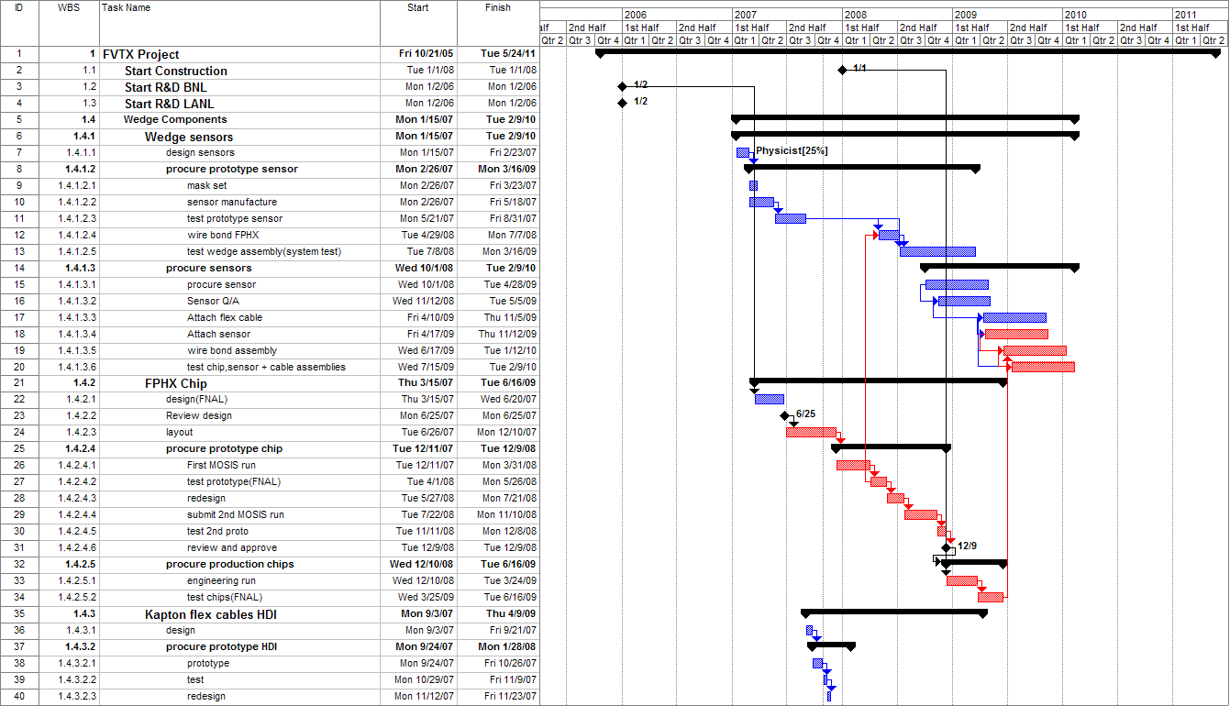
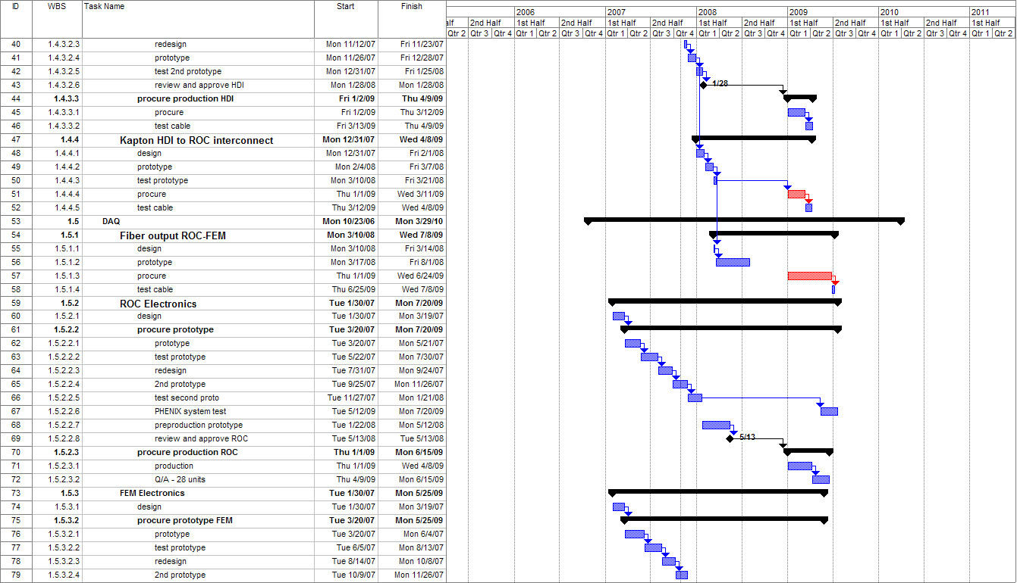
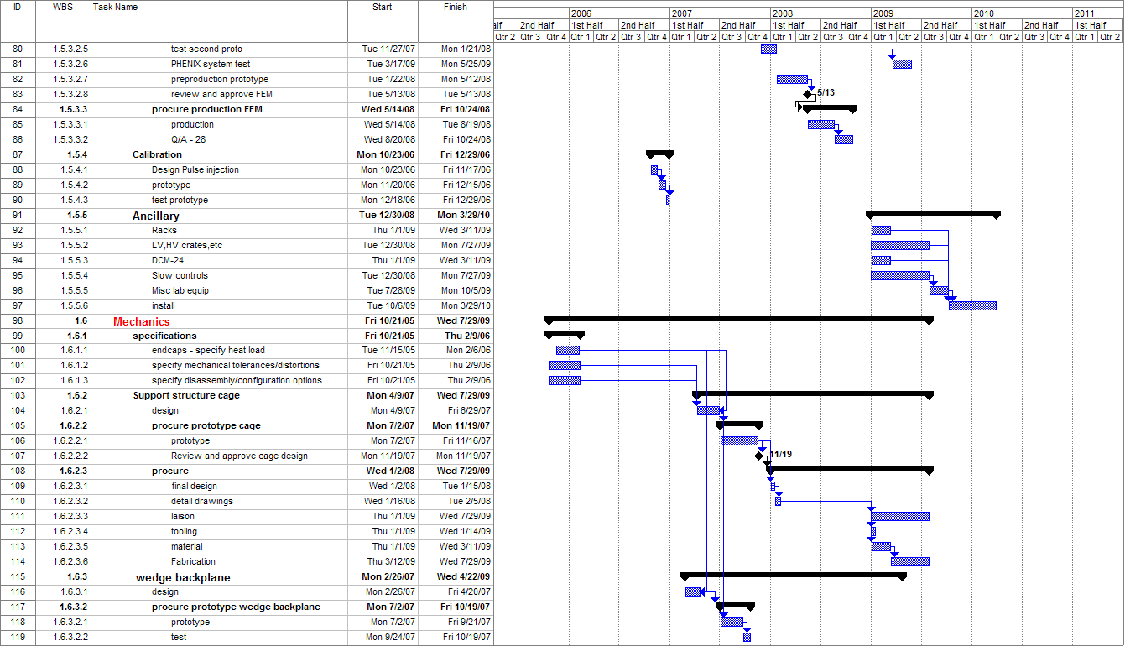
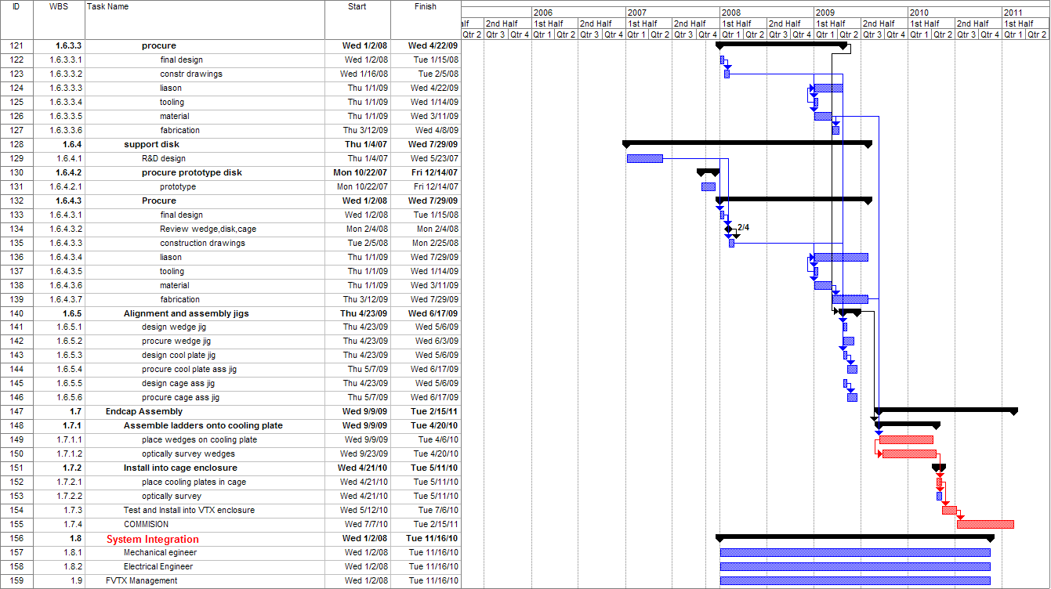

Cost Summary

3 Workforce Detail

3. WBS 1.4 Wedge Components
The wedge components consist of the silicon sensor, the high density interconnect (HDI), and the FPHX chips. The carbon back plane that supports these components is listed in section WBS 1.6.

WBS 1.4.1 Wedge Sensors

3.1.1 Hamamatsu Quote

3.1.2 Czech correspondence and ON Semi
Subject: RE: Sensors for FVTX project
From: "Miroslav Finger" <Miroslav.Finger@cern.ch>
To: "Melynda Brooks" <mbrooks@lanl.gov>
Cc: "Vaclav Vrba" <vrba@fzu.cz>, <dlee@lanl.gov>, <jonk@lanl.gov>

Dear Melynda,

At the moment we do not have price quotation for the Si sensor production
in ON Semiconductor for FVTX. But we estimate that we could pay up
to 50% of the cost of Si strip sensors for PHENIX FVTX providing that
the production order is placed to ON Semiconductor.

I would like to note, that the money we have at our disposal can be
dedicated and used for (mainly) R&D with domestic partners. This will
be the case of Si sensors development an production for PHENIX FVTX
in ON Semiconductor. Each sensor will be tested before sending to US.

To be more specific about our share, would you be so kind and ask ON
Semiconductor for price quotation (and send us CC). We assume that
for number of reasons it is more practical, that request for price quote
goes from you - particularly that the wording sent to different companies
being asked for price quotation is the same.

Looking forward to hear from you,
Sincerely,

Miroslav

3.1.3 CIS Quote
X-Sieve: CMU Sieve 2.2
X-Mailer: Novell GroupWise Internet Agent 6.0.4
Date: Fri, 16 Feb 2007 15:10:55 +0100
From: "Roeder Ralf" <rroeder@cismst.de>
To: <jonk@lanl.gov>
Cc: "Laser Hans-Joachim" <hjlaser@cismst.de>
Subject: new offer
X-Proofpoint-Virus-Version: vendor=fsecure engine=4.65.5502:2.3.11,1.2.37,4.0.164 definitions=2007-02-16_05:2007-02-14,2007-02-16,2007-02-16 signatures=0
X-Proofpoint-Spam: 0
X-PMX-Version: 4.7.1.128075

Dear Jon,

do You have got the email with the new order sent on 24th January ?

ps: estimation:

(1) DC n-type detectors: p on n silicon diode
(i) mask set:
J (adjustment marks)
A (Boron implantation)
C (contact opening)
D (metal structuring)
E (passivation opening)

(ii) Optional:
*Chip and Wafer Layout chip design Top and Bottom Sensor 10,600 USD

(iii) NRE Pre-Production (Prototyping)

- masks
* based on gds2 data base from LANL
*top sensor wafers with 3 top sensor chips (TOPS) per wafer
* bottom sensor wafers with 5 bottom sensor chips (BOS) per wafer
* mask set for 4inch top sensor wafer DCTS_OAS
1 mask finer writing grid + 4 masks standard 6,200 USD
* mask set for 4inch bottom sensor wafe DCBS_OAS
1 mask finer writing grid + 4 masks standard 6,200 USD

- wafer processing
* 1 batch = 18 wafer top sensor prototyping 10,200 USD
* 1 batch = 12 wafer bottom sensor prototyping 7,600 USD

- test
* prototyp test set up 3,550 USD
* prototyp testing 3,420 USD

prototyping amount: 37,170 USD (without layout work package)
(iv) Production

- TOP SENSOR WAFERS DC

* 350 pcs top sensor chips: 80 wafer with 3 TOPS chips meeting spec and 70 wafer with 2 TOPS chips meeting spec

* 80 wafer with 3 TOPS chips meeting spec
* wafer 635 USD each wafer
* chip test 112 USD each wafer
offer: 80 pcs wafers 747 USD each wafer = 59,760 USD

* 70 wafer with 2 TOPS chips meeting spec
* each wafer 423 USD each wafer
* chip test 112 USD each wafer
offer: 70 pcs wafers 535 USD each wafer = 37,450 USD

processing of 8 batches dc top sensor 97,210 USD

- TOP BOTTOM WAFERS DC
* 350 pcs bottom sensor chips:
34 wafer with 5 BOS chips meeting spec
+ 30 wafer with 4 BOS chips meeting spec
+ 20 wafer with 3 BOS chips meeting spec

* 34 wafer with 5 BOS chips meeting spec
* wafer 635 USD each wafer
* chip test 112 USD each wafer
offer: 34 pcs wafers 747 USD each wafer = 25,398 USD

* 30 wafer with 4 BOS chips meeting spec
* wafer 529 USD each wafer
* chip test 112 USD each wafer
offer 30 pcs wafers: 641 USD each wafer = 19,230 USD

* 20 wafer with 3 BOS chips meeting spec
* wafer 423 USD each wafer
* chip test 112 USD each wafer
offer 20 pcs wafers: 535 USD each wafer = 10,700 USD

processing of 4 batches dc bottom sensor 55,328 USD

----------------------------------------------------------------------------------------------------------------------------------------

(2) AC n-type detectors: p strips on n silicon + oxid+intrid

(v) mask set:
J (adjustment marks)
A (Boron implantation)
B (nitrid structuring, + option moderated pspray)
C (contact opening)
D (metal structuring)
E (passivation opening)

(vi) Optional:
* Chip and Wafer Layout chip design Top and Bottom Sensor 12,900 USD

(vii) NRE Pre-Production (Prototyping)

- masks
* based on gds2 data base from LANL
* top sensor wafers with 3 top sensor chips (TOPS) per wafer
* bottom sensor wafers with 5 bottom sensor chips (BOS) per wafer
* mask set for 4inch top sensor wafer ACTS_OAS
2 mask finer writing grid + 4 masks standard 7,500 USD
* mask set for 4inch bottom sensor wafer ACBS_OAS
2 mask finer writing grid + 4 masks standard 7,500 USD

- wafer processing
* 1 batch = 18 wafer top sensor prototyping 13,280 USD
* 1 batch = 12 wafer bottom sensor prototyping 9,920 USD

- test
* prototyp test set up 3,550 USD
* prototyp testing 3,420 USD

prototyping amount: 45,170 USD (without layout work package)

(viii) Production

* TOP SENSOR WAFERS AC
* 350 pcs top sensor chips: 80 wafer with 3 TOPS chips meeting spec + 70 wafer with 2 TOPS chips meeting spec

* 80 wafer with 3 TOPS chips meeting spec
* wafer 668 USD each wafer
* chip test 112 USD each wafer
offer: 80 pcs wafers 780 USD each wafer = 62,400 USD

* 70 wafer with 2 TOPS chips meeting spec
* wafer 446 USD each wafer
* chip test 112 USD each wafer
offer: 70 pcs wafers 558 USD each wafer = 39,060 USD

processing of 8 batches 101,460 USD

* TOP BOTTOM WAFERS AC

* 350 pcs bottom sensor chips: 34 wafer with 5 BOS chips meeting spec
+ 30 wafer with 4 BOS chips meeting spec
+ 20 wafer with 3 BOS chips meeting spec

* 34 wafer with 5 BOS chips meeting spec
* wafer 668 USD each wafer
* chip test 112 USD each wafer
offer: 34 pcs wafers 780 USD each wafer = 26,520 USD

* 30 wafer with 4 BOS chips meeting spec
* wafer 557 USD each wafer
* chip test 112 USD each wafer
offer: 30 pcs wafers 669 USD each wafer = 20,070 USD

* 20 wafer with 3 BOS chips meeting spec
* wafer 446 USD each wafer
* chip test 112 USD each wafer
offer: 20 pcs wafers 558 USD each wafer = 11,160 USD

processing of 4 batches 57,750 USD

- Delivery of tested wafers
* FOB LANL
* Option dicing: aditional offer

(3) delivery schedule
* mask set 2 ... 3 weeks
* prototyping * DC detectors 8 ... 10 week after confirmed order
* AC detectors 10 .... 12 weeks after confirmed order
attention ! 3 weeks service time at wafer processing line !

* production * DC detectors 8 ... 12 week after confirmed order
* AC detectors 10 ... 14 weeks after confirmed order
- first two batches after 8 ... 10 weeks; each week two following batches

Best regards / Mit freundlichen Grüßen

R. Röder
Manager MEMS, Radiation Detectors

CiS Institut f. Mikrosensorik gGmbH
Konrad-Zuse-Straße 14
D-99099 Erfurt

Tel.: +49 361 66314 61
Tel.: +49 361 66314 13
mobil: +49 171 5510794

Jon S Kapustinsky
Deputy Group Leader
P-25 Subatomic Physics
Mailstop - H846
phone: 665-2800
fax: 665-7920

3.1.4 Micron Quote
Los Alamos National Laboratory
P-25 Subatomic Physics 5th February 2007
Los Alamos
NM 87545
USA
Quotation number 5812
VAT NO. GB 376-8710-14
Fax No. 505-665-7920
Attention: Jon S. Kapustinsky / David M. Lee
e-mail: dlee@lanl.gov
Tel: 505-665-2800

Experiment: PHENIX FVTX (Forward Vertex) UPGRADE
Change : Height reduction to permit more devices/ wafer

- TECHNICAL
Technology: 6 inch single sided
Substrate: N-silicon 5000 – 8000 ohm-cm
Design: P-N silicon DC wedge subtending 7.5°
Electronics: Fermi lab design (Roy Yarena)
DC Design: a) With Polysilicon bias resistors b) Without resistors
Polysilicon resistor version has common ‘DRAIN’ easy to monitor QUALITY
Detector Thickness: 300 ± 15 microns
Detector Base: 23.27mm
Detector Apex: 5.60mm
Detector Height: 126.50mm
Bias Resistors: 5M ± 2.5 Megohms or 10M ± 5M (Optional)
Full Depletion (FD) 50V typical, 100V maximum
Operating Voltage: FD to FD+30V
Total Current 20°C (FD+30V): 1uA typical, 2uA maximum
Strip Leakage Current: 1nA typical, 10nA maximum
Metallising Aluminium: 1500Å
Strip (Ring) Pitch: 75 microns
No. of Strips: 1792 (14 x 128) to verify. With centre 3584
Detector Edge: 1mm (500 microns minimum)
Minimum Acceptance Level; 99%
Radiation Exposure 500 Kilorads equivalent 1MeV protons

ΔI damage 1nA/cm²/ 100RADS
Note: Resistor inclusive version whilst more complex to manufacture would be much simpler to test and evaluate as total current would be an instant quality factor by measuring leakage current between the drain and the ohmic side.
Lower value resistor may be referable as tolerance is better and gives less voltage drop after radiation damage. Previous PHENIX pixel wedge was AC Coupled with capacitors and resistors.

- REQUIREMENT
Supply 20 Pre-Series Prototype Detectors 2007
Supply 350 Series Production Detectors 2008
Detector is supplied as CHIP ONLY with probe-tested documentation and Q.A. (ISO9001) release in chip corner package suitable for handling and transit by FEDEX.

- Financial
NRE (Non recurring engineering)
Detector Design
  - Simple DC Single Sided Wedge
3 masks # $5000 $15000
3.2) Resistor Biased DC Wedge (optional)
6 masks # $7000 $30000
3.3) Silicon (NRE) Pre series $13000
3.4) Probe card for customer testing $1000
3.5) Packing boxes for wedge $1000
________

Total NRE (subject to design options) $30,000 or $45,000

Pre Series detectors 2007
Supply 20 pre series (prototype) PHENIX FVTX 6 inch technology silicon detectors to specification.
DC # $1750 $35,000
DC with resistor # $2000 $40,000

Total DC proposal $65,000

Total DC poly R proposal $70,000

Production Series 2008
Price 350 detectors to specification with probe test documentation
NRE Silicon 6 “ # $50,000
PHENIX FVTX DC # $1500
PHENIX FVTX DC with Poly R # $1750

Budget total $575,000 or $662,500

Base Price January 2007 for prices labour and materials
Final Price subject to pre series acceptance and yields

Prices: US dollars FOB Los Alamos
Payment terms: LANL net 30 days
Delivery: 4 months contingency +/- 1 month
Warranty: 12 months manufacturing defects/ specification attributed to Micron Semiconductor Ltd from Invoice date.
Origin: UK/ EEC
Quotation validity: 31st March 2007

Colin Wilburn
Director

NOTE On MICRON QUOTE: This quote was for a single working sensor on a 6-inch wafer. We expect to get 3 large sensors and 4 small sensors on a 6-inch wafer. The quote would be $220,000 for 350 large sensors.

3.2 WBS 1.4.2 FPHX Chips

3.2.1 MOSIS Quote
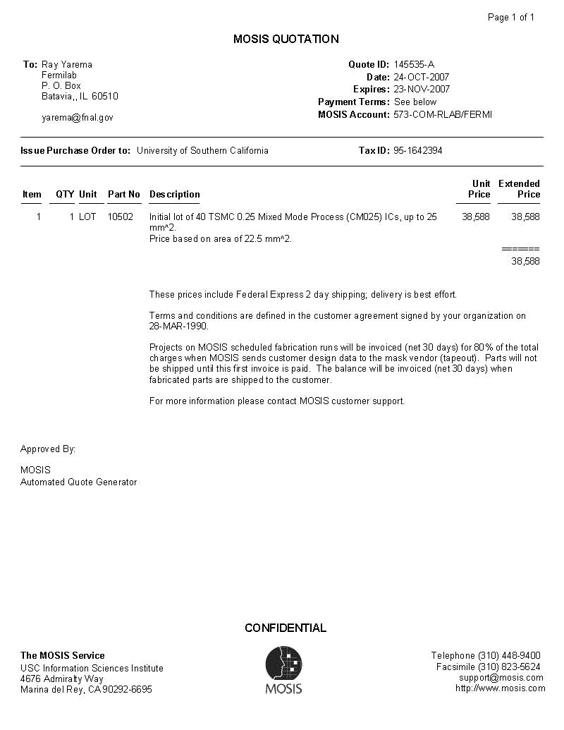

3.2.2 FNAL Quote

3.4 WBS 1.4.1.3.5 Promex and FNAL Wire Bonding Quote

3.3 WBS 1.4.3 Kapton Flex Cables HDI

3.4 WBS 1.4.4 Kapton HDI to ROC Interconnect

3.4.1 Samtec Cable

4 WBS 1.5 DAQ

4.1 WBS 1.5.1 Fiber Output ROC-FEM

4.2 WBS 1.5.2 ROC

4.3.WBS 1.5.3 FEM
4.3.1Combined Quote for Fiber, ROC, FEM,

4.4 WBS 1.5.5 Ancilliary

4.4.1 LV, HV, crates, etc. quotes

From: Eric Mannel <mannel@nevis.columbia.edu>
To: phenix-fvtx-l@bnl.gov
Subject: LV/Bias supplies for FVTX

Dear All-

In order to get a resonable cost estimate for power supplies, I need to have an
idea of level of segmentation that we will want. Specifically, I would
like feedback on the following:

Bias Voltage:
Expected Voltage Range
Number of channels ( 1 per wedge, 1/2 wedge, disk or faction thereof?)

Low Voltage(s) in the IR
Voltage(s)
Power/Current estimates per channel
Number of channels (1 per ROC, Wedge, disk or fraction there of?)

I have a quote from Wiener/ISEG for both their low voltage and high voltage
modules. The numbers are $6700 for crate and controller, $2400 for 8 channel,
programmable 0-8V, 50W/channel floating ground LV module and $5300 for 32
channel 0-500V common ground High voltage module. Both LV and HV modules can
share the same crate. For the VTX I have a requested an evaluation system which
I hope to have by the end of this year or the first of next year.

Eric J. Mannel
Associate Research Scientist,
Dept of Physics/Nevis Labs
Columbia University
914/591-2816 (Nevis Office)
914/659-3235 (Cell)
_______________________________________________
Phenix-fvtx-l mailing list
Phenix-fvtx-l@lists.bnl.gov
https://lists.bnl.gov/mailman/listinfo/phenix-fvtx-l

5 WBS 1.6 Mechanics

5.1 WBS 1.6.2 Support structure cage

5.2 WBS 1.6.3 Wedge Back Plane

5.2.1 Across Quote
Dear Mr. Sondheim

Thank you very much for your e-mail.

AC100 unit price
(size 140*50*0.76T, without machining, 150 pieces, flatness ^about0.1)
2500yen($22)

AC100 unit price
(size 136*45.03*0.76T,
with machining the finish wedge shape, 150 pieces, flatness ^about0.1)
5000yen($44)

Best regards,

Mihoko Yamashita
Across Corporation
yamashita@across-cc.co.jp

5.2.2 Alliance Quote
Subject: FW: Test Coupons
From: "RJ Ponchione" <rj@hytecinc.com>
To: <dlee@lanl.gov>

Hi Dave, here is the email again. Please let me know as soon as you get it. If I don’t hear from you today, I’ll assume it didn’t make it too you.



RJ PONCHIONE

MECHANICAL ENGINEER
:: FlashCT® Computed Tomography
:: Advanced Composites + Design Engineering Services

110 EASTGATE DRIVE LOS ALAMOS, NM 87544
Cell : 505-699-7329 Office : 505-661-3000
Email: rj@hytecinc.com

Note: HYTEC, Inc. has merged with IMTEC Corporation.
Merger Press Release

From: Rick Byrens [mailto:rbyrens@alliancespacesystems.com]
Sent: Tuesday, September 04, 2007 4:15 PM
To: RJ Ponchione
Subject: RE: Test Coupons

Hi RJ,

Here’s our quotation for the subject test coupons (please reference Alliance quote # V07-246):

NRE = $3,000
Unit Price = $1,225 each
X 10 each coupons = $12,250

Grand Total = $15,250

Notes/Exceptions:
- Material will be K13D2U/RS-3C, .063mm CPT
- The small (0.79mm) holes will be located to .02mm true position on a best effort basis.

Delivery of all coupons would be 4 weeks after receipt of order, FOB Signal Hill, CA
Terms are net 30 days
Quote validity: 60 days

Please give me a call or e-mail if you have any questions

Rick Byrens

Office: (626) 296-1373 x207
Mobile: (714) 325-0592
rbyrens@alliancespacesystems.com

From: RJ Ponchione [mailto:rj@hytecinc.com]
Sent: Friday, August 24, 2007 10:11 AM
To: Rick Byrens
Subject: RE: Test Coupons

I hate to do this to you, but the final parts have 2 high precision locating holes. I had originally removed them from the drawing to keeps the cost of the test parts down, but now the customer would like them in the test samples. I have attached an updated drawing.
Thanks.



RJ PONCHIONE

MECHANICAL ENGINEER
:: FlashCT® Computed Tomography
:: Advanced Composites + Design Engineering Services

110 EASTGATE DRIVE LOS ALAMOS, NM 87544
Cell : 505-699-7329 Office : 505-661-3000
Email: rj@hytecinc.com

Note: HYTEC, Inc. has merged with IMTEC Corporation.
Merger Press Release

From: Rick Byrens [mailto:rbyrens@alliancespacesystems.com]
Sent: Thursday, August 23, 2007 2:39 PM
To: RJ Ponchione
Subject: RE: Test Coupons

Well, considering the minimum buy on the K13C (which you won’t have to pay for on the K13D), there is a huge favorable cost difference for K13D.

Per pound, K13C is about $1,200/lb, K13D $1,400

Regards,

Rick Byrens
Office: (626) 296-1373 x207
Mobile: (714) 325-0592
rbyrens@alliancespacesystems.com

From: RJ Ponchione [mailto:rj@hytecinc.com]
Sent: Thursday, August 23, 2007 1:00 PM
To: Rick Byrens
Subject: RE: Test Coupons

I think that will be fine. The K13D is actually a better fiber for what we are doing. What is the relative cost difference between it and the K13C that we speced?

RJ PONCHIONE

MECHANICAL ENGINEER
:: FlashCT® Computed Tomography
:: Advanced Composites + Design Engineering Services

110 EASTGATE DRIVE LOS ALAMOS, NM 87544
Cell : 505-699-7329 Office : 505-661-3000
Email: rj@hytecinc.com

Note: HYTEC, Inc. has merged with IMTEC Corporation.
Merger Press Release

From: Rick Byrens [mailto:rbyrens@alliancespacesystems.com]
Sent: Thursday, August 23, 2007 12:52 PM
To: RJ Ponchione
Subject: RE: Test Coupons

RJ,

We have some K13D/RS-3 .0025” material in stock we could use for these. It’s a higher thermal conductivity/stiffness, so it should work out great. I’ll go ahead and quote this and we can go from there.

Ordering new K13C would likely be around $25K just for material…

Regards,

Rick Byrens
Office: (626) 296-1373 x207
Mobile: (714) 325-0592
rbyrens@alliancespacesystems.com

From: RJ Ponchione [mailto:rj@hytecinc.com]
Sent: Thursday, August 23, 2007 10:49 AM
To: Rick Byrens
Subject: RE: Test Coupons

Rick -
I was afraid of that. Unfortunately the in-plane conductivity of these panels is fairly critical, and since these test samples will be used for thermal testing at some point I think it is important that we get them built out of the right fiber. How expensive is an expensive small order? In order to consider a substitution, I think the fiber would have to be very equivalent in stiffness and thermal conductivity. I am not terribly familiar with all of the types of fiber available so if you think you have something close I am willing to consider it.

RJ PONCHIONE

MECHANICAL ENGINEER
:: FlashCT® Computed Tomography
:: Advanced Composites + Design Engineering Services

110 EASTGATE DRIVE LOS ALAMOS, NM 87544
Cell : 505-699-7329 Office : 505-661-3000
Email: rj@hytecinc.com

Note: HYTEC, Inc. has merged with IMTEC Corporation.
Merger Press Release

From: Rick Byrens [mailto:rbyrens@alliancespacesystems.com]
Sent: Thursday, August 23, 2007 11:39 AM
To: RJ Ponchione
Subject: RE: Test Coupons

Hi RJ,

Do you think M55J will be an acceptable alternate for these coupons? We do not have K13C in stock, and it would be an expensive small order to make these coupons. We can also talk about other alternates based on what we have in inventory if you want.

Let me know what you think…

Regards,

Rick Byrens
Office: (626) 296-1373 x207
Mobile: (714) 325-0592
rbyrens@alliancespacesystems.com

From: RJ Ponchione [mailto:rj@hytecinc.com]
Sent: Wednesday, August 22, 2007 9:49 AM
To: Rick Byrens
Cc: dlee@lanl.gov
Subject: Test Coupons

Hi Rick, We need to get some test blanks made up for a different portion of the same project as the pixel staves. They would like about 10 pieces. Please see the attached drawing. Could you give me a price and delivery time estimate? Thanks.

RJ PONCHIONE

MECHANICAL ENGINEER
:: FlashCT® Computed Tomography
:: Advanced Composites + Design Engineering Services

110 EASTGATE DRIVE LOS ALAMOS, NM 87544
Cell : 505-699-7329 Office : 505-661-3000
Email: rj@hytecinc.com

Note: HYTEC, Inc. has merged with IMTEC Corporation.
Merger Press Release

5.3 WBS 1.6.4 Support Disk

5.4 WBS 1.6.5 Alignment and Assembly Jigs

