2.2 Exploration of the nucleon structure in nuclei

Proton-nucleus collisions not only provide important baseline information for the study of QCD at high temperatures, they also address the fundamental issues of the parton structure of nuclei. Since the discovery of the EMC effect in the 1980's, it is clear that the parton-level processes and structure of a nucleon are modified when embedded in nuclear matter. These modifications reflect fundamental issues in the QCD description of the parton distributions, their modifications by the crowded nuclear environment of nucleons, gluons and quarks, and the effect of these constituents of the nucleus on the propagation and reactions of energetic partons that pass through them. Of particular interest is the depletion of low momentum partons (gluons or quarks), called shadowing, which results from the large density of very low momentum partons. For gluons at very low momentum fraction, x < 10⁻², one can associate with them, following the uncertainty principle, a large distance scale. These high-density gluons then will interact strongly with many of their neighbors and by gluon recombination or fusion are thought to promote themselves to larger momentum fraction, thus depleting small values of x. In most pictures the overall momentum is thought to be conserved in this process and so the small x region gluon density is depleted while the moderate x region above that is enhanced. In recent years a specific model for these processes, called gluon saturation, which affects both the asymptotic behavior of the nucleon gluon distributions as x approaches zero and the modification of this behavior in nuclei, i.e. shadowing, has been discussed extensively by McLerran and collaborators.

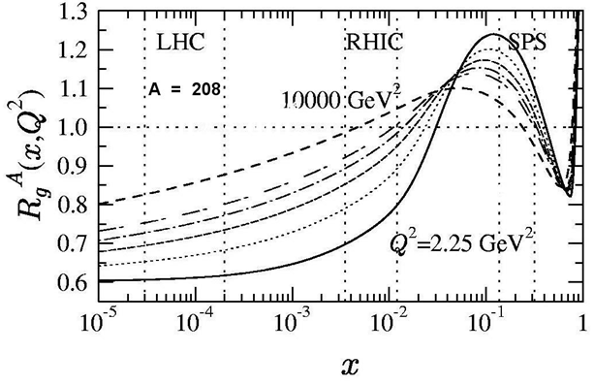
Figure 1 - Gluon shadowing from Eskola as a function of x for different Q² values: 2.25 GeV² (solid), 5.39 GeV² (dotted), 14.7 GeV² (dashed), 39.9 GeV² (dotted-dashed), 108 GeV² (double-dashed) and 10000 GeV² (dashed). The regions between the vertical dashed lines show the dominant values of x₂ probed by muon pair production from DDbar at SPS, RHIC and LHC energies.

At RHIC energies many of the observables sample regions of very small x where nuclear shadowing is thought to be quite strong. However, theoretical predictions of the amount of shadowing differ by factors as large as three. For example, in the production of J/Ψ in the large rapidity region covered by the PHENIX muon arms, models from Eskola et al (Figure 1) predict only a 30% reduction due to gluon shadowing, while those of Frankfurt & Strikman (Figure 7) or Kopeliovich predict up to a factor of three reduction. Results from the measurements of the just-completed d-Au run should help to clarify how much shadowing we have, but increased statistics from higher luminosity runs and more definitive measurements with enhanced detectors capable of making more exclusive measurements in several channels will be necessary to test the theory with sufficient power to constrain the underlying QCD processes.

In particular, it is clear that a precise knowledge of the shadowed gluon structure functions in nuclei is essential towards understanding several of the important signatures for QGP in heavy-ion collisions at RHIC including open and closed heavy-quark production. Recombination models for J/Ψ production, which might cause an enhancement of that production in heavy-ion collisions due to the large density of charm quarks created in a collision, must be constrained by the an accurate measurement of the amount of charm produced given the shadowing of the gluon densities in the colliding nuclei. In the J/Ψ studies done at CERN by NA38/50 the J/Ψ yields were usually divided by the Drell-Yan dimuon yields, since the latter should have little nuclear dependence. But this is actually an unnatural procedure since the Drell-Yan process involves quarks (q-qbar annihilation) while J/Ψ production involves gluons (gluon fusion). The nuclear effects on the initial parton distributions for quarks and gluons are likely different and their energy loss in the initial state before the hard interaction also likely different. Additionally the yields of Drell-Yan dimuon pairs were quite small at CERN and dominated the statistical uncertainties in this ratio. The rates for Drell-Yan at PHENIX are even smaller and making such a ratio makes even less sense here. It is much more natural to compare J/Ψ production to open-charm production, where the initial-state effects are probably the same. Therefore a robust measurement of open-charm is quite important for the physics of the J/Ψ. Of course, it has also been suggested by some theoretical groups that the effective gluon distributions are process dependent, and different for e.g. open- and closed-charm production. These models suggest that such a difference, if seen by comparisons of open and closed charm, would indicate that higher-twist contributions to closed charm production were substantial.

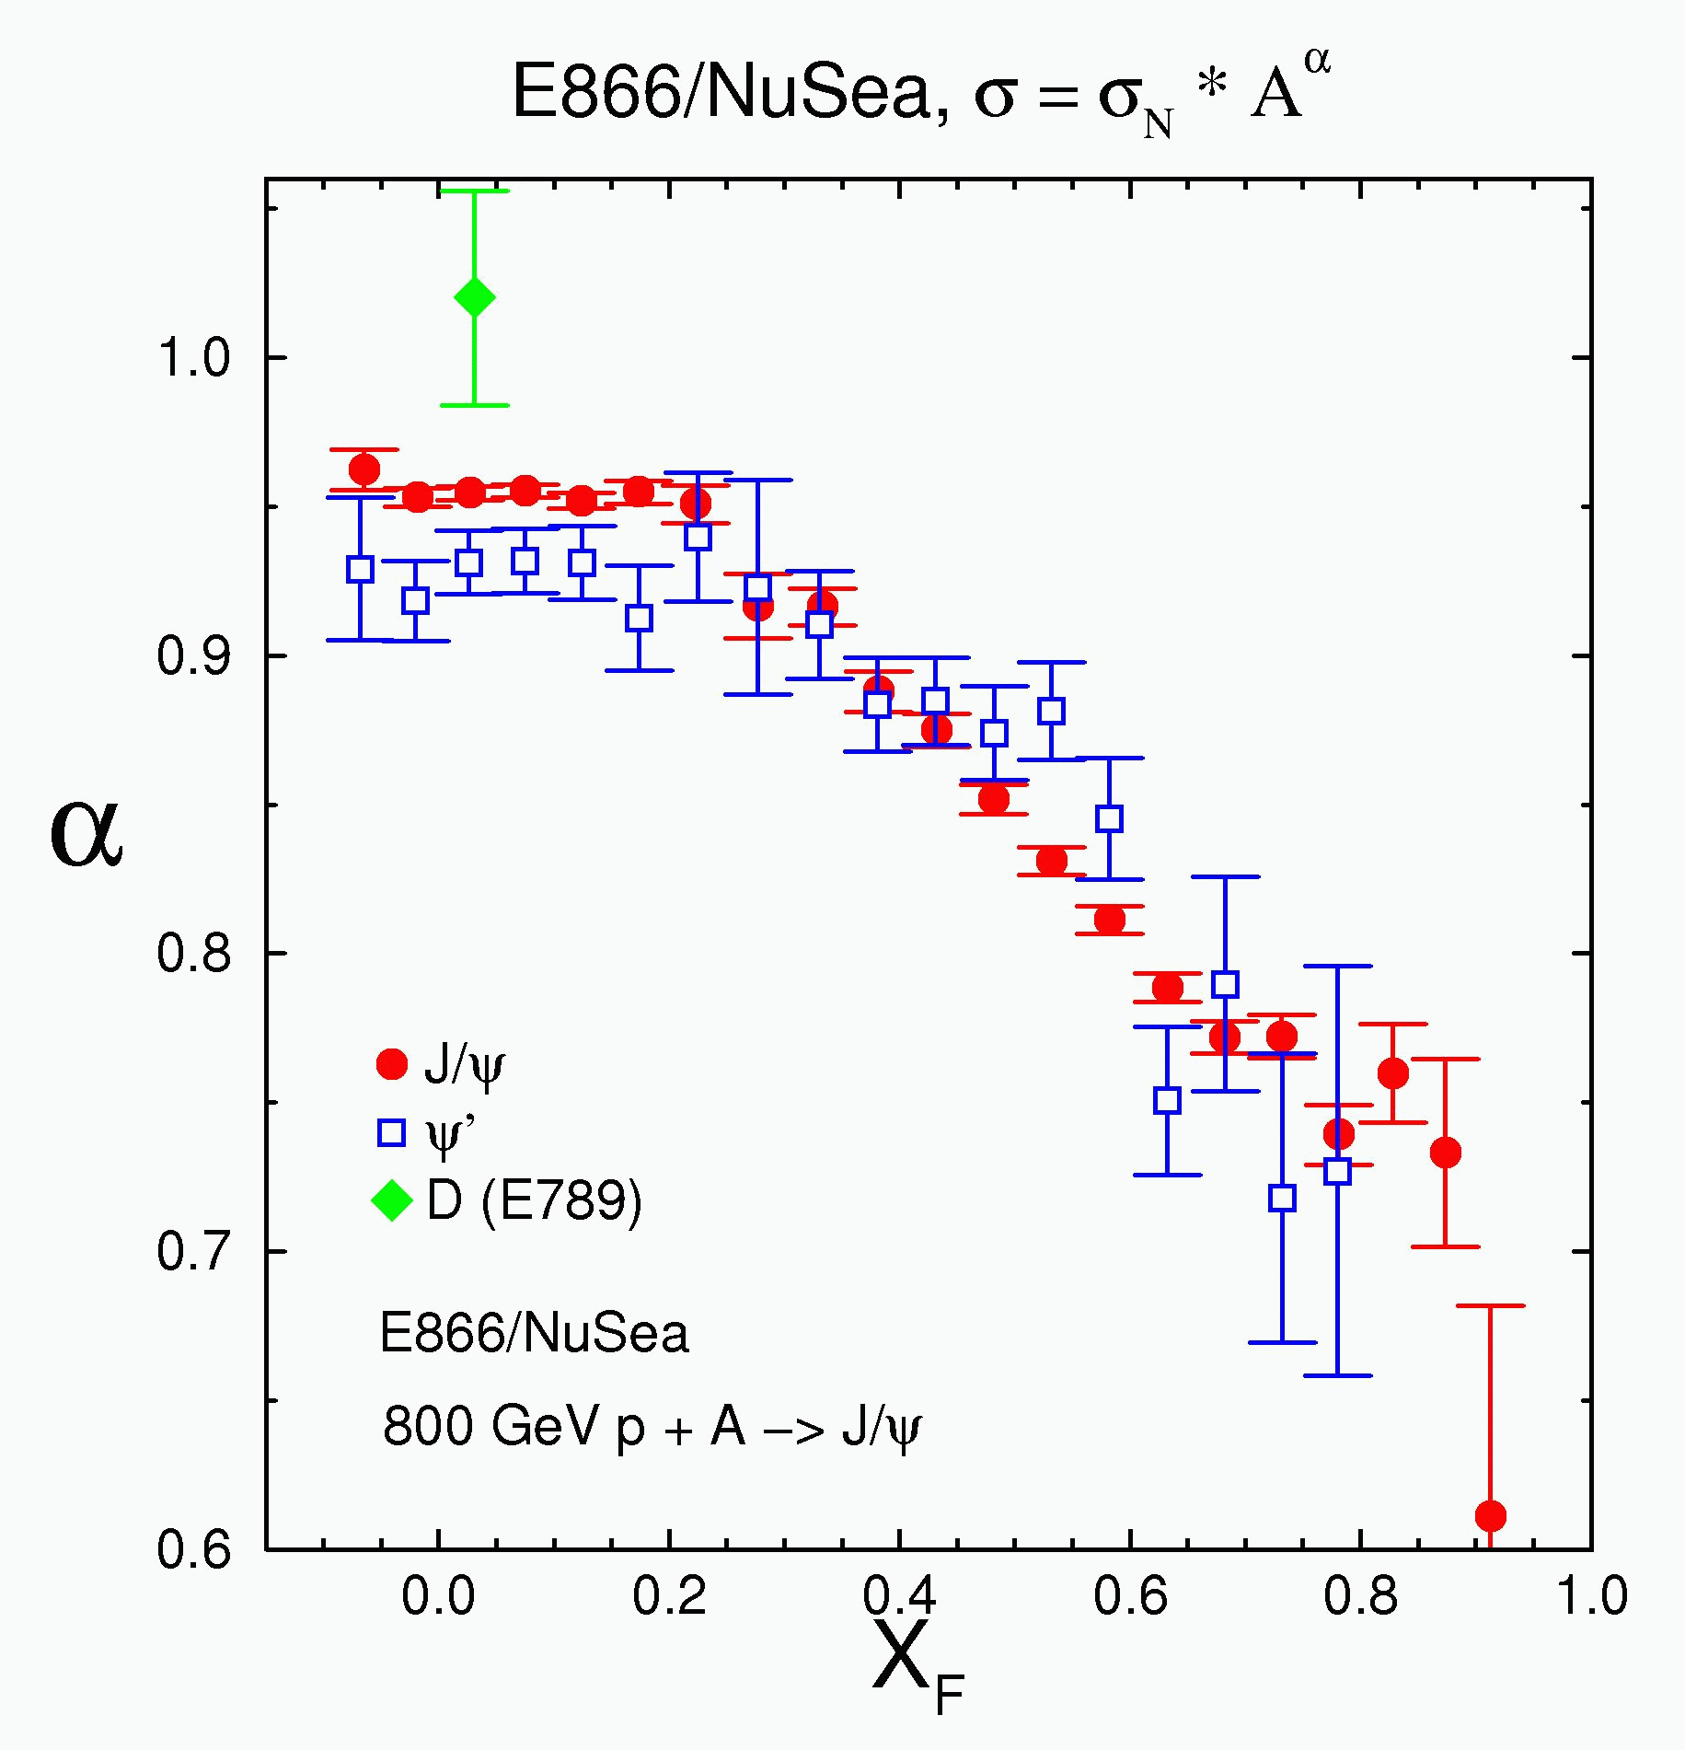
Figure 2 - Nuclear dependence in 800 GeV p+A collisions from E866/NuSea showing a comparison of open (D meson) and closed charm (J/Ψ). The open charm comparison here suffers from lack of statistics and lack of coverage at non-zero x_{F} (non-zero rapidity).

Another area of importance, especially to the J/Ψ measurements, is the production of beauty quarks. The decay of B-mesons will produce J/Ψ’s (BR ~ 1.14%) that tend to have somewhat higher p_{T} than prompt J/Ψ production. In a scenario where color-screening in a QGP created in heavy-ion collisions destroys most of the J/Ψ’s it is conceivable that, particularly at higher p_{T}, the remaining J/Ψ’s become dominated by those that come from B decays. An estimate of this from Lourenco several years ago indicated that for central collisions the fraction of J/Ψ’s from B decays might be as large as 20% overall, with even larger fractions at high p_{T}. Clearly one would like to measure the B cross sections at RHIC energies so that a more reliable estimate of their contribution to the J/Ψ production can be made, an issue which would be particularly important should a large suppression of J/Ψ’s be seen in central Au-Au collisions at RHIC. How strong a suppression is actually occurring would be difficult to know without establishing how many of the remaining J/Ψ’s do come from B decays. In addition, given sufficient RHIC luminosity, it would be quite instructive to measure for beauty the same observables already discussed for charm, and to compare these results. As RHIC luminosity increases we will also be able to measure the Upsilon, a b-bbar bound state; and for it, a comparison with open-beauty will obviously be important.

A number of other physics issues besides shadowing also need to be understood. Energy loss of partons in the initial state is thought to have a small effect at RHIC since the energy loss per fm, in most models, is thought to be approximately constant and small compared to the initial-state parton energies at RHIC. On the other hand, partons in the final state could show some effects of energy loss since their momentum is lower, while heavy-quarks are expected to lose less energy than light partons due to the dead-cone effect. These issues are very important in the high-density regions created in heavy-ion collisions, but need a baseline for normal nuclear densities from proton-nucleus collisions. Another general feature of most produced particles comes from the multiple scattering of initial-state partons which causes a broadening of the transverse momentum (Cronin effect) of the produced particles.

Many of the present measurements of the observables necessary to address these critical physics issues are weakened by the lack of a more exclusive observation of the process. For example, our present capability for identifying open-charm is via high-p_{T} single leptons (electrons or muons) and relies on the fact that the leptons at higher p_{T} come mostly from heavy quarks (charm or beauty) and on a subtraction of a large amount of background from light-meson decays. This procedure suffers from large uncertainties due to the limited knowledge of the background sources that are subtracted and also pushes one towards higher p_{T} where the yields for a given luminosity are smaller. The addition of a silicon vertex detector to PHENIX would allow for a much more convincing and accurate determination of the heavy-quark component in these spectra and also allow measurement to smaller p_{T} values by substantially reducing the low-mass meson decay backgrounds. Figure-3 and 4 show a simulation of the single muon spectra with contributions from charm, beauty and background decays with and without the use of detached vertex identification from a silicon vertex detector.

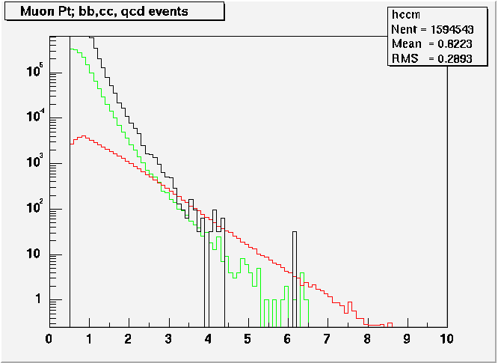
--- π, K decays
--- charm
--- beauty
Figure 3 - Single muon p_{T} distributions for charm, beauty and backgrounds from low-mass meson decays as expected for the 2003 d-Au run. Note that the light-meson decays are above charm up to near 4 GeV/c.
Figure 4 - Single muon p_{T} distribution for charm compared to backgrounds with a vertex cut showing signal/noise well above one even at p_{T}=0.5 GeV/c.

Figures 5 and 6 show a similar improvement for electrons in the central rapidity region when a vertex detector can be used to cut on the distance of closest approach (DCA) of the electrons to the primary vertex.

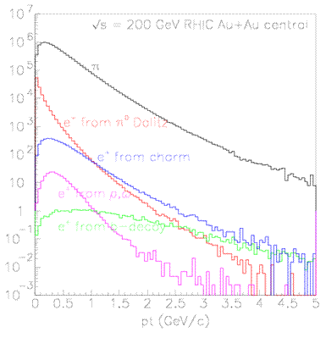
Figure 5 - Single electron p_{T} spectrum when no vertex detector is available to enrich the heavy-quark components.
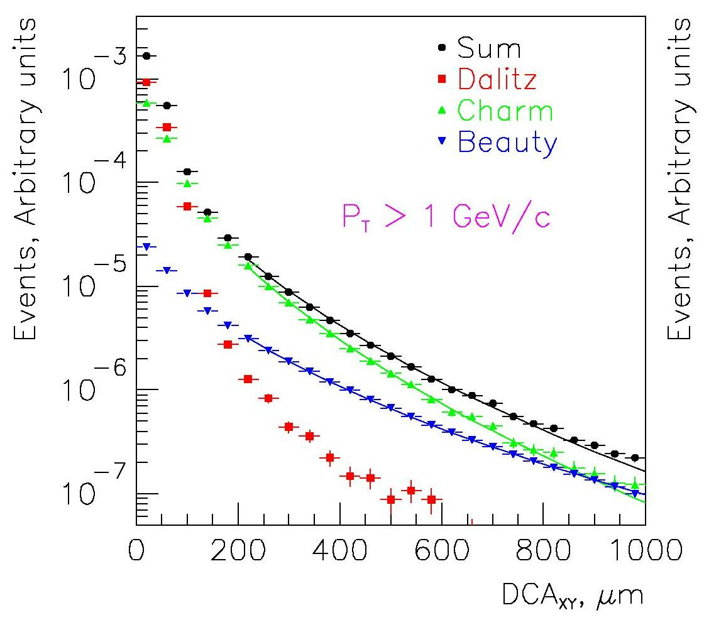
Figure 6 – Distance of closest approach (DCA) distribution for electrons from heavy-quark decays and backgrounds showing how backgrounds can be greatly reduced by a vertex detector which allows cuts on the DCA.

In general, all processes suitable for the measurement of gluon spin structure in nucleons are also ideal for probing the gluon distributions in nuclei. The reach in Bjorken x is indicated in Figure-7, superimposed on calculations of the ratio of nuclear to nucleon gluon structure functions.

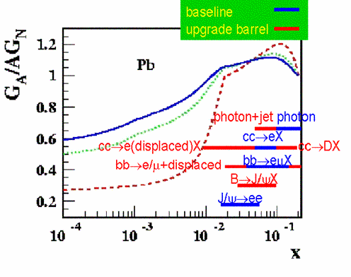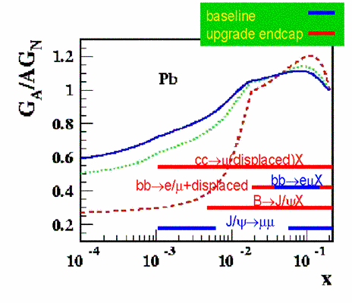
Figure 7 - Gluon shadowing predictions along with PHENIX coverage. The red bars indicate the additional range provided by the vertex upgrade, while the blue bars cover the PHENIX baseline. The three theoretical predictions are for different Q transferred, blue, green and red lines are Q = 10, 5 and 2 GeV/c respectively, from Frankfurt and Strikman.

The red bars indicate the additional coverage provided by the vertex upgrade compared to the baseline of PHENIX. The vertex upgrade extends the x-range from the anti-shadowing region into the shadowing domain and therefore will provide a measurement of shadowing and establish the shape of the shadowed structure functions versus x.

As a complement to the use of high-p_{T} leptons with a detached vertex as a tool for measurement of open-charm, we can also measure exclusive decays such as $D→Kπ$ with the PHENIX mid-rapidity detectors along with a deteached vertex from a silicon vertex barrel. These channels extend our range to larger x values, as shown in Figure 7 , and to larger p_{T} for the $c\bar{c}$process. Besides extending these ranges, measurement of these channels also serves as a verification of the results obtained using single leptons.

Another problem that a silicon vertex capability in PHENIX can help solve is the separation in mass of the Ψ’(3.690 GeV) from the J/Ψ(3.097 GeV). The Ψ’ is, in a physics sense, a cleaner probe than the J/Ψ because a large fraction of the J/Ψ’s (~40%) come from feed-down decays of higher mass resonances (e.g. the χ_{c}). This is particularly important in studies of the production mechanism of the J/Ψ, where mechanisms involving color-octet states should produce substantial polarization of the J/Ψ while others would not. But if many of the J/Ψs come from feed-down, then it is likely that most of the observed polarization is diluted by the decay and lost. On the other hand, the Ψ’s do not suffer from this problem and the polarization would be expected to persist for them. The challenge is to get high enough integrated luminosity to measure a significant number of Ψ’ and to have mass resolution sufficient to separate them from the larger J/Ψ peak next to them. Present mass resolution in the muon arms is around 150 MeV, which given the statistics in the peaks makes it very difficult to extract reliable Ψ’ signals. But the dominant contribution to the mass resolution in this mass region for muon pairs is multiple scattering in the absorber in front of the muon arms. If we can add space points from a silicon vertex detector in front of these absorbers, it is estimated that we can improve the mass resolution to around 100 MeV, and make the extraction of a Ψ’ signal from the dimuon spectra much easier as shown schematically in Figure-8.

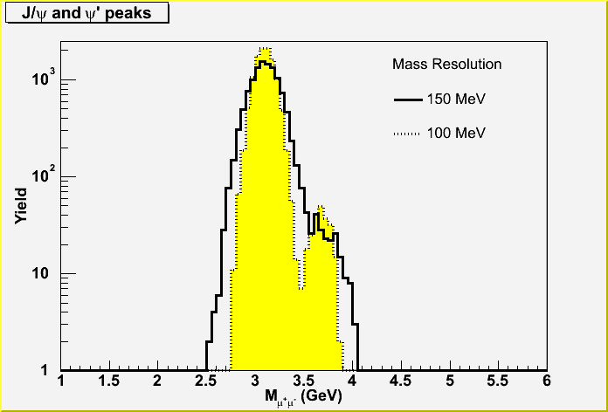
Figure 8 – Mass spectra for the J/Ψ and Ψ' showing the substantial improvement in separation expected with a vertex detector (yellow, 100 MeV resolution) compared to that without a vertex detector (black, 150 MeV resolution). The number of J/Ψ and Ψ’ in this plot represents our expectation for a ~25 pb⁻¹ p-p run.

The vertex detector can also help in the higher e⁺e⁻ mass region for separation of the members of the ϒ family of resonances , ϒ_{1S} (9.46 GeV), ϒ_{2S} (10.02 GeV) and ϒ_{3S} (10.36 GeV). As shown schematically in Figure 7, the vertex detector barrel can improve the resolution from ~170 MeV to ~60 MeV for the e⁺e⁻ channel, thus allowing studies of the separated ϒ states (although it is a significant challenge to reach sufficiently high luminosities to make these measurements).
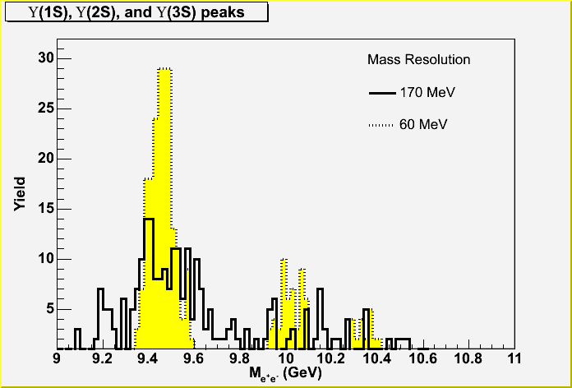
Figure 9 - Separation of Upsilon states for their di-electron decays with a vertex detector (yellow) and without (black). The number of ϒs in this plot represents our expectation for a ~1 nb⁻¹ Au-Au run.

Drell-Yan measurements, which provide a direct measure of the anti-quark distributions in nucleons or nuclei, have always been limited in the past in their reach to low x by the inability to separate the Drell-Yan muon pairs below the J/Ψ in mass from copious pairs from open-charm decays in that mass region. For example, in FNAL E866/NuSea, information extracted from the Drell-Yan process was limited to masses above 4 GeV.

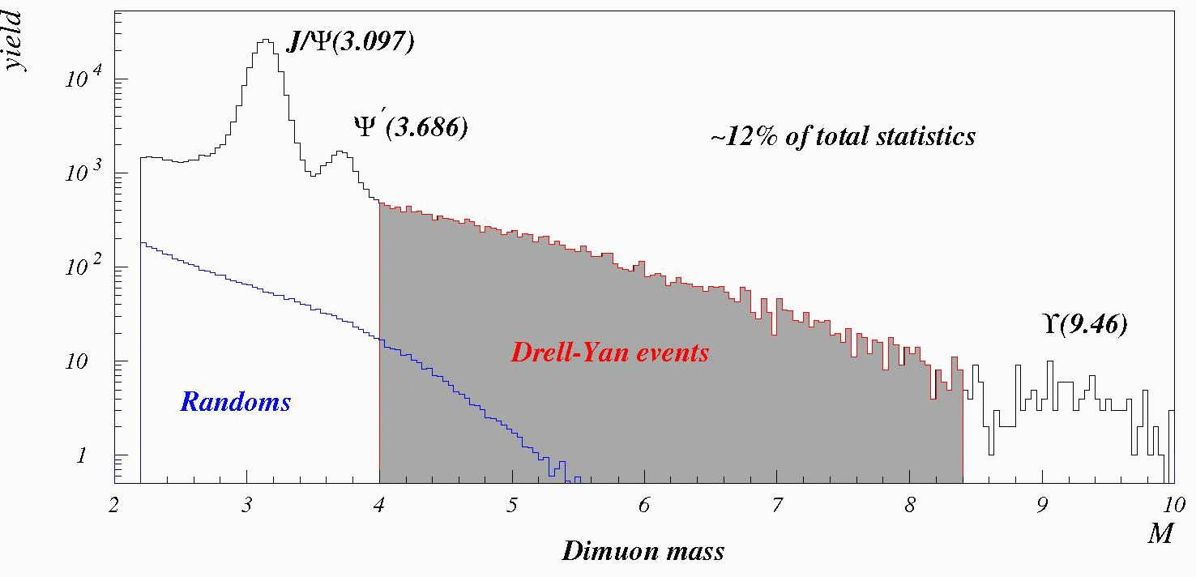
Figure 10 - Dimuon mass spectrum from E866/NuSea showing the mass region used in their analysis which excludes masses below 4 GeV. Lower masses were excluded because of the large backgrounds from open charm in that region.
On the other hand, PHENIX, with the addition of a vertex detector, should be able to identify and quantify the portion of the lower mass dimuon continuum from charm decays and therefore isolate the Drell-Yan process at these lower mass and lower x values. In the central-rapidity barrel region values as low as x₂ ~ 0.7x10⁻² could be accessed, while in the region covered by the muon arms, with an endcap vertex detector in that region, the reach could be extended down to x₂ ~ 0.9x10⁻³. This will still be a challenge because of the small cross sections and yields for Drell-Yan at RHIC, but has the potential of providing information on the anti-quark distributions at much smaller values of x. At the same time one would also learn more about charm production and the correlation of the charm pairs through the charm pairs found in the continuum.

The silicon vertex barrel, which covers the PHENIX central arm mid-rapidity range ( |y| < 0.35 ), addresses many of the physics issues discussed above, including:
- Charm and beauty at high p_{T} and mid-rapidity via high-p_{T} electrons and also exclusive decays such as $D→Kπ$ and $D→K\text{ππ}$.
- Providing a baseline in the anti-shadowing region for shadowing measurements at large rapidity or small x. Large rapidity, which corresponds to small x values in the shadowing region, would come from the muon arms with an endcap silicon vertex detector in front of them as described in section 6.
- Charm measurements at mid-rapidity as a baseline for J/Ψ production, i.e. for comparisons of open and closed charm which should share the same initial-state effects in nuclei.
- Charm cross sections as a constraint on recombination models for J/Ψ production.
- Beauty cross sections at mid-rapidity as a constraint of the contributions of $B→J/Ψ$to J/Ψ production.
- Comparison of light and heavy-quark p_{T} distribution to determine differences in energy loss and Cronin effects.
- Better separation in high-luminosity measurements of ϒ measurements of the three ϒ states.
- Low-mass electron pairs and anti-quark shadowing at small x values.

For many of these topics the physics picture that can be obtained is significantly strengthened with the planned addition of a endcap silicon vertex detector as described in section 6.

M. Arnedo, Phys. Rep. 240, 301 (1994), K.J. Eskola et al., hep-ph/9906484.
L. McLerran and R. Venugopalan, Phys. Rev. D49, 2233 (1994); A.H. Mueller and J.W. Qui, Nucl. Phys. B 268 427 (1986) and L.V. Bribox, E.M. Levin and M.G. Ryskin, Phys. Rept. 100, 1 (1983).
K.J. Eskola, V.J. Kolhinen and R. Vogt, Nucl. Phys. A696, 729 (2001) or hep-ph/0104124.
L. Frankfurt, M. Strikman, Eur. Phys. J A5, 293 (99)
B.Z. Kopeliovich, A.V. Tarasov, J. Huefner, Nucl. Phys. A696, 669 (2001) or hep-ph/0104256.
M.C. Abreu et al (NA50), Phys. Lett. B410, 327 (1997).
B.Z. Kopeliovich, A.V. Tarasov, Nucl. Phys. A710, 180 (2002) or hep-ph/0205151 and J. Raufeisen private communication.
M.J. Leitch et al (E866/NuSea), Phys. Rev. Lett. 84, 3256 (2000).
C.Lourenco, “Workshop on Quarkonium Production in Relativistic Nuclear Collisions”, Seattle, 11 May 1998, B-> J/Psi estimates, private communication.
D. Kharzeev, Nucl. Phys. A702, 39 (2002) or hep-ph/0111386.
L. Frankfurt, M. Strikman, Eur. Phys. J A5, 293 (99)
M.A. Vasiliev et al (E866/NuSea), Phys. Rev. Lett. 83, 2304 (1999).

