Kaon Production in $\sqrt{s_{\text{NN}}}$ = 200 GeV Au-Au Collisions measured with the PHENIX experiment at RHIC

Momchil Velkovsky for the PHENIX Collaboration,

Department of Physics, University at Stony Brook, Stony Brook, NY 11794

Abstract
The PHENIX experiment has measured K⁺ and K⁻ spectra from 200 GeV Au-Au collisions in a transverse momentum range p_{T} ~(0.4 – 2.0) GeV/c, using a high-resolution time of flight detector. dN/dy at mid rapidity and < p_{T} > were measured as a function of centrality, using 11 centrality classes. Comparisons to a simple hydrodynamic model are made. Ratios K⁺/K⁻, K⁻/π⁻, K⁺/π⁺ and ${\overline{p}}/p$ are shown as a function of p_{T} and centrality. These allow the extraction of the statistical thermal model parameters. The results are compared to earlier measurements at $\sqrt{s_{\text{NN}}}$ = 130 GeV. PHENIX can also identify K⁰_{S} via its decay into π⁺ π⁻ pairs. First results from this measurement are presented.

- Introduction
One of the valuable features of the PHENIX detector at RHIC is that it provides particle identification (PID) for charged particles over a broad momentum range [1]. Charged pions and kaons are identified up p_{T} = 2 GeV/c, and protons and anti-protons – up to p_{T} = 4 GeV/c at mid rapidity. The transverse momentum spectra of these six species provide information about the kinetic freeze out conditions: temperature and flow velocity. The ratios of ${\overline{p}}/p$ together with K⁺/K⁻ reflect the baryon chemical potential and the strangeness production mechanism. Studying the mean transverse momentum (<p_{T}>) and integrated yields (dN/dy) of the above species as a function of the number of participants (N_{part}) allows a comparison with hydrodynamic models and testing their applicability ranges. Related to this is the puzzle of having comparable numbers of (anti) protons and pions in the intermediate (2-4) GeV/c p_{T} range in central Au-Au collisions [2]. Proposed explanations refer either to protons being pushed to higher p_{T} by the hydrodynamic flow [3], because of their mass or to baryon specific mechanisms for hadron production [4]. Studying the kaon production in this p_{T} range, may discriminate between models, as kaons are mesons, but with mass in between the pion and the proton. Although the charged kaon PID in PHENIX is limited to p_{T} < 2 GeV/c, kaon PID can be extended up to p_{T} ~5-6 GeV/c through the measurement of K⁰_{S} → π⁺ π⁻.

- Hadron PID in PHENIX
For charged hadrons, a multi-layer drift chamber followed by a pad chamber provide a measurement of the momentum and the trajectory, while beam-beam counters (BBC) and a time-of-flight detector (TOF) provide the flight-time and consequently, their velocity. The TOF has resolution of σ=115 ps and the acceptance in rapidity depends on the particle species and p_{T}. Figure 1 shows the inverse momentum multiplied by the charge of the particle as a function of TOF. Pions, kaons and protons are separated in a wide momentum range. A GEANT-based Monte Carlo simulation is used to obtain corrections for p_{T} –dependent acceptance, decay-in-flight and reconstruction efficiency. Multiplicity dependent corrections are obtained by embedding simulated tracks into real events with different centrality.
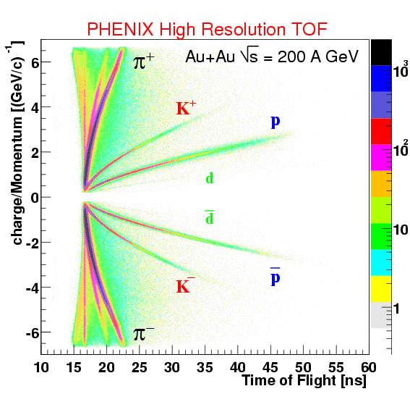

Fig. 1 TOF PID plot

- Hadron spectra and freeze out parameters
Figure 2 shows the p_{T} spectra for K⁺ and K⁻ for 9 centrality classes that are determined using signals from BBC and the zero degree calorimeter. A Glauber model calculation [5] is used to obtain N_{part} for each class. To obtain < p_{T} > and dN/dy the spectra were fitted with m_{T} exponents, shown on the plots with lines.
A hydrodynamics-motivated function was fit simultaneously to all identified hadron spectra in the low m_{T} range: (m_{T} -m₀) < 1 GeV. The freeze out parameters of the fireball: temperature T and transverse flow velocity β_{T} were extracted [6].
For the 5% most central:
β_{T} = 0.7 ± 0.2 syst.
(< β_{T}> = 0.5 ± 0.2 syst.)
T_{fo} = 110 ± 23 MeV
For the 80-91% peripheral:
β_{T} = 0.5 ±0.2 syst.
(< β_{T}> = 0.3 ± 0.2 syst. )
T_{fo} = 135 ± 23 MeV

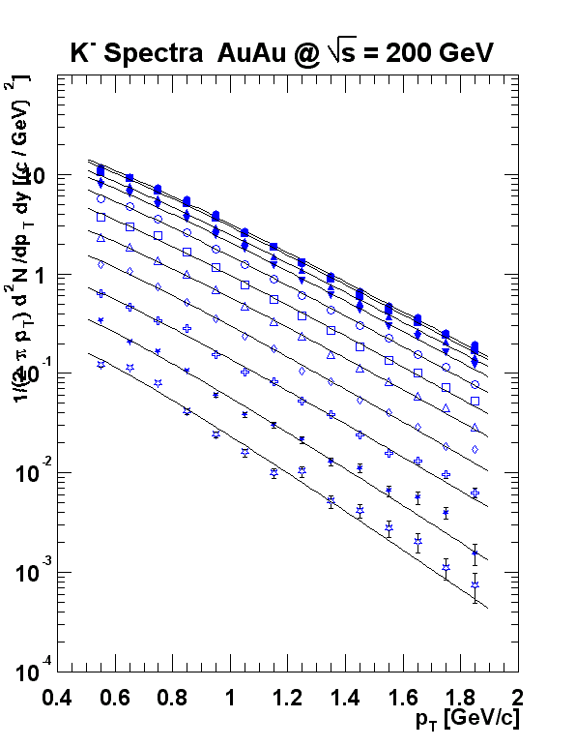
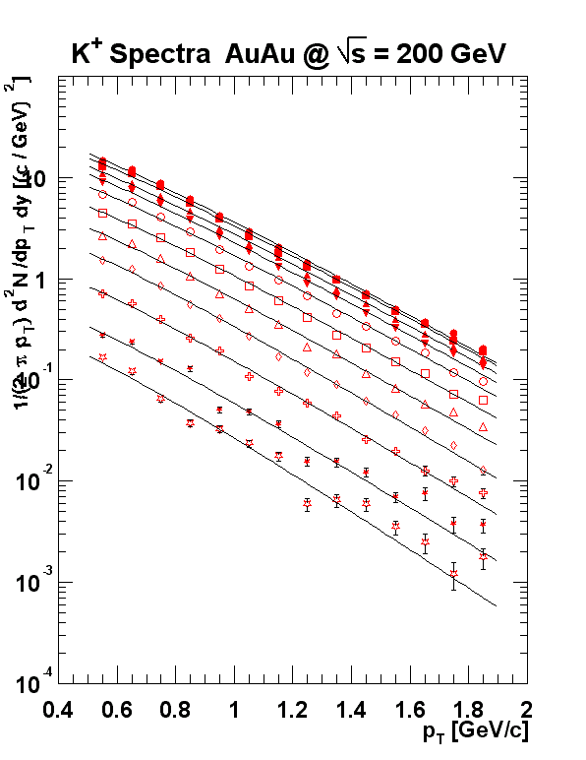
K⁺
K⁻
PHENIX Preliminary
PHENIX Preliminary
centrality
0 - 5 %
5 - 10 %
10 - 15 %
15 - 20 %
20 - 30 %
30 - 40 %
40 - 50 %
50 - 60%
60 - 70%
70 - 80 %
80 - 91 %

Fig. 2 Kaon p_{T} spectra for different centrality classes

- Hadron ratios and the baryon chemical potential
The statistical thermal model relates the temperature and the chemical potentials for all particle species with the particle yield ratios. In the simple case when only the baryon chemical potential is included, the two most important ratios are p /p and K⁻/K⁺. They are shown on Fig. 3 for the central and peripheral Au-Au events and also for the proton-proton collisions. All ratios change very little with centrality and also with p_{T}. Only the ratio for the peripheral events seem to drop above 2.5 GeV, but it is consistent with the proton-proton data, which goes only up to 2 GeV. The integrated yield ratios are: π⁻ / π⁺ = 1.02 ± 0.02 ± 0.1, K⁻ / K⁺ = 0.92 ± 0.03 ± 0.1, p /p= 0.70 ± 0.04 ± 0.1. The p /p ratio, measured in different experiments is shown on Fig. 4 as a function of $\sqrt{s_{\text{NN}}}$.
From the statistical thermal model, one can find dependence of different h⁺/h⁻ ratios on the baryon chemical potential μ_{B}. PHENIX $\sqrt{s_{\text{NN}}}$=130 and 200 GeV points for a K⁺/K⁻ vs. are shown. They correspond to μ_{B}~ 30MeV (200 GeV), μ_{B}~ 46MeV (130 GeV).

Au+Au$\sqrt{s_{\text{NN}}}$= 200 GeV central
Au+Au$\sqrt{s_{\text{NN}}}$= 200 GeV peripheral
p+p$\sqrt{s_{\text{NN}}}$= 200 GeV
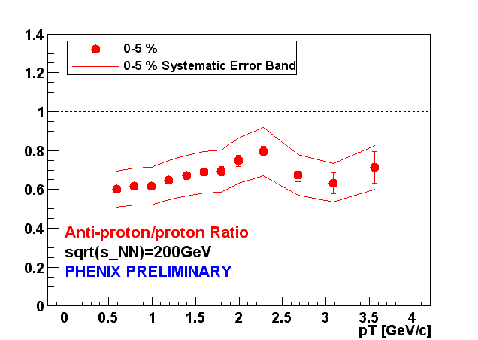
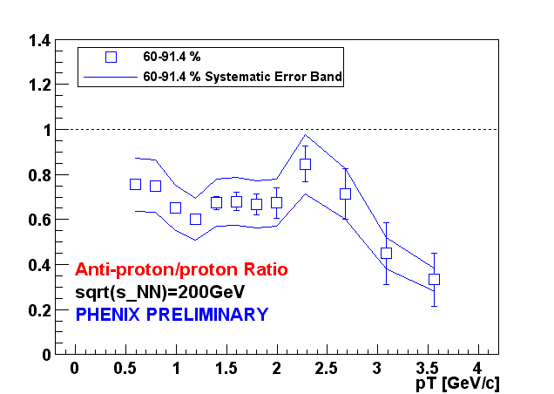
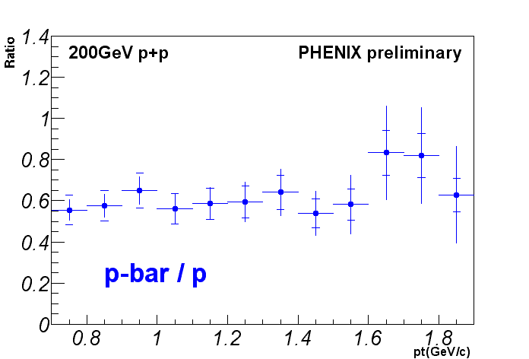
$${\overline{p}}/p$$

$${\overline{p}}/p$$

$${\overline{p}}/p$$

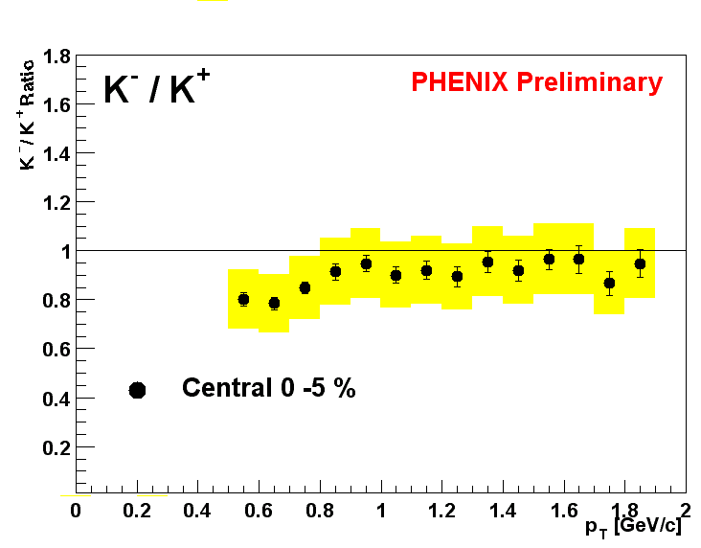
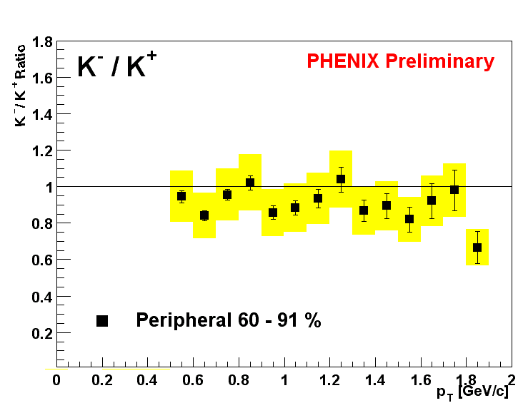
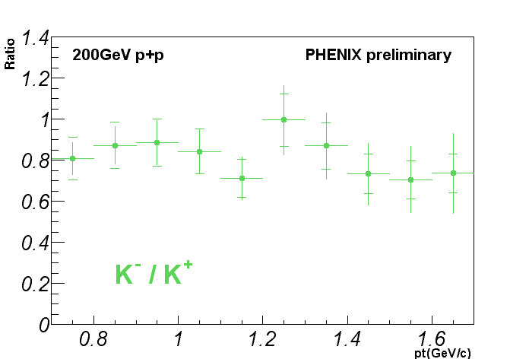

K⁻/K⁺

Fig. 3 ${\overline{p}}/p$ and K⁻/K⁺ for central and peripheral Au-Au and p-p collisions
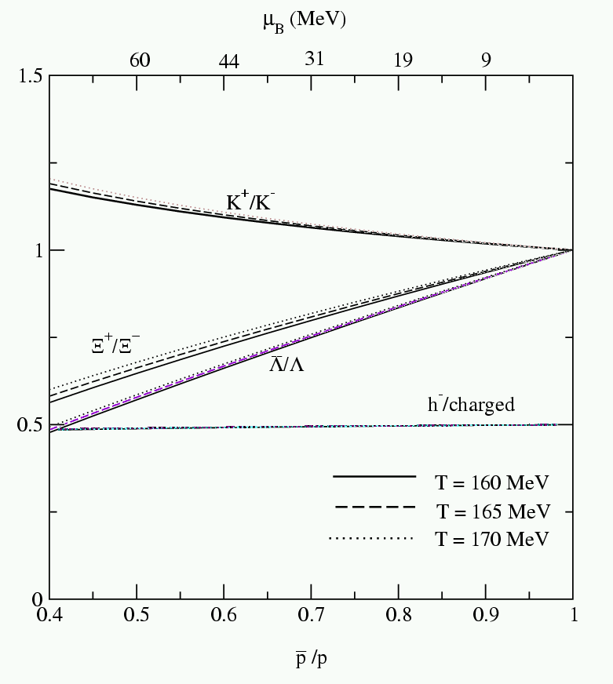
PHENIX preliminary (200 GeV), central (0-10%)
(130GeV)
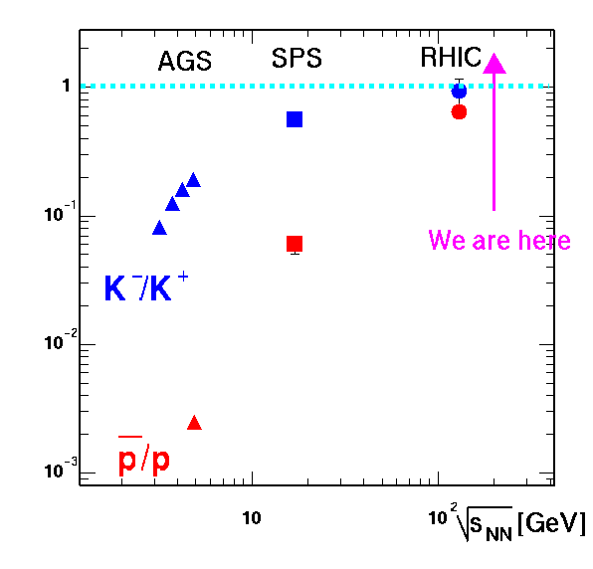

Fig. 4 ${\overline{p}}/p$ ratio in different experiments Fig. 5 K⁺/K⁻ vs. ${\overline{p}}/p$ from a model

- Integrated yields and <p_{T}> as a function of N_{part}
The dependence of <p_{T}> and dN/dy on N_{part} provides a test for different hydro-dynamic models. One such model [7], with only one free parameter – the initial p_{T} kick, has its predictions shown on Figures. 6 and 7.
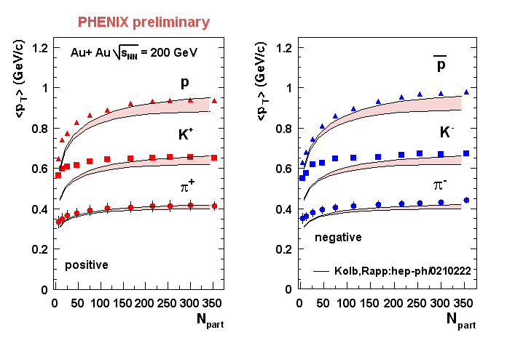
Syst.
error :
π (10%),
K (15%),
p (14%)

Fig. 6 <p_{T}> versus the number of participants. The model is shown with a strip.

The model fails below N_{part} ~ 150, when the conditions for a hydrodynamic description are not satisfied. The discrepancy is largest for the K^{+/-}, suggesting that strangeness is not completely thermalized. This is most evident in the K/π ratio, which grows with N_{part}.
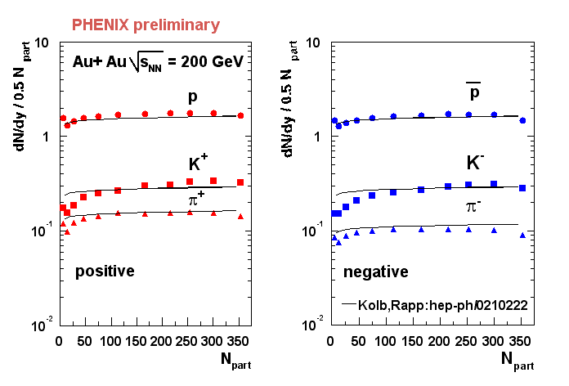
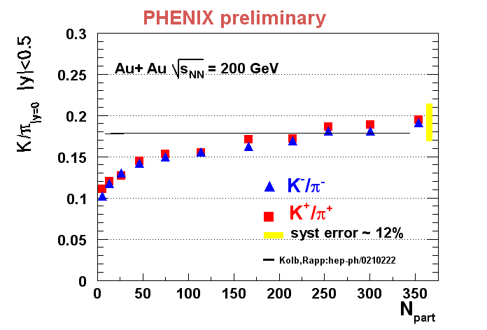
p
π⁻
π⁻
p
syst.
error
12%

π⁺

π⁻

Κ⁺

Κ⁻

p

p

Fig. 7 dN/dy at mid rapidity per participant pair for π^{+/−},Κ^{+/−}, p, $\overline{p}$. The right plot shows the K/π ratio versus N_{part}. Systematic errors are shown with bars. The lines are the Kolb-Rapp hydrodynamic predictions.

- K⁰_{s} measurement in PHENIX
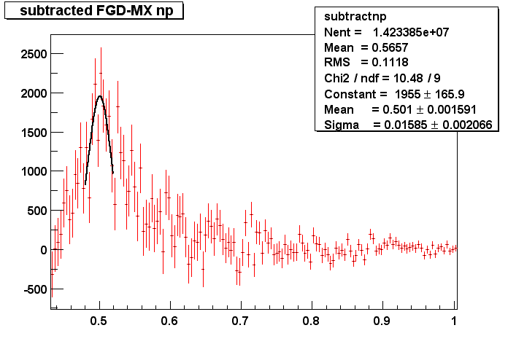
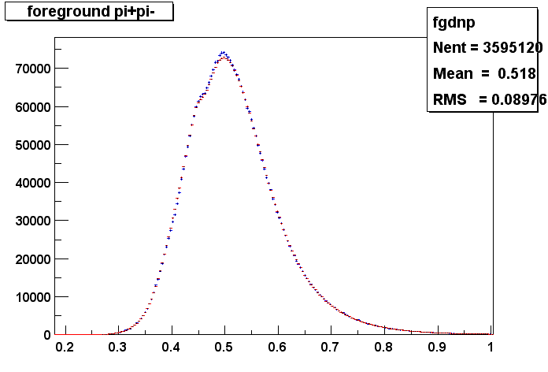
PHENIX has the ability to measure K⁰_{s} through its dominant decay into π⁺ π⁻ pairs. This will extend the kaon p_{T} spectra up to 5 GeV/c. Preliminary results on the K⁰_{s} peak in the π⁺ π⁻ pair invariant mass are shown on Fig. 8.
K⁰_{s->} π⁺π⁻
central
subtracted
_{m (GeV)}
K⁰_{s ->}π⁺π⁻
central
+foreground
+background
_{m (GeV)}
Fig. 8 π⁺ π⁻ invariant mass spectrum for central events.

7. Conclusions
From the measured π⁺,π⁻, K⁺, K⁻, $\overline{p}$, p spectra we extract β_{T}=0.7±0.2, T_{FO}=110 ±23 MeV, μ_{B}~30 MeV for the most central events at $\sqrt{s_{\text{NN}}}$ =200 MeV. The K⁺/K⁻ ratio is flat in p_{T} and centrality, consistent with thermal production. K yield grows faster than N_{part} and faster than the π one. Hydrodynamic models describe the $\overline{p}$, p spectra, but fail for meson dN/dy, <p_{T}> and the K/π ratio in peripheral events (N_{part}<150). Measuring K⁰_{s} up to high p_{T} will shed light on the p-π puzzle.

References:
1. PHENIX Collaboration, M. Aizawa et al. NIM A499, 508-520, (2003).
2. PHENIX Collaboration, S. S. Adler et al. to be published; J.Velkovska in this volume.
3. U. Heinz, P. Kolb, Nucl. Phys. A702, 269, (2002).
4. I.Vitev and M.Gyulassy, Phys. Rev C65, 041902, (2002); R. C. Hwa and C. B. Yang, Phys. Rev. C 67, 034902 (2003); R. J. Fries, B. Muller, C. Nonaka and S. A. Bass, nucl-th/0301087; V. Greco, C. M. Ko and P. Levai, nucl-th/0301093.
5. PHENIX Collaboration, S. S. Adler et al., submitted to PRL, nucl-ex/0304022.
6. PHENIX Collaboration, J. Burward-Hoy nucl-ex/0210001 and references therein.
7. P. F. Kolb and R. Rapp, Phys. Rev. C67, 044903, (2003).

